**SPRING ASSIGNMENT**

**1.Create a bean class called product (id, name, rate, qty, launch_date).Create object through dependency injection.**

**PRODUCT PROGRAM.JAVA**

**package** com.spring;

**import** java.util.*;

**public** **class** ProductProgram

{

**int** pid;

String pname;

**double** prate;

**int** qty;

Date launch_date;

**public** ProductProgram()

{

**super**();

// **TODO** Auto-generated constructor stub

}

**public** ProductProgram(**int** pid, String pname, **double** prate, **int** qty,

Date launch_date) {

**super**();

**this**.pid = pid;

**this**.pname = pname;

**this**.prate = prate;

**this**.qty = qty;

**this**.launch_date = launch_date;

}

// Setters and getters methods

**public** **int** getPid() {

**return** pid;

}

**public** **void** setPid(**int** pid) {

**this**.pid = pid;

}

**public** String getPname() {

**return** pname;

}

**public** **void** setPname(String pname) {

**this**.pname = pname;

}

**public** **double** getPrate() {

**return** prate;

}

**public** **void** setPrate(**double** prate) {

**this**.prate = prate;

}

**public** **int** getQty() {

**return** qty;

}

**public** **void** setQty(**int** qty) {

**this**.qty = qty;

}

**public** Date getLaunch_date() {

**return** launch_date;

}

**public** **void** setLaunch_date(Date launch_date) {

**this**.launch_date = launch_date;

}

@Override

**public** String toString() {

**return** "ProductProgram [pid=" + pid + ", pname=" + pname + ", prate="

+ prate + ", qty=" + qty + ", launch_date=" + launch_date + "]";

}

}

**PRODUCT.XML**

<?xml version=*"1.0"* encoding=*"UTF-8"*?>

<beans xmlns= *"http://www.springframework.org/schema/beans"* xmlns:xsi= *"http://www.w3.org/2001/XMLSchema-instance"* xsi:schemaLocation= *"http://www.springframework.org/schema/beans http://www.springframework.org/schema/beans/spring-beans-3.0.xsd"*>

//Creating bean object1 for product program using setter injection

<bean id=*"pro1"* class=*"com.spring.ProductProgram"*>

<property name=*"pid"* value=*"1"*></property>

<property name=*"pname"* value=*"Mobile"*></property>

<property name=*"prate"* value=*"34500"*></property>

<property name=*"qty"* value=*"5"*></property>

<property name=*"launch_date"* value=*"05-Jun-2020"*></property>

</bean>

//Creating bean object1 for product program using constructor injection

<bean id=*"pro2"* class=*"com.spring.ProductProgram"*>

<constructor-arg value=*"2"*></constructor-arg>

<constructor-arg value=*"Car"*></constructor-arg>

<constructor-arg value=*"150000"*></constructor-arg>

<constructor-arg value=*"10"*></constructor-arg>

<constructor-arg value=*"10-Jun-2020"*></constructor-arg>

</bean>

</beans>

**PRODUCT MAIN.JAVA**

**package com.spring.application;**

**import org.springframework.context.support.ClassPathXmlApplicationContext;**

**import com.spring.*;**

**public class ProductMain {**

**public static void main(String[] args)**

**{**

**// TODO Auto-generated method stud**

**ClassPathXmlApplicationContext cpa = new ClassPathXmlApplicationContext("Product.xml");**

**ProductProgram p1 = (ProductProgram)cpa.getBean("pro1");**

**ProductProgram p2 = cpa.getBean("pro2",ProductProgram.class);**

**System.out.println(p1);**

**System.out.println(p2);**

**cpa.close();**

**}**

**}**

**OUTPUT:**

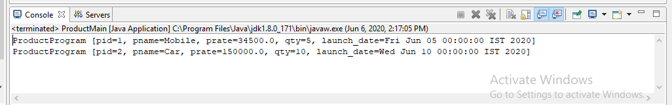

**2. Create a Spring/Hibernate based MVC web application to persist data in a table.Table should have atleast 5 fields with varchar,numeric and date fields.**

**STUDENT DETAILS.JAVA**

**package com.spring.mvc;**

**import java.sql.*;**

**import javax.persistence.*;**

**@Entity**

**@Table(name="student2")**

**public class StudentDetails**

**{**

**@Id**

**@Column(name="sid")**

**int sid;**

**@Column(name="sname")**

**String name;**

**@Column(name="dept")**

**String department;**

**@Column(name="gender")**

**String gender;**

**@Column(name="doj")**

**Date doj;**

**public StudentDetails()**

**{**

**super();**

**}**

**public StudentDetails(int sid, String name, String department,String gender, Date doj)**

**{**

**super();**

**this.sid = sid;**

**this.name = name;**

**this.department = department;**

**this.gender = gender;**

**this.doj = doj;**

**}**

**public int getSid()**

**{**

**return sid;**

**}**

**public void setSid(int sid)**

**{**

**this.sid = sid;**

**}**

**public String getName() {**

**return name;**

**}**

**public void setName(String name)**

**{**

**this.name = name;**

**}**

**public String getDepartment()**

**{**

**return department;**

**}**

**public void setDepartment(String department)**

**{**

**this.department = department;**

**}**

**public String getGender()**

**{**

**return gender;**

**}**

**public void setGender(String gender)**

**{**

**this.gender = gender;**

**}**

**public Date getDoj()**

**{**

**return doj;**

**}**

**public void setDoj(Date doj)**

**{**

**this.doj = doj;**

**}**

**@Override**

**public String toString() {**

**return "StudentDetails [sid=" + sid + ", name=" + name**

**+ ", department=" + department + ", gender=" + gender**

**+ ", doj=" + doj + "]";**

**}**

**}**

**ISTUDENT DAO .JAVA**

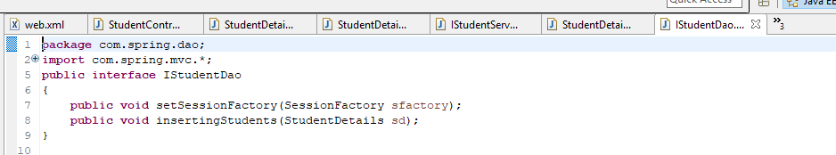

**STUDENT DETAILS DAO.JAVA**

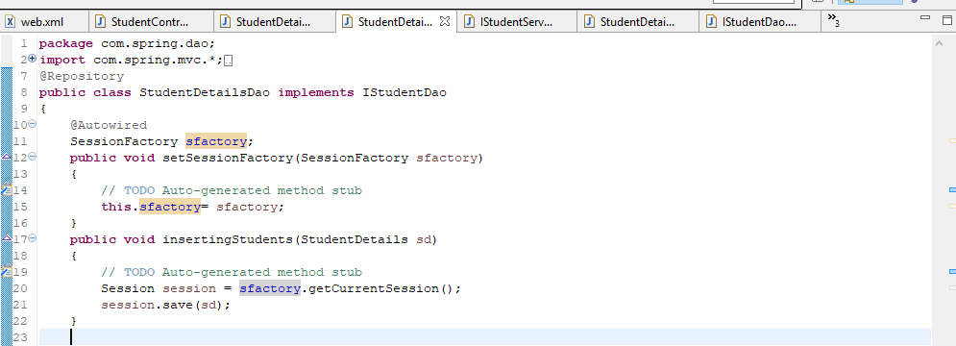

**ISTUDENT DETAILS SERVICE.JAVA**

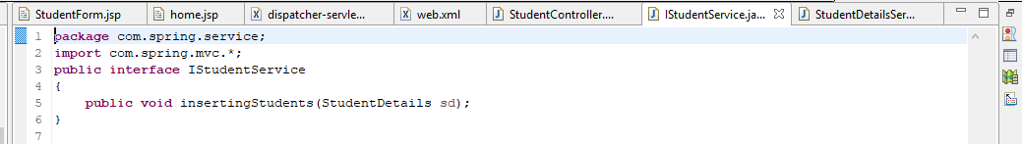

**STUDENT DETAILS SERVICE.JAVA**

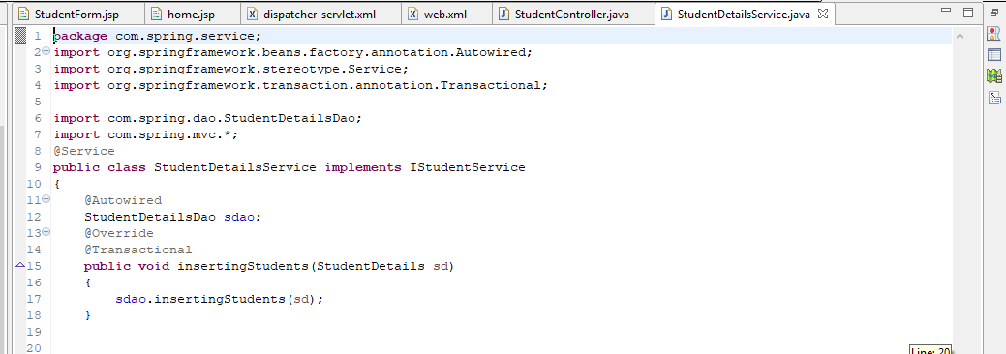

**STUDENT CONTROLLER.JAVA**

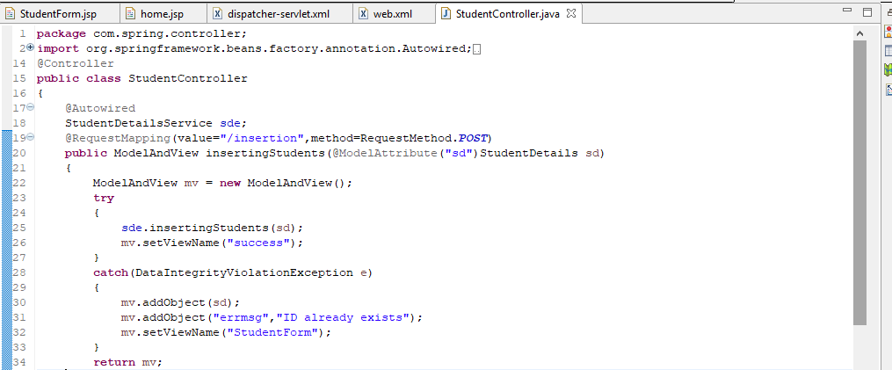

**DISPATCHER SERVLET.XML**

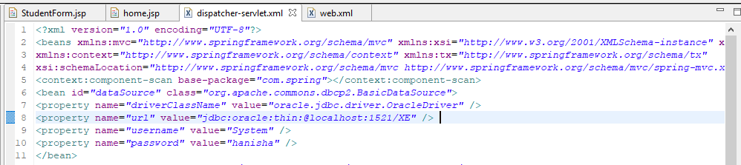

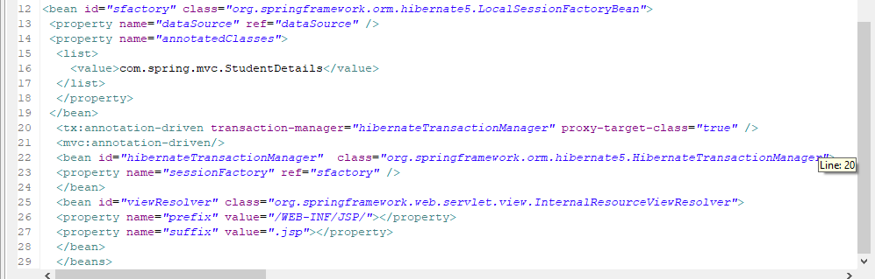

**WEB.XML**

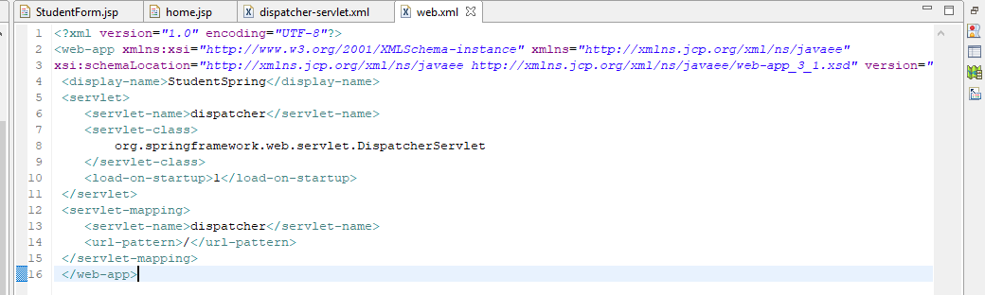

**HOME.JSP**

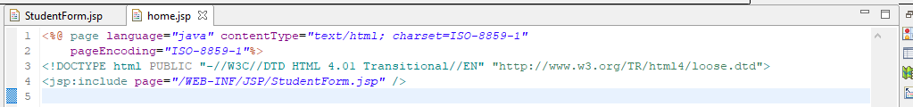

**STUDENTFORM.JSP**

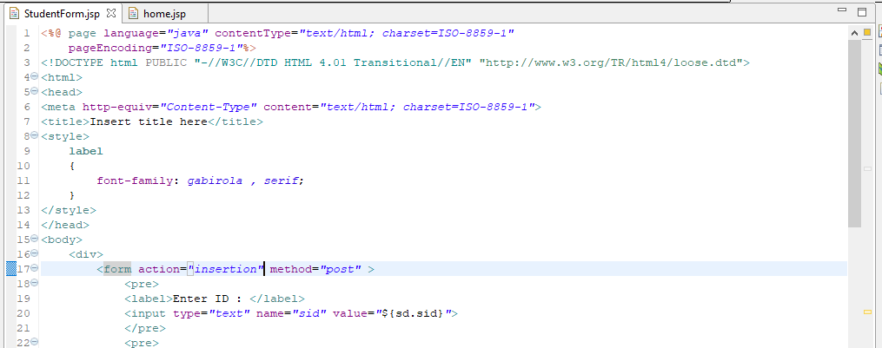

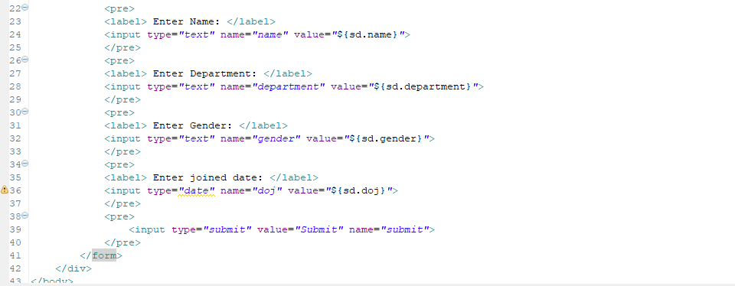

**SUCCESS.JSP**

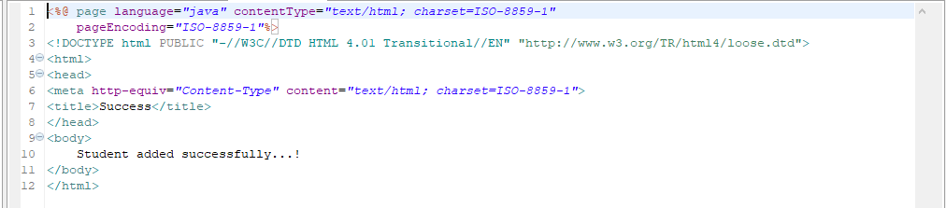

**OUTPUT:**

