**TERM-2**

1. Create the above table "Employee" and insert the records as mentioned. Also use relevant constraints.  
     
   Write the following queries:  
   a) Increase salary of Jacob by Rs.3000  
   b) Find the total salary to be paid for a month

**Solution:**

**Create table Employee**

create table Employee(eid varchar2(20) primary key,

ename varchar2(20) not null,

email varchar2(20) not null,

salary number(10) not null,

password varchar2(20) not null)

**insert values :**

insert into Employee values('1A001','jacob','jacob@gmail.com',20000,'jacob');

insert into Employee values('1A002','mahesh','mahi@gmail.com',20000,'mahi');

insert into Employee values('1A003','kumar','kumar@gmail.com',20000,'kumar');

1. **Increase salary of Jacob by Rs.3000**

update Employee set salary=salary+3000 where ename='jacob';

1. **Find the total salary to be paid for a month**

select sum(salary) from Employee

**outputs:**

**desc Employee**

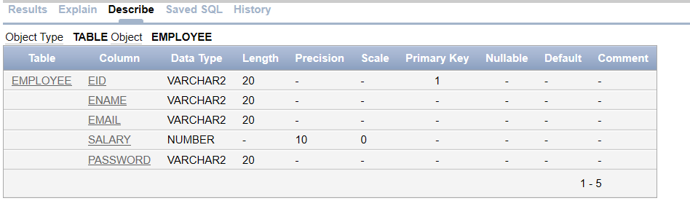

**Employees in database:**

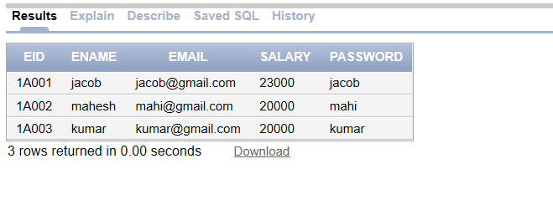

**Before update Jacob salary=23000**



**After update Jacob salary=26,000**

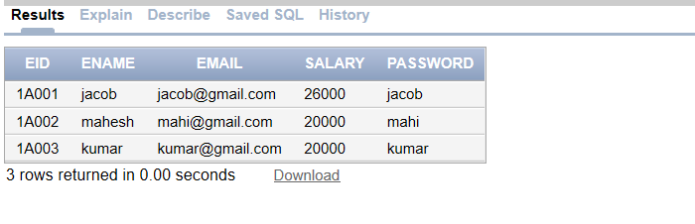

**Total salary:** 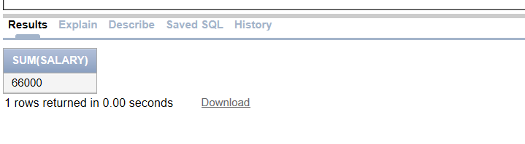

1. Anush need to create a website for a customer.   
   He need to ensure that all html pages follow same style.   
   So he plans to create a css file with headings follow a style and paragraphs follow another style.

Help him to implement it by creating the .css file. Also demonstrate it using an html page.

**Solution:**

**Sample.html**

<html>

<head>

<!-- add external css to the html-->

<link rel="stylesheet" type="text/css" href="samplecolor.css">

</head>

<body>

<!-- create form based on required parameters-->

<form>

<h1> DETAILS </h1>

<p> Please Fill Below Details </p>

<label>First Name</label>

<input type="text" name="fname" placeholder="Enter First Name" required><br/>

<label>Last Name</label>

<input type="text" name="lname" placeholder="Enter Last Name" required><br/>

<label>Email</label>

<input type="text" name="email" placeholder="Enter Email" required><br/>

<label>Address</label>

<input type="text" name="address" placeholder="Enter Address" ><br/>

<label>Gender</label>

<input type="radio" name="gender">Female

<input type="radio" name="gender">Male<br/>

<label>Mobile No </label>

<input type="tel" name="mobile" placeholder="Enter Mobile No"><br/>

<input type="submit" value="Submit">

<input type="reset" value="Reset">

</form>

</body>

</html>

**Samplecolor.css**

/* add background color to the body */

body{

background-color : #f2f2f2;

}

/* add css styles to the text and tel*/

input[type=text], [type=tel]{

width : 100%;

padding : 12px 20px;

margin : 8px 0;

display : inline-block;

border : 1px solid #ccc;

border-radius : 4px;

box-sizing : border-box;

}

/* add css styles to submit and reset*/

input[type=submit], [type=reset]{

width : 100%;

background-color :lightgreen;

color : #f2f2f2;

padding : 12px 20px;

margin : 8px 0;

border : 1px solid #ccc;

border-radius : 4px;

cursor : pointer;

}

h1,p{

font-family : times new roman;

color : red;

}

/*add background color to the submit and reset when cursor goes to the submit/reset */

input[type=submit]:hover,[type=reset]:hover {

background-color : pink;

}

**Output** :

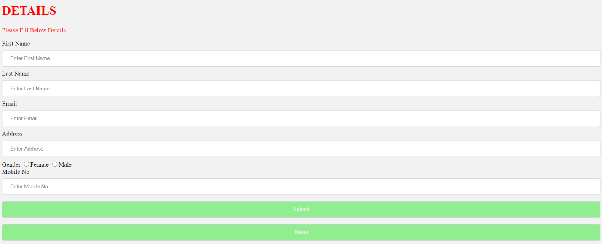

1. **Create an external javascript file to define a function that accepts a number from the user and display the factorial.**

Solution :

Fact.html

<html>

<head>

</head>

<body>

<!--adding external javascript to the html page-->

<script src="fact.js">

</script>

<!-- create form based on required details-->

<form>

<h1> FACTORIAL OF NUMBER </h1>

Enter Number : <input type="text" id="num" name="num" placeholder="Enter Number" required>

<button onclick="fact()">Factorial

</form>

</body>

</html>

**//fact.js**

//create function in javasript

function fact(){

//declare variables

var i;

var fact=1;

var num;

//alert message

alert("Hi..Welcome");

//retrieve value from html page

num=document.getElementById("num").value;

alert(num);

//logic for find factorial of number

for(i=1;i<=num;i++){

fact=fact*i;

}

//factorial of number

alert("Factorial of Number : "+ fact);

}

Output :

Output of html page:

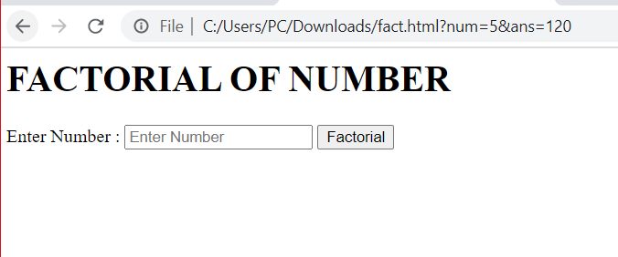

Factorial of number :

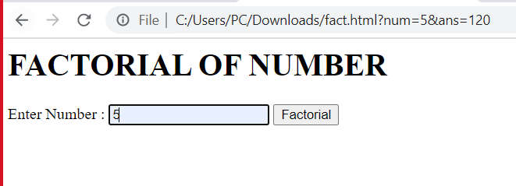

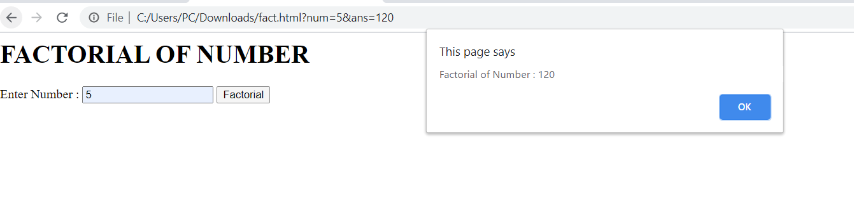

1. **Develop a web application to store the employee data in a table.   
     
   a) Employee ID  (Text box- Max 3 digits)   
   b) Employee Name  (Text box- Max 25 characters)  
   c) Date of Joining (Should be a valid date) <  
   d) Gender (Use Dropdown or Radio button)   
   e) Monthly Salary (Text box- max 8 digits)   
     
     
   Note:   
   1) Use the table created in Q1  
   2) Do all client side validations.  
   3) Share the relevant screenshots to prove that data is inserted into the table.**

<!DOCTYPE html>

<html>

<head>

<meta charset=*"ISO-8859-1"*>

<title>Employee Details</title>

</head>

<center></center>

<body>

<form action=*"employeeServlet"* method=*"get"*>

<h1>Employee Details</h1>

Employee Id : <input type=*"text"* name=*"id"* placeholder=*"Enter Id"* required><br/>

Employee Name : <input type=*"text"* name=*"name"* placeholder=*"Enter Name"* required><br/>

Employee Date Of Joining : <input type=*"date"* name=*"date"* required><br/>

Employee gender: <input type=*"text"* name=*"gender"* placeholder=*"Enter Gender"* required><br/>

Employee Salary : <input type=*"text"* name=*"salary"* placeholder=*"Enter salary"* required><br/>

<input type=*"submit"* value=*"Submit"*><br/>

<input type=*"reset"* value=*"Reset"*>

</form>

</body>

</center>

</html>

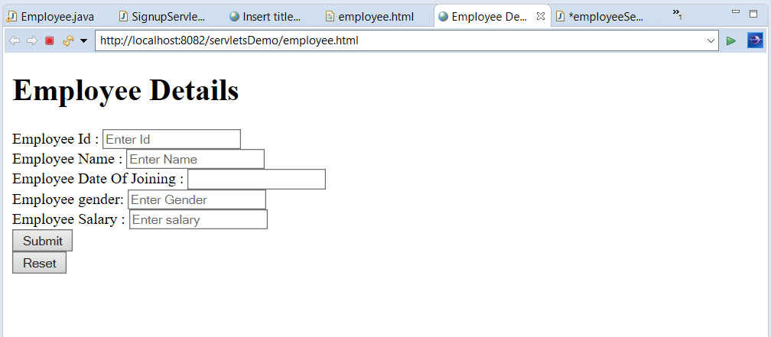

**package** hcl.com;

**import** java.io.IOException;

**import** java.sql.Connection;

**import** java.sql.DriverManager;

**import** java.sql.ResultSet;

**import** java.sql.SQLException;

**import** java.sql.Statement;

**import** javax.servlet.ServletException;

**import** javax.servlet.annotation.WebServlet;

**import** javax.servlet.http.HttpServlet;

**import** javax.servlet.http.HttpServletRequest;

**import** javax.servlet.http.HttpServletResponse;

/**

* Servlet implementation class employeeServlet

*/

@WebServlet("/employeeServlet")

**public** **class** employeeServlet **extends** HttpServlet {

**private** **static** **final** **long** ***serialVersionUID*** = 1L;

/**

* **@see** HttpServlet#HttpServlet()

*/

**public** employeeServlet() {

**super**();

// **TODO** Auto-generated constructor stub

}

/**

* **@see** HttpServlet#doGet(HttpServletRequest request, HttpServletResponse response)

*/

**protected** **void** doGet(HttpServletRequest request, HttpServletResponse response) **throws** ServletException, IOException {

// **TODO** Auto-generated method stub

//response.getWriter().append("Served at: ").append(request.getContextPath());

response.setContentType("text/html");

String id=request.getParameter("id");

String name=request.getParameter("name");

String doj=request.getParameter("doj");

String gender=request.getParameter("gender");

String salary=request.getParameter("salary");

String uid="dbuser";

String pwd = "1234";

String url = "jdbc:oracle:thin:@localhost:1521/XE";

Connection con;

**try** {

//load class dynamically

Class.*forName*("oracle.jdbc.driver.OracleDriver");

con = DriverManager.*getConnection*(url, uid, pwd);

System.***out***.println("Connected");

ResultSet rs ;

Statement stmt=con.createStatement();

**try** {

//insert employee record into database

String qry="INSERT INTO Q1 VALUES(id,name,doj,gender,salary)";

**int** i2=stmt.executeUpdate(qry);

**if**(i2>0) {

System.***out***.println("After Insertion");

}**catch**(SQLException e) {

System.***out***.println("unique key value vialotation " + e.getMessage());

}**catch**(IllegalArgumentException e) {

System.***out***.println("Invalid date format "+e.getMessage());

}

//update employee record into database

String qry5= "Update employee set salary=31000 where empid=2";

**int** i1= stmt.executeUpdate(qry5);

**if**(i1>0) {

System.***out***.println("Rows updated successfully");

System.***out***.println("After Update");

//read employee records from database

rs = stmt.executeQuery("Select * from employee");

System.***out***.println("read employee records from database");

**while**(rs.next()){

System.***out***.println("Emp Id : " + rs.getInt("empid") + ", Name : " + rs.getString("ename") + ", Date of Birth : " + rs.getDate("dob")+" salary : "+rs.getInt("salary")+" phone no : "+rs.getString("phone"));

}

}**else** {

System.***out***.println("Row is Not Updated Succesfully");

}

//delete employee record from database

con.close();

System.***out***.println("Disconnected");

}

**catch**(java.lang.ClassNotFoundException e) {

System.***out***.println("Oracle Driver not found");

}

**catch**(SQLException ex) {

System.***out***.println("SQLException:" + ex.getMessage());

}

}

/**

* **@see** HttpServlet#doPost(HttpServletRequest request, HttpServletResponse response)

*/

**protected** **void** doPost(HttpServletRequest request, HttpServletResponse response) **throws** ServletException, IOException {

// **TODO** Auto-generated method stub

doGet(request, response);

}

}