**TERM-3**

1. **Write a spring mvc web application which will insert rows to database table.**

**//create table :**

CREATE TABLE HCLEMP(EmpID VARCHAR2(3) PRIMARY KEY, EmpName VARCHAR2(25), Desig VARCHAR2(15), salary varchar2(20), City VARCHAR2(20))

**//Employee.java**

package com.hcl.model;

import javax.persistence.Column;

import javax.persistence.Entity;

import javax.persistence.Id;

import javax.persistence.Table;

@Entity

@Table(name="HclEmp") //allows to specify the details of table that will be used to persist the entity in the database

public class Employee {

@Id

@Column(name="EmpID")

private int empId;

@Column(name="EmpName")

private String empName;

@Column(name="Desig")

private String desig;

@Column(name="salary")

private String salary;

@Column(name="City")

private String city;

public Employee() {

super();

// TODO Auto-generated constructor stub

}

public Employee(int empId, String empName, String desig, String salary, String city) {

super();

this.empId = empId;

this.empName = empName;

this.desig = desig;

this.salary = salary;

this.city = city;

}

public int getEmpId() {

return empId;

}

public void setEmpId(int empId) {

this.empId = empId;

}

public String getEmpName() {

return empName;

}

public void setEmpName(String empName) {

this.empName = empName;

}

public String getDesig() {

return desig;

}

public void setDesig(String desig) {

this.desig = desig;

}

public String getSalary() {

return salary;

}

public void setSalary(String salary) {

this.salary = salary;

}

public String getCity() {

return city;

}

public void setCity(String city) {

this.city = city;

}

}

//IEmployeeDAO.java

**package** com.hcl.dao;

**import** org.hibernate.SessionFactory;

**import** com.hcl.model.Employee;

**public** **interface** IEmployeeDAO

{

**public** **void** setSessionFactory(SessionFactory s);

**void** addEmployee(Employee e);

}

**//EmployeeDAO.java**

**package** com.hcl.dao;

**import** org.hibernate.Session;

**import** org.hibernate.SessionFactory;

**import** org.springframework.beans.factory.annotation.Autowired;

**import** org.springframework.stereotype.Repository;

**import** com.hcl.model.Employee;

@Repository //Identifies a DAO class

**public** **class** EmployeeDAO **implements** IEmployeeDAO{

@Autowired//Automatically initialize by dependency injection

**private** SessionFactory sessionFactory;

**public** **void** setSessionFactory(SessionFactory sessionFactory) {

**this**.sessionFactory= sessionFactory;

}

**public** **void** addEmployee(Employee e) {

Session session= sessionFactory.getCurrentSession();

session.save(e);

}

}

**//IEmployeeServices.java**

**package** com.hcl.services;

**import** com.hcl.model.Employee;

**public** **interface** IEmployeeService {

**void** addEmployee(Employee e);

}

**//EmployeeServices.java**

package com.hcl.services;

import javax.transaction.Transactional;

import org.springframework.beans.factory.annotation.Autowired;

import org.springframework.stereotype.Service;

import com.hcl.dao.EmployeeDAO;

import com.hcl.model.Employee;

@Service//Identifies a service class

public class EmployeeService implements IEmployeeService{

@Autowired

private EmployeeDAO employeeDAO;

@Override

@Transactional//Declares a transaction

public void addEmployee(Employee e) {

employeeDAO.addEmployee(e);

}

}

**//EmployeeController.java**

package com.hcl.controller;

import org.springframework.beans.factory.annotation.Autowired;

import org.springframework.dao.DataIntegrityViolationException;

import org.springframework.stereotype.Controller;

import org.springframework.web.bind.annotation.ModelAttribute;

import org.springframework.web.bind.annotation.RequestMapping;

import org.springframework.web.bind.annotation.RequestMethod;

import org.springframework.web.servlet.ModelAndView;

import com.hcl.model.Employee;

import com.hcl.services.EmployeeService;

@Controller

public class EmployeeController{

@Autowired

private EmployeeService employeeService;

@RequestMapping(value = "/add", method = RequestMethod.POST)

public ModelAndView addEmployee(@ModelAttribute("employee") Employee employee) {

ModelAndView mv= new ModelAndView();

try {

employeeService.addEmployee(employee);

mv.setViewName("success"); //Return success.jsp

} catch(DataIntegrityViolationException e) {

mv.addObject(employee);

mv.addObject("errmsg","ID already exists");

mv.setViewName("Employee"); //Return addemployee.jsp with same data

}

return mv;

}

}

**//Web.xml**

<?xml version=*"1.0"* encoding=*"UTF-8"*?>

<web-app xmlns:xsi=*"http://www.w3.org/2001/XMLSchema-instance"* xmlns=*"http://xmlns.jcp.org/xml/ns/javaee"* xsi:schemaLocation=*"http://xmlns.jcp.org/xml/ns/javaee http://xmlns.jcp.org/xml/ns/javaee/web-app_3_1.xsd"* version=*"3.1"*>

<display-name>SpringWeb</display-name>

<servlet>

<servlet-name>dispatcher</servlet-name>

<servlet-class> org.springframework.web.servlet.DispatcherServlet </servlet-class>

<load-on-startup>1</load-on-startup>

</servlet>

<servlet-mapping>

<servlet-name>dispatcher</servlet-name>

<url-pattern>/</url-pattern>

</servlet-mapping>

</web-app>

**//dispatcher-servlet.xml**

<?xml version=*"1.0"* encoding=*"UTF-8"*?>

<beans xmlns:mvc=*"http://www.springframework.org/schema/mvc"*

xmlns:xsi=*"http://www.w3.org/2001/XMLSchema-instance"*

xmlns=*"http://www.springframework.org/schema/beans"*

xmlns:context=*"http://www.springframework.org/schema/context"*

xmlns:tx=*"http://www.springframework.org/schema/tx"*

xsi:schemaLocation=*"http://www.springframework.org/schema/mvc*

*http://www.springframework.org/schema/mvc/spring-mvc.xsd*

*http://www.springframework.org/schema/beans*

*http://www.springframework.org/schema/beans/spring-beans.xsd*

*http://www.springframework.org/schema/tx*

*http://www.springframework.org/schema/tx/spring-tx.xsd*

*http://www.springframework.org/schema/context*

*http://www.springframework.org/schema/context/spring-context.xsd"*>

<context:component-scan base-package=*"com.hcl"* />

<bean id=*"dataSource"* class=*"org.apache.commons.dbcp2.BasicDataSource"*>

<property name=*"driverClassName"* value=*"oracle.jdbc.driver.OracleDriver"* />

<property name=*"url"* value=*"jdbc:oracle:thin:@localhost:1521/XE"* />

<property name=*"username"* value=*"dbuser"* />

<property name=*"password"* value=*"1234"* />

</bean>

<bean id=*"sessionFactory"* class=*"org.springframework.orm.hibernate5.LocalSessionFactoryBean"*>

<property name=*"dataSource"* ref=*"dataSource"* />

<property name=*"annotatedClasses"*>

<list>

<value>com.hcl.model.Employee</value>

</list>

</property>

</bean>

<tx:annotation-driven transaction-manager=*"hibernateTransactionManager"* proxy-target-class=*"true"* />

<mvc:annotation-driven/>

<bean id=*"hibernateTransactionManager"* class=*"org.springframework.orm.hibernate5.HibernateTransactionManager"*>

<property name=*"sessionFactory"* ref=*"sessionFactory"* />

</bean>

<bean id=*"viewResolver"* class=*"org.springframework.web.servlet.view.InternalResourceViewResolver"*> <property name=*"prefix"* value=*"/WEB-INF/pages/"*></property> <property name=*"suffix"* value=*".jsp"*>

</property>

</bean>

</beans>

**//Employee.jsp**

<%@ page language=*"java"* contentType=*"text/html; charset=ISO-8859-1"*

pageEncoding=*"ISO-8859-1"*%>

<!DOCTYPE HTML PUBLIC "-//W3C//DTD HTML 4.01 Transitional//EN"

"http://www.w3.org/TR/html4/loose.dtd">

<html>

<head>

<meta http-equiv=*"Content-Type"* content=*"text/html; charset=ISO-8859-1"*>

<title>Add Employee</title>

</head>

<center>

<body>

<form action=*"add"* method=*"post"* >

ID: <input type=*'text'* name=*'empId'* value=*'*${employee.empId}*'*/>

<span style="color:*red*"> ${errmsg} </span><br/>

Name: <input type=*'text'* name=*'empName'* value=*'*${employee.empName}*'*/><br/>

Designation: <input type=*'text'* name=*'desig'* value=*'*${employee.desig}*'*/><br/>

Salary : <input type=*'text'* name=*'salary'* value=*'*${employee.salary}*'* /><br/>

City: <input type=*'text'* name=*'city'* value=*'*${employee.city}*'* /><br/>

<input type=*'submit'* value=*'submit'*/>

</form>

</body>

</center>

</html>

**//success.jsp**

<%@ page language=*"java"* contentType=*"text/html; charset=ISO-8859-1"*

pageEncoding=*"ISO-8859-1"*%>

<!DOCTYPE html>

<html>

<head>

<meta charset=*"ISO-8859-1"*>

<title>Insert title here</title>

</head>

<body>

Employee added successfully

</body>

</html>

**//home.jsp**

<%@ page language=*"java"* contentType=*"text/html; charset=ISO-8859-1"*

pageEncoding=*"ISO-8859-1"*%>

<!DOCTYPE HTML PUBLIC "-//W3C//DTD HTML 4.01 Transitional//EN"

"http://www.w3.org/TR/html4/loose.dtd">

<jsp:include page=*"/WEB-INF/pages/Employee.jsp"* />

**Outputs:**

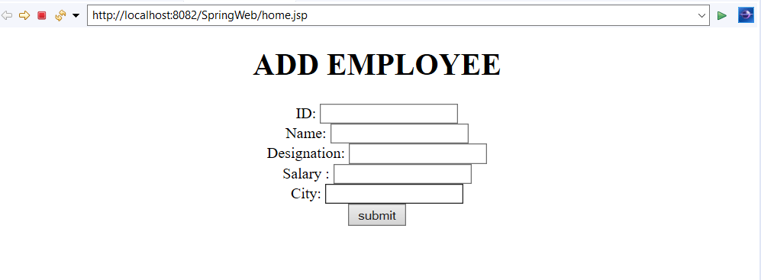

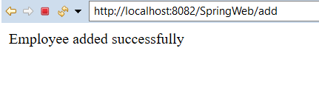

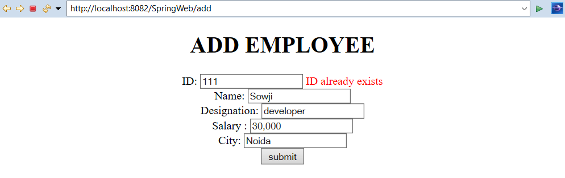

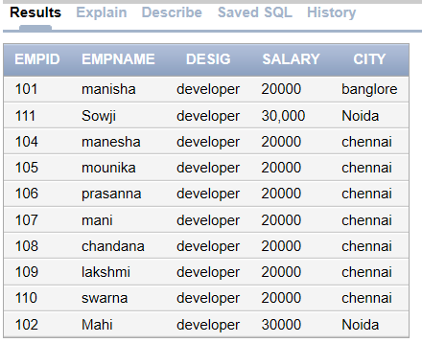

1. **Write a simple angular application to demonstrate the usage of web services. Implement the web service to fetch data from a table based on key field and show the other details.**

**Create a table:**

create table student(sid varchar2(20) primary key , sname varchar2(20), sdepartment varchar2(20), syear varchar2(20));

**//Student.java**

package com.hcl.model;

import java.sql.Connection;

import java.sql.DriverManager;

import java.sql.ResultSet;

import java.sql.SQLException;

import java.sql.Statement;

public class Student {

String sid;

String sname;

String sdepartment;

String syear;

public String getSid() {

return sid;

}

public void setSid(String sid) {

this.sid = sid;

}

public String getSname() {

return sname;

}

public void setSname(String sname) {

this.sname = sname;

}

public String getSdepartment() {

return sdepartment;

}

public void setSdepartment(String sdepartment) {

this.sdepartment = sdepartment;

}

public String getSyear() {

return syear;

}

public void setSyear(String syear) {

this.syear = syear;

}

public static Student getStudent(String sid) {

Student s = new Student();

String userid="dbuser";

String password= "1234";

String url= "jdbc:oracle:thin:@localhost:1521/XE";

Connection con;

Statement stmt;

String qry;

ResultSet rs;

try{

Class.forName("oracle.jdbc.driver.OracleDriver");

con= DriverManager.getConnection(url, userid, password);

System.out.println("connected");

stmt= con.createStatement();

qry="SELECT * FROM student WHERE sid='"+ sid+ "'";

rs= stmt.executeQuery(qry);

s.setSid(sid);

if(rs.next()) {

s.setSname("sname");

s.setSdepartment("sdepartment");

s.setSyear("syear");

} else{

s.setSname("not found");

s.setSdepartment("not found");

s.setSyear("not found");

}

stmt.close();

con.close();

} catch(java.lang.ClassNotFoundException ex) {

System.out.println("Oracle Driver not found");

} catch(SQLException ex) {

System.err.println("SQLException: "+ ex.getMessage());

}

return s;

}

}

**//StudentController.java**

package com.hcl.controller;

import org.springframework.web.bind.annotation.PathVariable;

import org.springframework.web.bind.annotation.RequestMapping;

import org.springframework.web.bind.annotation.RequestMethod;

import org.springframework.web.bind.annotation.RestController;

import com.hcl.model.Student;

@RestController

public class StudentController {

@RequestMapping(value = "/getStudent/{sid}", method = RequestMethod.GET)

public Student getEmployee(@PathVariable("sid") String sid) {

Student s = new Student();

return s;

}

}

**//web.xml**

<?xml version=*"1.0"* encoding=*"UTF-8"*?>

<web-app xmlns:xsi=*"http://www.w3.org/2001/XMLSchema-instance"* xmlns=*"http://xmlns.jcp.org/xml/ns/javaee"* xsi:schemaLocation=*"http://xmlns.jcp.org/xml/ns/javaee http://xmlns.jcp.org/xml/ns/javaee/web-app_3_1.xsd"* version=*"3.1"*>

<display-name>webServices</display-name>

<servlet>

<servlet-name>dispatcher</servlet-name>

<servlet-class> org.springframework.web.servlet.DispatcherServlet </servlet-class>

<load-on-startup>1</load-on-startup>

</servlet>

<servlet-mapping>

<servlet-name>dispatcher</servlet-name>

<url-pattern>/</url-pattern>

</servlet-mapping>

</web-app>

**//dispatcher-servlet.xml**

<?xml version=*"1.0"* encoding=*"UTF-8"*?>

<beans xmlns:mvc=*"http://www.springframework.org/schema/mvc"*

xmlns:xsi=*"http://www.w3.org/2001/XMLSchema-instance"*

xmlns=*"http://www.springframework.org/schema/beans"*

xmlns:context=*"http://www.springframework.org/schema/context"*

xmlns:tx=*"http://www.springframework.org/schema/tx"*

xsi:schemaLocation=*"http://www.springframework.org/schema/mvc*

*http://www.springframework.org/schema/mvc/spring-mvc.xsd*

*http://www.springframework.org/schema/beans*

*http://www.springframework.org/schema/beans/spring-beans.xsd*

*http://www.springframework.org/schema/tx*

*http://www.springframework.org/schema/tx/spring-tx.xsd*

*http://www.springframework.org/schema/context*

*http://www.springframework.org/schema/context/spring-context.xsd"*>

<context:component-scan base-package=*"com.hcl"* />

<mvc:annotation-driven/>

</beans>

**//Student.jsp**

<%@ page language=*"java"* contentType=*"text/html; charset=ISO-8859-1"* pageEncoding=*"ISO-8859-1"*%>

<!DOCTYPE html PUBLIC "-//W3C//DTD HTML 4.01 Transitional//EN"

"http://www.w3.org/TR/html4/loose.dtd">

<html>

<script src=*"http://ajax.googleapis.com/ajax/libs/angularjs/1.4.8/angular.min.js"*></script>

<body>

<div ng-app=*"StudentApp"* ng-controller=*"StudentController"*>

StudentId: <input type=*"text"* ng-model=*"student.sid"*>

<button ng-click=*"getstudent()"*> Search </button><br/>

Name: {{student.sname}} <br/>

Department: {{student.sdepartment}} <br/>

Year: {{student.syear}} <br/>

</div>

<script>

var app = angular.module('StudentApp', []);

app.controller('StudentController', function($scope,$http) {

$scope.student= [];

$scope.getstudent= function() {

$http({ method : 'GET', url : 'getstudent/' + $scope.student.sid

}).then(function successCallback(response) {

$scope.student= response.data;

}, function errorCallback(response) {

alert("Data Error");

console.log(response.statusText);

});

};

});

</script>

</body>

</html>

**Outputs:**

