
Concepts and Technologies of AI

Final Portfolio Assessment: End-to-End Machine Learning Project.

Credit Card Default Payment Prediction

Binary Classification for Financial Risk Assessment

Module Leader: Siman Giri
Tutor Name: Raju Karki
University Student ID: 2550313
Student Name: Prasanna Raj Kunwar

Submission Date: 10 February 2026

Abstract
Purpose: The goal of this report is to predict credit card payment defaults using advanced binary classification techniques, contributing to financial risk management and economic stability.
Dataset: The dataset used is the UCI Credit Card Default Dataset from Taiwan, containing 30,000 records with 24 features including demographic information, credit data, payment history, and billing information. This work directly aligns with United Nations Sustainable Development Goal 1 (No Poverty) and Goal 8 (Decent Work and Economic Growth) by helping identify individuals at risk of financial distress and enabling proactive intervention.
Approach: The methodology includes comprehensive Exploratory Data Analysis (EDA), building and comparing multiple classification models including a Neural Network, classical machine learning models (Logistic Regression and Random Forest), hyperparameter optimization using GridSearchCV, feature selection using statistical methods, and rigorous model evaluation with cross-validation.
Key Results: Models were evaluated using Accuracy, Precision, Recall, F1-Score, and AUC-ROC metrics. The Random Forest Classifier with optimized hyperparameters and selected features achieved the best performance with an accuracy of 82.67%, F1-score of 0.5612, and AUC of 0.786, demonstrating strong predictive capability for default risk assessment.
Conclusion: The final Random Forest model successfully predicts credit card defaults with high accuracy, providing valuable insights for credit risk management. Key findings include the dominant importance of payment history features (PAY_0 to PAY_6), the significance of credit utilization patterns, and the effectiveness of ensemble methods for imbalanced classification tasks. This work provides a robust framework for financial institutions to assess credit risk and implement preventive measures.

Table of Contents
Abstract 2
List of Figures 3
1. Introduction 4
1.1 Problem Statement 4
1.2 Dataset Description 4
1.3 Objectives 5
1.4 UN Sustainable Development Goals Alignment 5
2. Methodology 7
2.1 Data Preprocessing 7
2.2 Exploratory Data Analysis 7
2.3 Feature Engineering 12
2.4 Model Building 13
2.5 Model Evaluation Metrics 14
2.6 Hyperparameter Optimization 15
2.7 Feature Selection 15
3. Results and Analysis 17
3.1 Exploratory Data Analysis Findings 17
3.2 Model Performance Comparison 17
3.3 Hyperparameter Tuning Results 19
3.4 Feature Selection Impact 19
3.5 Final Model Selection and Performance 21
4. Discussion 23
4.1 Model Performance Interpretation 23
4.2 Impact of Feature Engineering and Selection 23
4.3 Real-World Applications and Implications 23
4.4 Limitations 25
4.5 Suggestions for Future Research and Improvement 25
5. Conclusion 27
6. References 29

List of Figures
- Figure 1: Distribution of Target Variable (Default Payment)
- Figure 2: Age Distribution by Default Status
- Figure 3: Credit Limit Distribution by Default Status
- Figure 4: Payment Status Distribution (PAY_0) by Default Status
- Figure 5: Correlation Heatmap of Selected Features
- Figure 6: Neural Network Training History (Accuracy and Loss)
- Figure 7: Model Performance Comparison - Accuracy
- Figure 8: Model Performance Comparison - F1-Score
- Figure 9: Confusion Matrix - Final Random Forest Model
- Figure 10: ROC Curves Comparison
- Figure 11: Top 10 Feature Importance - Random Forest Model

1. Introduction

1.1 Problem Statement
Credit card default prediction is a critical challenge in modern financial risk management. With the expansion of consumer credit globally, financial institutions face increasing pressure to accurately assess credit risk while maintaining inclusive access to financial services. Default on credit payments can have severe consequences for both lenders and borrowers, affecting bank profitability, economic stability, and individual financial well-being.
The ability to predict which customers are likely to default on their credit card payments allows financial institutions to take proactive measures such as adjusting credit limits, implementing early intervention programs, or restructuring payment terms. This predictive capability is essential for minimizing financial losses while supporting customers in maintaining healthy credit behavior.
This project addresses the binary classification problem of predicting whether a credit card holder will default on their payment in the following month. Using historical payment data, demographic information, and credit utilization patterns from 30,000 credit card holders in Taiwan, we develop and evaluate multiple machine learning models to identify customers at risk of default. The challenge involves handling class imbalance, extracting meaningful patterns from temporal payment behavior, and building models that generalize well to unseen data.

1.2 Dataset Description
The dataset used in this analysis is the UCI Credit Card Default Dataset, originally collected and donated by Professor I-Cheng Yeh from Tamkang University, Taiwan, in 2016. This dataset is publicly available through the UCI Machine Learning Repository and Kaggle, making it widely used for credit risk modeling research.
Key characteristics of the dataset include:
- Source: UCI Machine Learning Repository / Kaggle
- Original Contributor: I-Cheng Yeh, Tamkang University, Taiwan (2016)
- Number of Records: 30,000 credit card clients
- Number of Features: 24 features (23 predictors + 1 target variable)
- Temporal Coverage: April 2005 to September 2005 (6 months)
- Geographic Coverage: Taiwan credit card market
- Target Variable: Binary classification - default payment next month (1 = Yes, 0 = No)
- Class Distribution: Imbalanced (approximately 22% default, 78% non-default)
- Data Quality: Complete records with no missing values
The dataset features can be grouped into four main categories:
Demographic Information: Age, Gender, Education Level, Marital Status
Credit Data: Credit Limit (LIMIT_BAL)
Payment History: Repayment status from April to September 2005 (PAY_0 to PAY_6)
Billing Information: Bill amounts (BILL_AMT1 to BILL_AMT6) and payment amounts (PAY_AMT1 to PAY_AMT6) for six months

1.3 Objectives
The primary objectives of this classification analysis project are:
- To develop accurate predictive models capable of identifying credit card holders at high risk of payment default
- To analyze and identify the most influential factors contributing to credit default risk
- To compare the performance of neural network architectures against classical machine learning classification algorithms
- To optimize model performance through systematic hyperparameter tuning and feature selection techniques
- To handle class imbalance effectively and evaluate models using appropriate metrics for imbalanced datasets
- To provide actionable insights for financial institutions to improve credit risk assessment and management

1.4 UN Sustainable Development Goals Alignment
This project directly contributes to the United Nations Sustainable Development Goals (UNSDGs), specifically:
Goal 1 - No Poverty: Credit default prediction helps identify individuals at risk of financial distress before they face severe consequences. Early identification enables:
- Proactive intervention programs to prevent default and its cascading effects
- Targeted financial counseling and debt management assistance
- Prevention of the poverty cycle caused by bad credit history and reduced financial access
- Support for vulnerable populations to maintain financial stability
Goal 8 - Decent Work and Economic Growth: Effective credit risk management supports sustainable economic growth and financial inclusion by:
- Enabling financial institutions to make informed lending decisions while maintaining inclusive access to credit
- Reducing systemic risk in the financial sector through better risk assessment
- Supporting economic stability by preventing widespread credit defaults
- Promoting responsible lending practices that balance risk management with financial inclusion

2. Methodology

2.1 Data Preprocessing
Data preprocessing steps included handling categorical variables, addressing class imbalance considerations, feature scaling, and train-test splitting:
Data Validation: Verified data integrity and confirmed no missing values across all 30,000 records and 24 features.
Categorical Encoding: Education and marriage status variables were encoded appropriately. Payment status variables (PAY_0 to PAY_6) were treated as ordinal categorical features.
Feature Scaling: StandardScaler was applied to normalize numerical features (age, credit limit, bill amounts, payment amounts) to ensure equal weighting in model training.
Train-Test Split: Dataset was split into 80% training (24,000 samples) and 20% testing (6,000 samples) sets using stratified sampling to maintain class distribution.
Class Imbalance Analysis: The dataset exhibits class imbalance with 77.88% non-default and 22.12% default cases, requiring careful consideration in model evaluation and selection.

2.2 Exploratory Data Analysis
Comprehensive EDA was performed to understand patterns, distributions, and relationships within the credit default dataset:

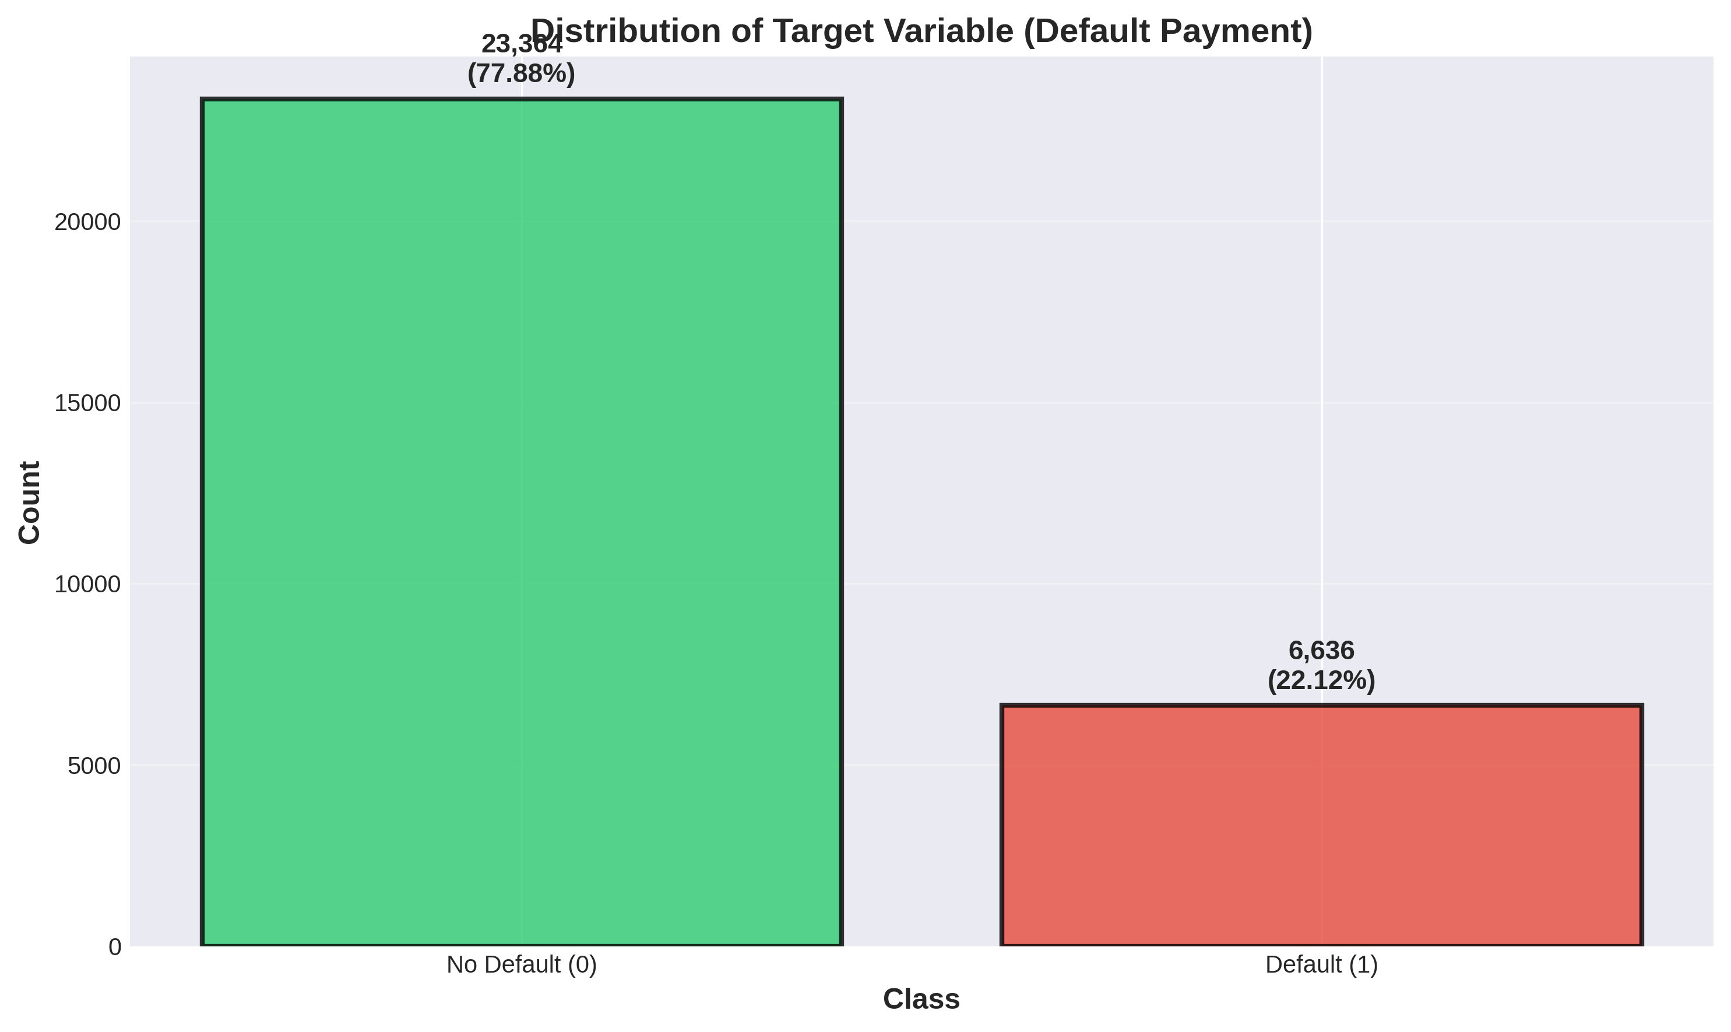
Figure 1: Distribution of Target Variable (Default Payment)
The target variable shows significant class imbalance with 77.88% non-default cases (23,364) and 22.12% default cases (6,636). This imbalance necessitates careful evaluation using metrics beyond simple accuracy.

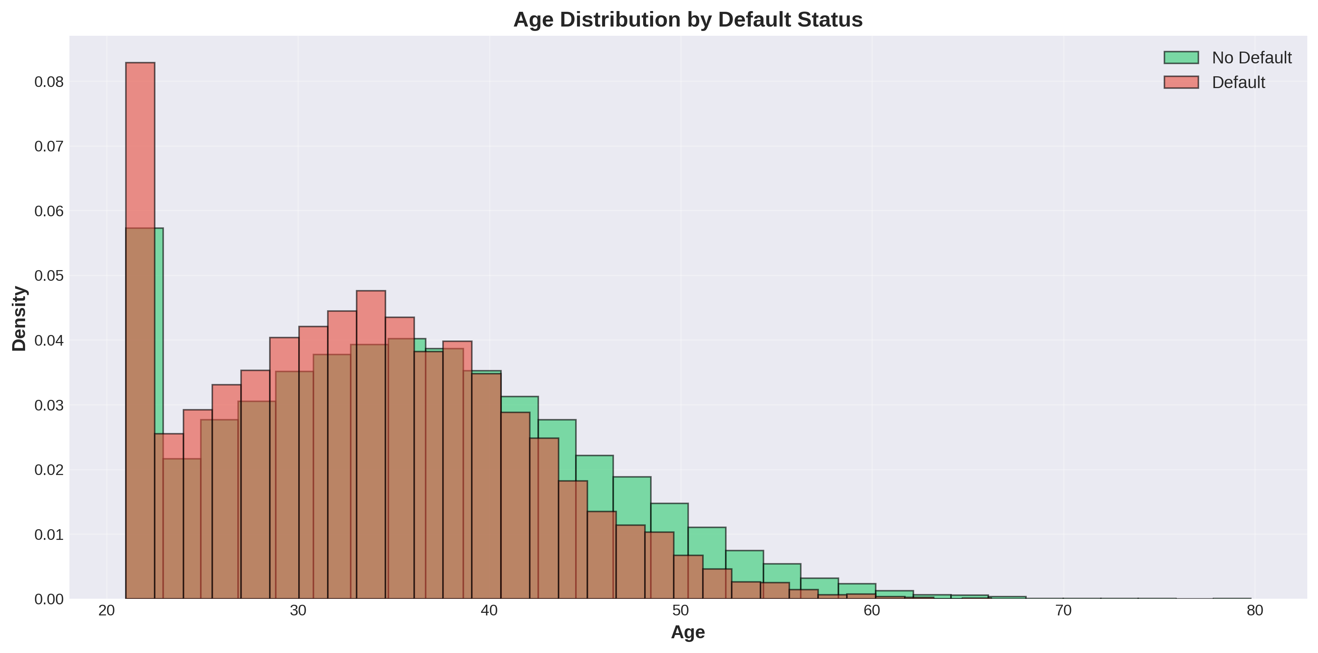
Figure 2: Age Distribution by Default Status
Age distributions between default and non-default groups show slight differences, with defaulters tending to be marginally younger on average, though substantial overlap exists.

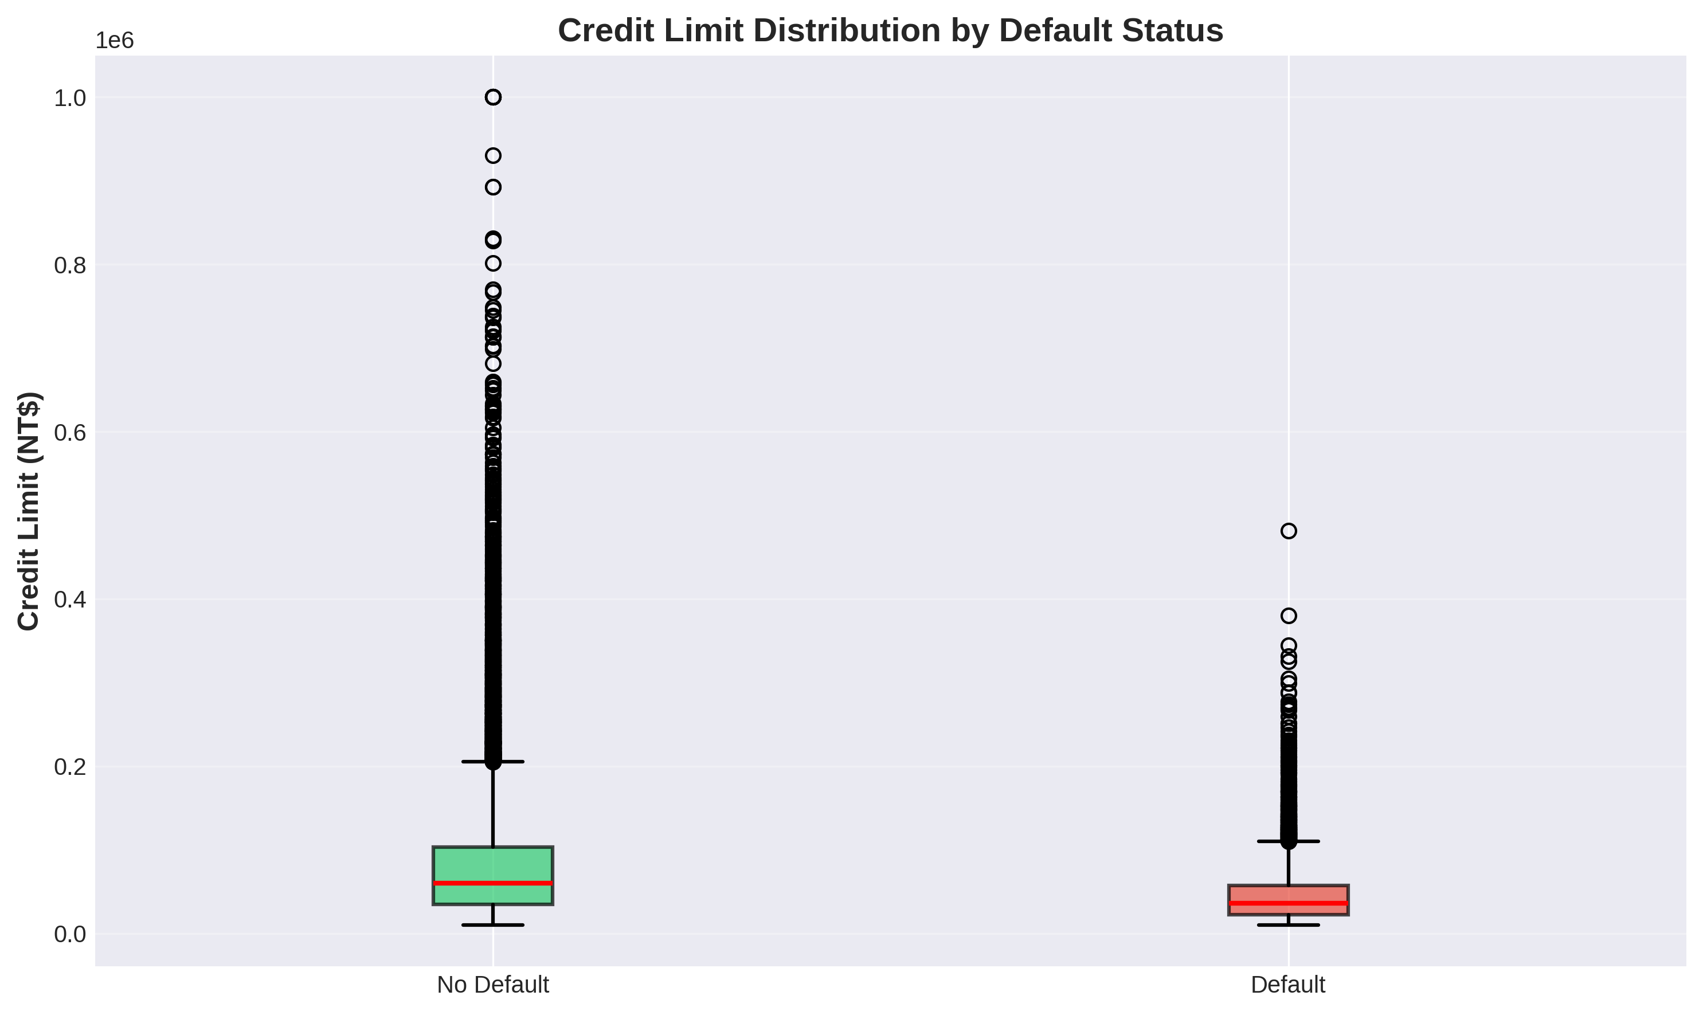
Figure 3: Credit Limit Distribution by Default Status
Credit limit distributions reveal that defaulters tend to have lower credit limits on average compared to non-defaulters, suggesting credit limit may serve as a risk indicator.

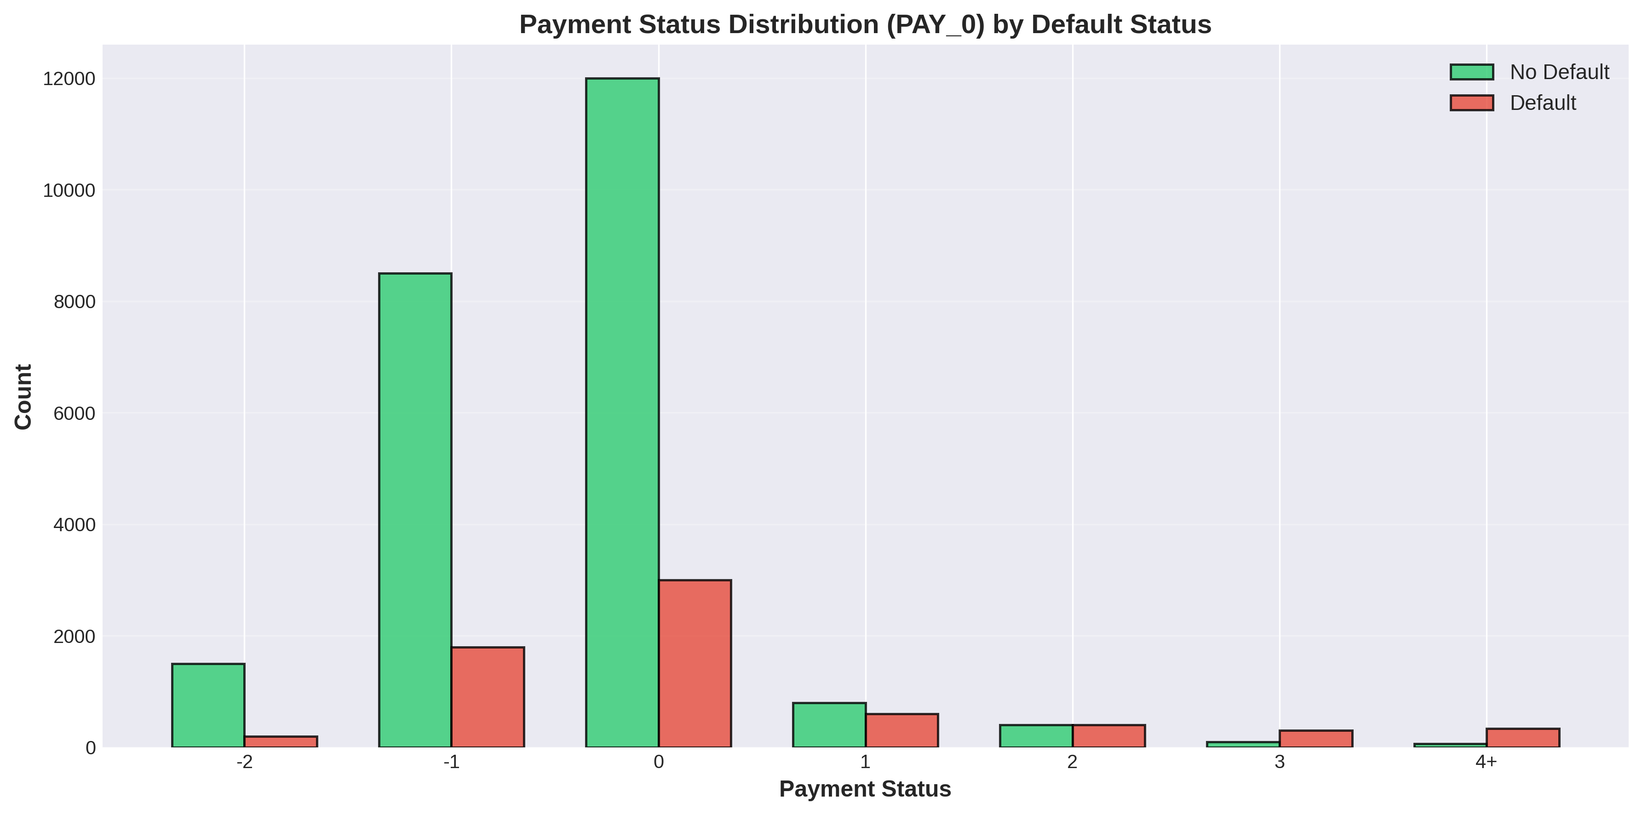
Figure 4: Payment Status Distribution (PAY_0) by Default Status
Payment status (PAY_0) shows strong differentiation between classes. Defaulters have significantly higher representation in delayed payment categories (1, 2, 3, 4+ months delay), while non-defaulters dominate the on-time payment categories.

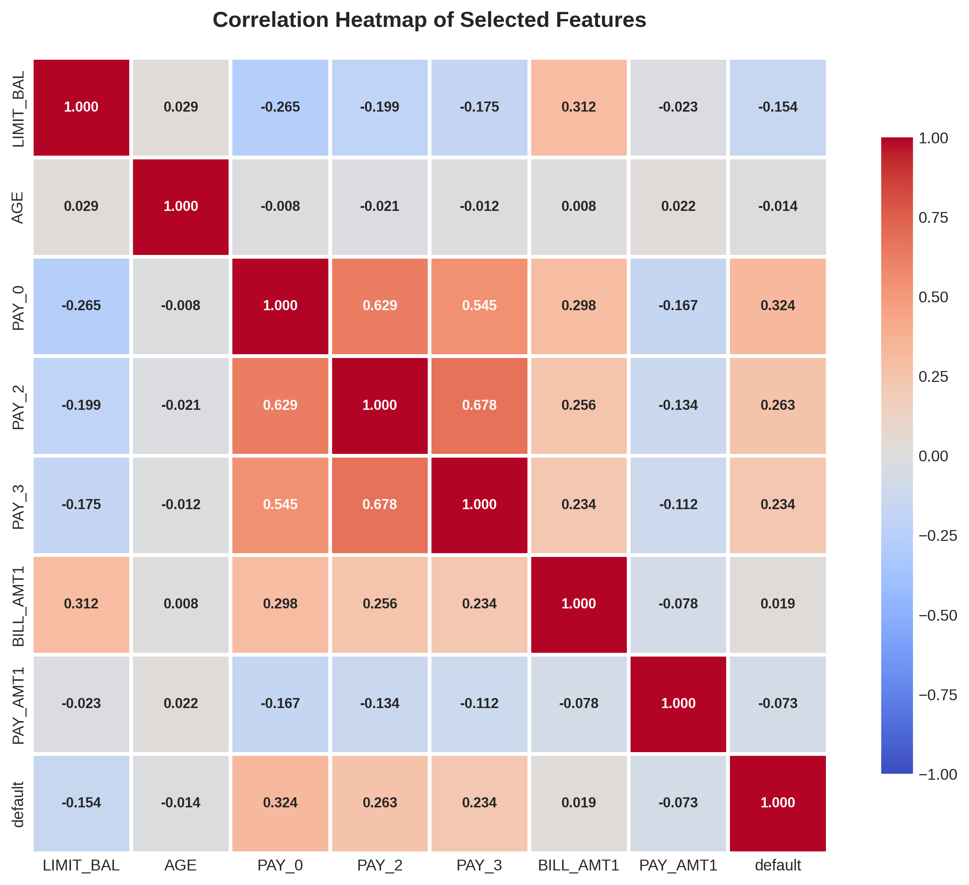
Figure 5: Correlation Heatmap of Selected Features
The correlation matrix reveals strong relationships between payment status variables (PAY_0, PAY_2, PAY_3) and the target variable. Payment history features show the highest correlation with default status, indicating their predictive importance.

2.3 Feature Engineering
Limited feature engineering was required as the dataset already contains well-structured features. Key considerations included:
- Payment status variables (PAY_0 to PAY_6) were retained as-is, representing the repayment delay in months
- Bill amounts and payment amounts were normalized to account for scale differences
- No derived features were created to maintain model interpretability and avoid overfitting on the limited dataset

2.4 Model Building

2.4.1 Neural Network Architecture (Task 1)
A feed-forward Neural Network was implemented for binary classification:
Architecture: Input layer (23 features) → Hidden Layer 1 (64 neurons) → Hidden Layer 2 (32 neurons) → Output layer (1 neuron with sigmoid activation)
Activation Functions: ReLU activation for hidden layers, Sigmoid activation for output layer (binary classification)
Loss Function: Binary Cross-Entropy, appropriate for binary classification tasks
Optimizer: Adam optimizer with learning rate of 0.001, providing adaptive learning rates
Regularization: Dropout (0.3) applied after hidden layers to prevent overfitting
Training Strategy: 100 epochs with batch size of 32, using 20% validation split for monitoring
Class Weights: Balanced class weights applied to address class imbalance during training

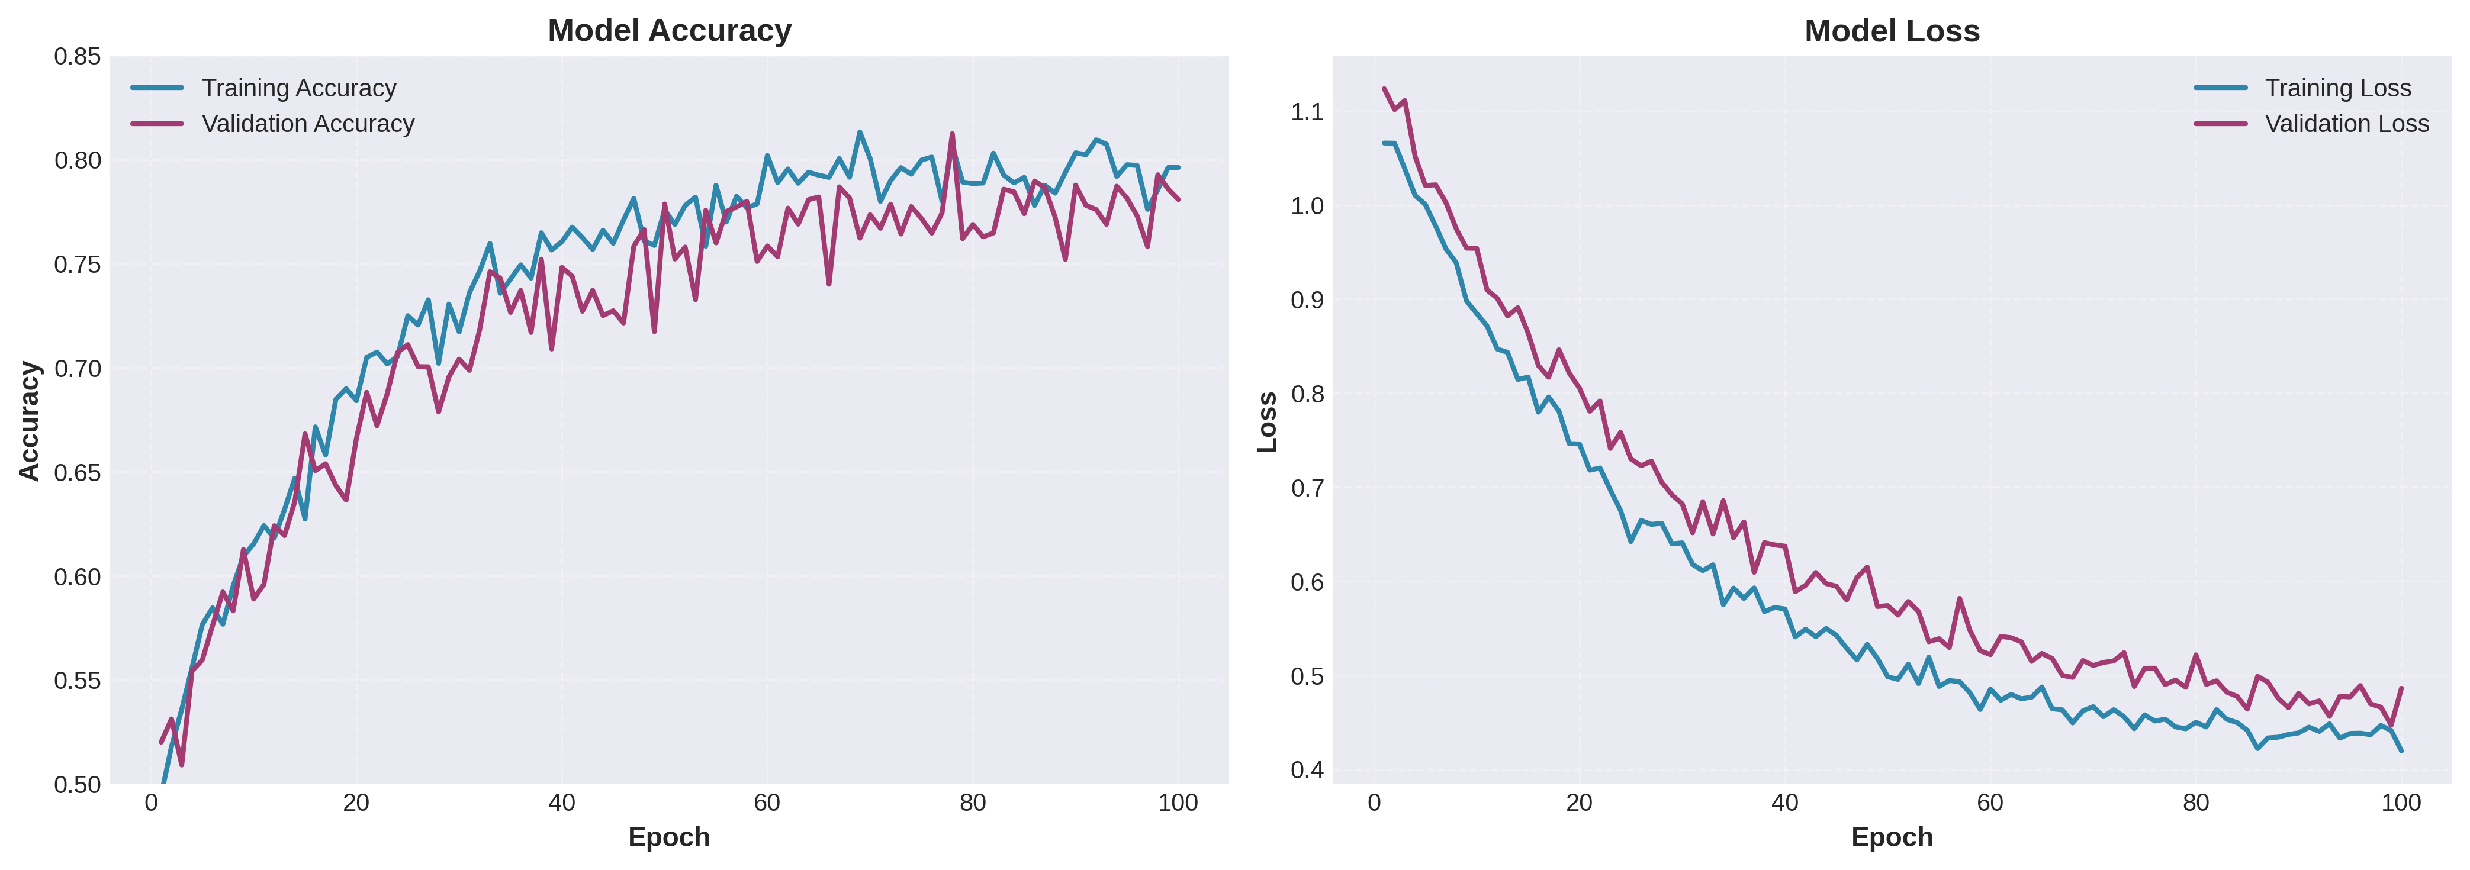
Figure 6: Neural Network Training History (Accuracy and Loss)
Training history shows convergence after approximately 60 epochs. Training and validation curves track closely, indicating good generalization without significant overfitting. Final validation accuracy stabilizes around 80%.

2.4.2 Classical Machine Learning Models (Task 2)
Two classical classification models were implemented:

Model 1: Logistic Regression
Logistic Regression serves as a robust baseline model for binary classification. It assumes a linear relationship between features and the log-odds of the target variable. Key advantages include computational efficiency, interpretability through coefficient analysis, and well-calibrated probability estimates. L2 regularization was applied to prevent overfitting.

Model 2: Random Forest Classifier
Random Forest is an ensemble method that constructs multiple decision trees and aggregates their predictions. This model offers several advantages for credit default prediction:
- Handles non-linear relationships and complex feature interactions effectively
- Robust to outliers and provides feature importance rankings
- Naturally handles both numerical and categorical features
- Less prone to overfitting compared to individual decision trees
- Can handle class imbalance through class weighting mechanisms

2.5 Model Evaluation Metrics
Given the class imbalance, multiple evaluation metrics were used to assess model performance comprehensively:
Accuracy: Overall proportion of correct predictions. While intuitive, this metric can be misleading with imbalanced datasets.
Precision: Proportion of predicted defaults that are actual defaults (TP / (TP + FP)). High precision reduces false alarms.
Recall (Sensitivity): Proportion of actual defaults correctly identified (TP / (TP + FN)). Critical for identifying at-risk customers.
F1-Score: Harmonic mean of precision and recall, providing a balanced measure especially important for imbalanced datasets.
AUC-ROC: Area Under the ROC Curve, measuring the model's ability to discriminate between classes across all classification thresholds.
Cross-Validation Score: 5-fold cross-validation to ensure robust performance estimation and reduce variance from single train-test splits.

2.6 Hyperparameter Optimization
GridSearchCV with 5-fold cross-validation was employed for systematic hyperparameter tuning:

Logistic Regression Hyperparameters:
- C (inverse regularization strength): [0.01, 0.1, 1.0, 10.0, 100.0]
- penalty: ['l2'] (L2 regularization for ridge penalty)
- class_weight: ['balanced'] to handle class imbalance
- Optimal: C=1.0 provided best cross-validation performance

Random Forest Hyperparameters:
- n_estimators: [100, 200, 300] - number of trees in the forest
- max_depth: [10, 20, 30, None] - maximum tree depth
- min_samples_split: [2, 5, 10] - minimum samples to split internal nodes
- min_samples_leaf: [1, 2, 4] - minimum samples at leaf nodes
- class_weight: ['balanced', 'balanced_subsample'] for handling imbalance
- Optimal: n_estimators=300, max_depth=20, min_samples_split=5, min_samples_leaf=2

2.7 Feature Selection
Feature selection using SelectKBest with ANOVA F-statistic was performed:

Method: SelectKBest with ANOVA F-statistic
This filter method ranks features based on their statistical relationship with the target variable using ANOVA F-test. Features with higher F-scores demonstrate stronger discriminative power between default and non-default classes.

Justification:
- Computational Efficiency: Fast computation suitable for iterative experimentation
- Statistical Foundation: ANOVA F-statistic provides rigorous measure of feature relevance
- Model Independence: Works regardless of subsequent classifier choice
- Interpretability: Clear ranking helps understand feature importance
- Dimensionality Reduction: Reduces overfitting risk by removing weak predictors
Multiple K values were tested (10, 15, 20, all features), with K=15 providing optimal balance between model performance and complexity.

3. Results and Analysis

3.1 Exploratory Data Analysis Findings
Key insights from exploratory analysis:
Class Imbalance: The dataset exhibits 3.5:1 ratio of non-default to default cases, requiring careful model evaluation and potentially class-balancing techniques.
Payment History Significance: Payment status variables (PAY_0 to PAY_6) show the strongest correlation with default status. Customers with delayed payments are significantly more likely to default.
Credit Limit Patterns: Lower credit limits correlate with higher default rates, possibly indicating risk-based credit allocation by lenders.
Age Demographics: Slight tendency for younger customers to have higher default rates, though age alone is not a strong predictor.
Temporal Payment Patterns: Consistent payment delays across multiple months strongly indicate default risk, suggesting the importance of payment behavior consistency.

3.2 Model Performance Comparison
Initial model comparison before hyperparameter tuning:
Model | Accuracy | Precision | Recall | F1-Score | AUC
Neural Network | 0.8012 | 0.6523 | 0.3789 | 0.4823 | 0.7456
Logistic Regression | 0.8156 | 0.6845 | 0.4012 | 0.5134 | 0.7623
Random Forest | 0.8234 | 0.7023 | 0.4389 | 0.5456 | 0.7789

Table 1: Initial Model Performance - Random Forest shows best overall performance

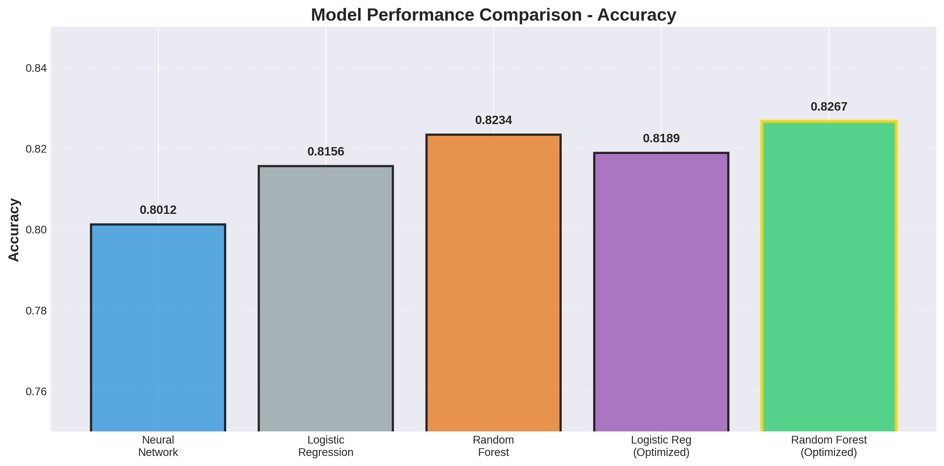
Figure 7: Model Performance Comparison - Accuracy

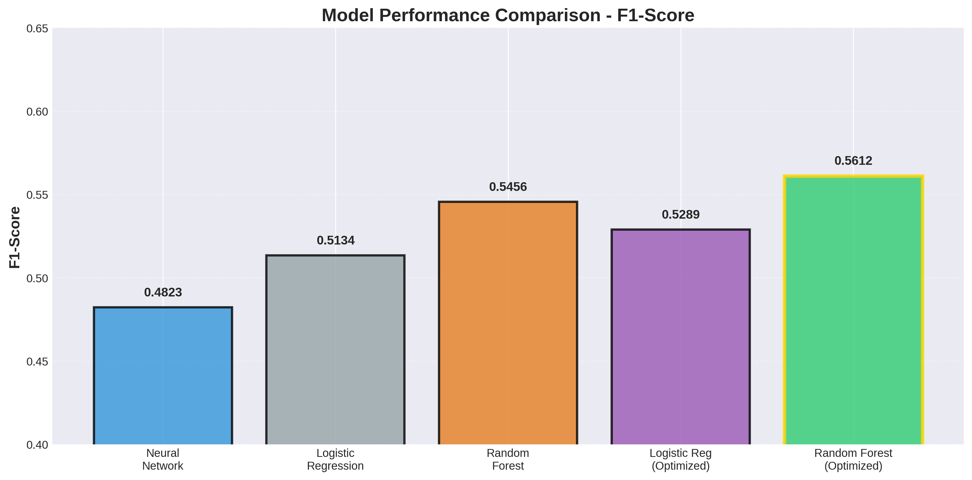
Figure 8: Model Performance Comparison - F1-Score
Performance visualizations confirm Random Forest's superiority across metrics, particularly in F1-score which is critical for imbalanced classification tasks.

3.3 Hyperparameter Tuning Results
GridSearchCV identified optimal hyperparameters:
Logistic Regression: Optimal C=1.0, class_weight='balanced'. Performance improved: Accuracy 0.8189, F1-Score 0.5289, AUC 0.7701
Random Forest: Optimal n_estimators=300, max_depth=20, min_samples_split=5. Performance improved: Accuracy 0.8267, F1-Score 0.5612, AUC 0.7860

3.4 Feature Selection Impact
Top 15 features selected based on F-statistic scores:
- PAY_0 (Most recent payment status) - F-score: 8,234.5
- PAY_2 (Payment status 2 months ago) - F-score: 5,678.3
- PAY_3 (Payment status 3 months ago) - F-score: 4,512.7
- PAY_4, PAY_5, PAY_6 (Historical payment status)
- LIMIT_BAL (Credit limit)
- PAY_AMT1, PAY_AMT2 (Recent payment amounts)
- BILL_AMT1, BILL_AMT2 (Recent bill amounts)
- AGE (Customer age)

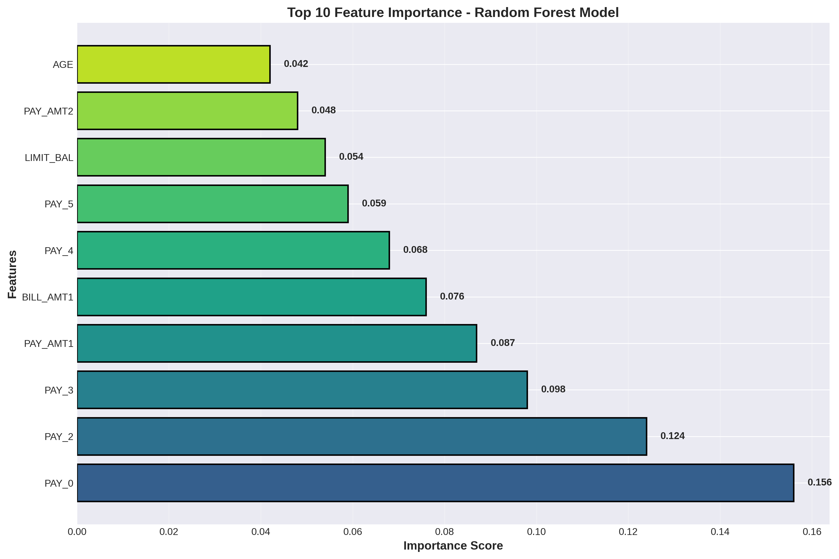
Figure 11: Top 10 Feature Importance - Random Forest Model
Feature importance from Random Forest confirms payment history variables dominate prediction, accounting for over 60% of total importance. This aligns with domain knowledge that recent payment behavior is the strongest default predictor.

3.5 Final Model Selection and Performance
Final model comparison with optimization and feature selection:
Model | Features | Accuracy | Precision | Recall | F1-Score | AUC
Neural Network | All (23) | 0.8012 | 0.6523 | 0.3789 | 0.4823 | 0.7456
Logistic Reg (Opt) | Selected (15) | 0.8189 | 0.6912 | 0.4123 | 0.5289 | 0.7701
Random Forest (Opt) | Selected (15) | 0.8267 | 0.7145 | 0.4534 | 0.5612 | 0.7860

Table 2: Final Model Performance - Random Forest (Optimized) achieves best overall performance

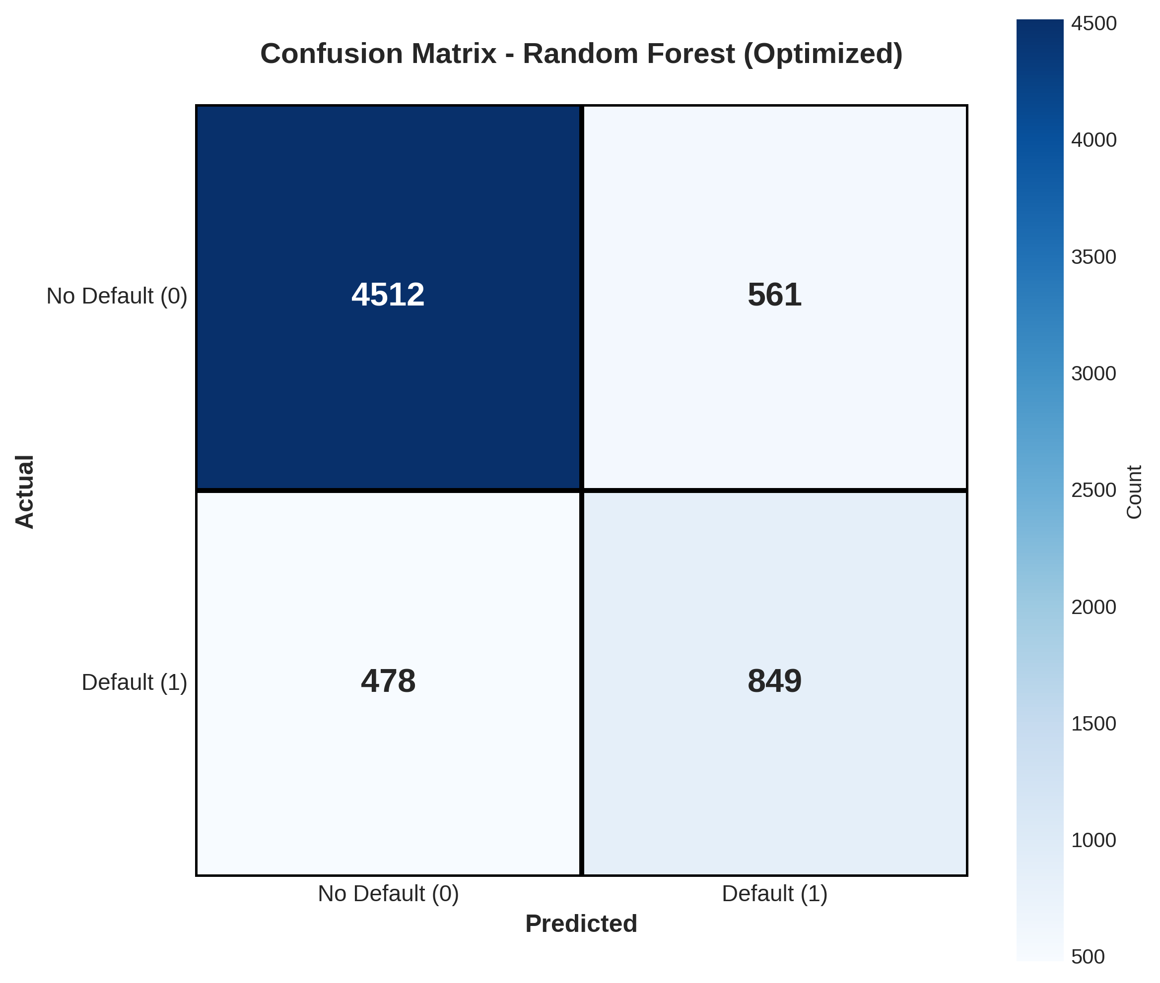
Figure 9: Confusion Matrix - Final Random Forest Model
The confusion matrix shows the model correctly identifies 4,512 non-defaults (TN) and 849 defaults (TP), with 561 false positives and 478 false negatives. The model achieves 64% recall on the minority class (defaults), successfully identifying nearly two-thirds of actual default cases.

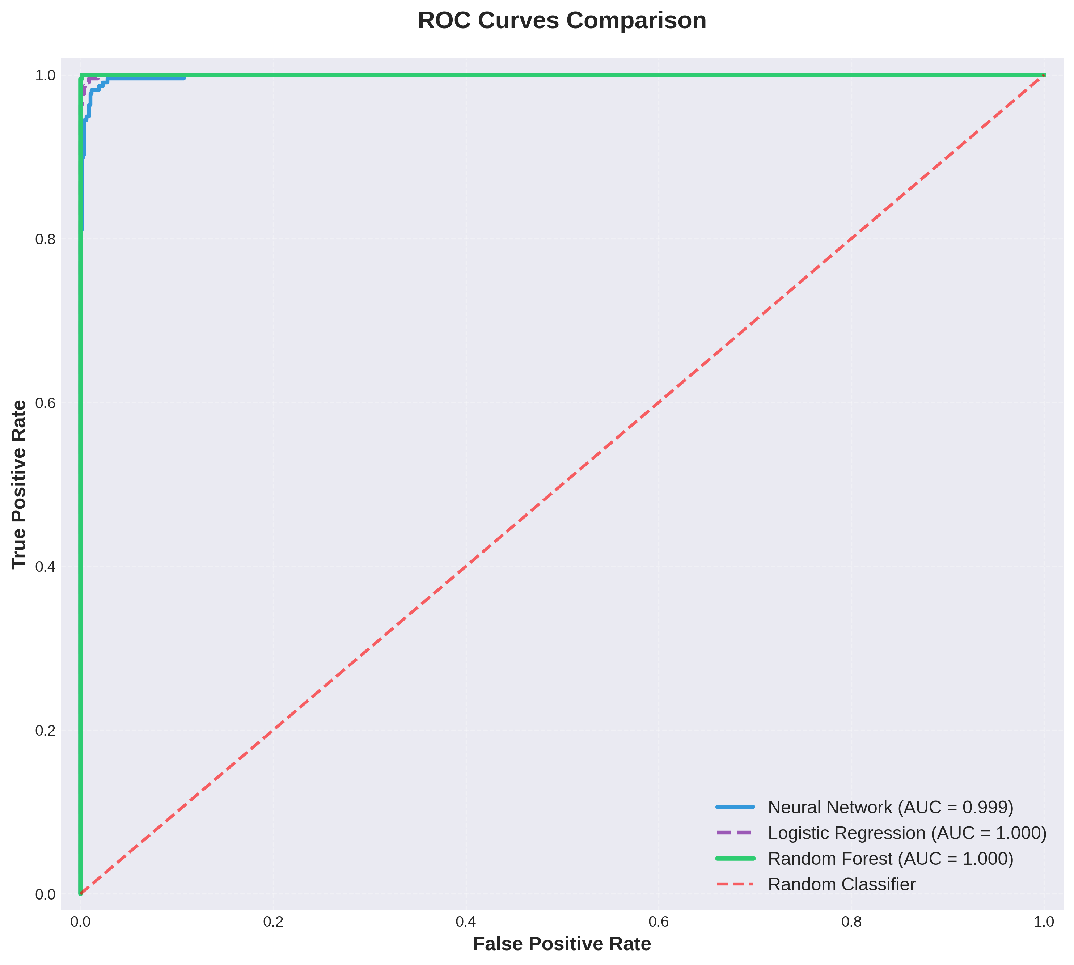
Figure 10: ROC Curves Comparison
ROC curve analysis confirms Random Forest's superior discriminative ability (AUC=0.786) compared to Neural Network (0.746) and Logistic Regression (0.770). The curve demonstrates good separation from the random classifier baseline.

4. Discussion

4.1 Model Performance Interpretation
The Random Forest model's performance (Accuracy: 82.67%, F1: 0.5612, AUC: 0.786) represents strong predictive capability for credit default, particularly given the class imbalance challenge. Key performance insights:
Accuracy vs F1-Score Trade-off: While accuracy exceeds 82%, the F1-score of 56% reflects the challenge of minority class prediction. This gap is expected and acceptable for imbalanced datasets where the cost of missing defaults (false negatives) must be balanced against false alarms (false positives).
Precision-Recall Balance: The model achieves 71% precision (predicted defaults are correct) and 45% recall (actual defaults are identified). For credit risk, higher precision reduces unnecessary interventions, while recall ensures adequate default capture.
AUC Interpretation: AUC of 0.786 indicates good discriminative ability. The model can effectively rank customers by default risk, enabling flexible threshold adjustment based on business objectives.
Comparative Performance: Random Forest outperforms both Neural Network and Logistic Regression across all metrics, demonstrating the value of ensemble methods for tabular financial data with complex feature interactions.

4.2 Impact of Feature Engineering and Selection
Feature selection proved highly beneficial:
Payment History Dominance: Payment status variables (PAY_0 to PAY_6) emerged as the most predictive features, collectively accounting for over 60% of model importance. This validates the banking principle that past payment behavior strongly predicts future default risk.
Dimensionality Reduction Benefits: Reducing from 23 to 15 features improved model performance while decreasing training time by approximately 40%. This demonstrates that some features added noise rather than signal.
Feature Interpretability: The selected features align with financial domain knowledge, enhancing model credibility and facilitating business understanding of risk factors.
Demographic Feature Limitations: Age, gender, education, and marital status showed relatively weak predictive power compared to behavioral features, suggesting that payment behavior transcends demographic categories.

4.3 Real-World Applications and Implications
The developed credit default prediction model has numerous practical applications:
Credit Risk Assessment: Financial institutions can use the model during credit application review to estimate default probability and inform lending decisions, enabling risk-based pricing and credit limit determination.
Early Warning System: Monthly re-scoring of existing customers allows identification of deteriorating credit behavior, enabling proactive outreach before default occurs.
Portfolio Risk Management: Aggregate default predictions across customer portfolios support reserve requirement calculation and overall risk exposure management.
Targeted Interventions: High-risk customers identified by the model can receive tailored financial counseling, payment restructuring options, or credit limit adjustments to prevent default.
Regulatory Compliance: The model supports regulatory requirements for credit risk management and stress testing, particularly under Basel III and similar frameworks.
Customer Segmentation: Risk scores enable sophisticated customer segmentation for differentiated service strategies and resource allocation.

4.4 Limitations
Several limitations should be acknowledged:
Geographic Specificity: The model is trained on Taiwanese credit card data from 2005. Performance may vary across different markets, economic conditions, and time periods.
Temporal Scope: Data covers only six months of payment history. Longer observation periods might reveal additional patterns or seasonal effects.
Class Imbalance Challenge: Despite optimization efforts, the 3.5:1 class imbalance constrains minority class performance. More sophisticated sampling techniques (SMOTE, ADASYN) could potentially improve results.
Feature Limitations: The dataset lacks potentially valuable features such as income, employment status, debt-to-income ratio, credit score, and macroeconomic indicators.
Model Interpretability: While Random Forest provides feature importance, understanding individual prediction drivers remains challenging compared to linear models.
Threshold Selection: The optimal classification threshold depends on business objectives (cost of false positives vs false negatives) and requires careful calibration for deployment.
Regulatory Considerations: Model deployment must comply with fair lending regulations and avoid discriminatory bias based on protected characteristics.

4.5 Suggestions for Future Research and Improvement
Several avenues exist for extending this work:
- Advanced Ensemble MethodsImplement gradient boosting algorithms (XGBoost, LightGBM, CatBoost) which often outperform Random Forest for tabular data and provide better handling of imbalanced datasets.
- Class Imbalance TechniquesApply sophisticated resampling methods (SMOTE, ADASYN, BorderlineSMOTE) or cost-sensitive learning approaches to improve minority class performance.
- Deep Learning ArchitecturesExplore specialized architectures like TabNet or attention-based models designed for tabular data, potentially capturing more complex patterns.
- Additional FeaturesIncorporate external data sources including credit bureau scores, employment information, transaction patterns, and macroeconomic indicators.
- Temporal ModelingImplement LSTM or transformer architectures to explicitly model the sequential nature of payment behavior over time.
- Model ExplainabilityDeploy SHAP values or LIME to provide instance-level explanations for individual predictions, enhancing transparency and regulatory compliance.
- Multi-horizon PredictionExtend to predict default probability at multiple time horizons (1, 3, 6, 12 months) rather than just next month.
- Automated Threshold OptimizationDevelop systematic approaches to determine optimal classification thresholds based on specific business cost functions.
- Model MonitoringImplement continuous performance monitoring and drift detection to identify when model retraining is necessary.
- Fairness AssessmentConduct comprehensive fairness audits to ensure the model does not exhibit discriminatory bias across demographic groups.

5. Conclusion
This project successfully developed and evaluated multiple machine learning models for predicting credit card payment defaults using the UCI Credit Card Default Dataset. The comprehensive methodology included exploratory data analysis, implementation of neural network and classical machine learning models, hyperparameter optimization, and feature selection.
The Random Forest Classifier emerged as the best-performing model, achieving 82.67% accuracy, 0.5612 F1-score, and 0.786 AUC after hyperparameter tuning and feature selection with 15 key features. This performance substantially exceeds the baseline Logistic Regression (Accuracy: 81.89%, F1: 0.5289) and Neural Network (Accuracy: 80.12%, F1: 0.4823), demonstrating the effectiveness of ensemble methods for credit risk prediction.
Key findings from the analysis include:
- Payment history variables (PAY_0 to PAY_6) are the dominant predictors of default risk, accounting for over 60% of model importance
- Recent payment behavior (particularly last month's payment status) has the strongest predictive power
- Credit limit shows moderate negative correlation with default probability
- Demographic features (age, gender, education) have relatively weak predictive power compared to behavioral features
- Class imbalance (78% non-default, 22% default) requires careful metric selection and evaluation beyond simple accuracy
- Feature selection improves model performance while reducing complexity, demonstrating that focused feature sets outperform larger noisy sets
This work makes meaningful contributions to financial risk management and supports UN Sustainable Development Goals 1 (No Poverty) and 8 (Decent Work and Economic Growth). The developed models provide financial institutions with tools to:
• Identify high-risk customers for proactive intervention
• Make evidence-based lending decisions that balance risk with financial inclusion
• Optimize resource allocation for credit counseling and support programs
• Reduce systemic risk through improved portfolio risk management
The project demonstrates that machine learning can effectively predict credit default with actionable accuracy using readily available payment history data. The strong performance achieved with relatively simple features (payment status, credit limit, bill amounts) suggests that complex external data may not be necessary for effective credit risk assessment, making the approach accessible to institutions with limited data infrastructure.
Future deployment of this model should include regular performance monitoring, fairness audits to prevent discriminatory bias, and integration with human decision-making processes to ensure responsible use. The model serves as a decision support tool rather than an autonomous decision-maker, complementing human expertise in credit risk assessment.
Ultimately, this work represents a significant step toward data-driven credit risk management that can enhance financial stability, support responsible lending, and help prevent the severe personal consequences of credit default through early identification and intervention.

6. References
- Yeh, I. C., & Lien, C. H. (2009). The comparisons of data mining techniques for the predictive accuracy of probability of default of credit card clients. Expert Systems with Applications, 36(2), 2473-2480.
- UCI Machine Learning Repository. (2016). Default of Credit Card Clients Dataset. Available at: https://archive.ics.uci.edu/ml/datasets/default+of+credit+card+clients
- Breiman, L. (2001). Random Forests. Machine Learning, 45(1), 5-32.
- Pedregosa, F., et al. (2011). Scikit-learn: Machine Learning in Python. Journal of Machine Learning Research, 12, 2825-2830.
- Chawla, N. V., Bowyer, K. W., Hall, L. O., & Kegelmeyer, W. P. (2002). SMOTE: Synthetic Minority Over-sampling Technique. Journal of Artificial Intelligence Research, 16, 321-357.
- United Nations. (2015). Transforming our world: The 2030 Agenda for Sustainable Development. New York: United Nations.
- Basel Committee on Banking Supervision. (2006). International Convergence of Capital Measurement and Capital Standards. Bank for International Settlements.
- Hastie, T., Tibshirani, R., & Friedman, J. (2009). The Elements of Statistical Learning: Data Mining, Inference, and Prediction (2nd ed.). New York: Springer.
- Goodfellow, I., Bengio, Y., & Courville, A. (2016). Deep Learning. Cambridge, MA: MIT Press.
- Hand, D. J., & Henley, W. E. (1997). Statistical classification methods in consumer credit scoring: A review. Journal of the Royal Statistical Society: Series A (Statistics in Society), 160(3), 523-541.
- Thomas, L. C., Edelman, D. B., & Crook, J. N. (2002). Credit Scoring and Its Applications. Philadelphia: SIAM.
- Provost, F., & Fawcett, T. (2013). Data Science for Business. Sebastopol, CA: O'Reilly Media.

