

Stop Yield Railroad Construction

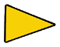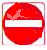

School Ahead No passing Zone Guide Sign do not enter

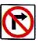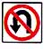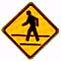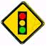
No Right Turn No U- Turn Pedestrian Signal Ahead

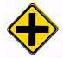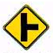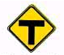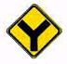

Crossroad Side road T intersection Y intersection

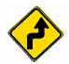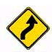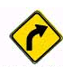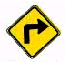

Right & Left Right & left Right curve Right Turn
Turn coming curve coming Ahead Ahead

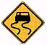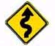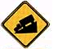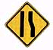

Slippery pavement winding Downgrade Reduction in lanes
Road ahead

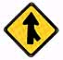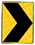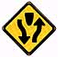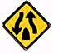

Merge in Lane Change in Direction Divided Highway

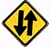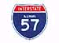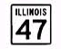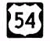

Two-Way Interstate State Route US Highway
Roadway Route

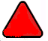

Slow Moving vehicle

