Promise can be resolve or a reject . promise can be with a delay as it is contacting server

Callback will not have rejections

Json very easy to

npx create-react-app myapp01

cd myapp01

npm start

the more the component hierarchy better react will perform

props (predefine) is an object from react .Props are used to pass variable from parent to child

we are using Dependency Injection pattern (react will create the props object if we ask ,and react will delete the props obj so it is handling the dependency).

Lifecycle

Constructor

componentDidMount

componentWillunMount

createRef() gives the reference to html element(instead of document.getElementBYID() we can use createRef())

setState() => rerenders the render function(). But in browser dom only the change will be updated

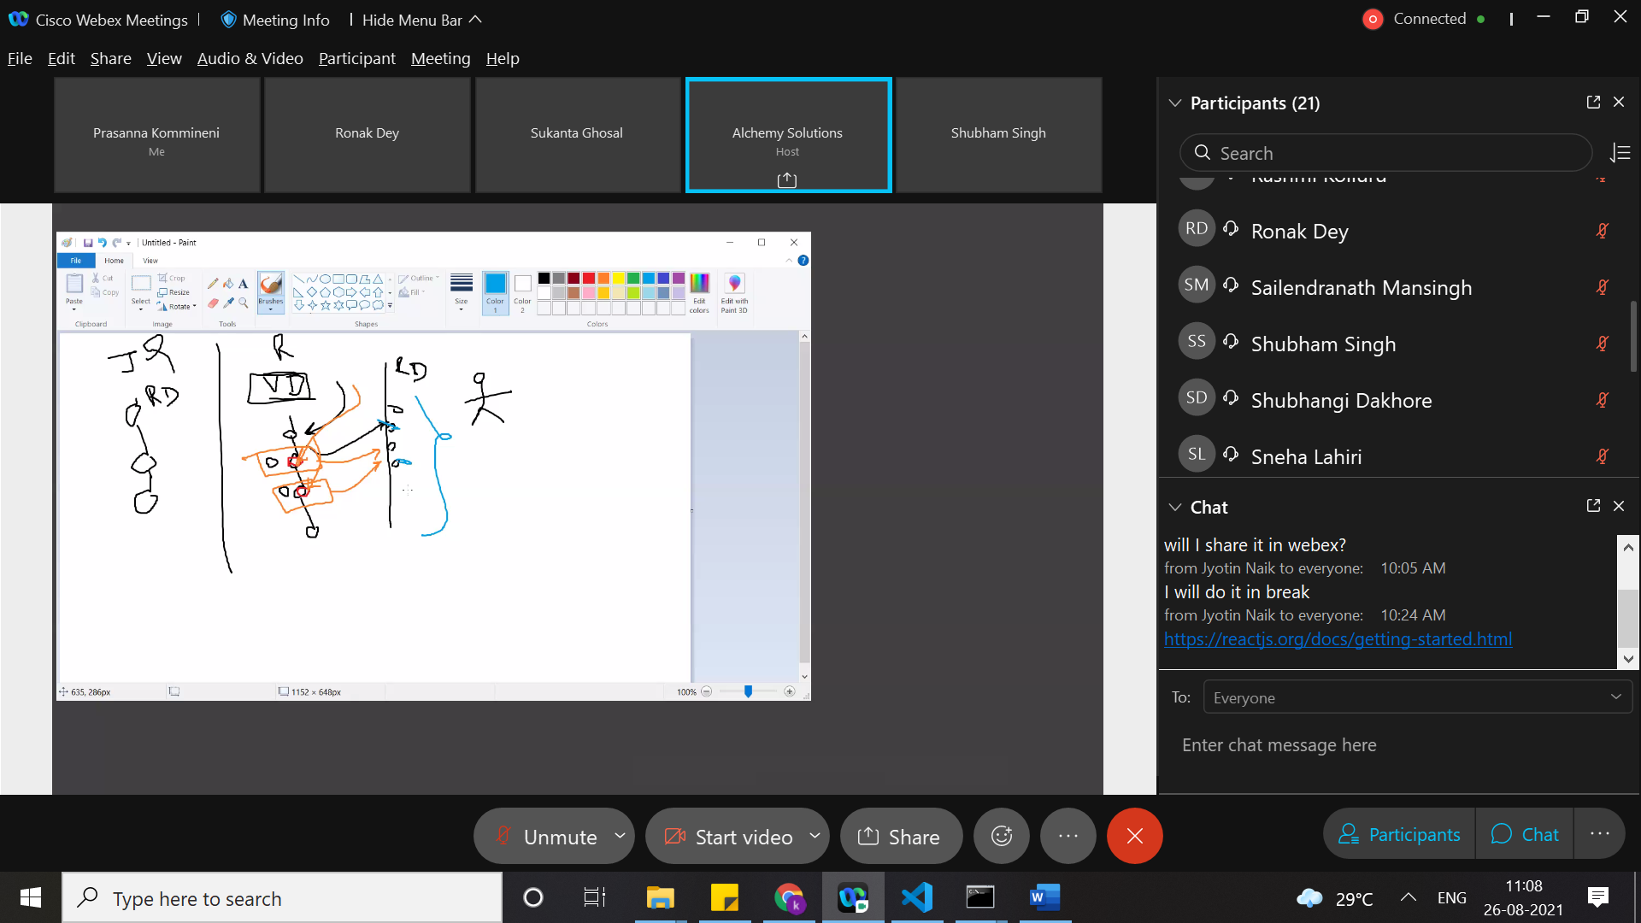

How react dom works is defined as reconciliation algorithm.

Data should be large and changes should be delta

Changes will be updated as abatch(updates elements all at a time).

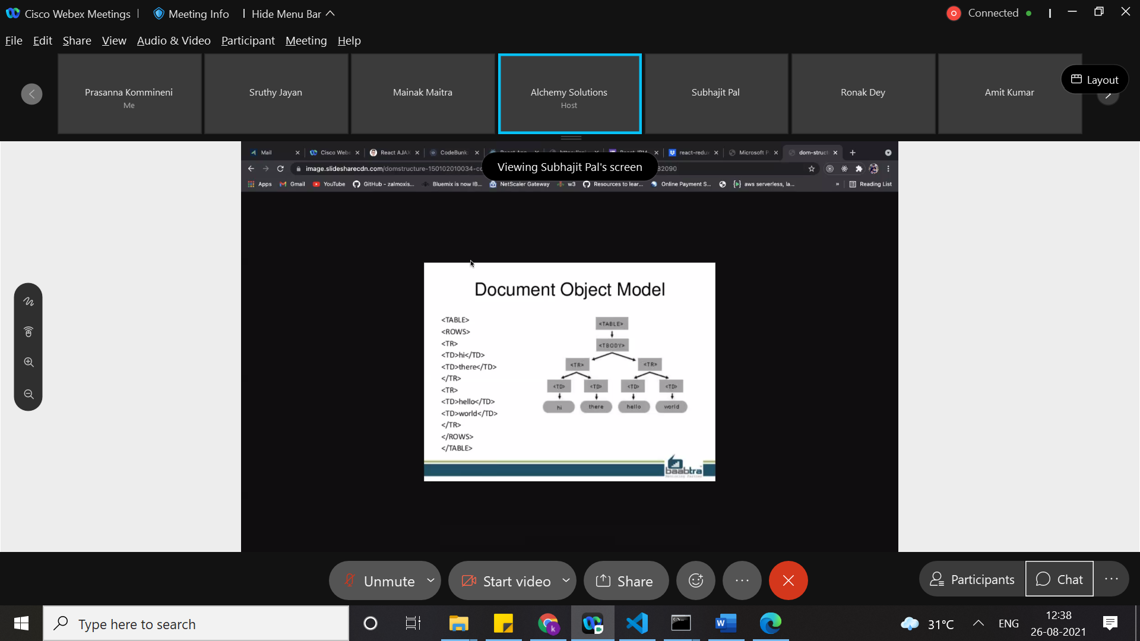

We can achieve two way data binding with the help of set state and onchange events.

Parent defines the function and child executes it (parent delegate the function to the child) . parent to child communication will happen using function delegation

Proptypes is resembles with interface to make sure have all objects are using some type

For exectuting methods at parent level from child.context is accessible in child components

getChildContext()

Galaxy.childContextTypes = {

    planetClickHandler: PropTypes.func,

    mydata: PropTypes.string

};

By signing up in child components we can use the context

Planet.propTypes = {

    name: PropTypes.string,

    color: PropTypes.string,

    diameter: PropTypes.number,

};

Planet.contextTypes = {

    planetClickHandler: PropTypes.func,

    mydata: PropTypes.string

};

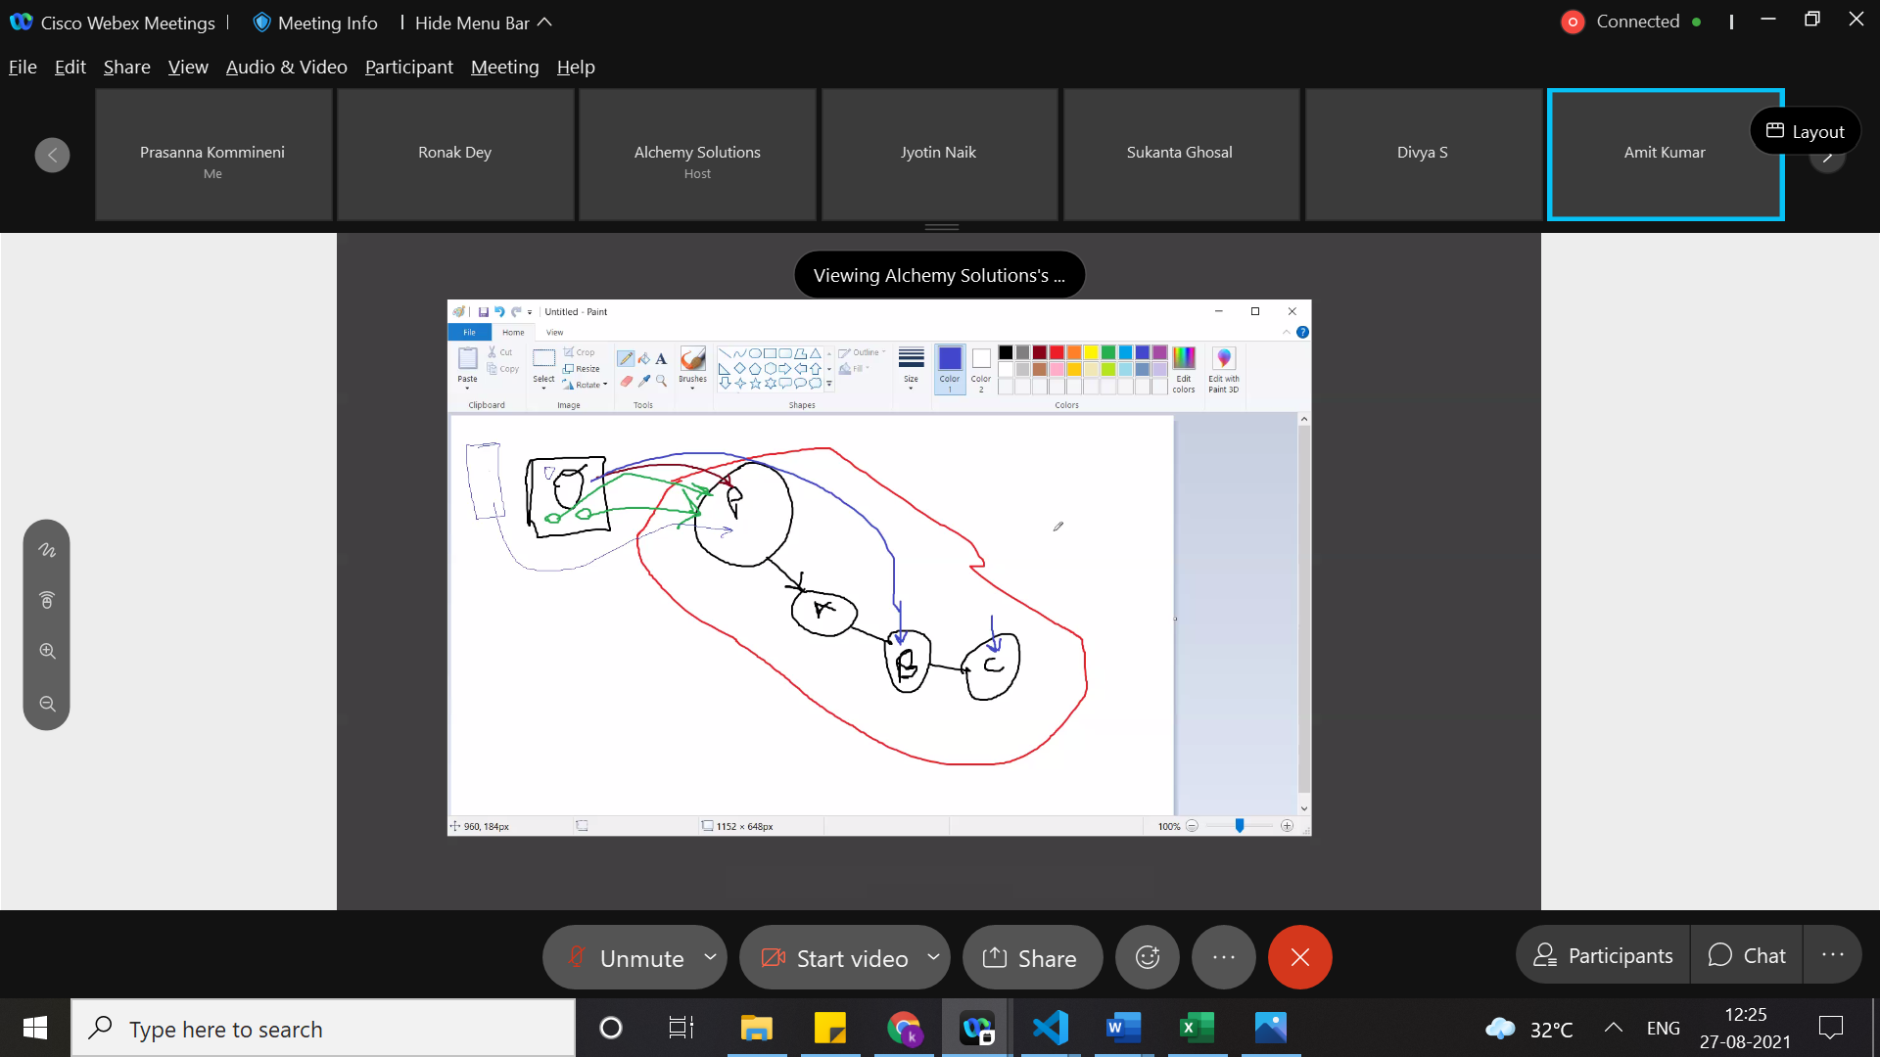

React provider consumer

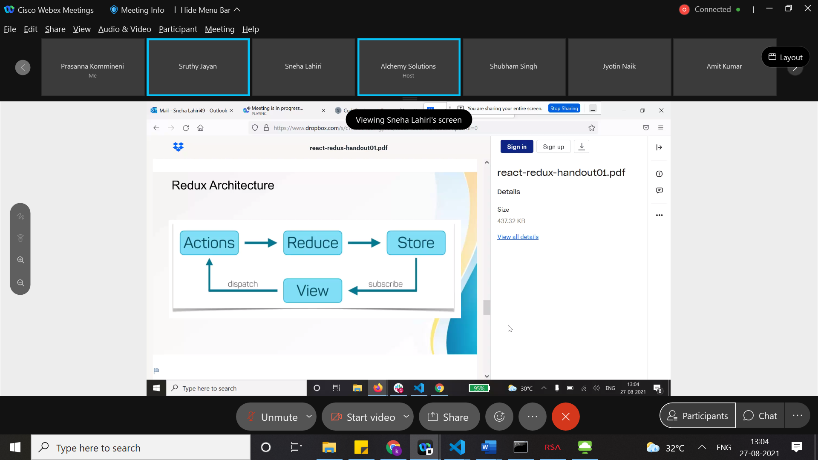

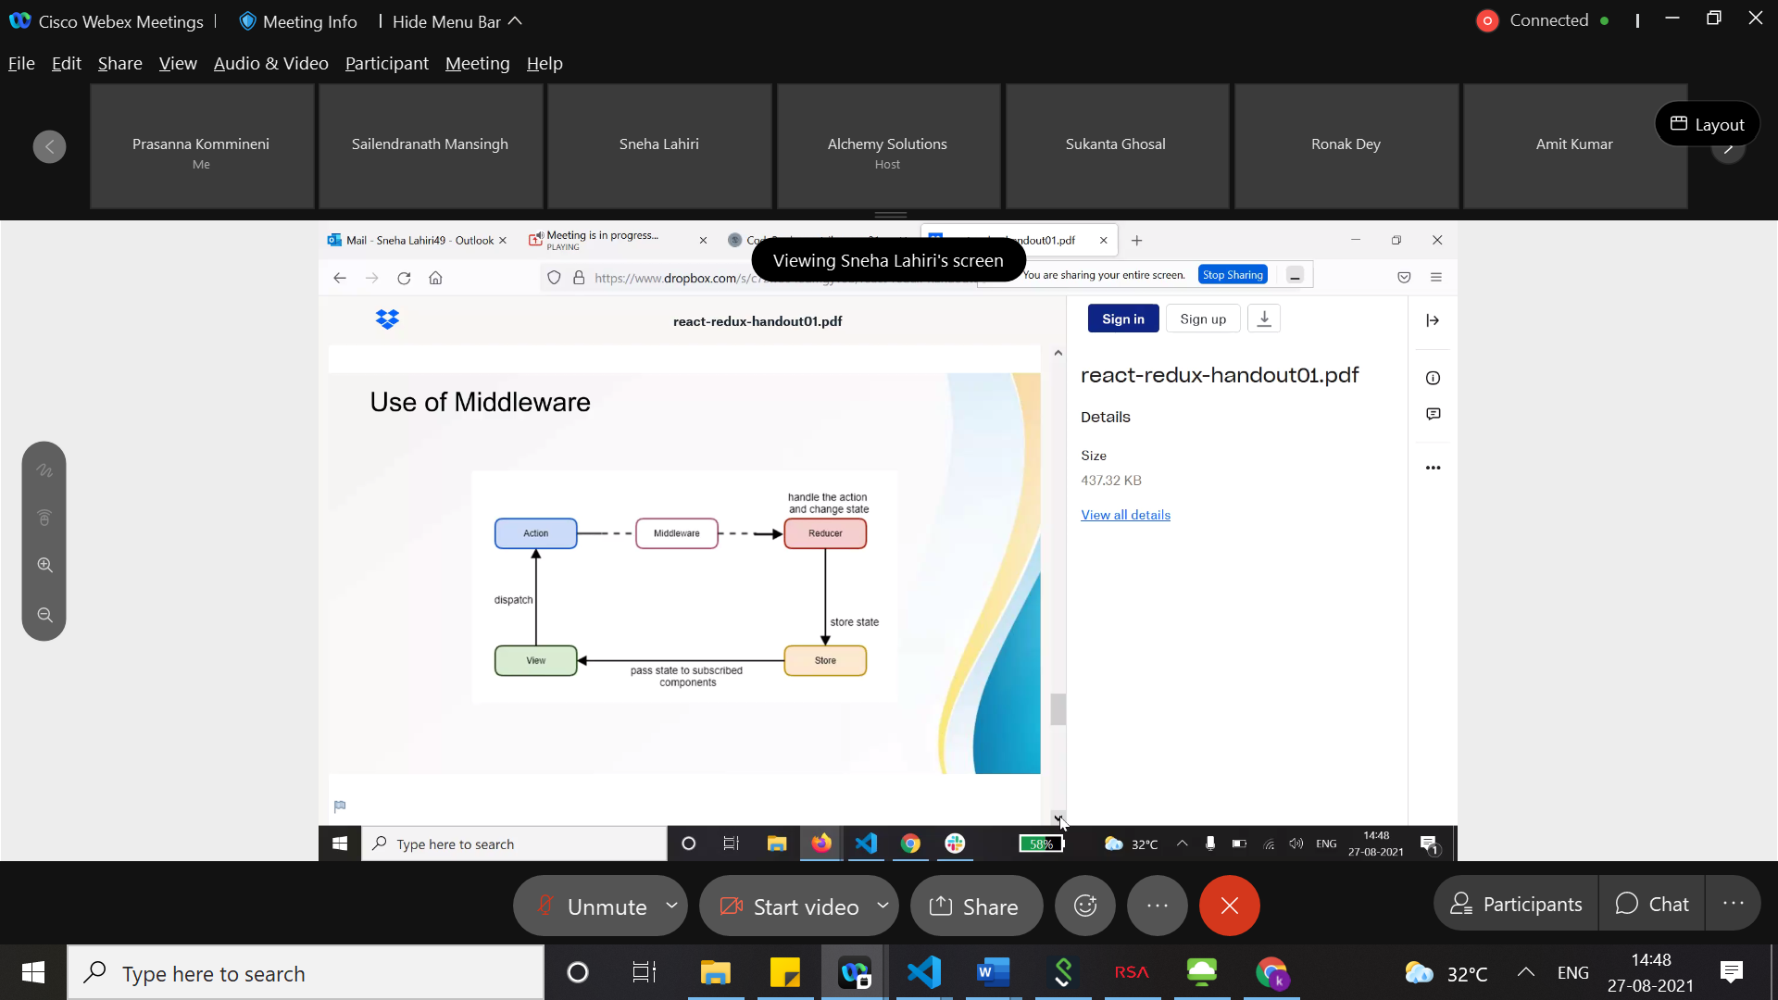

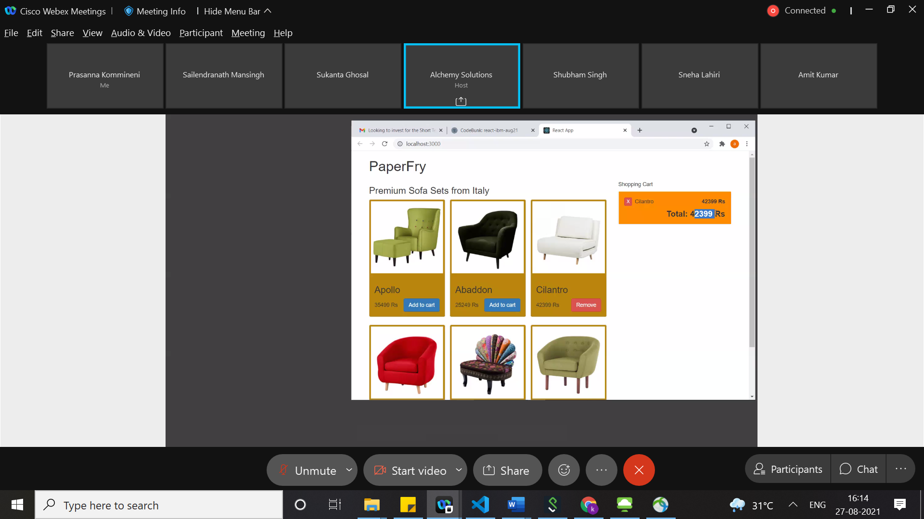

[https://alchemy-solutions.webex.com/alchemy-solutions/ldr.php?RCID=e67faec91a87421d9b4fc7ef39e31482](https://urldefense.proofpoint.com/v2/url?u=https-3A__alchemy-2Dsolutions.webex.com_alchemy-2Dsolutions_ldr.php-3FRCID-3De67faec91a87421d9b4fc7ef39e31482&d=DwMFAg&c=jf_iaSHvJObTbx-siA1ZOg&r=Em2_VLF7gcGJeo2ngrsy6pfYWbUYgtukPSIk0xjvVQI&m=g9dD0g0AD6rgogD_FHB10kipGyturHYXLVj3xtK2Y6E&s=IfyebBD0peIhfQa0OR0TGe64UVq1hhAecWRaH7rHX04&e=)