Insurance Claim Assistant – Technical Specification

# 1. Project Overview

The Claims Inquiry Assistant is implemented in Salesforce using Agentforce. It provides self-service capabilities for members to inquire about claim status, denial reasons, reimbursement timelines, and submit support requests. It integrates with custom Salesforce data models and flows, leveraging Agentforce topics, Omni-Channel flows, and OTP verification.

# 2. Objectives

- Enable automated responses to member claim-related questions.

- Minimize dependency on manual call center support.

- Log support tasks when issues can't be resolved by the agent.

- Allow secure access through OTP-based email verification.

# 3. Data Model

Custom Objects Used:

• Claim__c: Includes Claim_ID__c, Member__c, Provider__c, Date_of_Service__c, Amount_Billed__c, Amount_Paid__c, Status__c, Denial_Code__c.

• Member__c: Includes Member_ID__c, Email__c, First_Name__c, Last_Name__c, DOB, Phone, Gender.

• Denial_Code__c: Includes Code, Short_Description, and Resolution_Steps.

• Member_Inquiry__c: Captures topic, description, and escalation flag.

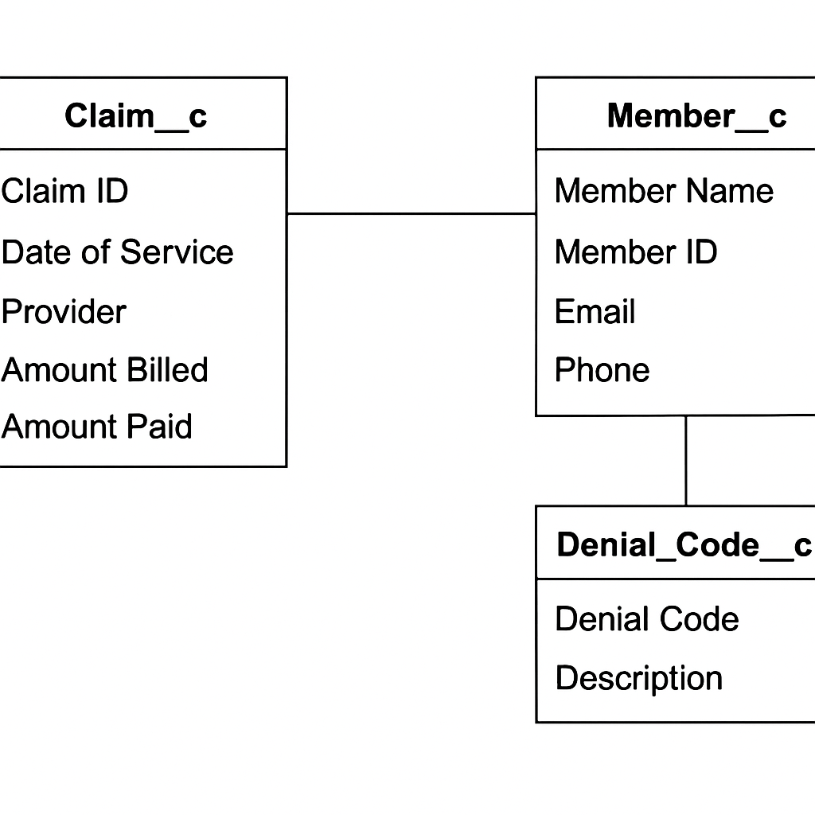

📌 Diagram 🡪 Claim__c, Member__c, Denial_Code__c and their relations.

# 4. Topics Implemented

• Get Claim Status: Checks Claim ID and Email to show claim details.

• Member Claim Lookup: Lists claims for a Member ID; prompts selection.

• Estimate Reimbursement: Calculates and displays reimbursement ETA.

• Denial Reason: Explains denial reason based on Denial Code.

• Member Inquiry: Logs inquiry and checks if escalation needed.

• Support Interaction: Logs support request with user input.

• Support Request Status: Returns status of a previous support task.

• Escalation: Routes to support agent when agent fails to resolve.

# 5. Flows Implemented

• Create_support_Task_vesrion2_flow: Logs a support task using the agent’s captured inputs.

• Estimate_Reimbursement_Date: Returns calculated reimbursement date for a claim.

• Explain_Denial_Reason: Fetches steps explaining a denial based on Denial_Code__c.

• Get_Support_Case_Status: Returns task status using the support reference number.

• Log_Member_Inquiry_Flow: Creates a record of the member’s inquiry for audit/logging.

• Member Inquiry: Alternative helper flow to create Member Inquiry records.

• Send Verification Code Custom Member: Sends an OTP to the member’s email.

• Verify Member Code Custom: Validates the OTP entered by the member.

# 6. Omni-Channel Integration

Omni-Channel flows used for fallback routing and escalation:

• Route to Agent – Escalates to a live agent via queue.

• Route to Queue – Assigns routed records to a preconfigured queue.

# 7. Security Measures

• OTP-based identity verification before displaying claim data.

• Member lock post verification to prevent impersonation.

• Field-level access and permission set enforced on records.

# 8. Deployment Configuration

• Copilot-enabled Agentforce site created in Experience Cloud.

• Agent activated with 8 topics and 10+ flows.

• Guest user permissions and flow access configured.

# 9. Screenshot Placeholders

⬜ Agentforce Topics List

⬜ Agent Action Configuration for Denial Reason, Reimbursement, Claim Status

⬜ OTP Verification Success Screen

⬜ Task Record: CLM-SUP Reference View

⬜ Claim__c and Member__c record view with linked fields

# 10. Future Enhancements

• Add SMS-based OTP as secondary option.

• Link family members under shared insurance (household support).

• Integrate predictive routing using claim history or denial patterns.

Implementation

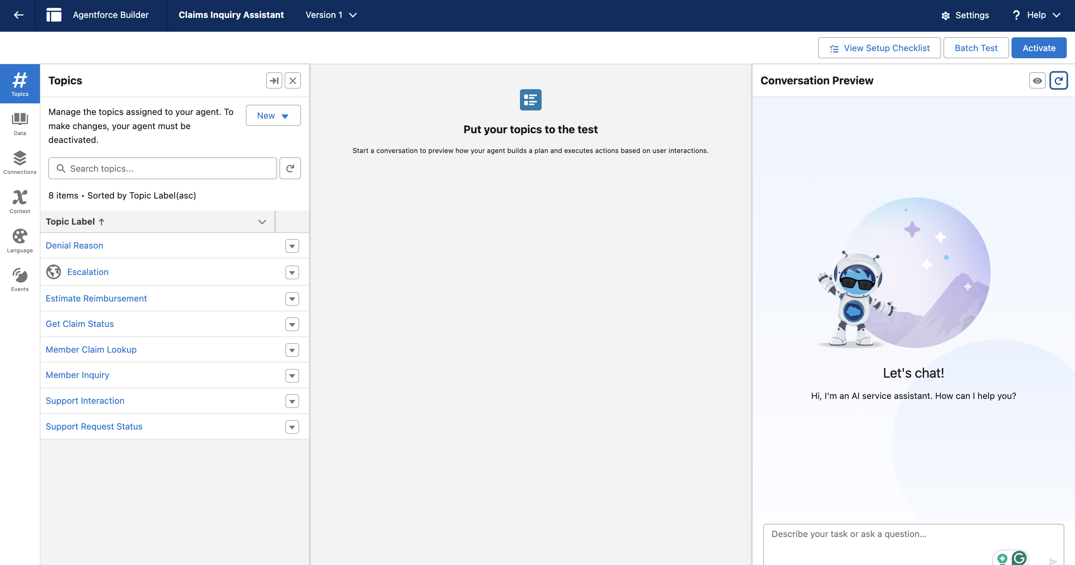

Denial Reason

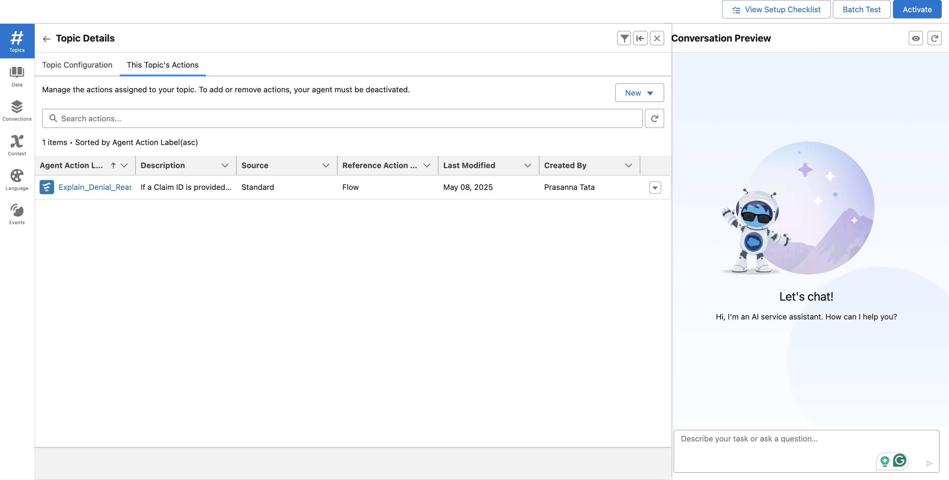

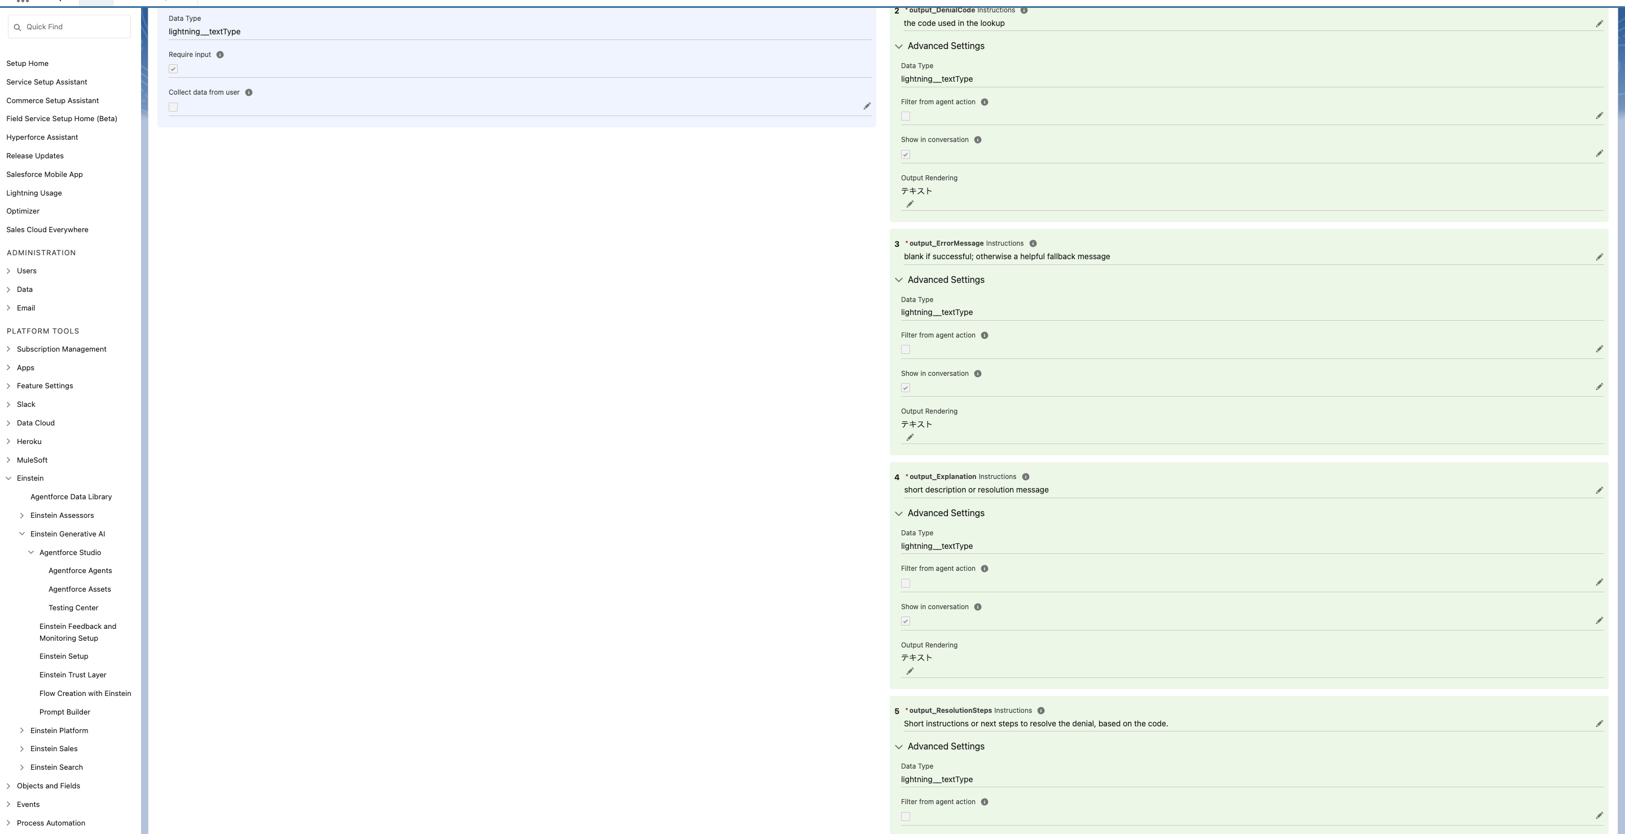

Estimate_Reimbursement_Date  
