Create the following tables for HMS(Hospital Management System):
The Doctor_master table contains information about doctors in the hospital.
DOCTOR_MASTER(doctor_id,doctor_name,dept)
Column Name | Data type & Data size | Description
doctor_id | Varchar(15) | doctorid must be unique and not null
doctor_name | Varchar(15) | Doctor name should be not null
Dept | Varchar(15) | Dept name should be not null

Sample Data:
doctor_id | doctor_name | Dept
D0001 | Ram | ENT
D0002 | Rajan | ENT
D0003 | Smita | Eye
D0004 | Bhavan | Surgery’’
D0005 | Sheela | Surgery
D0006 | Nethra | Surgery

The room_master table contains information about room availability in the hospital.

Column Name | Data type & Data size | Description
room_no | Varchar(15) | roomno must be unique and not null
room_type | Varchar(15) | room type name should be not null
status | Varchar(15) | status name should be not null

Sample Data:
room_no | room_type | status
R0001 | AC | occupied
R0002 | Suite | vacant
R0003 | NonAC | vacant
R0004 | NonAC | occupied
R0005 | AC | vacant
R0006 | AC | occupied

The patient_master table contains information about patients in the hospital.
PATIENT_MASTER(pid, name,age,weight,gender,address,phoneno,disease,doctorid)
Column Name | Data type & Data size | Description
pid | Varchar(15) | pid must be unique and not null
name | Varchar(15) | name should be not null
age | number(15) | age should be not null
Weight | number(15) | weight should be not null
Gender | Varchar(10) | gender should be not null
Address | Varchar(50) | address should be not null
phoneno | varchar(10) | phoneno should be not null
Disease | Varchar(50) | disease should be not null
Doctor_id | Varchar(5) | Must be an existing doctor

Sample Data:
pid | name | age | weight | gender | address | phoneno | disease | Doctor_id
P0001 | Gita | 35 | 65 | F | Chennai | 9867145678 | Eye Infection | D0003
P0002 | Ashish | 40 | 70 | M | Delhi | 9845675678 | Asthma | D0003
P0003 | Radha | 25 | 60 | F | Chennai | 9867166678 | Pain in heart | D0005
P0004 | Chandra | 28 | 55 | F | Bangalore | 9978675567 | Asthma | D0001
P0005 | Goyal | 42 | 65 | M | Delhi | 8967533223 | Pain in Stomach | D0004
The room_allocation table contains information about the allocation of room to the patients in the hospital.
ROOM_ALLOCATION(room_no, pid, admission_date,release_date)
Column Name | Data type & Data size | Description
room_no | Varchar(15) | Must be an existing rooms
pid | Varchar(15) | Must be an existing patients
admission_date | date | Admission date should be not null
Release_date | date
Sample Data:
room_no | pid | admission_date | Release_date
R0001 | P0001 | 15-oct-16 | 26-oct-16
R0002 | P0002 | 15-nov-16 | 26-nov-16
R0002 | P0003 | 01-dec-16 | 30-dec-16
R0004 | P0001 | 01-jan-17 | 30-jan-17

NOTE:
You are supposed to fill in the given records in DOCTOR_MASTER, ROOM_MASTER, PATIENT_MASTER and ROOM_ALLOCATION tables following these rules:
- Identify the primary key and foreign key (if applicable) in each table.
- Take care of the constraints and the relationships among the tables.

QUERIES

Query #1:Display the patients who were admitted in the month of january.

Query #2:Display the female patient who is not suffering from asthma
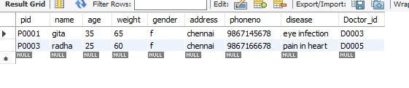

Query #3:Count the number of male and female patients.

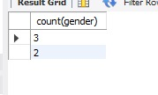

Query #4:Display the patient_id,patient_name, doctor_id, doctor_name, room_no, room_type and admission_date.

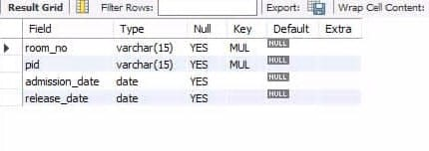

Query #5:Display the room_no which was never allocated to any patient.
select * from room_master;
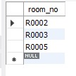

Query #6:Display the room_no, room_type which are allocated more than once.
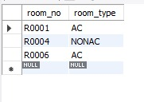

PRIME For Internal Use Only Version 4.2

