1. Create a maven project (filter as java-quickstart) select 2nd template

EmployRealTime

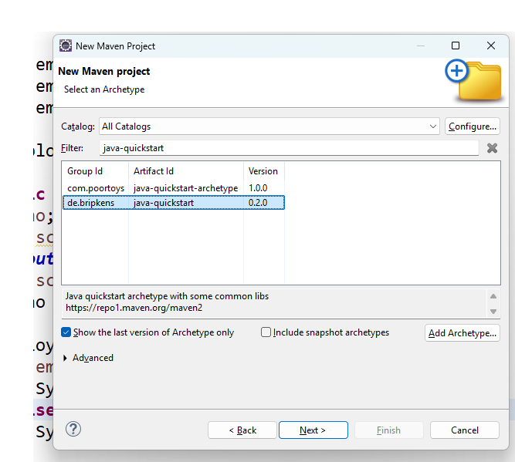

After that please fill the options as

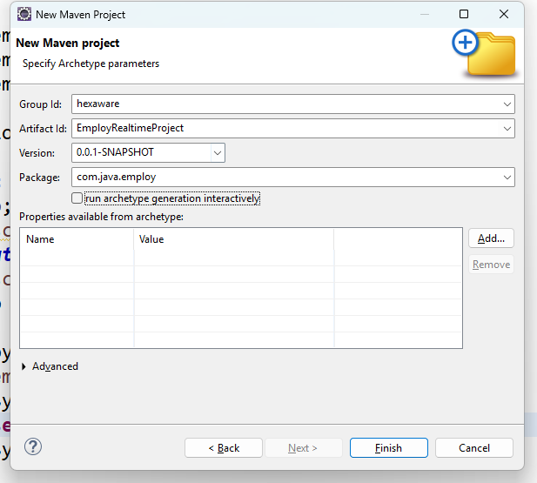

Step 3 :

You need to add the maven dependency for mysql server

In pom.xml file after 19th line add the below code

<!-- https://mvnrepository.com/artifact/mysql/mysql-connector-java -->

<dependency>

<groupId>mysql</groupId>

<artifactId>mysql-connector-java</artifactId>

<version>8.0.32</version>

</dependency>

Step 4 :

Right-Click on the project and select “resource folder” and give the name as resources

Step 5 :

Right-Click on resources folder, add new file and give the file name as “db.properties”

Step 6 :

In property file write the below code (adjust as per ur credentials)

driver=com.mysql.cj.jdbc.Driver

url=jdbc:mysql://localhost:3306/hexamarch

user=root

password=root

Step 7 :

Create a file name as “ConnectionHelper.java” in com.java.employ.util package and write the below code in that

**package** com.java.employ.util;

**import** java.sql.Connection;

**import** java.sql.DriverManager;

**import** java.sql.SQLException;

**import** java.util.ResourceBundle;

**public** **class** ConnectionHelper {

**public** **static** Connection getConnection() **throws** ClassNotFoundException, SQLException {

ResourceBundle rb = ResourceBundle.*getBundle*("db");

String driver = rb.getString("driver");

String url = rb.getString("url");

String user = rb.getString("user");

String pwd = rb.getString("password");

Class.*forName*(driver);

Connection connection = DriverManager.*getConnection*(url, user, pwd);

**return** connection;

}

}

Step 8 :

Create one interface file as “EmployDao.java” and in that write the below code in (com.java.employ.dao) pacakge

**package** com.java.employ.dao;

**import** java.sql.SQLException;

**import** java.util.List;

**import** com.java.employ.model.Employ;

**public** **interface** EmployDao {

List<Employ> showEmployDao() **throws** ClassNotFoundException, SQLException;

Employ searchEmployDao(**int** empno) **throws** ClassNotFoundException, SQLException;

}

Step 9 :

Create one class name as “EmployDaoImpl.java” and write the below code there

**package** com.java.employ.dao;

**import** java.sql.Connection;

**import** java.sql.PreparedStatement;

**import** java.sql.ResultSet;

**import** java.sql.SQLException;

**import** java.util.ArrayList;

**import** java.util.List;

**import** com.java.employ.model.Employ;

**import** com.java.employ.model.Gender;

**import** com.java.employ.util.ConnectionHelper;

**public** **class** EmployDaoImpl **implements** EmployDao {

Connection connection;

PreparedStatement pst;

@Override

**public** List<Employ> showEmployDao() **throws** ClassNotFoundException, SQLException {

connection = ConnectionHelper.*getConnection*();

String cmd = "select * from Employ";

pst = connection.prepareStatement(cmd);

ResultSet rs = pst.executeQuery();

List<Employ> employList = **new** ArrayList<Employ>();

Employ employ = **null**;

**while**(rs.next()) {

employ = **new** Employ();

employ.setEmpno(rs.getInt("empno"));

employ.setName(rs.getString("name"));

employ.setGender(Gender.*valueOf*(rs.getString("gender")));

employ.setDept(rs.getString("dept"));

employ.setDesig(rs.getString("desig"));

employ.setBasic(rs.getDouble("basic"));

employList.add(employ);

}

**return** employList;

}

@Override

**public** Employ searchEmployDao(**int** empno) **throws** ClassNotFoundException, SQLException {

connection = ConnectionHelper.*getConnection*();

String cmd = "select * from Employ where empno = ?";

pst = connection.prepareStatement(cmd);

pst.setInt(1, empno);

ResultSet rs = pst.executeQuery();

Employ employFound = **null**;

**if** (rs.next()) {

employFound = **new** Employ();

employFound.setEmpno(rs.getInt("empno"));

employFound.setName(rs.getString("name"));

employFound.setGender(Gender.*valueOf*(rs.getString("gender")));

employFound.setDept(rs.getString("dept"));

employFound.setDesig(rs.getString("desig"));

employFound.setBasic(rs.getDouble("basic"));

}

**return** employFound;

}

}

Step 10 :

Create a file as “EmployShowMain.java” in com.java.employ.main package and write the below code

**package** com.java.employ.main;

**import** java.sql.SQLException;

**import** java.util.List;

**import** com.java.employ.dao.EmployDao;

**import** com.java.employ.dao.EmployDaoImpl;

**import** com.java.employ.model.Employ;

**public** **class** EmployShowMain {

**public** **static** **void** main(String[] args) {

EmployDao dao = **new** EmployDaoImpl();

**try** {

List<Employ> employList = dao.showEmployDao();

**for** (Employ employ : employList) {

System.***out***.println(employ);

}

} **catch** (ClassNotFoundException | SQLException e) {

// **TODO** Auto-generated catch block

e.printStackTrace();

}

}

}

Step 11 :

Create a class as “EmploySearchMain.java” in com.java.employ.main package and write the below code

**package** com.java.employ.main;

**import** java.sql.SQLException;

**import** java.util.Scanner;

**import** com.java.employ.dao.EmployDao;

**import** com.java.employ.dao.EmployDaoImpl;

**import** com.java.employ.model.Employ;

**public** **class** EmploySearchMain {

**public** **static** **void** main(String[] args) {

**int** empno;

Scanner sc = **new** Scanner(System.***in***);

System.***out***.println("Enter Employ No ");

empno = sc.nextInt();

EmployDao dao = **new** EmployDaoImpl();

**try** {

Employ employFound = dao.searchEmployDao(empno);

**if** (employFound != **null**) {

System.***out***.println(employFound);

} **else** {

System.***out***.println("*** Record Not Found ***");

}

} **catch** (ClassNotFoundException | SQLException e) {

// **TODO** Auto-generated catch block

e.printStackTrace();

}

}

}