**Aspect Oriented Programming (AOP) in Spring Framework**

**Aspect-Oriented Programming (AOP) in Spring Boot** is a powerful feature that enhances modularity by handling cross-cutting concerns such as **logging, security**, and **transaction management** separately from business logic. Without

AOP, these concerns would be scattered throughout the codebase, leading to duplication and maintenance challenges. **Spring AOP** provides a lightweight proxy-based approach to implementing AOP efficiently in enterprise applications. In this article, we will explore **AOP concepts, Spring AOP implementation**, and real-world examples to help you integrate AOP into your Spring Boot projects effectively.

**Understanding AOP Concepts**

* **Aspect**: An Aspect is a modular unit of cross-cutting concerns. For example, a logging aspect can be applied across various methods in different classes..
* **Advice:** This is the action taken by an aspect at a particular join point. There are five types of advice:
  + **Before**: Executed before the method call.
  + **After**: Executed after the method call, regardless of its outcome.
  + **AfterReturning**: Executed after the method returns a result, but not if an exception occurs.
  + **Around:** Surrounds the method execution, allowing you to control the method execution and its result.
  + **AfterThrowing**: Executed if the method throws an exception.

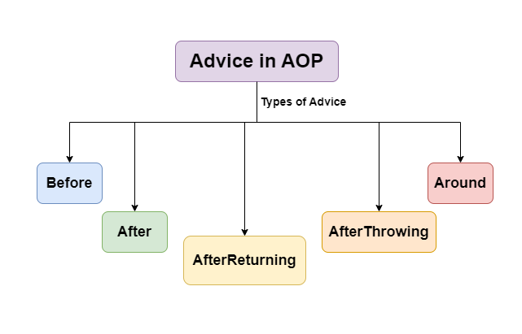

* **Join Point:** A specific point in the execution of a program, such as method execution or exception handling, where an aspect can be applied.
* **Pointcut**: A Pointcut is a predicate that defines where advice should be applied. It matches join points using expressions.
* **Weaving**: This is the process of linking aspects with the target object. Spring AOP only supports runtime weaving using proxy-based mechanisms (JDK dynamic proxies for interfaces and CGLIB for concrete classes). It does not modify bytecode like AspectJ.

**Dominant AOP Frameworks**

* **AspectJ**: A powerful and mature AOP framework that supports compile-time and load-time weaving. It offers full AOP support with its own syntax and tools.
* **JBoss AOP**: Part of the JBoss application server, offering integration with Java EE applications.
* **Spring AOP**: A simpler, proxy-based framework that integrates with the Spring Framework, using XML configurations or annotations to define aspects and pointcuts.

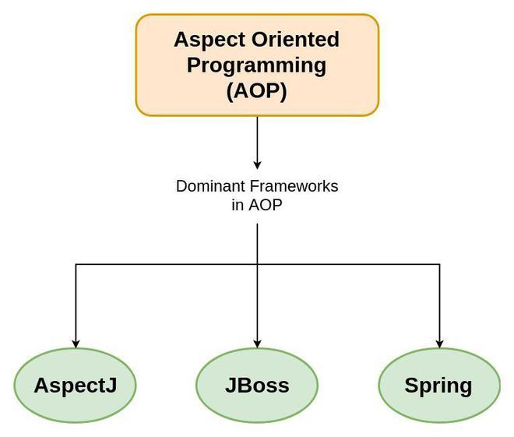

**AOP in the Spring Framework**

Spring AOP leverages proxy-based mechanisms to provide aspect-oriented functionality. It creates a proxy object that wraps around the original object, adding the necessary advice. This proxy can be generated automatically using configurations in XML or annotations like @Aspect .

**Example: Implementing Logging with AOP in Spring**

Here's a practical example to illustrate AOP concepts in Spring:

**Aspect Class with Different Types of Advice:**

**package** **com.example.aspect**;

**import** **org.aspectj.lang.JoinPoint**;

**import** **org.aspectj.lang.ProceedingJoinPoint**;

**import** **org.aspectj.lang.annotation.After**;

**import** **org.aspectj.lang.annotation.AfterReturning**;

**import** **org.aspectj.lang.annotation.AfterThrowing**;

**import** **org.aspectj.lang.annotation.Around**;

**import** **org.aspectj.lang.annotation.Aspect**;

**import** **org.aspectj.lang.annotation.Before**;

**import** **org.aspectj.lang.annotation.Pointcut**;

**import** **org.springframework.stereotype.Component**;

@Aspect *// Marks the class as an aspect, which contains cross-cutting concerns*

@Component *// Registers this aspect as a Spring bean*

**public** **class** **LoggingAspect** {

@Pointcut("execution(public void com.example.service.*.*(..))")

*// Defines a pointcut that matches the execution of any public method in classes under com.example.service package*

**public** void allServiceMethods() {}

@Before("allServiceMethods()")

*// Advice that runs before the execution of methods matched by the pointcut*

**public** void logBefore(JoinPoint joinPoint) {

System.out.println("Before method: " + joinPoint.getSignature().getName());

}

@After("allServiceMethods()")

*// Advice that runs after the execution of methods matched by the pointcut, regardless of their outcome*

**public** void logAfter(JoinPoint joinPoint) {

System.out.println("After method: " + joinPoint.getSignature().getName());

}

@AfterReturning(pointcut = "allServiceMethods()", returning = "result")

*// Advice that runs after a method matched by the pointcut returns successfully*

**public** void logAfterReturning(JoinPoint joinPoint, Object result) {

System.out.println("Method returned: " + result);

}

@AfterThrowing(pointcut = "allServiceMethods()", throwing = "error")

*// Advice that runs if a method matched by the pointcut throws an exception*

**public** void logAfterThrowing(JoinPoint joinPoint, Throwable error) {

System.out.println("Method threw exception: " + error);

}

@Around("allServiceMethods()")

*// Advice that runs before and after the execution of methods matched by the pointcut*

**public** Object logAround(ProceedingJoinPoint joinPoint) **throws** Throwable {

System.out.println("Before and after method: " + joinPoint.getSignature().getName());

**return** joinPoint.proceed(); *// Proceed with the next advice or target method invocation*

}

}

**Key Concepts:**

* **Aspect:** The LoggingAspect class is an aspect handling logging functionality.
* **Pointcut**: Defined using @Pointcut, it determines where advice should be applied.
* **Advice**: Different types of advice execute at various points during method execution.

**Enabling AOP in Spring**

**Java-Based Configuration**

To enable AOP in Spring, you need to configure your Spring application context appropriately.

**import** **org.springframework.context.annotation.Configuration**;

**import** **org.springframework.context.annotation.EnableAspectJAutoProxy**;

@Configuration

@EnableAspectJAutoProxy

**public** **class** **AopConfig** {

}

**XML Configuration**

**<beans** xmlns="http://www.springframework.org/schema/beans"

xmlns:xsi="http://www.w3.org/2001/XMLSchema-instance"

xmlns:aop="http://www.springframework.org/schema/aop"

xsi:schemaLocation="http://www.springframework.org/schema/beans

http://www.springframework.org/schema/beans/spring-beans.xsd

http://www.springframework.org/schema/aop

http://www.springframework.org/schema/aop/spring-aop.xsd"**>**

**<aop:aspectj-autoproxy/>**

**<bean** id="loggingAspect" class="com.example.aspect.LoggingAspect"**/>**

**</beans>**