Microservice Architecture is a Service Oriented Architecture. In the microservice architecture, there are a large number of microservices. By combining all the microservices, it constructs a big service. In the microservice architecture, all the services communicate with each other.
In the Microservices tutorial, we will understand how to implement microservices using Spring Cloud. We will learn how to establish communication between microservices, enable load balancing, scaling up and down of microservices. We will also learn to centralize the configuration of microservices with Spring Cloud Config Server. We will implement Eureka Naming Server and Distributed tracing with Spring Cloud Sleuth and Zipkin. We will create fault tolerance microservices with Zipkin.
Our microservices tutorial discusses the basic functionalities of Microservice Architecture along with relevant examples for easy understanding.

What are Microservices
Definition: According to Sam Newman, "Microservices are the small services that work together."
According to James Lewis and Martin Fowler, "The microservice architectural style is an approach to develop a single application as a suite of small services. Each microservice runs its process and communicates with lightweight mechanisms. These services are built around business capabilities and independently developed by fully automated deployment machinery."
There is a bare minimum of centralized management of these services, which may be written in different programming language and use different data storage technologies.

Points to remember
- These are the services which are exposed by REST.
- These are small well-chosen deployable units.
- The services must be cloud-enabled.
The microservice defines an approach to the architecture that divides an application into a pool of loosely coupled services that implements business requirements. It is next to Service-Oriented Architecture (SOA). The most important feature of the microservice-based architecture is that it can perform continuous delivery of a large and complex application.
Microservice helps in breaking the application and build a logically independent smaller applications. For example, we can build a cloud application with the help of Amazon AWS with minimum efforts.
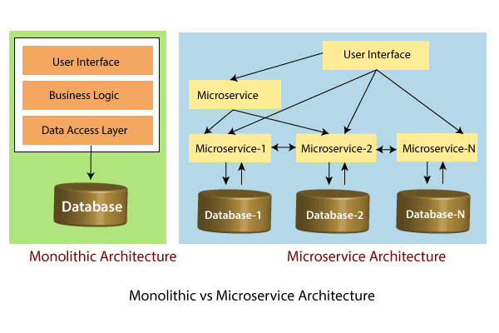
In the above figure, each microservice has its own business layer and database. If we change in one microservice, it does not affect the other services. These services communicate with each other by using lightweight protocols such as HTTP or REST or messaging protocols.

Principles of Microservices
There are the following principles of Microservices:
- Single Responsibility principle
- Modelled around business domain
- Isolate Failure
- Infrastructure automation
- Deploy independently

Single Responsibility Principle
The single responsibility principle states that a class or a module in a program should have only one responsibility. Any microservice cannot serve more than one responsibility, at a time.

Modeled around business domain
Microservice never restrict itself from accepting appropriate technology stack or database. The stack or database is most suitable for solving the business purpose.

Isolated Failure
The large application can remain mostly unaffected by the failure of a single module. It is possible that a service can fail at any time. So, it is important to detect failure quickly, if possible, automatically restore failure.

Infrastructure Automation
The infrastructure automation is the process of scripting environments. With the help of scripting environment, we can apply the same configuration to a single node or thousands of nodes. It is also known as configuration management, scripted infrastructures, and system configuration management.

Deploy independently
Microservices are platform agnostic. It means we can design and deploy them independently without affecting the other services.

Audience
Our microservices tutorial is designed for Software Professionals and beginners who want to learn microservices architecture in easy steps. This tutorial will give you an in-depth knowledge of microservices architecture and its components like RabbitMQ Server, Eureka Naming Server, Zuul API Gateway, Ribbon, Hystrix, and Zipkin Server. After completing this tutorial, you can develop microservices services with Spring Cloud.

Prerequisites
Before continuing with this tutorial, you should have a basic understanding of Java, Spring, and Spring Cloud Framework. Because we are going to develop microservices using Spring Cloud.

Problem
We assure you that you will not find any problem with the microservices tutorial. If there is any mistake, please post the problem in the contact form.

Advantages of Microservices
29 Aug 2024 | 1 min read
- Microservices are self-contained, independent deployment module.
- The cost of scaling is comparatively less than the monolithic architecture.
- Microservices are independently manageable services. It can enable more and more services as the need arises. It minimizes the impact on existing service.
- It is possible to change or upgrade each service individually rather than upgrading in the entire application.
- Microservices allows us to develop an application which is organic (an application which latterly upgrades by adding more functions or modules) in nature.
- It enables event streaming technology to enable easy integration in comparison to heavyweight interposes communication.
- Microservices follows the single responsibility principle.
- The demanding service can be deployed on multiple servers to enhance performance.
- Less dependency and easy to test.
- Dynamic scaling.
- Faster release cycle.

Disadvantages of Microservices
- Microservices has all the associated complexities of the distributed system.
- There is a higher chance of failure during communication between different services.
- Difficult to manage a large number of services.
- The developer needs to solve the problem, such as network latency and load balancing.
- Complex testing over a distributed environment.

Eureka Naming Server
11 Jan 2025 | 4 min read
In the previous section, we have configured the Ribbon and distributed the load between the two services. In this section, we will set up the Eureka naming Server.

Naming server
The naming server is a computer application that implements a network service for responding to queries against a directory service.

Eureka naming server
Eureka naming server is a REST-based server that is used in the AWS Cloud services for load balancing and failover of middle-tier services.
Eureka naming server is an application that holds information about all client service applications. Each microservice registers itself with the Eureka naming server. The naming server registers the client services with their port numbers and IP addresses. It is also known as Discovery Server. Eureka naming server comes with the bundle of Spring Cloud. It runs on the default port 8761. It also comes with a Java-based client component, the eureka client, which makes interactions with the service much easier.

The need of naming server
We have another load balancer application, which is known as AWS Cloud. Because of its inherent nature, server ups and down. There is no middle-tier load balancer. Eureka naming server fills the gap between the client and the middle tier load balancer.
Suppose that we want to start another instance of currency-exchange-service that is CurrencyExchangeService3 and launch it on port 8002. Here a question arises, will ribbon be able to distribute the load to it?
If the Ribbon wants to distribute the load to the new server, we need to add it to the configuration. Based on the load, we can increase or decrease the number of instances of the services.
In this section, we will be able to increase or decrease the number of instances dynamically.
If we keep on changing in the CurrencyCalulationService, based on how many CurrenyExchangeService are active right, then, it becomes very difficult to maintain.
The Eureka naming server comes into existence when we want to make maintenance easier. All the instances of all microservices will be register with the Eureka naming server. Whenever a new instance of a microservice comes up, it would register itself with the Eureka naming server. The registration of microservice with the naming server is called Service Registration.
Whenever a service wants to talk with another service, suppose CurrencyCalculationService wants to talk to the CurrencyExchangeService. The CurrencyCalculationService first talk with the Eureka naming server. The naming server provides the instances of CurrencyExchangeService that are currently running. The process of providing instances to other services is called Service Discovery.
Service registration and service discovery are the two important features of the naming server. In the next step, we will set up a Eureka naming server.

Setting up Eureka naming server
There are a lot of steps that are involved in setting up the Eureka naming server are as follows:
- Create a component for the Eureka naming server
- Update the CurrencyCalculationService to connect to the Eureka naming server
- Connect CurrencyExchangeService to the Eureka naming server
- Configure the Ribbon
Once the instances of currency-exchange-service are registered with the Eureka naming server, then we will use the Ribbon to find the detail from the naming server. Let’s follow the steps specified above:
Create a component for the Eureka naming server
Step 1: Open Spring Initializr https://start.spring.io.
Step 2: Provide the Group name. We have provided com.javatpoint.microservices.
Step 3: Provide the Artifact Id. We have provided netflix-eureka-naming-server.
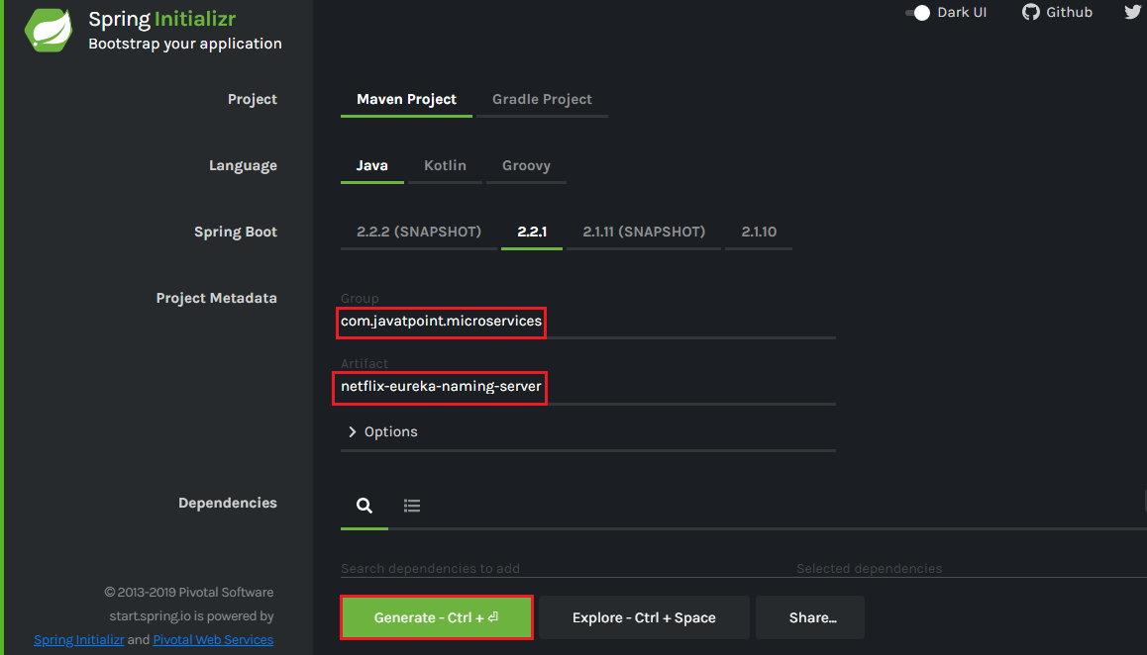
Step 4: Add the following dependencies: Eureka Server, Config Client, Actuator, and DevTools.
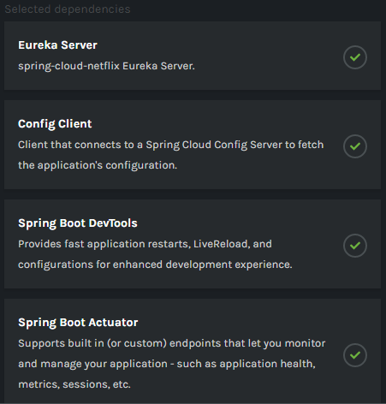
Step 5: Click on the Generate button. It downloads a zip file.
Step 6: Extract the zip file and paste the folder in the Spring Tool Suite (STS) workspace and then import it.
File -> Import -> Existing Maven Projects -> Next -> Browse -> Select the netflix-eureka-naming-server project -> Finish
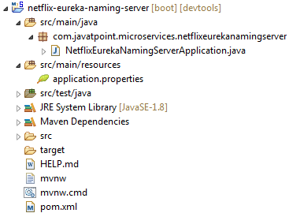
Step 7: Open the NetflixEurekaNamingServerApplication.java file and enable Eureka naming server by using an annotation @EnableEurekaServer.
NetflixEurekaNamingServerApplication.java
- package com.javatpoint.microservices.netflixeurekanamingserver;
- import org.springframework.boot.SpringApplication;
- import org.springframework.boot.autoconfigure.SpringBootApplication;
- import org.springframework.cloud.netflix.eureka.server.EnableEurekaServer;
- @SpringBootApplication
- @EnableEurekaServer
- public class NetflixEurekaNamingServerApplication
- {
- public static void main(String[] args) {
- SpringApplication.run(NetflixEurekaNamingServerApplication.class, args);
- }
- }
Step 8: Open the application.properties file and configure the application name, port, and eureka server.
- spring.application.name=netflix-eureka-naming-server
- server.port=8761
- eureka.client.register-with-eureka=false
- eureka.client.fetch-registry=false
Port 8761 is the default port for the Eureka naming server.
Step 9: Run the NetflixEurekaNamingServerApplication.java file as Java Application.
Step 10: Open the browser and type the URL http://localhost:8761. It shows the Eureka server UI.
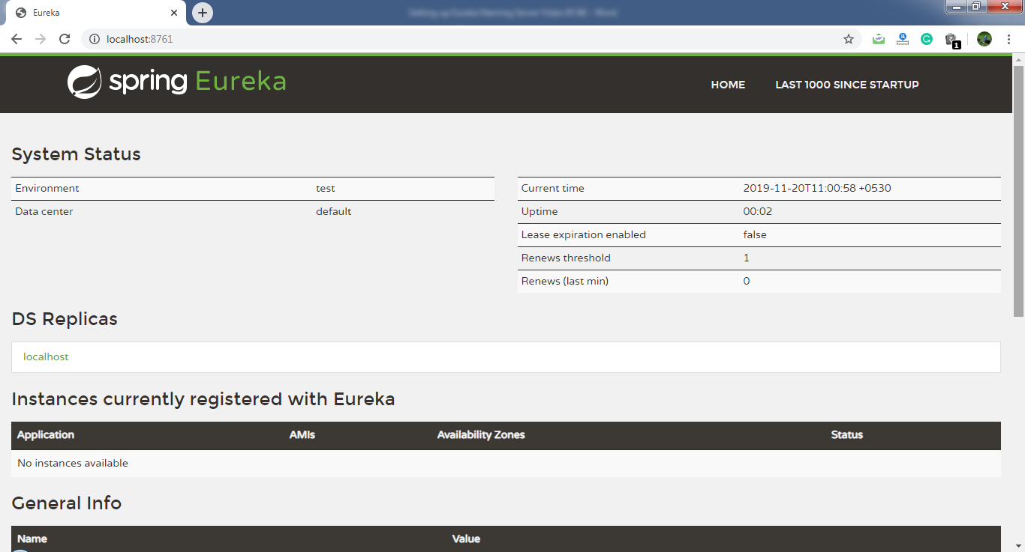
In this section, we have created a component Eureka naming server. In the next step, we will connect the microservices with the Eureka naming server.

Connecting Microservices to Eureka naming server
17 Mar 2025 | 2 min read
In this section, we will connect the currency-conversion-service and currency-exchange-service to the Eureka naming server.
First, we will connect the currency-conversion-service.
Step 1: Select the currency-conversion-service project.
Step 2: Open the pom.xml file and add the eureka-client dependency.
- <dependency>
- <groupId>org.springframework.cloud</groupId>
- <artifactId>spring-cloud-starter-netflix-eureka-client</artifactId>
- </dependency>
Step 3: Open CurrencyConversionServiceApplication.java file and enable discovery client by using the annotation @EnableDiscoveryClient.
CurrencyConversionServiceApplication.java
- package com.javatpoint.microservices.currencyconversionservice;
- import org.springframework.boot.SpringApplication;
- import org.springframework.boot.autoconfigure.SpringBootApplication;
- import org.springframework.cloud.client.discovery.EnableDiscoveryClient;
- import org.springframework.cloud.openfeign.EnableFeignClients;
- @SpringBootApplication
- @EnableFeignClients("com.javatpoint.microservices.currencyconversionservice")
- @EnableDiscoveryClient
- public class CurrencyConversionServiceApplication
- {
- public static void main(String[] args)
- {
- SpringApplication.run(CurrencyConversionServiceApplication.class, args);
- }
- }
After enabling the discovery client, configure the URL for the Eureka naming server.
Step 4: Open the application.properties file and configure the URL for the Eureka naming server.
application.properties
- spring.application.name=currency-conversion-service
- server.port=8100
- eureka.client.service-url.default-zone=http://localhost:8761/eureka
- currency-exchange-service.ribbon.listOfServers=http://localhost:8000, http://localhost:8001
If we look at the Eureka UI, we see that there is no instance registered with the Eureka server.
Step 5: Run the CurrencyConversionServiceApplication.java file.
Step 6: Open the browser and refresh the Eureka server page. It shows the instances of registered microservices.
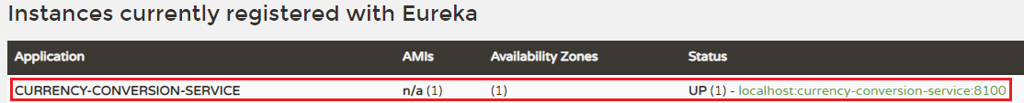
We see that an instance of currency-conversion-service is registered with the Eureka naming server, and running on port 8100.
Let's connect currency-exchange-service with Eureka naming server.
Step 1: Select the currency-exchange-service project.
Step 2: Open the pom.xml file and add the eureka-client dependency.
- <dependency>
- <groupId>org.springframework.cloud</groupId>
- <artifactId>spring-cloud-starter-netflix-eureka-client</artifactId>
- </dependency>
Step 3: Open CurrencyExchangeServiceApplication.java file and enable the discovery client by using the annotation @EnableDiscoveryClient.
CurrencyExchangeServiceApplication.java
- package com.javatpoint.microservices.currencyexchangeservice;
- import org.springframework.boot.SpringApplication;
- import org.springframework.boot.autoconfigure.SpringBootApplication;
- import org.springframework.cloud.client.discovery.EnableDiscoveryClient;
- @SpringBootApplication
- @EnableDiscoveryClient
- public class CurrencyExchangeServiceApplication
- {
- public static void main(String[] args)
- {
- SpringApplication.run(CurrencyExchangeServiceApplication.class, args);
- }
- }
Step 4: Open the application.properties file and configure the URL for Eureka naming server.
application.properties
- spring.application.name=currency-exchange-service
- server.port=8000
- spring.jpa.show-sql=true
- spring.h2.console.enabled=true
- spring.datasource.platform=h2
- spring.datasource.url=jdbc:h2:mem:javatpoint
- eureka.client.service-url.default-zone=http://localhost:8761/eureka
Step 5: Run the two instances of CurrencyExchangeServiceApplication.java. First instance on port 8000 and the second instance on port 8001.
Step 6: Open the browser and refresh the Eureka server. It shows the registered microservice.
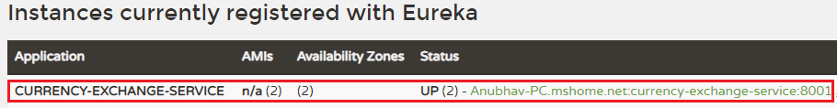
We see that the two instances of currency-exchange-service are registered with the Eureka naming server. The two instances are running on port 8001 and 8000.
In the following image, we can see that both the microservices has registered with the Eureka naming server.
