Click on <https://mobaxterm.mobatek.net/download-home-edition.html> to down load MobaXterm

You can down load any of the below editions.

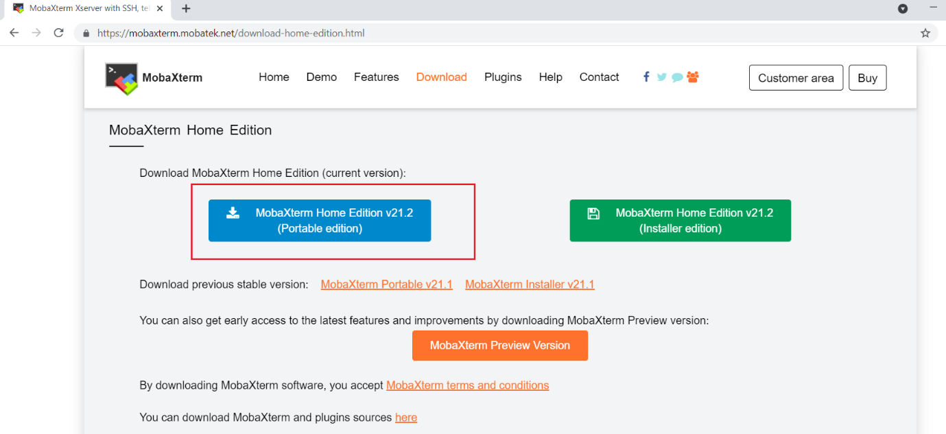

Once down load, then unzip the file and double click on it.

Click on **Session** ===> **SSH**===> Provide public IP/DNS Against to **Remote host**===> Specify user name as **ec2-user** (For Linux) ===> **Advanced SSH Settings**===> Check the box against to **Use private key** ===> Browse private key and click on **OK**.

