Go to AWS console ===> Peering Connections ===> Create Peering Connection ===>fill below details.

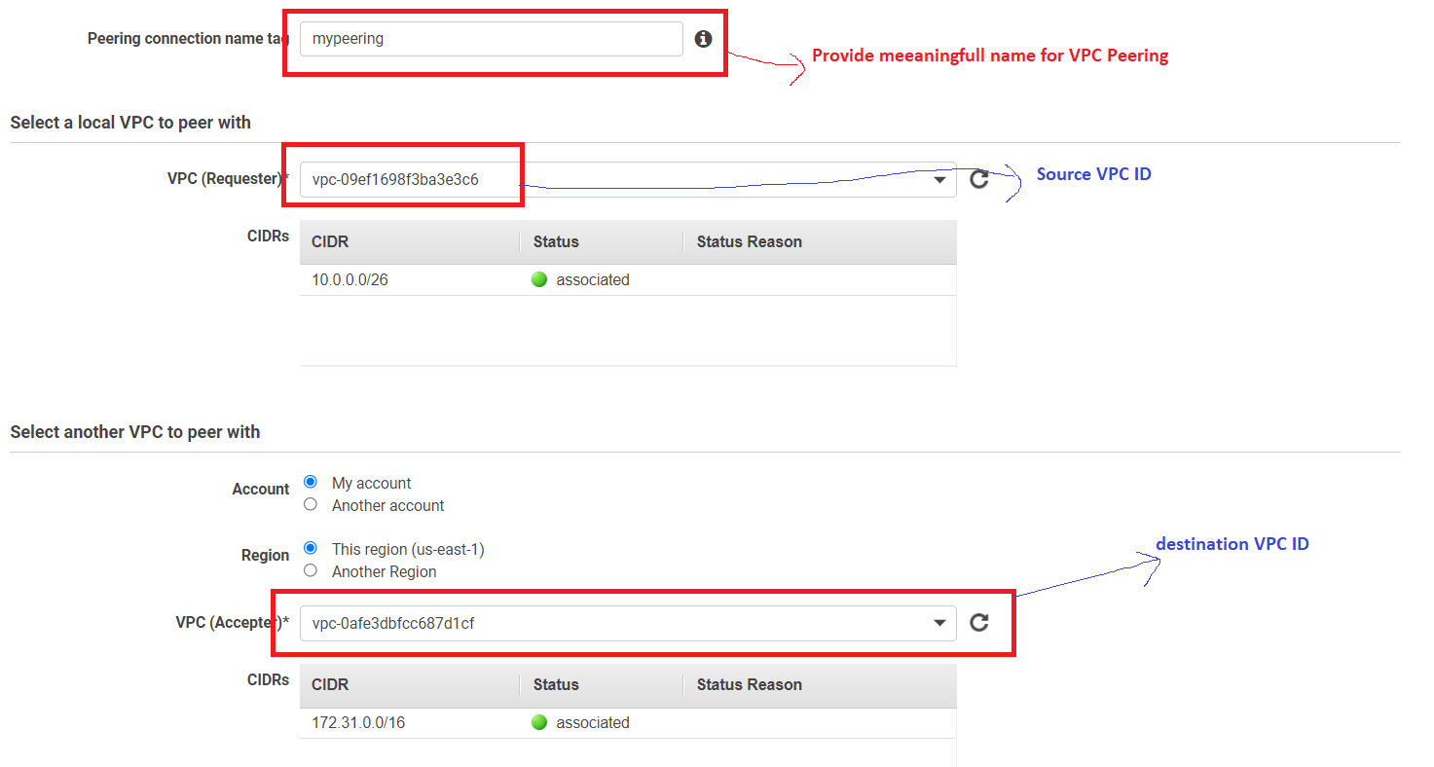

Click on **Create Peeing Connection**

**Note:** Traffic between VPsC will happens through Internet.

<https://docs.aws.amazon.com/vpc/latest/peering/vpc-peering-basics.html>

<https://docs.aws.amazon.com/vpc/latest/peering/invalid-peering-configurations.html>