Create the following tables for HMS(Hospital Management System):

The Doctor_master table contains information about doctors in the hospital.

DOCTOR_MASTER(doctor_id,doctor_name,dept)

|  |  |  |
| --- | --- | --- |
| Column Name | Data type & Data size | Description |
| doctor_id | Varchar(15) | doctorid must be unique and not null |
| doctor_name | Varchar(15) | Doctor name should be not null |
| Dept | Varchar(15) | Dept name should be not null |

Sample Data:

|  |  |  |
| --- | --- | --- |
| doctor_id | doctor_name | Dept |
| D0001 | Ram | ENT |
| D0002 | Rajan | ENT |
| D0003 | Smita | Eye |
| D0004 | Bhavan | Surgery’’ |
| D0005 | Sheela | Surgery |
| D0006 | Nethra | Surgery |

The room_master table contains information about room availability in the hospital.

|  |  |  |
| --- | --- | --- |
| Column Name | Data type & Data size | Description |
| room_no | Varchar(15) | roomno must be unique and not null |
| room_type | Varchar(15) | room type name should be not null |
| status | Varchar(15) | status name should be not null |

Sample Data:

|  |  |  |
| --- | --- | --- |
| room_no | room_type | status |
| R0001 | AC | occupied |
| R0002 | Suite | vacant |
| R0003 | NonAC | vacant |
| R0004 | NonAC | occupied |
| R0005 | AC | vacant |
| R0006 | AC | occupied |

The patient_master table contains information about patients in the hospital.

PATIENT_MASTER(pid, name,age,weight,gender,address,phoneno,disease,doctorid)

|  |  |  |
| --- | --- | --- |
| Column Name | Data type & Data size | Description |
| pid | Varchar(15) | pid must be unique and not null |
| name | Varchar(15) | name should be not null |
| age | number(15) | age should be not null |
| Weight | number(15) | weight should be not null |
| Gender | Varchar(10) | gender should be not null |
| Address | Varchar(50) | address should be not null |
| phoneno | varchar(10) | phoneno should be not null |
| Disease | Varchar(50) | disease should be not null |
| Doctor_id | Varchar(5) | Must be an existing doctor |

Sample Data:

|  |  |  |  |  |  |  |  |  |
| --- | --- | --- | --- | --- | --- | --- | --- | --- |
| pid | name | age | weight | gender | address | phoneno | disease | Doctor_id |
| P0001 | Gita | 35 | 65 | F | Chennai | 9867145678 | Eye Infection | D0003 |
| P0002 | Ashish | 40 | 70 | M | Delhi | 9845675678 | Asthma | D0003 |
| P0003 | Radha | 25 | 60 | F | Chennai | 9867166678 | Pain in heart | D0005 |
| P0004 | Chandra | 28 | 55 | F | Bangalore | 9978675567 | Asthma | D0001 |
| P0005 | Goyal | 42 | 65 | M | Delhi | 8967533223 | Pain in Stomach | D0004 |

The room_allocation table contains information about the allocation of room to the patients in the hospital.

ROOM_ALLOCATION(room_no, pid, admission_date,release_date)

|  |  |  |
| --- | --- | --- |
| Column Name | Data type & Data size | Description |
| room_no | Varchar(15) | Must be an existing rooms |
| pid | Varchar(15) | Must be an existing patients |
| admission_date | date | Admission date should be not null |
| Release_date | date |  |

Sample Data:

|  |  |  |  |
| --- | --- | --- | --- |
| room_no | pid | admission_date | Release_date |
| R0001 | P0001 | 15-oct-16 | 26-oct-16 |
| R0002 | P0002 | 15-nov-16 | 26-nov-16 |
| R0002 | P0003 | 01-dec-16 | 30-dec-16 |
| R0004 | P0001 | 01-jan-17 | 30-jan-17 |

NOTE:

You are supposed to fill in the given records in DOCTOR_MASTER, ROOM_MASTER, PATIENT_MASTER and ROOM_ALLOCATION tables following these rules:

1. Identify the primary key and foreign key (if applicable) in each table.
2. Take care of the constraints and the relationships among the tables.

# QUERIES

Query #1:Display the patients who were admitted in the month of january.



Query #2:Display the female patient who is not suffering from asthma

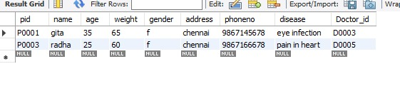

Query #3:Count the number of male and female patients.

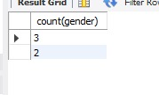

Query #4:Display the patient_id,patient_name, doctor_id, doctor_name, room_no, room_type and admission_date.

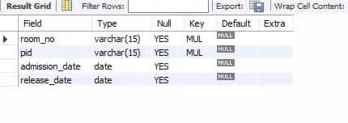

Query #5:Display the room_no which was never allocated to any patient.

select * from room_master;

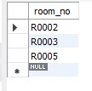

Query #6:Display the room_no, room_type which are allocated more than once.

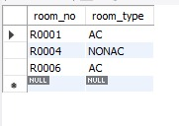

*PRIME For Internal Use Only Version 4.2*