WEEK-4
Write a JDBC program to perform CRUD operations on student database
Create a table Person with the following fields:
PersonIDint, FirstNamevarchar(255), City varchar(255)
Write a JDBC program to connect to the database for inserting data into the Person table using callable statement.
Write a JDBC program using prepared Statement to select the employee whose salary is greater than X.(consider x as random value)
Serial Number | Employee number | Employee name | Salary

CODE:
import java.sql.*;
public class EmployeeSalaryOutput {
public static void main(String[] args) {
String url = "jdbc:mysql://localhost:3306/testdb";
String user = "root";
String pass = "root";
double X = 30000;
try {
Class.forName("com.mysql.cj.jdbc.Driver");
Connection con = DriverManager.getConnection(url, user, pass);
String sql = "SELECT serial_no, emp_no, emp_name, salary FROM Employee WHERE salary > ?";
PreparedStatement ps = con.prepareStatement(sql);
ps.setDouble(1, X);
ResultSet rs = ps.executeQuery();
System.out.println("\n\t1. Employee With Salary Greater Than X\n");
System.out.println("\t(X = " + (int)X + ")\n");
System.out.printf("%-12s %-15s %-20s %-10s\n",
"Serial No", "Employee No", "Employee Name", "Salary");
while (rs.next()) {
System.out.printf("%-12d %-15d %-20s %-10.0f\n",
rs.getInt("serial_no"),
rs.getInt("emp_no"),
rs.getString("emp_name"),
rs.getDouble("salary"));
}
con.close();
} catch (Exception e) {
e.printStackTrace();
}
}
}
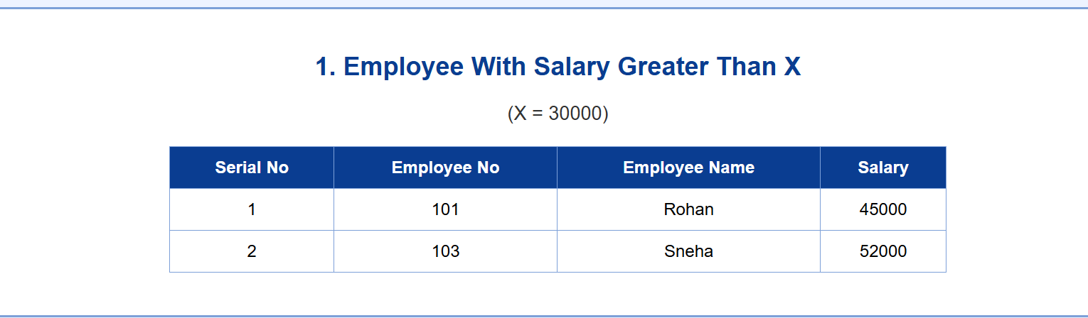
Create a Java Program to connect to database which contain the following table
Serial Number | Product number | Produce name | Price

CODE:
import java.sql.*;
public class ProductInsertDisplay {
static final String URL = "jdbc:mysql://localhost:3306/testdb";
static final String USER = "root";
static final String PASS = "root";
public static void main(String[] args) {
try {

Class.forName("com.mysql.cj.jdbc.Driver");
Connection con = DriverManager.getConnection(URL, USER, PASS);
System.out.println("\n2. Product Insert and Display (PreparedStatement)\n"); insertProduct(con, 1, 201, "Keyboard", 1200);
insertProduct(con, 2, 202, "Mouse", 700);
insertProduct(con, 3, 203, "Monitor", 8500);
System.out.println("Product inserted successfully.\n");
displayProducts(con);
con.close();
} catch (Exception e) {
e.printStackTrace();
}
}
static void insertProduct(Connection con, int serialNo, int productNo, String name, double price)
throws SQLException {
String sql = "INSERT INTO Product (serial_no, product_no, product_name, price) VALUES (?, ?, ?, ?)";
PreparedStatement ps = con.prepareStatement(sql);
ps.setInt(1, serialNo);
ps.setInt(2, productNo);
ps.setString(3, name);
ps.setDouble(4, price);
ps.executeUpdate();
ps.close();
}
static void displayProducts(Connection con) throws SQLException {
String sql = "SELECT * FROM Product";
PreparedStatement ps = con.prepareStatement(sql);
ResultSet rs = ps.executeQuery();
System.out.printf("%-12s %-12s %-20s %-10s\n",
"Serial No", "Product No", "Product Name", "Price");
while (rs.next()) {
System.out.printf("%-12d %-12d %-20s %-10.0f\n",
rs.getInt("serial_no"),
rs.getInt("product_no"),
rs.getString("product_name"),
rs.getDouble("price"));
}
rs.close();
ps.close();
}
}
import java.sql.*;
public class ProductInsertDisplay {
static final String URL = "jdbc:mysql://localhost:3306/testdb";
static final String USER = "root";
static final String PASS = "root";
public static void main(String[] args) {
try {
Class.forName("com.mysql.cj.jdbc.Driver");
Connection con = DriverManager.getConnection(URL, USER, PASS);
System.out.println("\n2. Product Insert and Display (PreparedStatement)\n");
insertProduct(con, 1, 201, "Keyboard", 1200);
insertProduct(con, 2, 202, "Mouse", 700);
insertProduct(con, 3, 203, "Monitor", 8500);
System.out.println("Product inserted successfully.\n");
displayProducts(con);
con.close();
} catch (Exception e) {
e.printStackTrace();
}
}
static void insertProduct(Connection con, int serialNo, int productNo, String name, double price)
throws SQLException {
String sql = "INSERT INTO Product (serial_no, product_no, product_name, price) VALUES (?, ?, ?, ?)";
PreparedStatement ps = con.prepareStatement(sql);
ps.setInt(1, serialNo);
ps.setInt(2, productNo);
ps.setString(3, name);
ps.setDouble(4, price);
ps.executeUpdate();
ps.close();
}
static void displayProducts(Connection con) throws SQLException {
String sql = "SELECT * FROM Product";
PreparedStatement ps = con.prepareStatement(sql);
ResultSet rs = ps.executeQuery();
System.out.printf("%-12s %-12s %-20s %-10s\n",
"Serial No", "Product No", "Product Name", "Price");
while (rs.next()) {
System.out.printf("%-12d %-12d %-20s %-10.0f\n",
rs.getInt("serial_no"),
rs.getInt("product_no"),
rs.getString("product_name"),
rs.getDouble("price"));
}
rs.close();
ps.close();
}
}
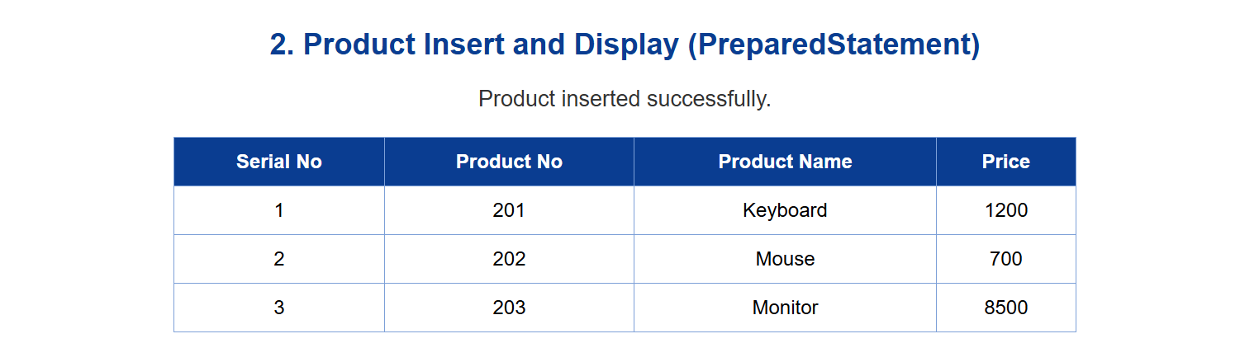
Write a program to insert the data and display all the contents of the table using Prepared Statement interface.

Create a table Person with the following fields
Deaprtment int,
Department name Namevarchar(255),
City varchar(255)
Write a JDBC program to connect to the database for deleting the department from the department table using callable statement.

Illustrate with a given table how to connect to a database and perform the CRUD operations with a Java Program
Serial Number | Book Number | Book name | Price

CODE:
import java.sql.*;
public class BookTableCRUDOutput {
static final String URL = "jdbc:mysql://localhost:3306/testdb";
static final String USER = "root";
static final String PASS = "root";
public static void main(String[] args) {
Connection con = null;
try {
Class.forName("com.mysql.cj.jdbc.Driver");
con = DriverManager.getConnection(URL, USER, PASS);
clearTable(con);
System.out.println("\n4. Book Table CRUD Operations Output\n");
insertBook(con, 1, 501, "Java", 450);
insertBook(con, 2, 502, "DBMS", 500);
System.out.println("After Insert:\n");
displayBooks(con);
System.out.println();
updateBookPriceByBookNo(con, 501, 550);
System.out.println("After Update (Price of Book No 501 changed):\n");
displayBooks(con);
System.out.println();
deleteBookByBookNo(con, 502);
System.out.println("After Delete (Book No 502 deleted):\n");
displayBooks(con);
System.out.println();
} catch (Exception e) {
e.printStackTrace();
} finally {
try { if (con != null) con.close(); } catch (Exception e) {}
}
}
static void clearTable(Connection con) throws SQLException {
String sql = "DELETE FROM Book";
PreparedStatement ps = con.prepareStatement(sql);
ps.executeUpdate();
ps.close();
}
static void insertBook(Connection con, int serialNo, int bookNo,
String name, double price) throws SQLException {
String sql = "INSERT INTO Book(serial_no, book_no, book_name, price) VALUES(?, ?, ?, ?)";
PreparedStatement ps = con.prepareStatement(sql);
ps.setInt(1, serialNo);
ps.setInt(2, bookNo);
ps.setString(3, name);
ps.setDouble(4, price);
ps.executeUpdate();
ps.close();
}
static void updateBookPriceByBookNo(Connection con, int bookNo, double newPrice)
throws SQLException {
String sql = "UPDATE Book SET price = ? WHERE book_no = ?";
PreparedStatement ps = con.prepareStatement(sql);
ps.setDouble(1, newPrice);
ps.setInt(2, bookNo);
ps.executeUpdate();
ps.close();
}
static void deleteBookByBookNo(Connection con, int bookNo) throws SQLException {
String sql = "DELETE FROM Book WHERE book_no = ?";
PreparedStatement ps = con.prepareStatement(sql);
ps.setInt(1, bookNo);
ps.executeUpdate();
ps.close();
}
static void displayBooks(Connection con) throws SQLException {
String sql = "SELECT serial_no, book_no, book_name, price FROM Book ORDER BY serial_no";
PreparedStatement ps = con.prepareStatement(sql);
ResultSet rs = ps.executeQuery();
System.out.printf("%-10s %-10s %-15s %-10s%n",
"Serial No", "Book No", "Book Name", "Price");

while (rs.next()) {
System.out.printf("%-10d %-10d %-15s %-10.0f%n",
rs.getInt("serial_no"),
rs.getInt("book_no"),
rs.getString("book_name"),
rs.getDouble("price"));
}
rs.close();
ps.close();
}
}
