WEEK-6
HTTP Servlet

AIM: To create a HttpServlet that handles GET requests and displays "Hello" on a web browser using doGet() method.

import java.io.IOException;
import java.io.PrintWriter;
import javax.servlet.ServletException;
import javax.servlet.http.HttpServlet;
import javax.servlet.http.HttpServletRequest;
import javax.servlet.http.HttpServletResponse;
public class Hello extends HttpServlet {
@Override
protected void doGet(HttpServletRequest request, HttpServletResponse response)
throws ServletException, IOException {
// Set content type
response.setContentType("text/html");
// Print "Hello"
PrintWriter out = response.getWriter();
out.println("<h1>Hello</h1>");
}
}
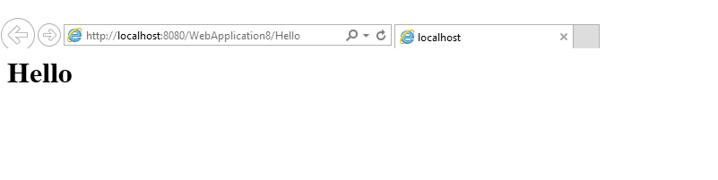
Generic Servlet

AIM : To create a GenericServlet that handles all types of requests using the service() method and prints "Hello from GenericServlet" on a webpage.

Source Code:
import java.io.IOException;
import java.io.PrintWriter;
import javax.servlet.GenericServlet;
import javax.servlet.ServletException;
import javax.servlet.ServletRequest;
import javax.servlet.ServletResponse;
public class Genric_servlet extends GenericServlet {
@Override
public void service(ServletRequest request, ServletResponse response)
throws ServletException, IOException {
response.setContentType("text/html");
// Print "Hello"
PrintWriter out = response.getWriter();
out.println("<h1>Hello from GenericServlet</h1>");
}
}
OUTPUT:
