**Steps to Run**

1. Prerequisite: **JDK 1.8+, Maven 3+.**
2. Download/Clone “[ChangeLogLevelAtRunTime](https://github.com/prasantakumar83/ChangeLogLevelAtRunTime)” project from below location.

<https://github.com/prasantakumar83/ChangeLogLevelAtRunTime.git>

1. Open Command Prompt and Go to “[ChangeLogLevelAtRunTime](https://github.com/prasantakumar83/ChangeLogLevelAtRunTime)e” folder as below.

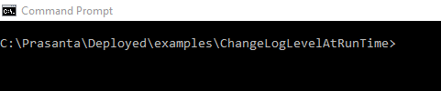

1. Run mvn clean install which will create jar file

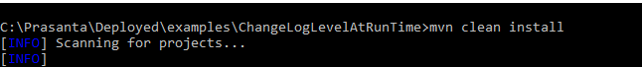

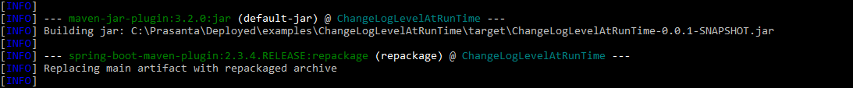

1. Run java -jar target\ChangeLogLevelAtRunTime-0.0.1-SNAPSHOT.jar that will start the server.



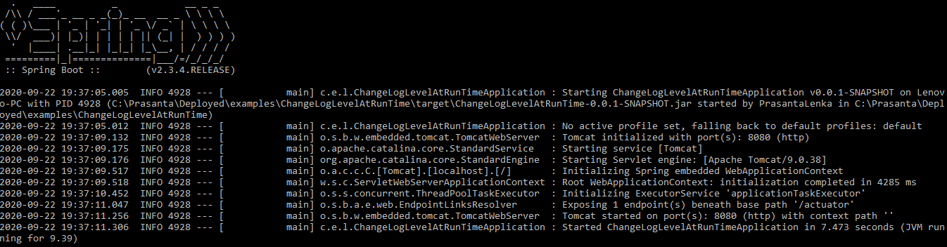

1. Go to Postman to check default log level ‘INFO’.

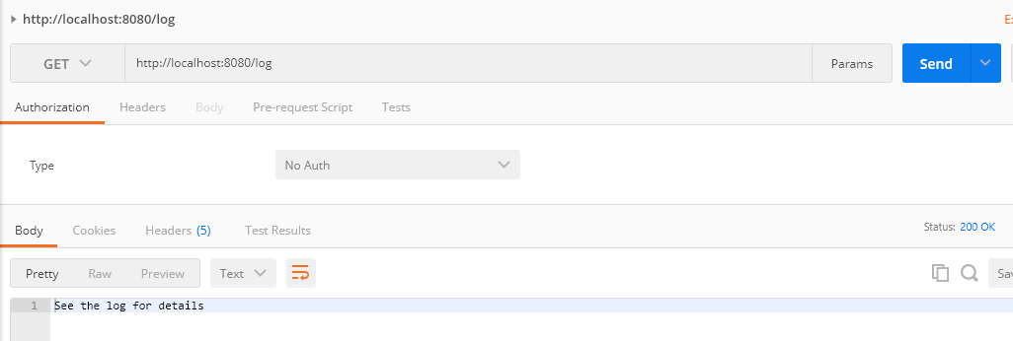

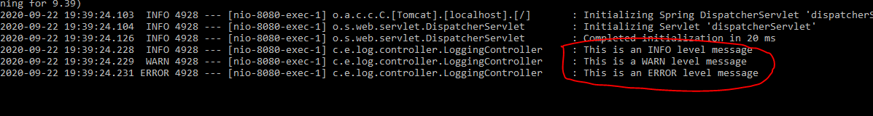

1. Here is how to change log level at run time.

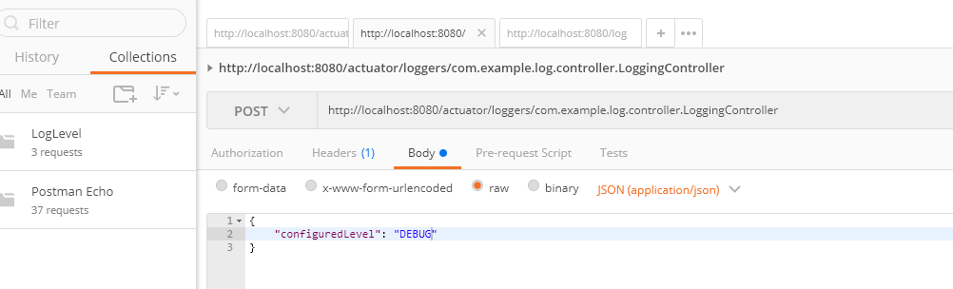

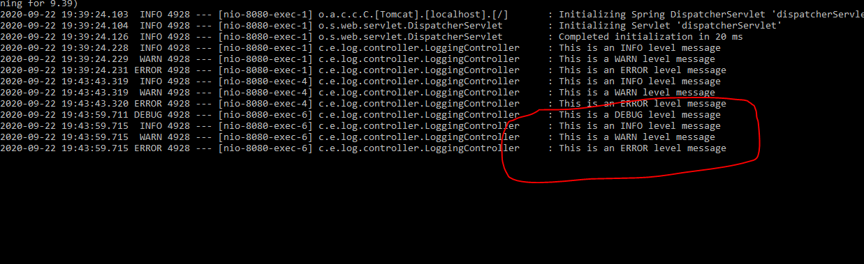

**Note**:

* + 1. Any editor can be used to import and run code instead of command line.
    2. Please note that postman end point collection([LogLevel.postman\_collection.json](https://github.com/prasantakumar83/ChangeLogLevelAtRunTime/blob/master/LogLevel.postman_collection.json" \o "LogLevel.postman_collection.json)) added in project but feel free to use Curl instead.

Refer below link for more details

<https://www.baeldung.com/spring-boot-changing-log-level-at-runtime>