**Steps for Java Services**

There are three services as part of “CitizenRepositoryService” as below.

GET /view-all-citizen

DELETE /delete-citizen/{id}

POST /add-citizen

1. Prerequisite: **JDK 1.8+, Maven 3+.**
2. Download/Clone “CitizenRepositoryService” project from below location.

<https://github.com/prasantakumar83/CitizenRepositoryService.git>

1. Open Command Prompt and Go to “CitizenRepositoryService” folder as below.

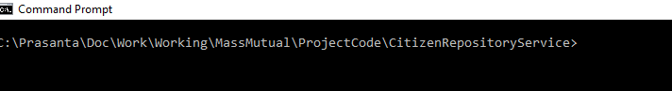

1. Run mvn clean install which will create jar file



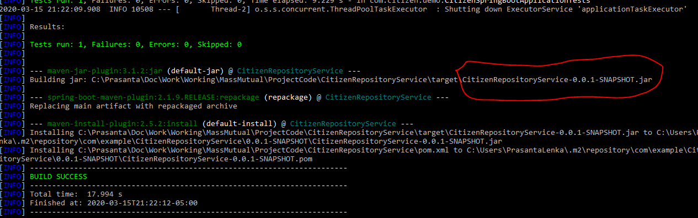

1. Run java -jar target\CitizenRepositoryService-0.0.1-SNAPSHOT.jar that will start the server.



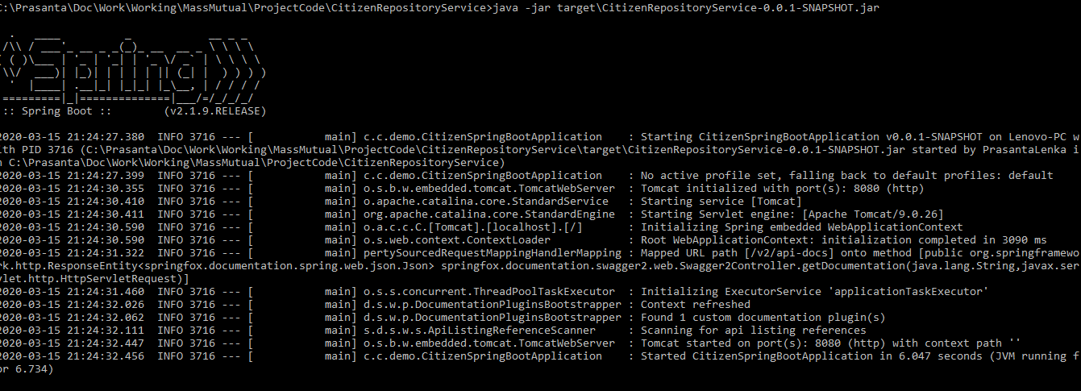

1. Go to Swagger to check all services and can be try out.

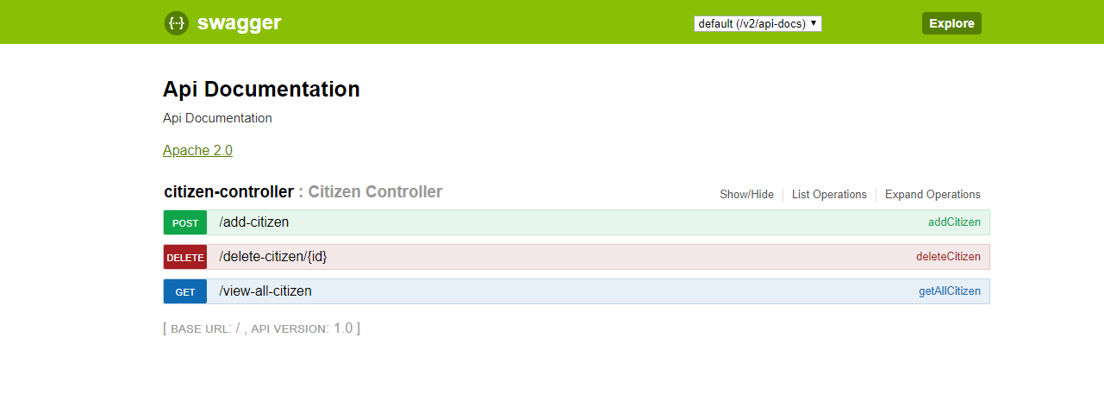

1. To check “GET /view-all-citizen”, click try it out button to display all citizen details

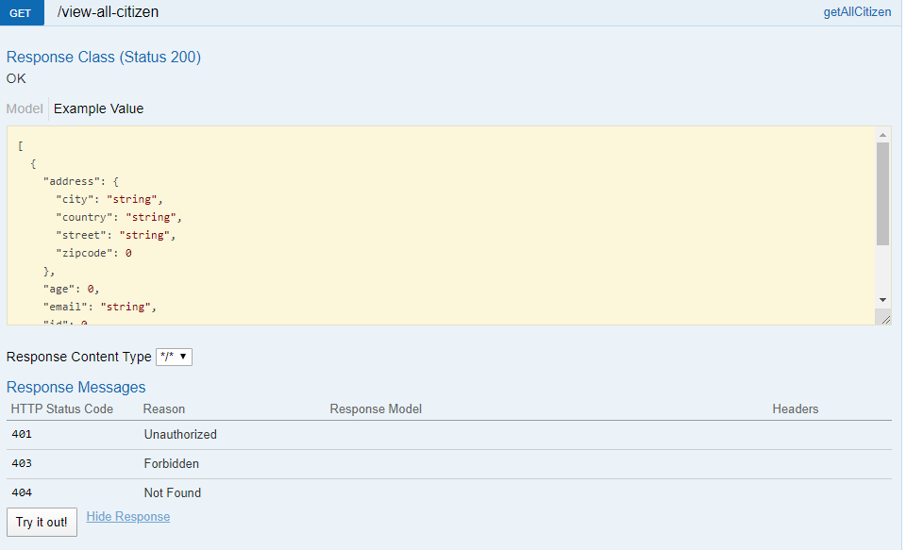

1. To check “POST /add-citizen”, enter below citizen details and click try it out button to add successfully. Need to give unique Ids.

Request: {

"id" : 109,

"name" : *"Prasanta Kumar Lenka"*,

"email" : *"aa@example.com"*,

"phone" : *"+49 176 14890478"*,

"age" : 35,

"address" : {

"street" : *"Yorckstr. 75"*,

"city" : *"Berlin"*,

"zipcode" : 10965,

"country" : *"Germany"*

}

}

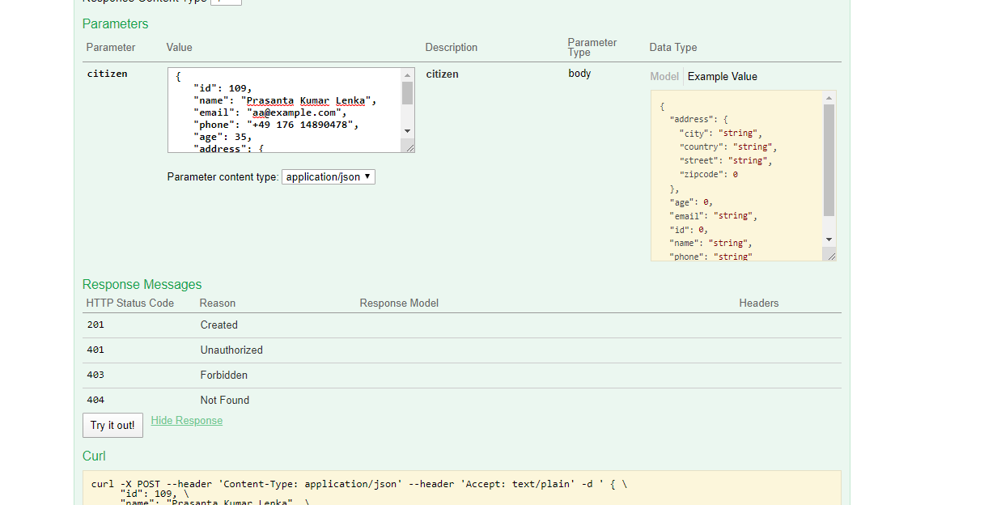

1. To check “DELETE /delete-citizen/{id}”, enter id need to be delete and click try it out button to delete successfully.

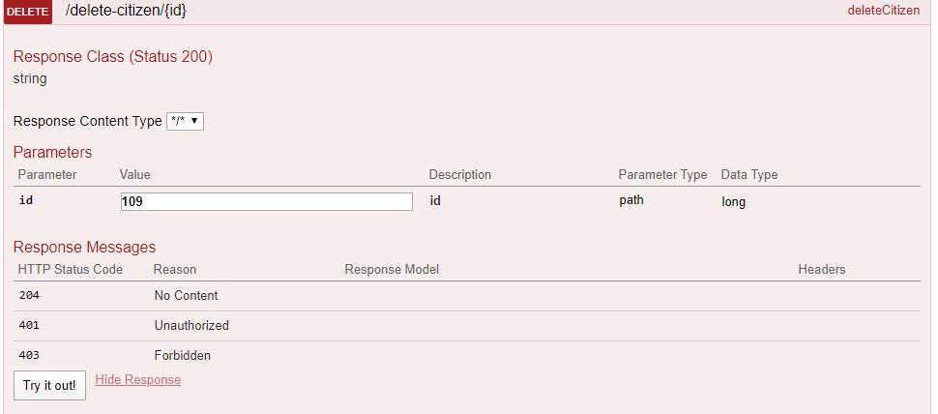

**Note**: Please note that as part of this exercise I am using json file to store data and every add/delete it clean the json file and upload again which can be a constrain and may not happen in real time.

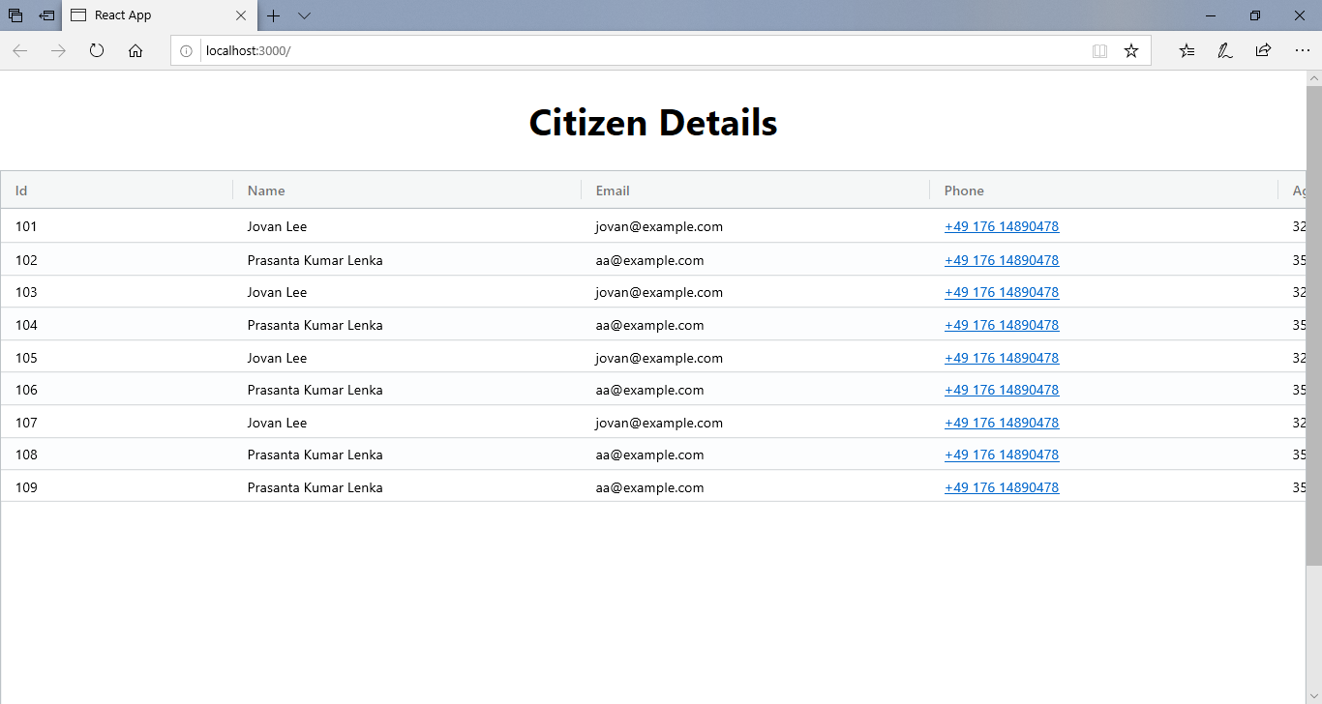

**Note**: Due to time constraints, only one service (GET /view-all-citizen) has been integrated.