**Steps for UI(ReactJS)**

1. Prerequisite: **NodeJS**

**All java services should be up and running.**

1. Download/Clone project “citizen-repository” from below location.

<https://github.com/prasantakumar83/citizen-repository.git>

1. Open Command Prompt and Go to “citizen-repository” folder as below.

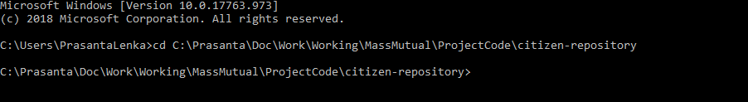

1. Run npm install to download all dependency.

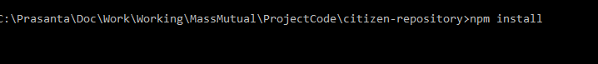



1. Run npm start to start server to display UI.



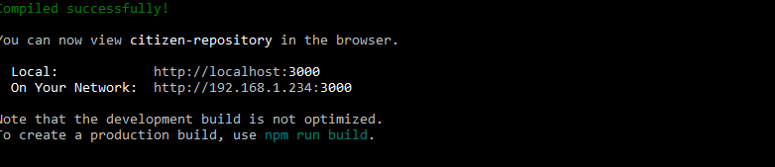

1. Open browser and go to <http://localhost:3000/>

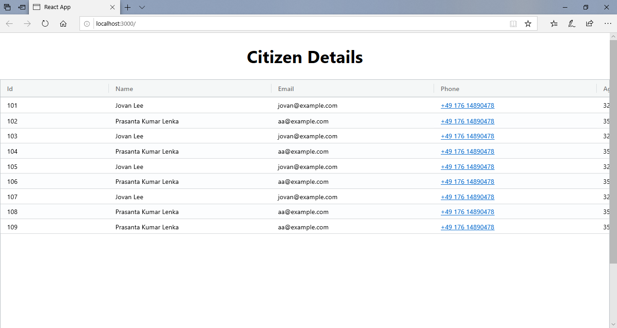

**Note**: Due to time constraints, only one service (GET /view-all-citizen) has been integrated.