DC/DQ Frame work

**Initial Setup:**

1. To have a entry in the "Table " dropdown , we would need to insert table name in "rev_table_class_assignment" table with table_classification_cd as 340

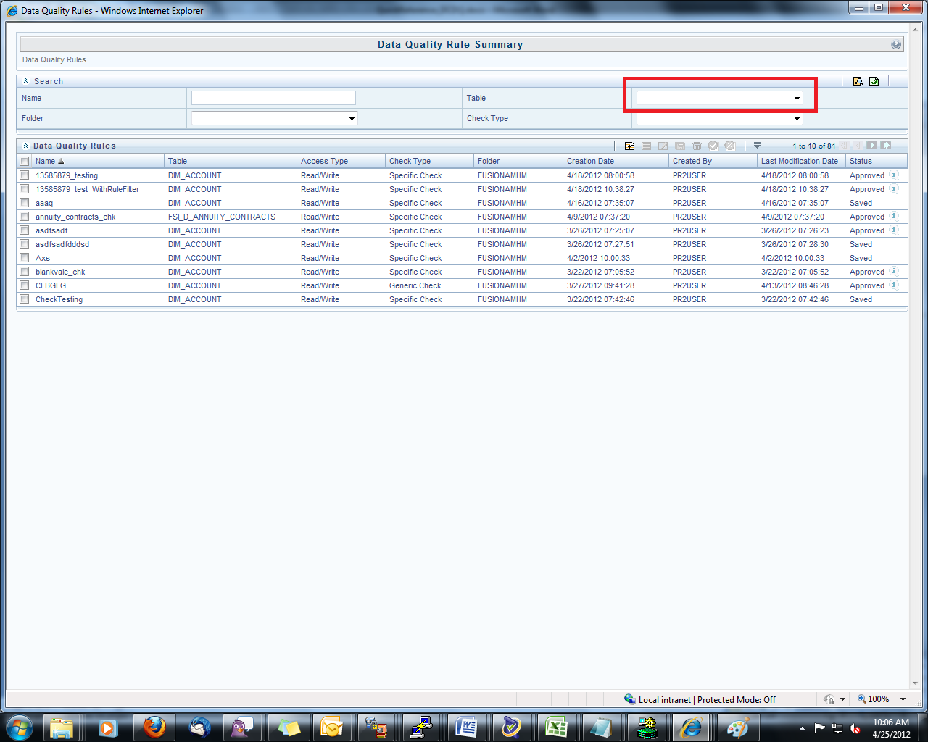

Database :

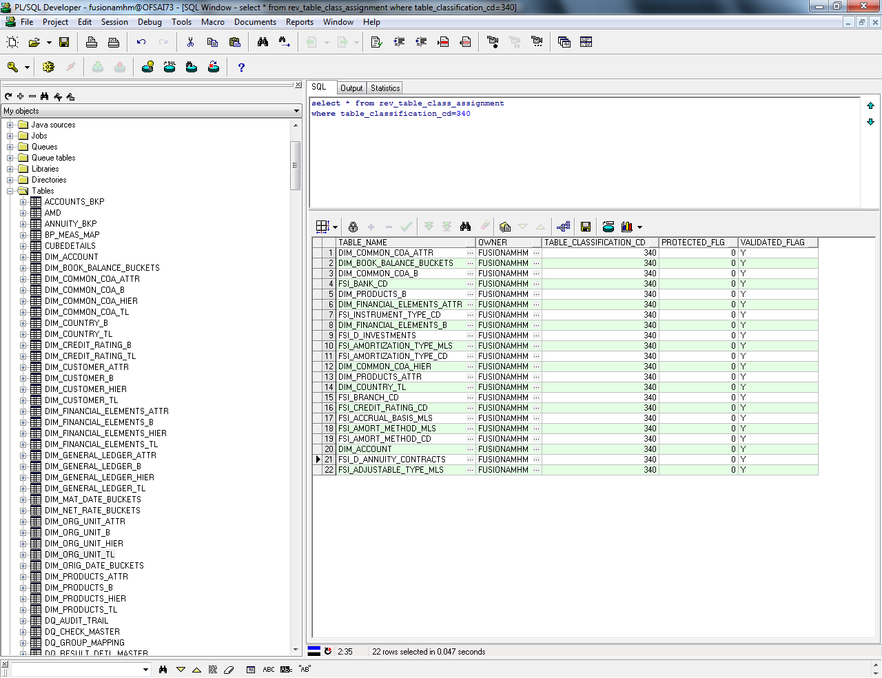

In case of any Referential integrity issue, please make a entry of the table in these Tables as well.

**select** * **from** rev_tables_b

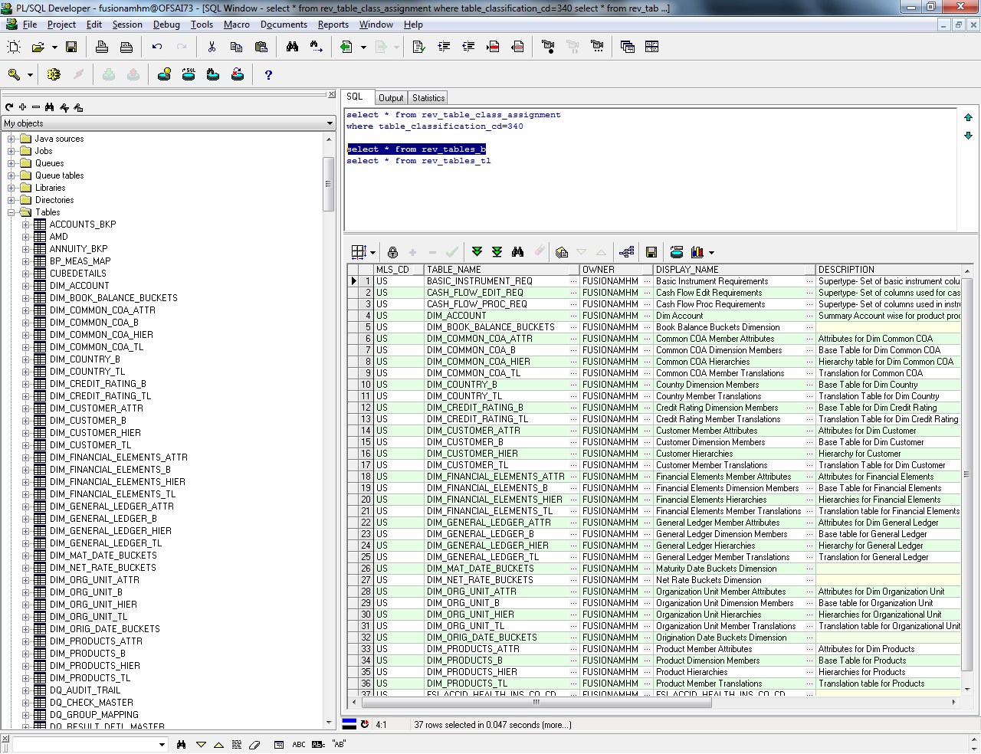

Also, add a entry in rev_tables_tl table as well.

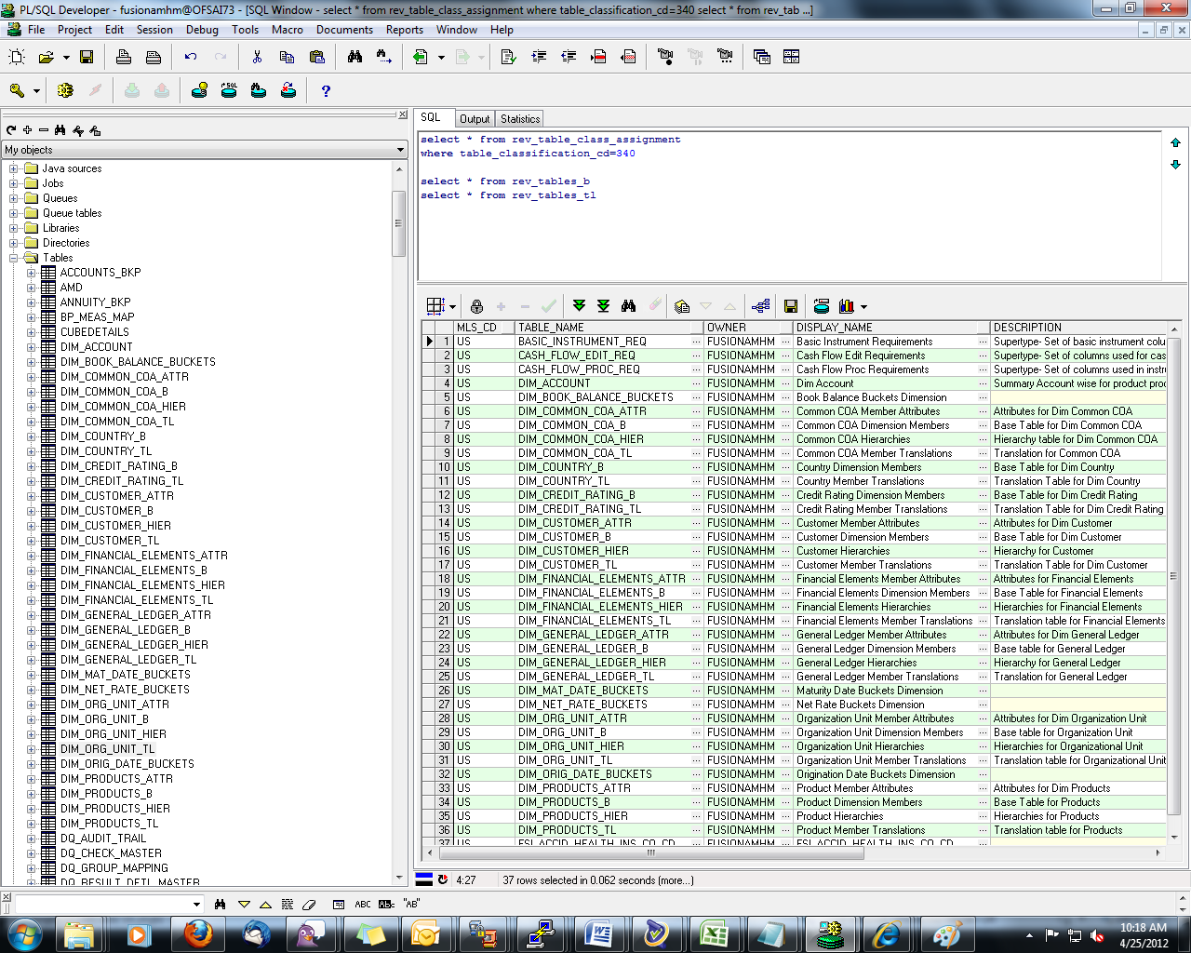

**select** * **from** rev_tab_columns_mls;  
**select** * **from** rev_tab_columns ;

we would need to add all the columns of the table which we are going to add newly to the above tables as well.

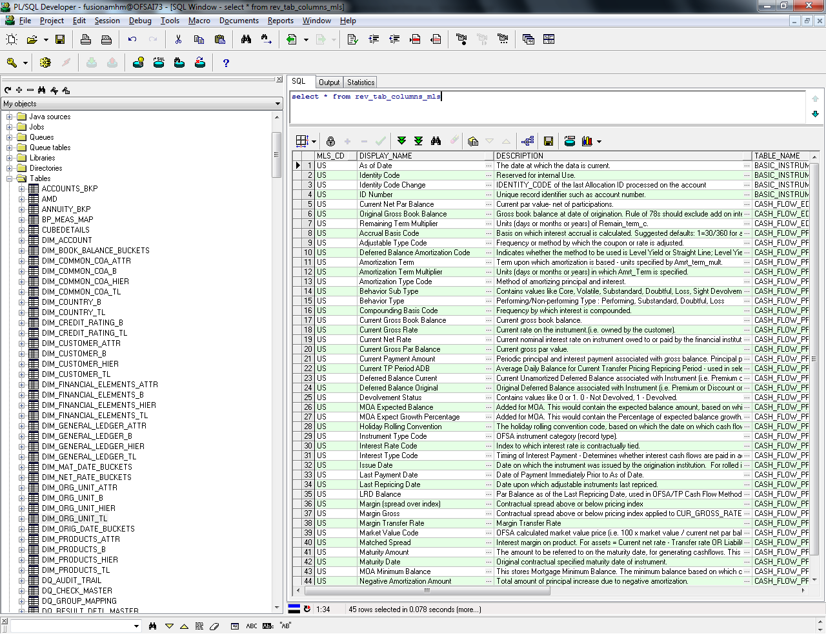

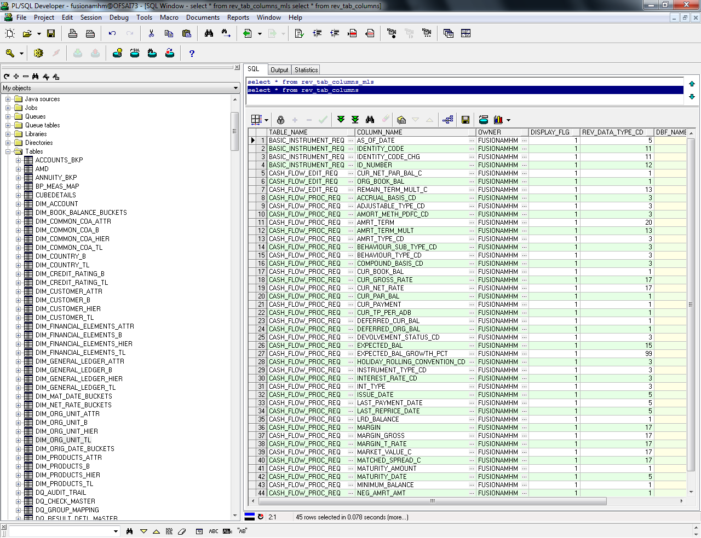

INSERT INTO atom012.rev_tables_b SELECT * FROM dqinfo.rev_tables_b

INSERT INTO atom012.rev_tables_tl SELECT * FROM dqinfo.rev_tables_tl

INSERT INTO atom012.rev_tab_columns_mls SELECT * FROM dqinfo.rev_tab_columns_mls

INSERT INTO atom012.rev_tab_columns SELECT * FROM dqinfo.rev_tab_columns

INSERT INTO atom012.rev_table_class_assignment SELECT * FROM dqinfo.rev_table_class_assignment

**DCDQ Tables**

|  |
| --- |
| **When we create Rule and Group** |
| **Table Name** |
| dq_group_mappings |
|  |
| **For specific check:(before execution)** |
| **Table Name** |
| dq_check_master |
| rev_dq_assignments |
|  |
| **For generic check:(before execution)** |
| **Table Name** |
| dq_check_master |
| rev_dq_conditions |
| rev_dq_assignments |
|  |
| **Tables to check after exeuction** |
| dq_audit_trail |
| dq_result_summ_master |
| dq_result_detail_master |
| **Messages tables:**  REV_DATA_ASSIGNMENTS_MSG_MLS  REV_DATA_ASSIGNMENTS_MSG_CD |
| **Example SQLs** |
| SELECT * FROM dq_group_mapping |
| SELECT * FROM dq_check_master where v_dq_check_id = 'paramtest1_rule' |
| SELECT * FROM rev_dq_assignments WHERE N_CONDTION_SYS_ID_NUM = '201707' |
| SELECT * FROM dq_audit_trail WHERE v_execution_identifier = 'FUSIONAMHM_paramtest_group_DQBATCH_1' |
| SELECT * FROM dq_result_summ_master WHERE v_batch_id = 'FUSIONAMHM_paramtest_group_DQBATCH_1' |
| SELECT * FROM dq_result_detl_master WHERE v_batch_id = 'FUSIONAMHM_paramtest_group_DQBATCH_1' |
| rev_table_class_assignments(table_classification_cd=340) |

-------------

**Code and leaf population method.**

Code and/or  Leaf members can be populated at two stages :-

1. Specific Check
   1. List of Value/Code Check – we need to select Input Value has Code
   2. Assignment Type has Code
2. Generic Check
   1. Assignment Type has Code

Steps to populate Code/Leaf in DQ Definition Screen :-

1. DataType for Code is 3 and Leaf is 10
   1. SELECT ODT.REV_DATA_TYPE,ODT.REV_DATA_TYPE_CD FROM FSI_DATA_TYPE_DESC ODT
2. To identify which all DQ tables have Code and leaf
   1. SELECT TABLE_NAME FROM REV_TABLE_CLASS_ASSIGNMENT WHERE TABLE_NAME IN(SELECT DISTINCT TABLE_NAME FROM REV_TAB_COLUMNS WHERE REV_DATA_TYPE_CD IN (3,10) ) AND TABLE_CLASSIFICATION_CD=340

Eg:- 'FSI_D_ANNUITY_CONTRACTS’ table is obtained

1. For the obtained DQ tables from point 2, we get the columns which are having code/leaf
   1. SELECT TABLE_NAME,COLUMN_NAME,REV_DATA_TYPE_CD FROM REV_TAB_COLUMNS WHERE REV_DATA_TYPE_CD IN (3,10) AND TABLE_NAME IN ('FSI_D_ANNUITY_CONTRACTS')

Eg:-

|  |  |  |
| --- | --- | --- |
| TABLE_NAME | COLUMN_NAME | REV_DATA_TYPE_CD |
| FSI_D_ANNUITY_CONTRACTS | BEHAVIOUR_SUB_TYPE_CD | 3 |
| FSI_D_ANNUITY_CONTRACTS | BEHAVIOUR_TYPE_CD | 3 |
| FSI_D_ANNUITY_CONTRACTS | COMMON_COA_ID | 10 |

1. For Codes following queries are fired:-

            Say I have choose base Table = 'FSI_D_ANNUITY_CONTRACTS' and base Column = 'BEHAVIOUR_SUB_TYPE_CD'

* 1. SELECT MEMBER_BASE_TABLE_NAME B,DESCRIPTION_TABLE_NAME T1,DESCRIPTION_JOIN_COLUMN_NAME JOINING_COL,VALUES_COLUMN_NAME CODE_VALUES_FROM

FROM **REV_DESCRIPTION_TABLES**  WHERE COLUMN_NAME ='BEHAVIOUR_SUB_TYPE_CD' AND TABLE_NAME    ='FSI_D_ANNUITY_CONTRACTS'

|  |  |  |  |
| --- | --- | --- | --- |
| B | TL | JOINING_COL | CODE_VALUES_FROM |
| FSI_BEHAVIOUR_SUB_TYPE_CD | FSI_BEHAVIOUR_SUB_TYPE_MLS | BEHAVIOUR_SUB_TYPE_CD | BEHAVIOUR_SUB_TYPE_DESC |

* 1. Dynamic Query is built based on the output of 4.a query. This provides us the Code list.

SELECT B.BEHAVIOUR_SUB_TYPE_CD CODE, TL.BEHAVIOUR_SUB_TYPE_DESC CODE_VALUES FROM FSI_BEHAVIOUR_SUB_TYPE_CD B,  FSI_BEHAVIOUR_SUB_TYPE_MLS TL

WHERE B.BEHAVIOUR_SUB_TYPE_CD = TL.BEHAVIOUR_SUB_TYPE_CD

|  |  |
| --- | --- |
| CODE | CODE_VALUES |
| 101 | Core |
| 102 | Volatile |
| 201 | Substandard |
| 202 | Doubtful |
| 203 | Loss |
| 301 | Sight Devolvement |
| 302 | Sight Recovery |
| 303 | Usance Devolvement |
| 304 | Usance Recovery |
| 305 | Usance |
| 306 | Sight |

1. For Leaf ,following queries are fired:-

Say I have choose base Table = 'FSI_D_ANNUITY_CONTRACTS' and base Column =’COMMON_COA_ID’

* 1. Need to identify the dimension member for the selected base column

SELECT B.DIMENSION_ID, TL.DIMENSION_NAME FROM **REV_DIMENSIONS_B** B, REV_DIMENSIONS_TL TL WHERE B.MEMBER_COL = 'COMMON_COA_ID' AND B.DIMENSION_ID = TL.DIMENSION_ID AND B.DEFINITION_LANGUAGE = 'US'

|  |  |
| --- | --- |
| DIMENSION_ID | DIMENSION_NAME |
| 3 | Common Chart of Accounts |

* 1. For this dimension , what the joining tables where we can query the leaf

SELECT MEMBER_B_TABLE_NAME B, MEMBER_TL_TABLE_NAME TL, MEMBER_COL JOINING_COL, MEMBER_DISPLAY_CODE_COL LEAF_CODE, MEMBER_NAME_COL LEAF_VALUES_FROM FROM **REV_DIMENSIONS_B** WHERE DIMENSION_ID = 3

|  |  |  |  |  |
| --- | --- | --- | --- | --- |
| B | TL | JOINING_COL | LEAF_CODE | LEAF_VALUES_FROM |
| DIM_COMMON_COA_B | DIM_COMMON_COA_TL | COMMON_COA_ID | COMMON_COA_DISPLAY_CODE | COMMON_COA_NAME |

* 1. Dynamic Query is built based on the output of 5.b query. This provides us the Leaf list.

SELECT B.COMMON_COA_DISPLAY_CODE LEAF_CODE, TL.COMMON_COA_NAME LEAF_VALUES FROM DIM_COMMON_COA_B B,  DIM_COMMON_COA_TL TL

WHERE B.COMMON_COA_ID = TL.COMMON_COA_ID

AND TL.LANGUAGE = 'US'

AND B.LEAF_ONLY_FLAG ='Y'

ORDER BY TL.COMMON_COA_NAME

|  |  |
| --- | --- |
| LEAF_CODE | LEAF_VALUES |
| 502 | AMUM_MEM5 |
| 503 | AMUM_MEM6 |
| 504 | AMUM_MEM7 |
| 506 | AMUM_MEM77 |
| 505 | AMUM_MEM8 |
| 513 | Return Value 1 |
| 511 | Return& |
| 515 | dfdsfffg |
| 104 | ewrwe1 |
| 101 | ewrwe1234 |
| 105 | key_num_01_leaf |
| 7 | mem/0101 |
| 79 | mem/01013423sdfdgrt |
| 78 | mem/0101gfdg7869876 |

Custom Check SQL

select PK_NAMES,PK_1,PK_2,PK_3,PK_4,PK_5,PK_6,ERROR_COLUMN from

(SELECT NULL PK_NAMES, NULL PK_1,NULL PK_2,NULL PK_3,NULL PK_4,

ACCOUNT_NUMBER PK_5, ACCOUNT_GROUP_CD PK_6, CASE WHEN

ACCOUNT_GROUP_CD IS NULL AND ACCOUNT_NUMBER IS NOT NULL

THEN 1 ELSE 0 END ERROR_COLUMN FROM FSI_D_INVESTMENTS)