1. Certificate
This is to certify that the project report entitled “Stock Price Prediction Using Artificial Neural Network” is a bonafide work carried out by the student as part of the academic requirements of the M.Sc. Artificial Intelligence and Machine Learning programme at Coimbatore Institute of Technology.
The project demonstrates the application of Artificial Neural Networks and machine learning techniques for predicting stock closing prices using historical financial market data.
Project Guide | Head of the Department
Signature: | Signature:
Date: | Date:

2. Declaration
I hereby declare that the project entitled “Stock Price Prediction Using Artificial Neural Network” is my original academic work carried out as part of the requirements of the M.Sc. Artificial Intelligence and Machine Learning programme.
The work presented in this report is based on the implementation, experimentation, evaluation, and analysis of an Artificial Neural Network model for stock price prediction.
Signature: ____________________ Date: ____________________

3. Acknowledgement
I express my sincere gratitude to the management and faculty members of Coimbatore Institute of Technology for providing the necessary facilities and academic support to complete this project.
I thank my project guide and faculty members for their valuable guidance, suggestions, and encouragement throughout the development of the project.
I also thank my friends and classmates for their support during implementation, testing, and documentation.
Finally, I express my gratitude to everyone who contributed directly or indirectly to the successful completion of this project.

4. Abstract
Stock market prediction is a challenging machine learning problem because stock prices are influenced by several factors, including historical price movements, trading volume, market conditions, investor behaviour, and unexpected events.
This project presents an Artificial Neural Network (ANN)-based stock price prediction system that uses historical stock market data to predict the next day’s closing price. The system uses historical features such as Open, High, Low, Close, Volume, and the previous day’s closing price.
The data is first cleaned, transformed, chronologically sorted, and normalized using MinMaxScaler. An 80:20 chronological train-test split is used to preserve the temporal nature of financial data. An ANN consisting of multiple dense layers with ReLU activation is trained using the Adam optimizer and Mean Squared Error loss function.
The ANN model is evaluated using Mean Absolute Error (MAE), Mean Squared Error (MSE), Root Mean Squared Error (RMSE), and R² score. Linear Regression and Random Forest Regression are also implemented as baseline models for comparison.
A Streamlit-based interactive dashboard is developed to visualize historical stock prices, trading volume, model architecture, actual versus predicted prices, training loss, and model comparison.
The system demonstrates how artificial neural networks can be applied to financial time-series prediction while highlighting the limitations and uncertainty involved in stock market forecasting.
Keywords: Stock Price Prediction, Artificial Neural Network, Regression, Time Series, Streamlit, Keras

5. Table of Contents
No. | Chapter | No. | Chapter
1 | Certificate | 25 | Data Leakage Prevention
2 | Declaration | 26 | Importance of Chronological Splitting
3 | Acknowledgement | 27 | Evaluation Metrics
4 | Abstract | 28 | Results
5 | Table of Contents | 29 | Visualization and Graph Analysis
6 | Introduction | 30 | Discussion
7 | Problem Statement | 31 | Overfitting and Underfitting
8 | Objectives | 32 | Error Analysis
9 | Scope of the Project | 33 | Streamlit Application
10 | Literature Survey | 34 | Software Modules
11 | Existing System | 35 | Project Directory Structure
12 | Proposed System | 36 | Testing
13 | System Requirements | 37 | Test Cases
14 | Dataset Description | 38 | Advantages
15 | Data Preprocessing | 39 | Limitations
16 | Feature Engineering | 40 | Future Enhancements
17 | Methodology | 41 | Ethical and Responsible Use
18 | System Architecture | 42 | Performance Considerations
19 | ANN Architecture | 43 | Reproducibility Steps
20 | ANN Hyperparameters | 44 | Application Execution
21 | Baseline Models | 45 | Output Files
22 | Random Forest Regression | 46 | Conclusion
23 | Model Comparison | 47 | References
24 | Model Training

6. Introduction
The stock market generates large amounts of historical data containing information about stock prices and trading activity. The major attributes generally include opening price, closing price, highest price, lowest price, and trading volume.
Predicting stock prices is difficult because financial markets are highly dynamic and affected by multiple external and internal factors. Traditional statistical methods may not always capture complex relationships between different variables.
Machine learning provides an alternative approach by learning patterns from historical data. Artificial Neural Networks are particularly useful because they can learn nonlinear relationships between input features and output values.
In this project, an Artificial Neural Network is developed to predict the next day’s closing stock price using historical market information. The system also compares the ANN model with traditional machine learning models such as Linear Regression and Random Forest Regression.

7. Problem Statement
Stock prices continuously change based on market conditions and various influencing factors. Manually analyzing historical stock data to estimate future prices can be difficult and time-consuming.
The problem addressed in this project is:
To develop an Artificial Neural Network-based system capable of predicting the next day’s stock closing price using historical stock market data.
The system should:
- Process historical stock data.
- Extract relevant features.
- Normalize numerical values.
- Maintain chronological order during training and testing.
- Train an Artificial Neural Network.
- Predict the next closing price.
- Evaluate prediction performance.
- Compare ANN performance with baseline models.
- Provide an interactive visualization dashboard.

8. Objectives

8.1 Primary Objective
To develop an Artificial Neural Network model for predicting the next day’s stock closing price.

8.2 Secondary Objectives
- Collect and preprocess historical stock market data.
- Handle missing values and duplicate records.
- Create useful features from historical price data.
- Normalize input features using MinMaxScaler.
- Develop a multi-layer Artificial Neural Network.
- Train the model using historical data.
- Evaluate the model using standard regression metrics.
- Compare ANN performance with Linear Regression and Random Forest.
- Visualize actual and predicted stock prices.
- Develop a Streamlit-based interactive application.

9. Scope of the Project
The scope of this project includes the development of a machine learning system for stock closing price prediction. The system focuses on historical market data containing Date, Open, High, Low, Close, Volume, and Previous Close.
Potential applications:
- Academic financial analysis.
- Machine learning experimentation.
- Financial data visualization.
- Time-series prediction research.
- Educational demonstrations of ANN-based regression.
The project can be extended to include additional financial indicators and external information. It is primarily designed as an academic machine learning application and should not be considered a guaranteed financial prediction system.

10. Literature Survey
Several researchers have investigated the application of machine learning and deep learning techniques to stock market prediction.
Researchers | Focus | Key Takeaway
Zhang and Wu | Neural-network-based stock prediction | Neural networks can model nonlinear relationships that simple statistical models may miss.
Nikou et al. | Machine learning with historical financial features | Feature selection and reliable evaluation metrics are important.
Mehtab and Sen | Deep learning for financial time-series forecasting | Neural architectures are useful for identifying temporal patterns.
Patel et al. | Comparison of machine learning techniques | Feature engineering and appropriate model selection matter.
Fischer and Krauss | LSTM networks for financial market prediction | Sequential networks can capture temporal relationships in financial data.

Research Gap
Although advanced models such as LSTM and GRU are commonly used for time-series prediction, this project focuses on a comparatively simpler Artificial Neural Network architecture. The objective is to demonstrate the complete machine learning pipeline from data preprocessing to model deployment and evaluation.

11. Existing System
Traditional stock prediction systems generally use statistical or machine learning approaches. Common approaches include:
- Moving averages.
- Linear Regression.
- Statistical time-series models.
- Decision Trees.
- Random Forest.
- Support Vector Regression.
- Neural Networks.

Limitations of Existing Approaches
Traditional models may have difficulty representing nonlinear relationships between multiple financial variables. For example, Linear Regression assumes a linear relationship between input features and the target variable. Stock market data may contain nonlinear patterns, making neural-network-based approaches useful.

12. Proposed System
The proposed system uses an Artificial Neural Network to predict the next day’s closing stock price. The complete system consists of the following stages:
Historical Stock Dataset
↓
Data Cleaning
↓
Date Processing
↓
Feature Engineering
↓
Chronological Train-Test Split
↓
Feature Scaling
↓
ANN Model Training
↓
Prediction
↓
Model Evaluation
↓
Visualization
↓
Streamlit Dashboard
The system also implements Linear Regression and Random Forest Regression as baseline models, allowing the ANN’s performance to be evaluated comparatively.

13. System Requirements

13.1 Hardware Requirements
Component | Recommendation
Processor | Intel Core i5 or equivalent
RAM | Minimum 8 GB
Storage | Minimum 5 GB free space
Network | Internet connection for downloading datasets and packages

13.2 Software Requirements
Software | Purpose
Windows / Linux / macOS | Operating system
Python 3.x | Programming language
TensorFlow / Keras | ANN development
Scikit-learn | Baseline models, scaling, metrics
Pandas, NumPy | Data handling
Matplotlib | Visualization
Streamlit | Interactive dashboard
Git / GitHub (optional) | Version control

13.3 Development Environment
Visual Studio Code, Jupyter Notebook, PyCharm, Anaconda, and Command Prompt/Terminal.

14. Dataset Description
The project uses historical stock market data, which may be obtained from a financial dataset source such as Kaggle or generated as synthetic stock data.
Feature | Description
Date | Trading date
Open | Opening stock price
High | Highest price during the trading day
Low | Lowest price during the trading day
Close | Closing stock price
Volume | Number of shares traded
Prev_Close | Previous day’s closing price
The target variable is the Close price. The objective is to predict the next day’s closing price based on historical information.
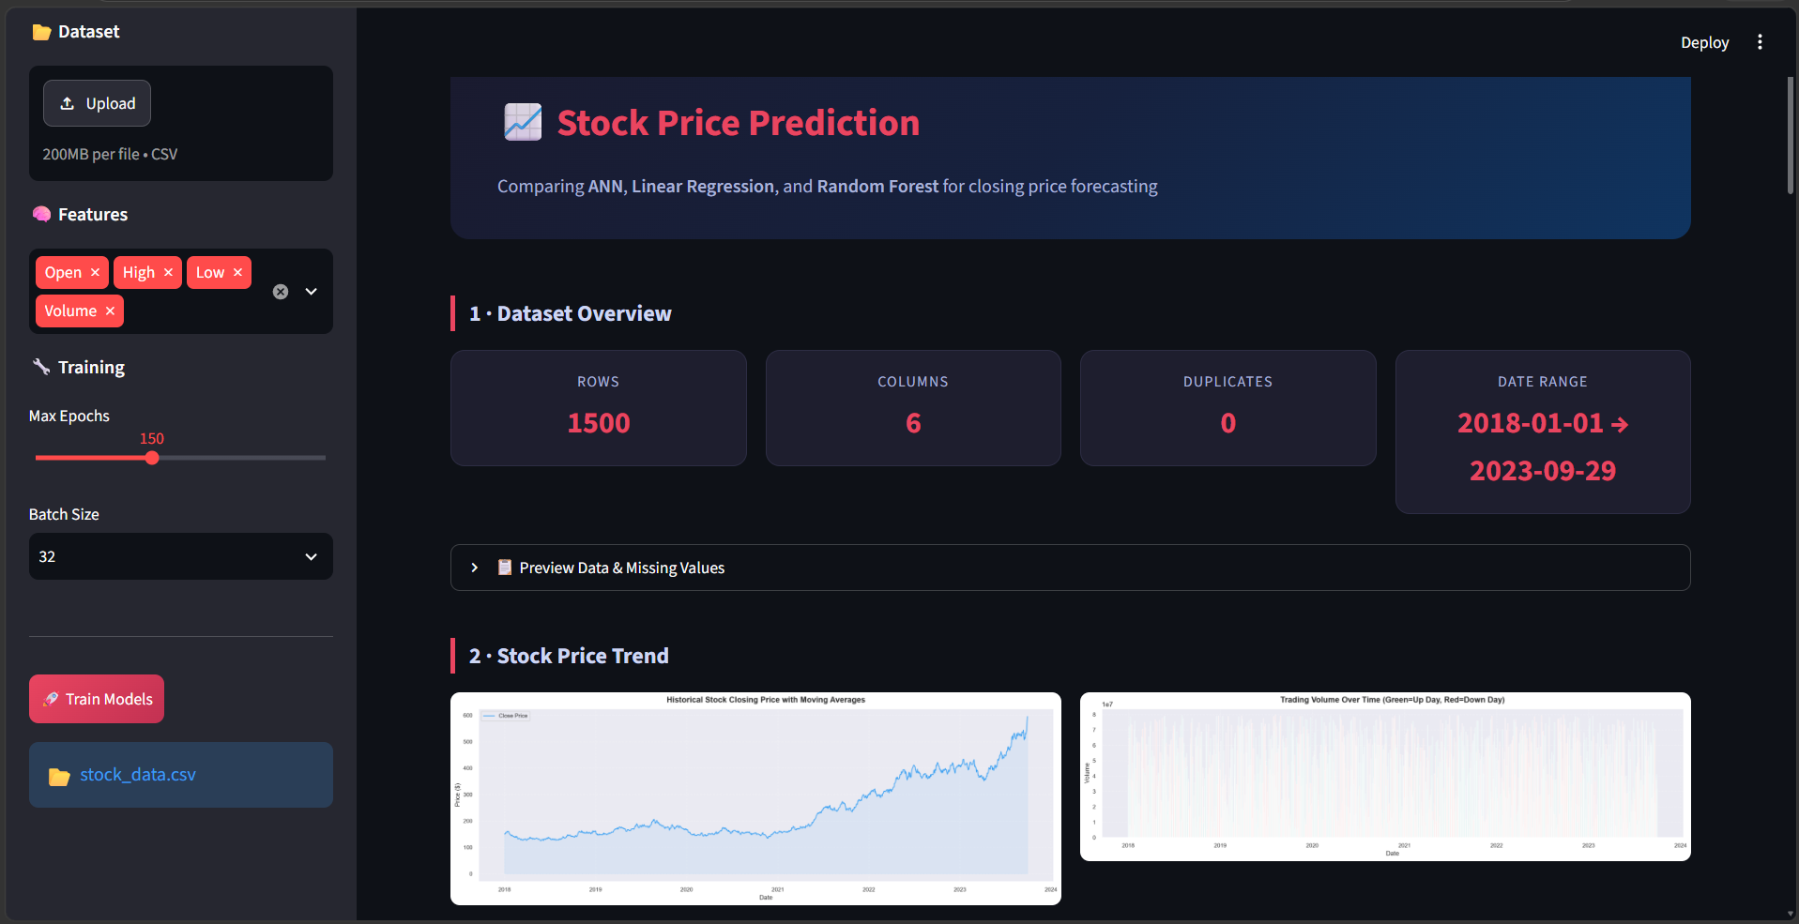
Fig. 1: Streamlit dashboard – dataset overview (1500 rows, 6 columns, 0 duplicates, 2018-01-01 to 2023-09-29), historical closing price, and trading volume.

15. Data Preprocessing
Data preprocessing is an important stage because machine learning models require clean and properly formatted data.
Step | Operation | Description
15.1 | Loading the dataset | The stock CSV file is loaded using Pandas.
15.2 | Column normalization | Column names are normalized for consistency.
15.3 | Date conversion | The Date column is converted into an appropriate date format.
15.4 | Chronological sorting | Data is sorted by date, since stock data is time-dependent.
15.5 | Missing value handling | Missing values are identified and handled before training.
15.6 | Duplicate removal | Duplicates are removed so repeated observations do not bias training.
15.7 | Feature scaling | Numerical features are scaled with MinMaxScaler into a common range.

16. Feature Engineering
Feature engineering involves creating additional information from the existing dataset. The major engineered feature is the Previous Closing Price:
Prev_Close = Close.shift(1)
Date | Close | Prev_Close
Day 1 | 100 | NaN
Day 2 | 103 | 100
Day 3 | 105 | 103
Day 4 | 102 | 105
The first record has no previous closing value and is handled during preprocessing. This feature helps the ANN identify relationships between current market variables and previous price behaviour.

17. Methodology
Step | Stage | Description
1 | Data Collection | Historical stock data is collected from a suitable source.
2 | Data Cleaning | Missing values and duplicates are handled.
3 | Feature Engineering | The Prev_Close feature is created.
4 | Data Splitting | 80:20 chronological train-test split.
5 | Scaling | MinMaxScaler is fitted on training data, then applied to test data.
6 | ANN Construction | A multi-layer feed-forward network is built.
7 | Model Training | Adam optimizer with Mean Squared Error loss.
8 | Prediction | The trained model predicts closing prices on unseen test data.
9 | Evaluation | MAE, MSE, RMSE, and R² are calculated.
10 | Comparison | ANN is compared with Linear Regression and Random Forest.
11 | Visualization | Results are shown through graphs and a Streamlit dashboard.

18. System Architecture
HISTORICAL STOCK DATA
│
↓
DATA PREPROCESSING
│
┌───────────┴───────────┐
↓ ↓
FEATURE ENGINEERING DATA CLEANING
│ │
└───────────┬───────────┘
↓
CHRONOLOGICAL SPLIT
│
┌────────┴────────┐
↓ ↓
TRAIN DATA TEST DATA
│ │
↓ ↓
FEATURE SCALING SCALING
│
↓
ANN MODEL TRAINING
│
↓
PREDICTION
│
↓
MODEL EVALUATION
│
┌──────┼─────────┐
↓ ↓ ↓
MAE RMSE R²
│
↓
STREAMLIT DASHBOARD

19. ANN Architecture
The Artificial Neural Network consists of multiple fully connected layers:
Input Layer
↓
Dense Layer – 64 neurons (ReLU)
↓
Dropout – 20%
↓
Dense Layer – 32 neurons (ReLU)
↓
Dropout – 20%
↓
Dense Layer – 16 neurons (ReLU)
↓
Output Layer – 1 neuron (Linear)

Activation Functions
ReLU is used in the hidden layers and allows the network to learn nonlinear relationships:
ReLU(x) = max(0, x)
Linear activation is used in the output layer because this is a regression problem; the output is the predicted closing price.
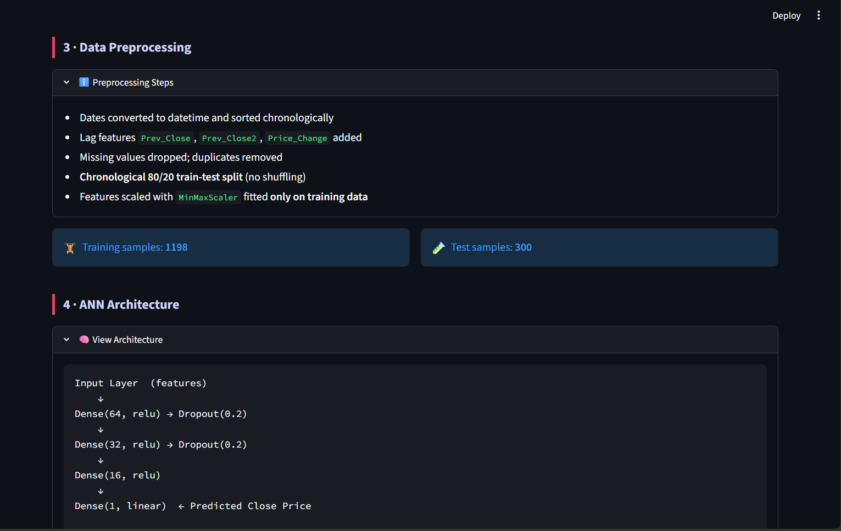
Fig. 2: Streamlit dashboard – preprocessing steps (1198 training and 300 test samples) and the ANN architecture (64 → 32 → 16 → 1).

20. ANN Hyperparameters
Parameter | Value
Architecture | 64 → 32 → 16 → 1
Hidden Activation | ReLU
Output Activation | Linear
Optimizer | Adam
Loss Function | Mean Squared Error
Batch Size | 32
Maximum Epochs | 150
Dropout | 20%
Early Stopping Patience | 15
Restore Best Weights | Yes
Early stopping prevents unnecessary training when validation performance stops improving. A patience of 15 lets the model continue for a limited number of epochs before stopping, and the best weights are restored.

21. Baseline Models
Baseline models provide a reference for evaluating the ANN.

21.1 Linear Regression
Models the relationship between input features and the target using a linear equation. It is simple, fast, and easy to interpret.

21.2 Random Forest Regression
Combines multiple decision trees; each produces a prediction and the final output combines them. It can model nonlinear relationships and feature interactions.

22. Random Forest Regression
Random Forest is an ensemble learning algorithm that builds multiple decision trees instead of relying on a single one.
Training Data
↓
Multiple Random Samples
↓
Decision Tree 1 | Decision Tree 2 | ... | Decision Tree N
↓
Combine Predictions
↓
Final Prediction
Advantages
- Handles nonlinear relationships.
- Works with multiple features.
- Less sensitive to individual decision-tree errors.
- Can model feature interactions.
Role in the project: used as a baseline to compare against the ANN.

23. Model Comparison
Three regression models are compared: Linear Regression, Random Forest Regression, and the Artificial Neural Network, using MAE, MSE, RMSE, and R².
Model | MAE | MSE | RMSE | R² | MAPE (%)
Linear Regression | 0.0000 | 0.0000 | 0.0000 | 1.0000 | 0.0000
Random Forest | 26.8263 | 2640.4475 | 51.3853 | 0.0693 | 5.3358
ANN | 36.5778 | 1483.9734 | 38.5224 | 0.4769 | 8.4986
The actual values are taken from the metrics generated by the application.

24. Model Training
The training process includes:
- Loading preprocessed data.
- Separating input features and target values.
- Scaling the features.
- Creating the ANN architecture.
- Compiling the model.
- Training the model.
- Monitoring validation performance.
- Applying early stopping.
- Restoring the best model weights.
- Saving the trained model.
The training history is recorded so the loss curve can be visualized.
Loss function (Mean Squared Error):
MSE = (1/n) Σ(yᵢ - ŷᵢ)²
where yᵢ is the actual value, ŷᵢ the predicted value, and n the number of observations.

25. Data Leakage Prevention
Data leakage occurs when information from the testing dataset unintentionally influences model training, producing unrealistically high performance. To prevent it, the scaler is fitted only on training data.
Training Data → Fit Scaler → Transform Training Data
Testing Data → Use Existing Scaler → Transform Testing Data
The test data must not be used to calculate scaling parameters, so evaluation reflects performance on unseen information.

26. Importance of Chronological Splitting
Stock market data is time-dependent, so randomly shuffling before splitting creates an unrealistic experiment. Past data must precede future data:
80% → Training (earlier observations)
20% → Testing (later observations)
No random shuffling is applied. The model learns from earlier observations and is evaluated on later ones, which better represents real-world forecasting.

27. Evaluation Metrics
Metric | Formula | Interpretation
MAE | (1/n) Σ |yᵢ − ŷᵢ| | Average absolute error; lower is better.
MSE | (1/n) Σ (yᵢ − ŷᵢ)² | Average squared error; lower is better.
RMSE | √MSE | Penalizes larger errors more; lower is better.
R² | 1 − SSres / SStot | Share of variance explained; higher is better.

28. Results
Results are generated by the application and reported using the actual experimental values. The analysis covers training and testing performance, ANN prediction accuracy, comparison with Linear Regression and Random Forest, error measurements, and R² performance.
Model | MAE | MSE | RMSE | R² | MAPE (%)
Linear Regression | 0.0000 | 0.0000 | 0.0000 | 1.0000 | 0.0000
Random Forest | 26.8263 | 2640.4475 | 51.3853 | 0.0693 | 5.3358
ANN | 36.5778 | 1483.9734 | 38.5224 | 0.4769 | 8.4986
The best-performing model is identified by lower error values and higher R².

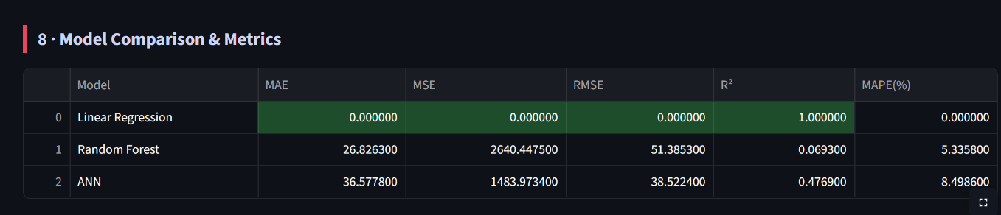
Fig. 3: Model comparison and metrics table generated by th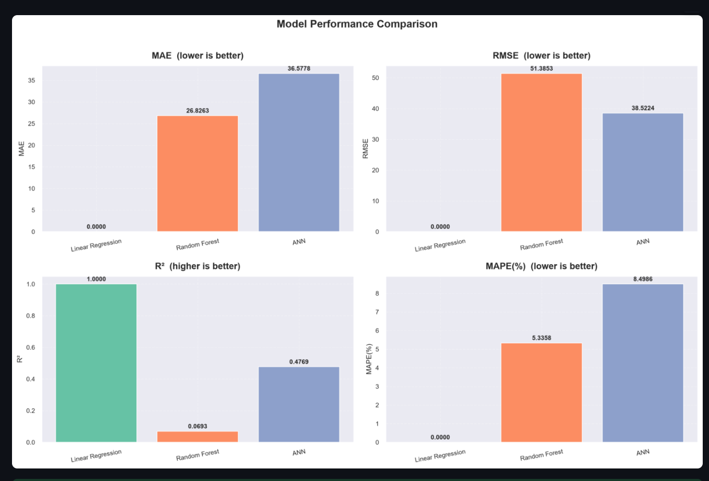e application.

Fig. 4: Model performance comparison – MAE, RMSE, R² and MAPE (%).

29. Visualization and Graph Analysis
Figure | What it shows
29.1 Closing Price | Historical closing price: trends, fluctuations, volatility.
29.2 Volume | Trading volume over time, indicating market activity.
29.3 Actual vs Predicted | Actual closing prices against ANN predictions; closer curves mean better performance.
29.4 Training Loss | Training and validation loss; a decreasing loss shows learning.
29.5 Model Comparison | ANN versus Linear Regression and Random Forest.
29.6 Residuals | Residual = Actual − Predicted; reveals systematic errors.
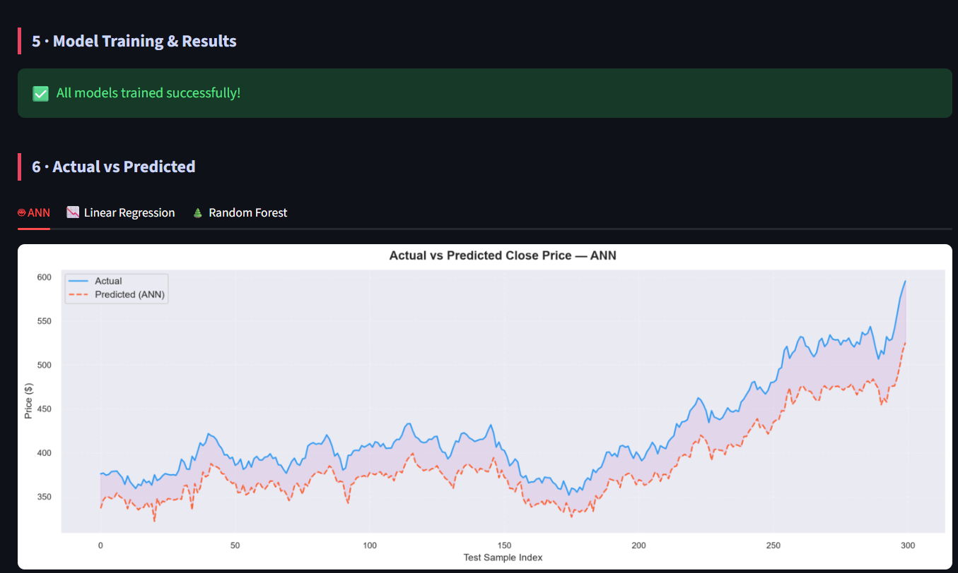
Fig. 5: Actual vs predicted closing price – ANN, on the 300 test samples.
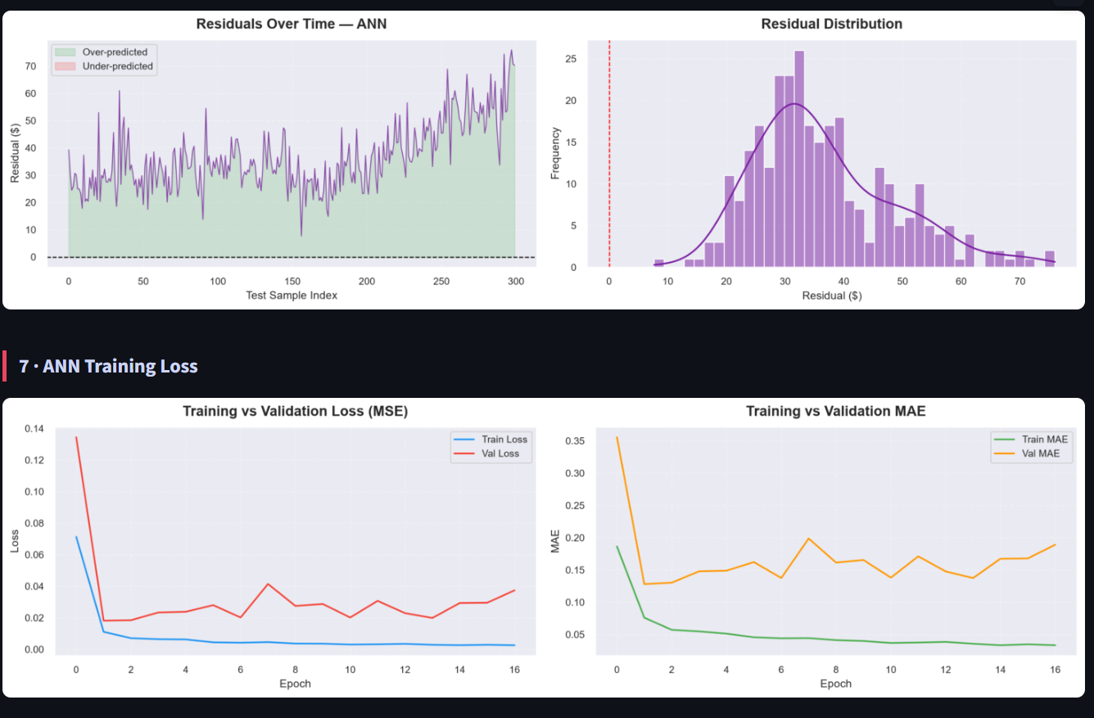
Fig. 6: Residuals over time and residual distribution for the ANN, followed by training vs validation loss (MSE) and MAE.

30. Discussion
The developed system demonstrates the application of ANNs to stock price prediction. The ANN can learn nonlinear relationships among historical stock features, and the previous closing price gives the model information about recent price behaviour. Chronological splitting makes the setup more realistic because future information is never used in training. The baseline models show whether the ANN improves on simpler approaches.
However, stock prediction remains difficult because historical patterns alone cannot represent all influencing factors, such as external events, economic conditions, investor behaviour, company announcements, and market sentiment. Model performance should therefore be interpreted carefully.

31. Overfitting and Underfitting

31.1 Overfitting
Occurs when a model performs very well on training data but poorly on unseen data. Possible causes: excessive complexity, insufficient data, and too many epochs. This project uses:
- Dropout (20%) in the hidden layers, which randomly disables neurons during training to encourage robust patterns.
- Early stopping, which terminates training when validation performance stops improving.

31.2 Underfitting
Occurs when a model is too simple to capture important patterns. Possible causes: insufficient capacity, too few epochs, and poor feature selection. The chosen architecture aims to provide enough capacity while controlling overfitting.

32. Error Analysis
The residual is calculated as:
Residual = Actual Price − Predicted Price
- A positive residual means the model predicted a lower value than the actual price.
- A negative residual means the model predicted a higher value than the actual price.
Large residuals may occur during periods of significant volatility. Error analysis helps identify large prediction errors, sudden market movements, systematic bias, and periods where the model performs poorly. Residual plots provide a visual method for examining these errors.

33. Streamlit Application
Launch the interactive dashboard with:
streamlit run app.py
Access it at http://localhost:8501.
Dashboard Feature | Description
Dataset Overview | Information about the stock dataset.
Historical Price Chart | Closing price movement over time.
Trading Volume | Historical trading volume.
Train/Test Information | Division between training and testing data.
ANN Architecture | Structure of the neural network.
Actual vs Predicted | Actual and predicted closing prices.
Training Loss | Training and validation loss curves.
Model Comparison | ANN compared with baseline models.
Single Price Prediction | User inputs values and gets a predicted price.
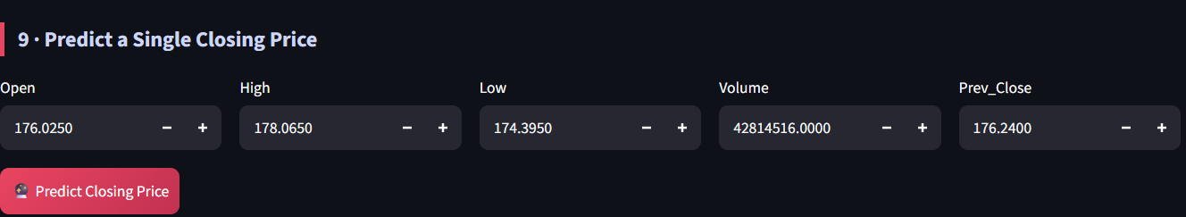
Fig. 7: Single closing-price prediction interface (inputs: Open, High, Low, Volume, Prev_Close).

34. Software Modules
Module | Responsibilities
preprocessing.py | Load dataset, clean data, process dates, create Prev_Close, split data, scale features.
train_ann.py | Build the ANN, configure optimizer, train, apply early stopping, save the model.
train_baseline.py | Train Linear Regression and Random Forest Regression.
evaluation.py | Generate predictions; calculate MAE, MSE, RMSE, R²; generate evaluation figures.
generate_sample_data.py | Generate synthetic stock data when a real dataset is unavailable (testing and demos).
app.py | Streamlit app: data visualization, model information, prediction interface, evaluation results.

35. Project Directory Structure
Stock-Price-Prediction/
│
├── data/
│ └── stock_data.csv
│
├── models/
│ └── ann_model.keras
│
├── outputs/
│ ├── metrics.csv
│ └── figures/
│ ├── 01_closing_price.png
│ ├── 02_volume.png
│ ├── 03_actual_vs_predicted.png
│ ├── 04_training_loss.png
│ ├── 05_model_comparison.png
│ └── 06_residuals_ANN.png
│
├── preprocessing.py
├── train_ann.py
├── train_baseline.py
├── evaluation.py
├── generate_sample_data.py
├── app.py
├── requirements.txt
└── README.md
This modular structure makes the project easier to understand, maintain, test, and extend.

36. Testing
- 36.1 Data testing: missing values, duplicate records, column names, date format, chronological ordering.
- 36.2 Model testing: the trained model is run on unseen test data and predictions are compared with actual values.
- 36.3 Application testing: application startup, dataset loading, graph rendering, model loading, prediction functionality, error-free interaction.
- 36.4 Integration testing: verifies that Preprocessing → Training → Evaluation → Dashboard works as a complete pipeline.

37. Test Cases
Test Case | Input | Expected Output
TC01 | Valid CSV file | Dataset loads successfully
TC02 | Missing values | Missing values handled
TC03 | Duplicate rows | Duplicate rows removed
TC04 | Date column | Dates parsed correctly
TC05 | Feature creation | Prev_Close generated
TC06 | Data splitting | 80:20 chronological split
TC07 | Model training | ANN trains successfully
TC08 | Model prediction | Predicted price generated
TC09 | Metrics calculation | MAE, MSE, RMSE, R² generated
TC10 | Streamlit launch | Dashboard opens successfully
TC11 | Invalid prediction input | Input validation / error handling
TC12 | Model file loading | Saved ANN model loads correctly

38. Advantages
- Nonlinear learning: the ANN learns nonlinear relationships between inputs and prices.
- Automated prediction: predictions are generated automatically after training.
- Multiple evaluation metrics: MAE, MSE, RMSE, and R² give a comprehensive evaluation.
- Model comparison: ANN is compared with Linear Regression and Random Forest.
- Interactive dashboard: Streamlit offers an easy-to-use interface.
- Modular design: separate modules for preprocessing, training, evaluation, and deployment.
- Data visualization: graphs make trends and prediction performance easy to understand.
- Leakage prevention: chronological splitting and training-only scaling reduce leakage risk.

39. Limitations
- Limited historical features: mainly price and volume information.
- Market volatility: sudden movements cause large prediction errors.
- External factors: news, political events, economic indicators, company announcements, and investor sentiment are not included.
- Limited sequence memory: the dense ANN does not explicitly model long-term dependencies like LSTM or GRU.
- Hyperparameter sensitivity: depends on layers, neurons, learning rate, batch size, and epochs.
- Generalization: may not perform equally under completely different market conditions.
- Interpretability: neural networks are harder to interpret than simple regression models.
- Financial uncertainty: accurate historical prediction does not guarantee accurate future prediction.

40. Future Enhancements
No. | Enhancement | Description
40.1 | LSTM Integration | Better capture sequential dependencies.
40.2 | GRU Model | Computationally efficient alternative to LSTM.
40.3 | Technical Indicators | Moving Average, EMA, RSI, MACD, Bollinger Bands.
40.4 | Sentiment Analysis | Extract market sentiment from news and social media.
40.5 | Hyperparameter Optimization | Automated tuning with Keras Tuner or Optuna.
40.6 | Multi-Step Forecasting | Predict prices for multiple future days.
40.7 | Real-Time Data | Connect to financial APIs.
40.8 | Portfolio Optimization | Integrate with portfolio optimization techniques.
40.9 | Hybrid Models | CNN + LSTM, ANN + LSTM, ARIMA + ANN, Sentiment Analysis + LSTM.

41. Ethical and Responsible Use
Stock prediction systems must be used responsibly because financial decisions involve risk. This model is intended primarily for academic and research purposes, and its predictions should not be treated as guaranteed future prices.
- Transparency: clearly communicate the limitations of the system.
- Avoiding misleading claims: model accuracy must not be presented as a guarantee of returns.
- Data privacy: apply appropriate privacy and security measures if user-specific financial data is introduced.
- Responsible decision making: financial decisions should not rely entirely on machine learning predictions.
- Model monitoring: if deployed, performance should be continuously monitored because markets change over time.

42. Performance Considerations
No. | Aspect | Description
42.1 | Computational efficiency | Small ANN trains without powerful hardware.
42.2 | Early stopping | Avoids unnecessary training and saves resources.
42.3 | Batch processing | Batch size of 32 processes data efficiently.
42.4 | Data scaling | Helps the network converge more effectively.
42.5 | Modular execution | Each stage can run independently.
42.6 | Model saving | models/ann_model.keras avoids retraining on every app launch.
42.7 | Visualization efficiency | Pre-generated figures avoid repeated recalculation.
42.8 | Scalability | Scales to larger datasets and features, with more compute for larger models.
Overall, the implementation balances model complexity, computational requirements, and practical usability for an academic stock price prediction application.

43. Reproducibility Steps
Following these steps allows the complete project workflow to be reproduced.
Step | Action | Command / Detail
43.1 | Prepare data | Place the stock dataset in data/, or generate synthetic data: python generate_sample_data.py
43.2 | Train models | Run the preprocessing and training modules to prepare data and train the ANN and baselines. The ANN is saved so the application can reuse it.
43.3 | Evaluate | The evaluation module generates metrics and figures. Metrics: outputs/metrics.csv; figures: outputs/figures/
43.4 | Run the application | streamlit run app.py, then open http://localhost:8501

44. Application Execution
The application provides an interactive interface for exploring the stock prediction system.
Step | Task | Detail
1 | Install Python | Python 3.x; verify with python --version
2 | Install required packages | pip install -r requirements.txt
3 | Prepare the dataset | Place the stock dataset inside the data directory with the required stock market columns.
4 | Generate sample data | If no real dataset is available: python generate_sample_data.py
5 | Train the models | Run the corresponding Python modules; the trained ANN is stored in models/ann_model.keras.
6 | Launch Streamlit | streamlit run app.py; the dashboard opens in the browser.
7 | Explore the dashboard | View dataset information, historical price charts, trading volume, ANN architecture, actual vs predicted values, training loss, model comparison, and the prediction interface.

45. Output Files
The project generates the following files during execution.
No. | File | Description
45.1 | outputs/metrics.csv | Evaluation results of the implemented models (MAE, MSE, RMSE, R²).
45.2 | outputs/figures/01_closing_price.png | Historical closing-price movement.
45.3 | outputs/figures/02_volume.png | Historical trading volume.
45.4 | outputs/figures/03_actual_vs_predicted.png | Actual closing prices compared with ANN predictions.
45.5 | outputs/figures/04_training_loss.png | Training and validation loss during ANN training.
45.6 | outputs/figures/05_model_comparison.png | Performance comparison of the implemented models.
45.7 | outputs/figures/06_residuals_ANN.png | Residual errors generated by the ANN.
45.8 | models/ann_model.keras | Trained ANN; loaded by the Streamlit app without retraining.

46. Conclusion
The project “Stock Price Prediction Using Artificial Neural Network” demonstrates the application of machine learning and artificial neural networks to the problem of stock closing price prediction.
Historical stock market data containing Open, High, Low, Close, Volume, and Previous Closing Price was processed and used to develop a prediction system. The preprocessing stage includes cleaning, date processing, chronological sorting, feature engineering, train-test splitting, and feature scaling.
An Artificial Neural Network with multiple dense layers was developed. The hidden layers use 64, 32, and 16 neurons followed by a single output neuron, with ReLU activation in the hidden layers and a linear activation for regression output. The model is trained with the Adam optimizer and Mean Squared Error loss, and dropout and early stopping are used to reduce overfitting and improve generalization.
Linear Regression and Random Forest Regression are implemented as baseline models, and all models are evaluated using MAE, MSE, RMSE, and R². The Streamlit dashboard lets users visualize historical data, model architecture, predictions, training performance, and model comparison.
The project shows that Artificial Neural Networks can be effectively applied to financial regression problems. However, stock markets are highly dynamic, and historical information alone cannot completely capture future market behaviour. The developed system should therefore be considered an academic machine learning demonstration rather than a guaranteed financial forecasting or investment system.
Future scope: LSTM, GRU, technical indicators, sentiment analysis, real-time financial APIs, hyperparameter optimization, and hybrid deep-learning architectures.

47. References
- T. Fischer and C. Krauss, “Deep learning with long short-term memory networks for financial market predictions,” European Journal of Operational Research, vol. 270, no. 2, pp. 654–669, 2018.
- R. H. Shumway and D. S. Stoffer, Time Series Analysis and Its Applications: With R Examples, Springer.
- S. Haykin, Neural Networks and Learning Machines, 3rd ed., Pearson Education.
- I. Goodfellow, Y. Bengio, and A. Courville, Deep Learning, MIT Press, 2016.
- F. Chollet, Deep Learning with Python, 2nd ed., Manning Publications.
- T. Hastie, R. Tibshirani, and J. Friedman, The Elements of Statistical Learning, Springer.
- L. Breiman, “Random forests,” Machine Learning, vol. 45, pp. 5–32, 2001.
- C. M. Bishop, Pattern Recognition and Machine Learning, Springer, 2006.
- M. Kuhn and K. Johnson, Applied Predictive Modeling, Springer, 2013.
- A. Géron, Hands-On Machine Learning with Scikit-Learn, Keras, and TensorFlow, O’Reilly Media.
- F. Pedregosa et al., “Scikit-learn: Machine learning in Python,” Journal of Machine Learning Research, vol. 12, pp. 2825–2830, 2011.
- M. Abadi et al., “TensorFlow: Large-scale machine learning on heterogeneous systems,” 2015.
- W. McKinney, Python for Data Analysis, O’Reilly Media.
- A. Nikou, M. Mansourfar, and J. Bagherzadeh, “Stock price prediction using machine learning techniques,” research on machine-learning-based financial forecasting.
- R. Patel et al., research on machine learning approaches for stock market prediction and financial time-series analysis.
- Mehtab and Sen, research on deep learning approaches for stock market prediction and financial forecasting.
- Y. Zhang and Y. Wu, research on neural-network-based approaches for stock market prediction.
- Yahoo Finance, historical financial market data and stock information.
- Kaggle, publicly available datasets for machine learning and financial-data analysis.
- Streamlit Documentation, documentation for developing interactive Python-based data applications.
- TensorFlow Documentation, documentation for developing and training neural-network models.
- Scikit-learn Documentation, documentation for machine-learning algorithms, preprocessing, and evaluation metrics.

