React-app-EKS-Submission-Screenshot

1. **GitHub Link:**

<https://github.com/prasanth-wizard/Brain-Tasks-App.git>

**Forking the Repository and Git Setup:**

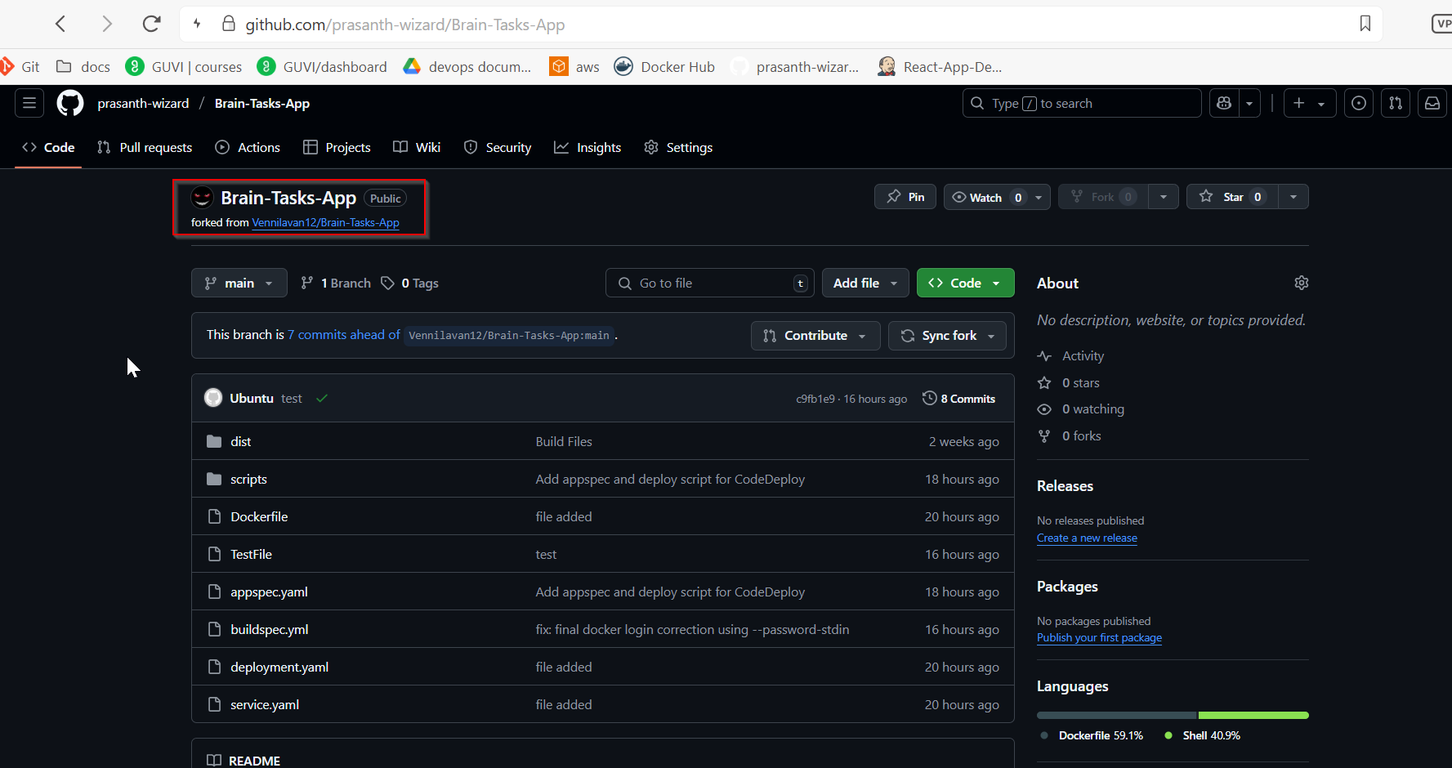

**Document Link:**

**https://drive.google.com/drive/folders/1EZHViJB1smpfqmM-xEVRXNNeR16ScIFL**

**Load balancer ARN:**

a0c18816cdde3463bab242a4290109ac-1186182071.eu-north-1.elb.amazonaws.com

http://a0c18816cdde3463bab242a4290109ac-1186182071.eu-north-1.elb.amazonaws.com:3000

