REACTJS E-COMMERCE APPLICATION

Jenkins_Server:
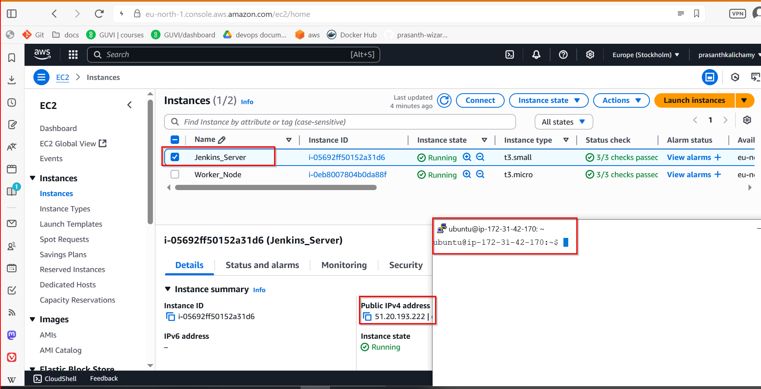

Jenkins_server Security_Group Inbound rules:

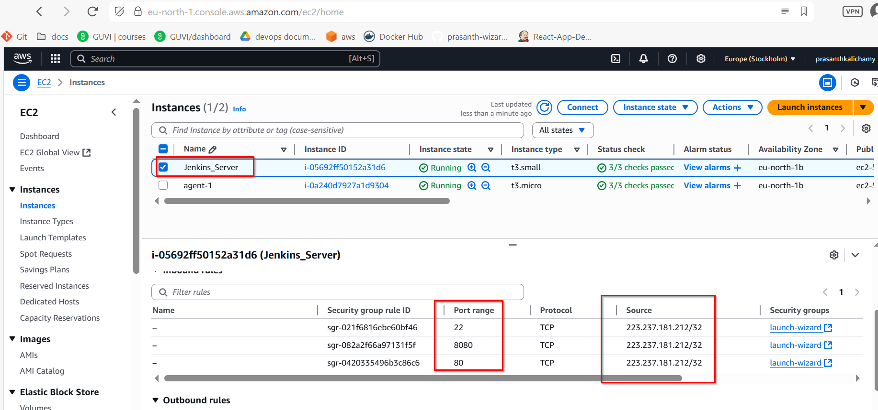
Forking the Repository and Git Setup

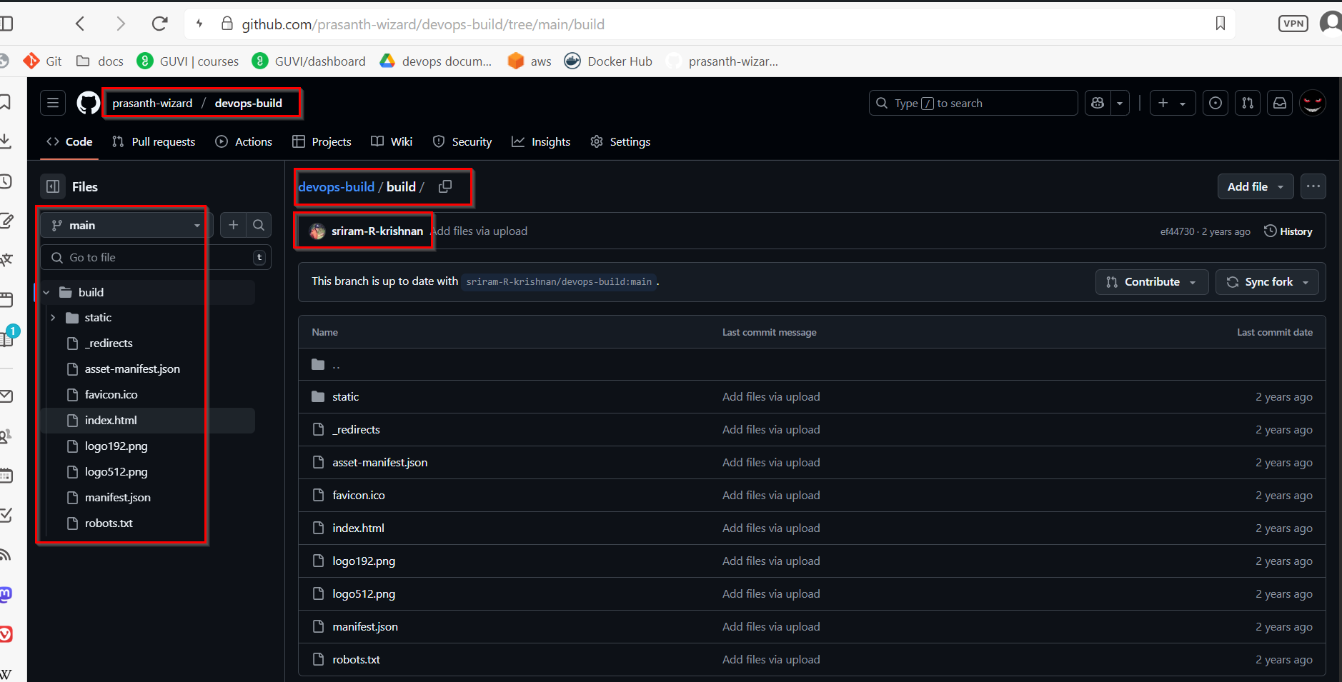

Install Git: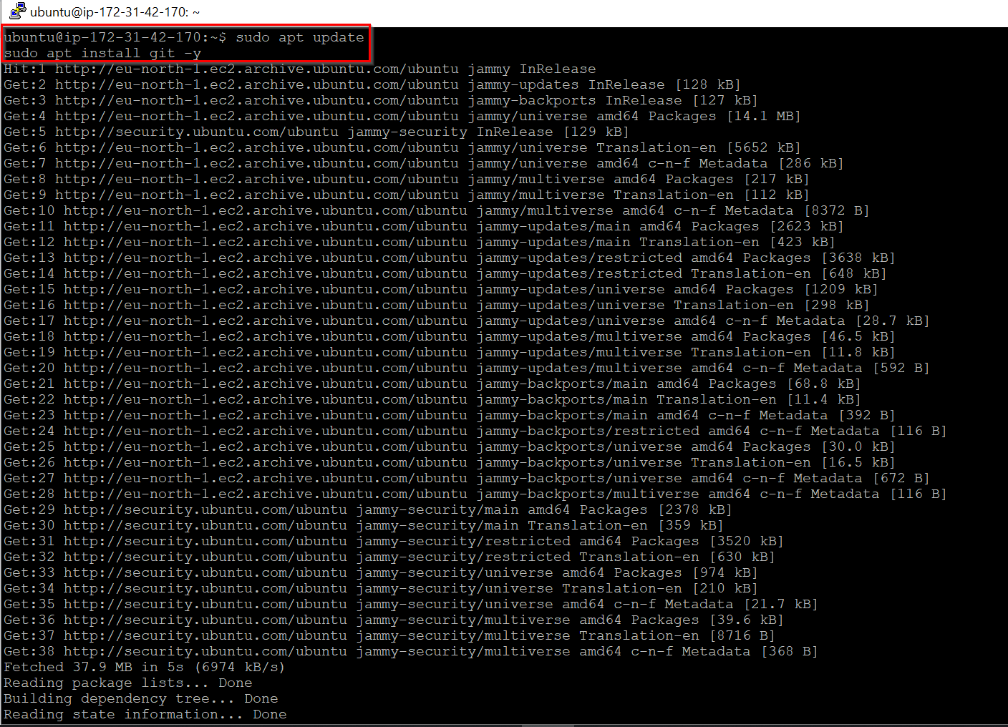

Clone my Forked Repository (on Jenkins Server):
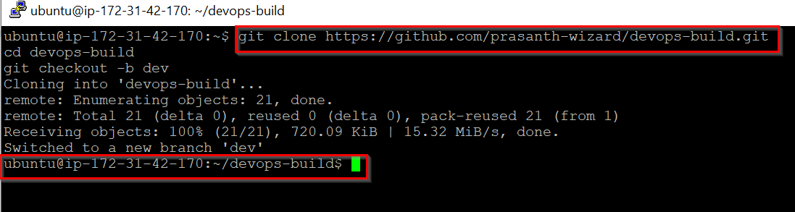

Docker Setup and Application Dockerization

sudo apt update

sudo apt install apt-transport-https ca-certificates curl gnupg-agent software-properties-common -y

curl -fsSL https://download.docker.com/linux/ubuntu/gpg | sudo apt-key add –

sudo add-apt-repository "deb [arch=amd64] https://download.docker.com/linux/ubuntu $(lsb_release -cs) stable"

sudo apt update
sudo apt install docker-ce docker-ce-cli containerd.io -y
sudo usermod -aG docker $USER

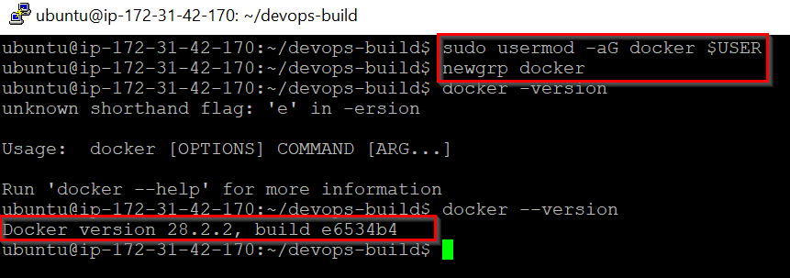

Install Docker Compose:

sudo curl -SL https://github.com/docker/compose/releases/latest/download/docker-compose-linux-x86_64 -o /usr/local/bin/docker-compose

sudo chmod +x /usr/local/bin/docker-compose

docker-compose –version

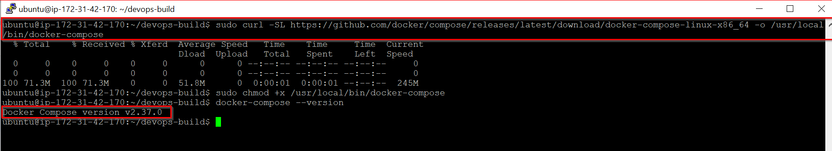

Create Dockerfile

FROM nginx:alpine
WORKDIR /usr/share/nginx/html
RUN rm -rf ./*
COPY build/ .
EXPOSE 80
CMD ["nginx", "-g", "daemon off;"]

Create docker-compose.yml

version: '3'
services:
react_app:
build: .
image: prasanth0003/react_app
container_name: react_app
ports:
- "80:80"
restart: unless-stopped

Create .dockerignore

node_modules
.git
.gitignore

Create .gitignore

node_modules/
.DS_Store
.env
dist/

Bash Scripting

build.sh

#!/bin/bash
docker build -t prasanth0003/react_app:dev .

deploy.sh

#!/bin/bash
docker-compose down
docker-compose up -d

Change .sh file permission executable:

chmod +x build.sh deploy.sh

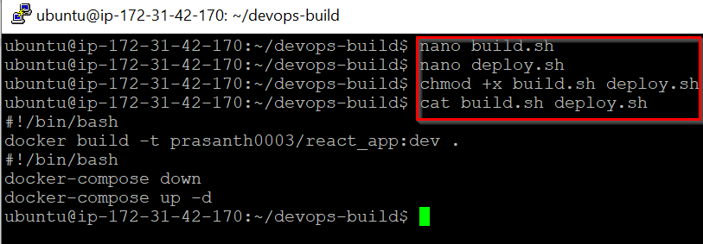

Version Control

Git Commands to Push to Dev Branch

git add .
git commit -m "Added Docker configuration and scripts"
git push origin dev

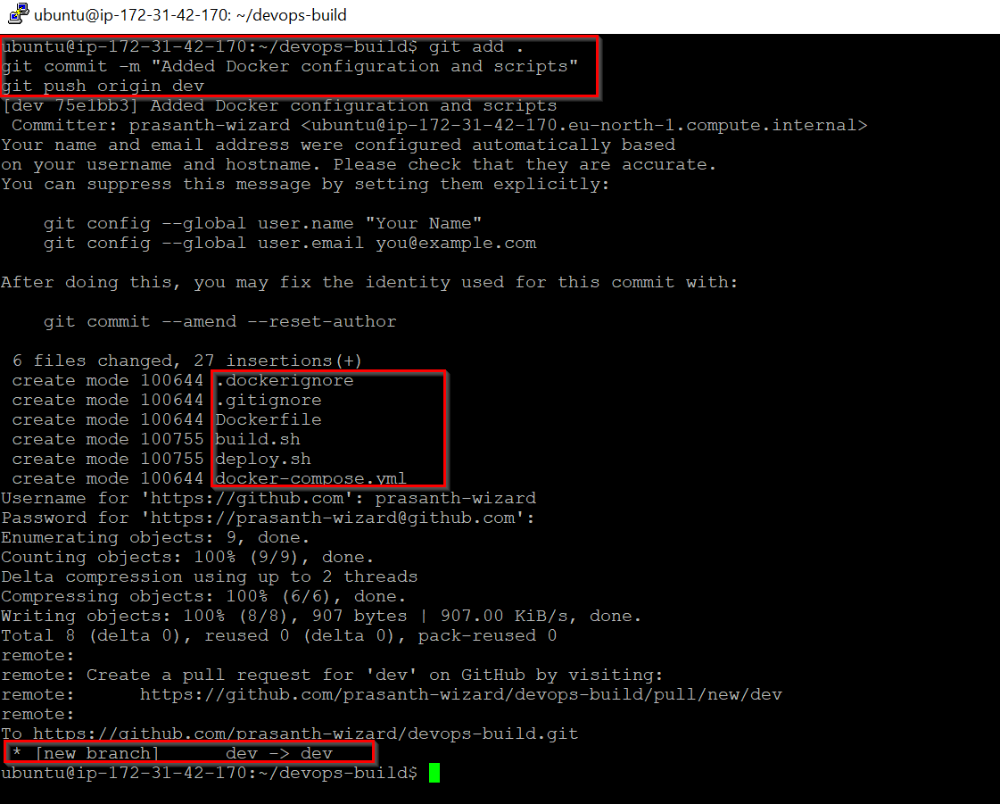

Set Up GitHub Webhook:

- GitHub repository -> Settings -> Webhooks
- Add webhook:
  - Payload URL: http://51.20.193.222:8080/github-webhook/
  - Content type: application/json
  - Which events: Just the push event
- Save
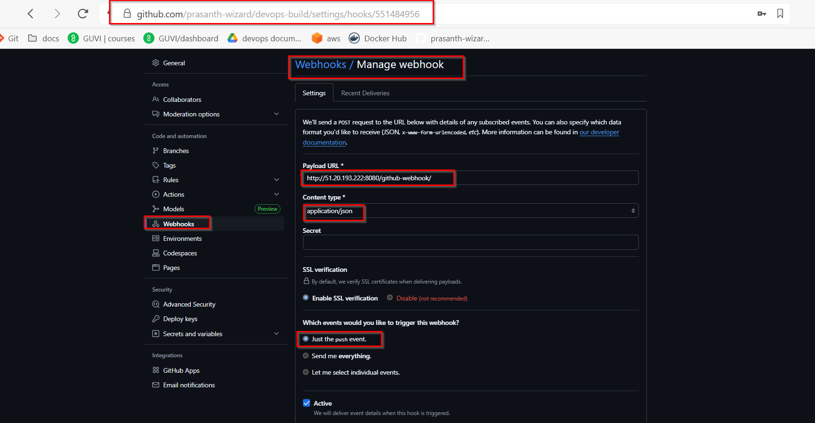
Docker Hub Setup

- Creating two repositories:
  - "dev" (Public)
  - "prod" (Private)

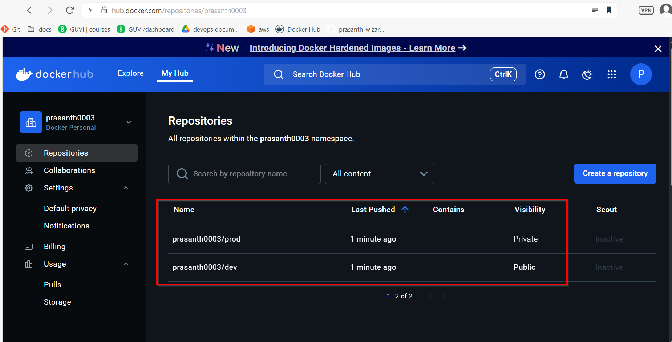

Docker login:

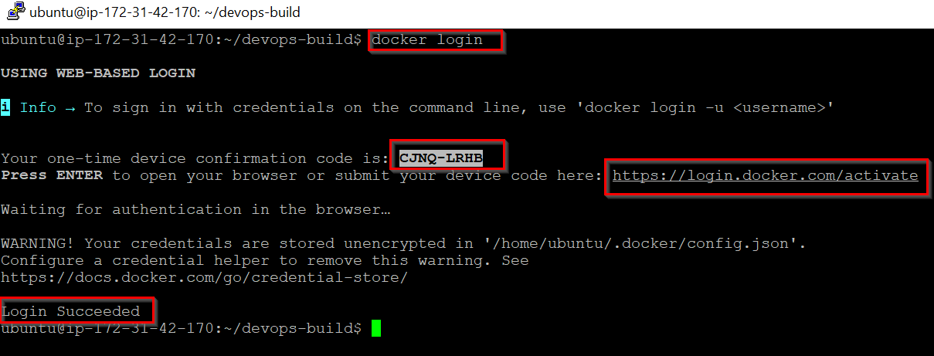

Jenkins Setup

Install Java 17

sudo apt update
sudo apt install openjdk-17-jdk -y
java --version

Install Jenkins

curl -fsSL https://pkg.jenkins.io/debian-stable/jenkins.io-2023.key | sudo tee \
/usr/share/keyrings/jenkins-keyring.asc > /dev/null

echo deb [signed-by=/usr/share/keyrings/jenkins-keyring.asc] \
https://pkg.jenkins.io/debian-stable binary/ | sudo tee \
/etc/apt/sources.list.d/jenkins.list > /dev/null

sudo apt update
sudo apt install jenkins -y
sudo systemctl start jenkins
sudo systemctl enable Jenkins

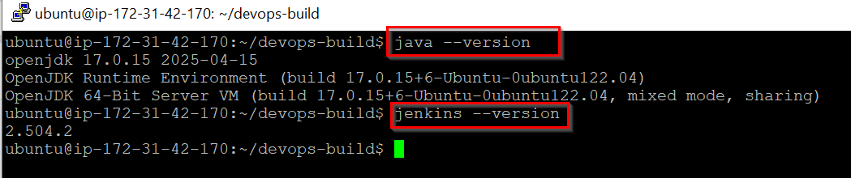

Access Jenkins

- Open a browser to http://51.20.193.222:8080
- Get admin password: sudo cat /var/lib/jenkins/secrets/initialAdminPassword
- Complete setup wizard, install suggested plugins

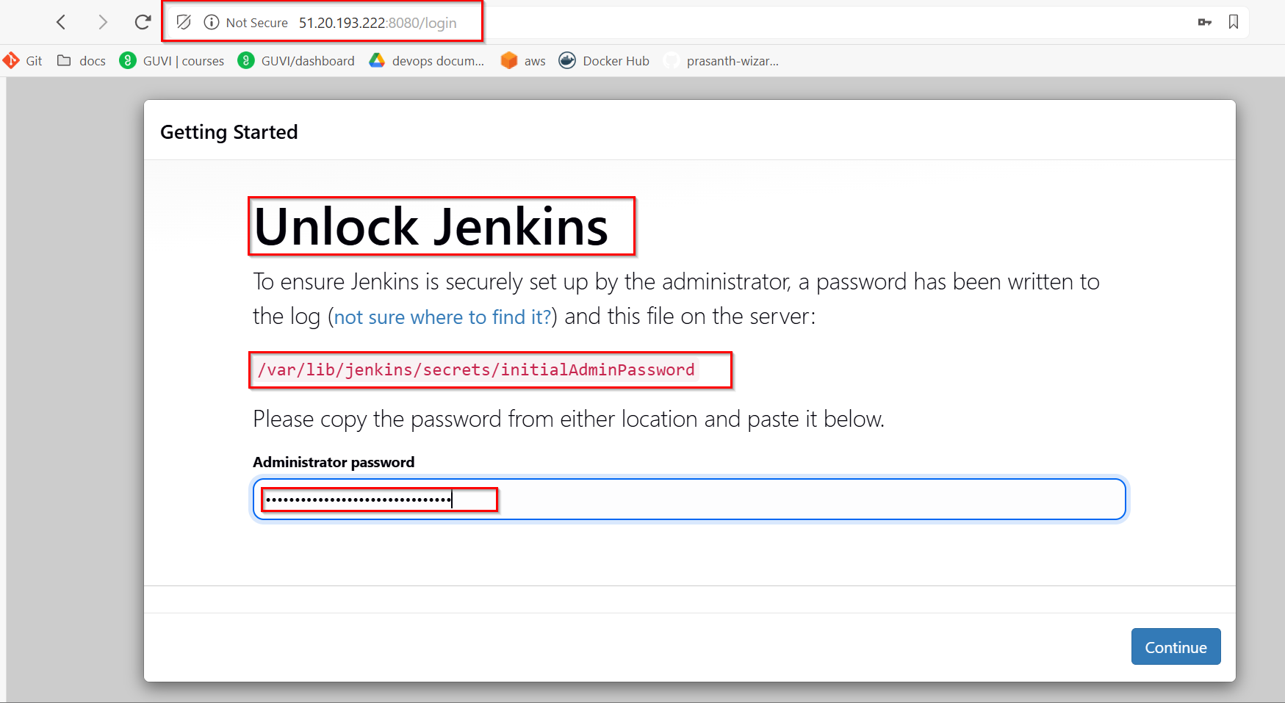

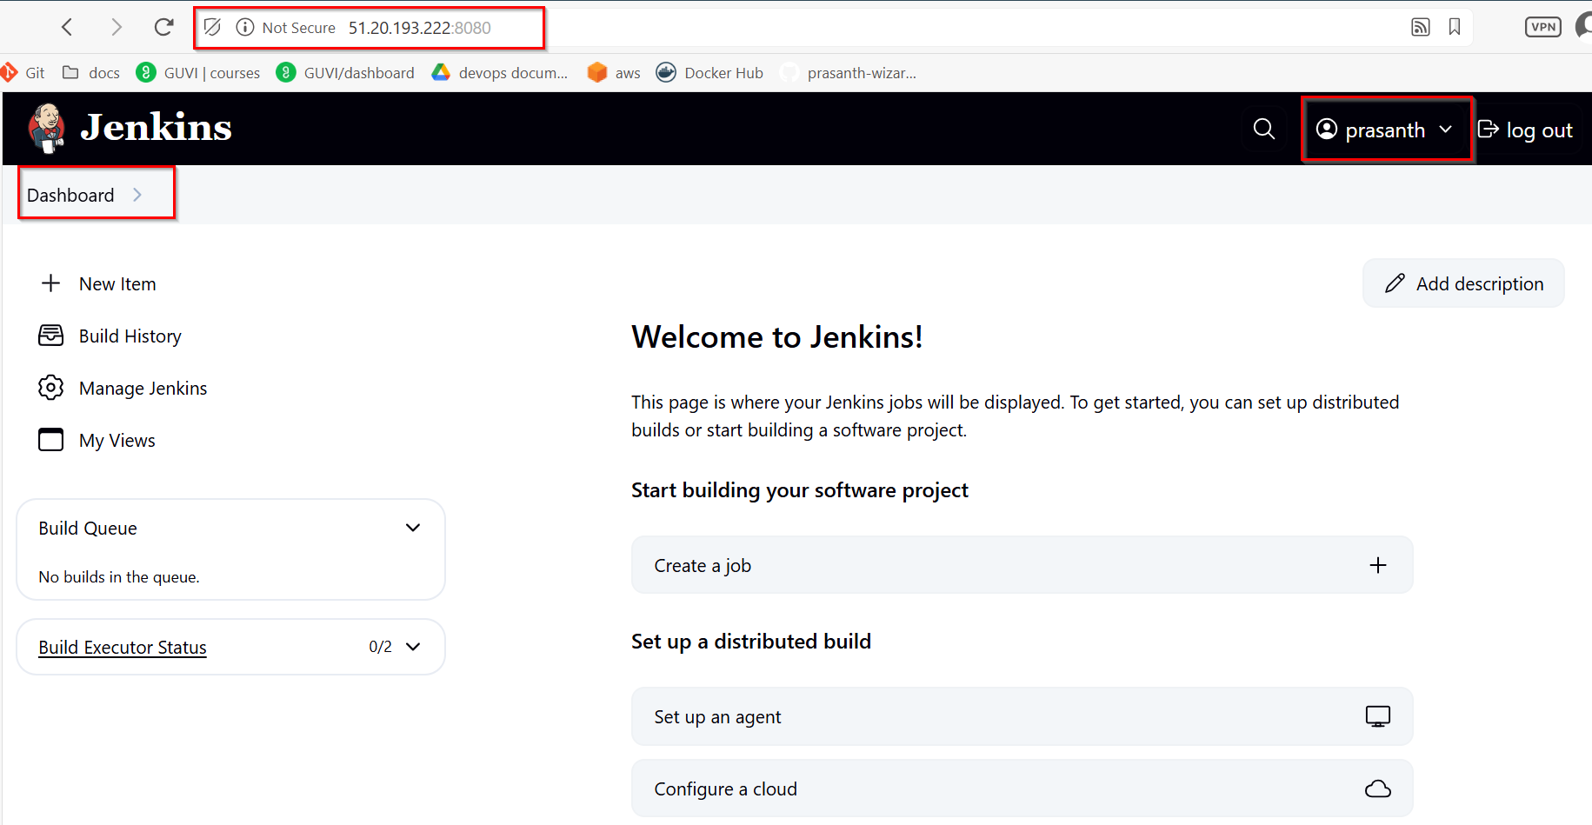

Configure Jenkins Pipeline:

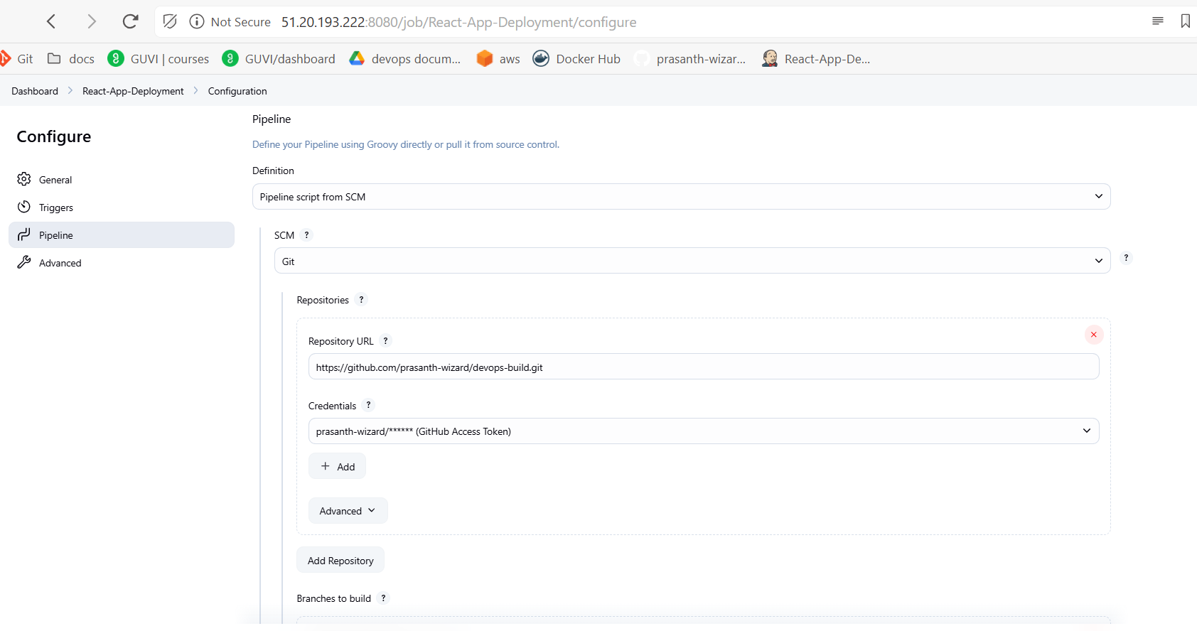
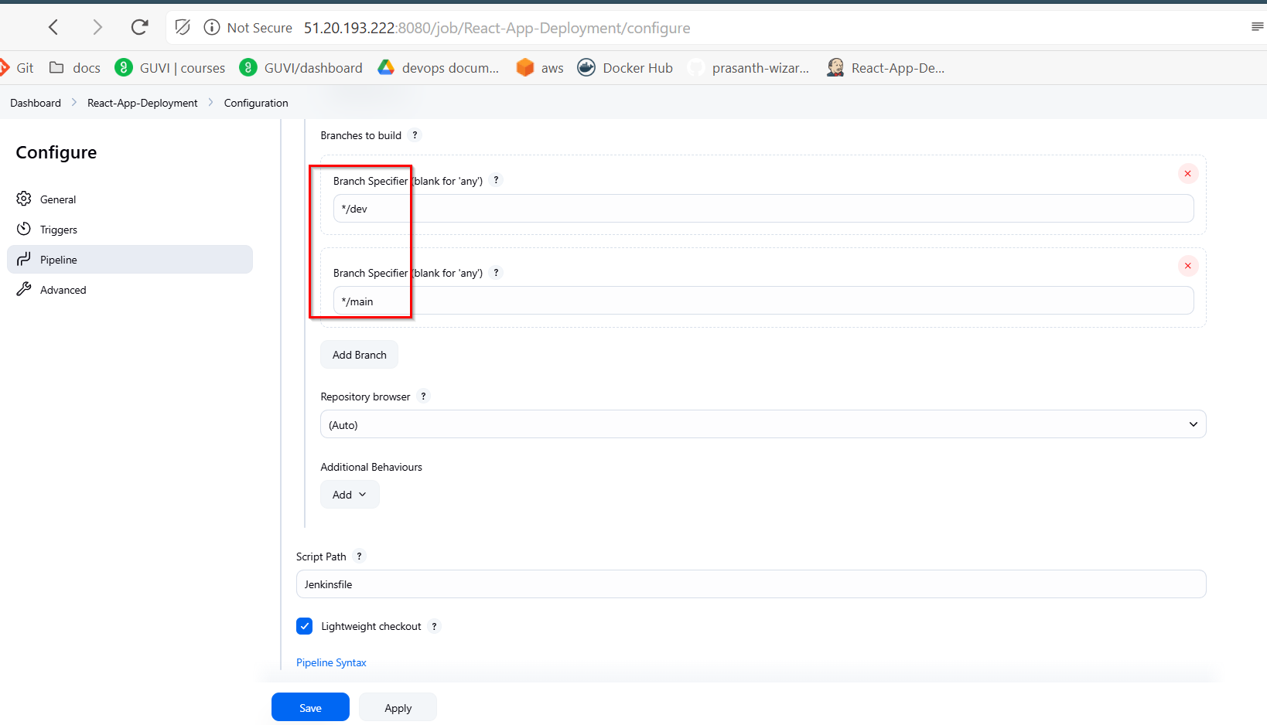

Add Credentials in Jenkins

- Add three credentials:
  - Git Hub credentials (Username with password)
    - ID: github-creds
    - Username: prasanth-wizard
    - Password: Access Token
  - Docker Hub credentials (Username with password)
    - ID: dockerhub-creds
    - Username: prasanth0003
    - Password: Access Token
  - SSH credentials for Worker Node
    - ID: worker-node-ssh
    - Username: ubuntu
    - Private key: SSH private key
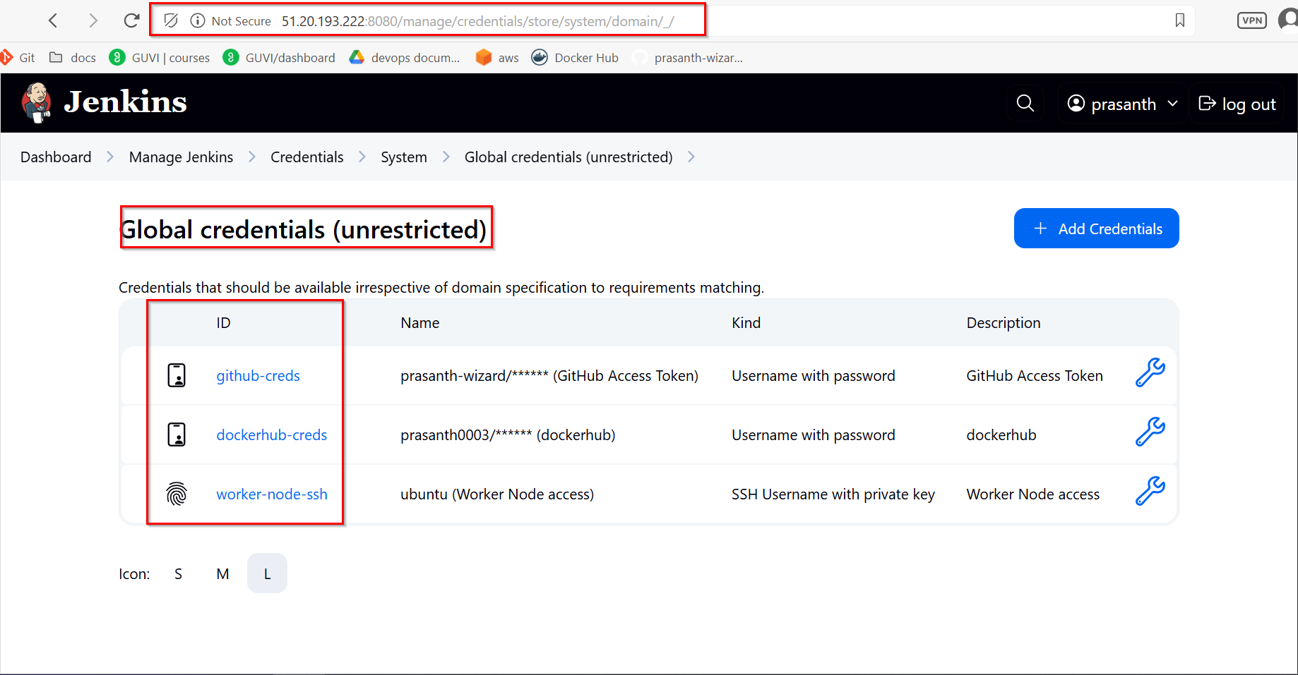
Creating Pipeline:
- Create new item -> Pipeline
- Name: "React-App-Deployment"
- Under Pipeline section:
  - Definition: Pipeline script from SCM
  - SCM: Git
  - Repository URL: https://github.com/prasanth-wizard/devops-build.git
  - Credentials: Added GitHub credentials
  - Branches to build: */dev and */main
  - Script Path: Jenkinsfile

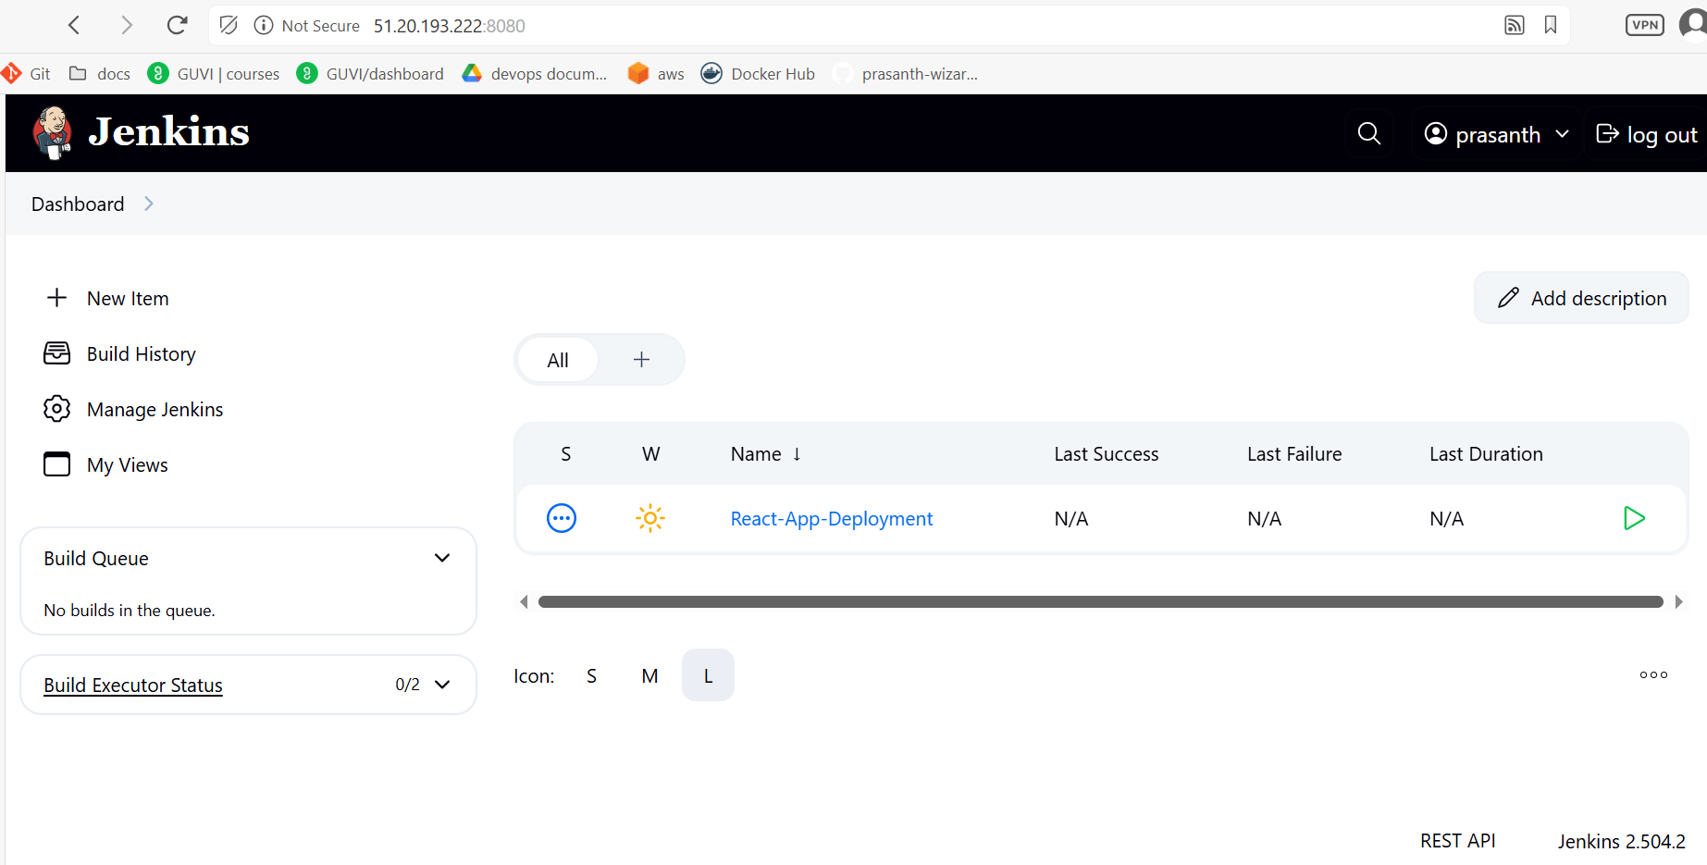

Create Jenkinsfile

pipeline {
agent any

environment {
DOCKER_DEV_REPO = "prasanth0003/dev"
DOCKER_PROD_REPO = "prasanth0003/prod"
DOCKER_REGISTRY = "docker.io"
AGENT_IP = "51.20.2.247"
AGENT_SSH_CREDS = "agent-1-ssh-creds"
}

stages {
stage('Checkout Code') {
steps {
checkout scm
script {
env.COMMIT_HASH = sh(
script: 'git rev-parse --short=7 HEAD',
returnStdout: true
).trim()

env.BRANCH_NAME = env.GIT_BRANCH?.replace("origin/", "") ?: sh(
script: "git rev-parse --abbrev-ref HEAD",
returnStdout: true
).trim()

if (env.BRANCH_NAME == 'dev') {
env.BASE_IMAGE = "${DOCKER_REGISTRY}/${DOCKER_DEV_REPO}"
} else if (env.BRANCH_NAME == 'main') {
env.BASE_IMAGE = "${DOCKER_REGISTRY}/${DOCKER_PROD_REPO}"
} else {
error("Unsupported branch '${env.BRANCH_NAME}'. Only 'dev' and 'main' are allowed.")
}

// Define tags as a string joined by spaces for docker build command
env.DOCKER_TAGS = "${env.BASE_IMAGE}:${env.COMMIT_HASH} ${env.BASE_IMAGE}:latest ${env.BASE_IMAGE}:${env.BRANCH_NAME} ${env.BASE_IMAGE}:${env.BUILD_NUMBER}"

echo "Branch: ${env.BRANCH_NAME}"
echo "Image Tags: ${env.DOCKER_TAGS}"
}
}
}

stage('Build Docker Image') {
steps {
script {
// Convert tags string to build arguments
def buildArgs = env.DOCKER_TAGS.split().collect { "-t ${it}" }.join(' ')

sh """
docker build ${buildArgs} .
docker images | grep prasanth0003
"""

// Verify the image built successfully
def imageCheck = sh(
script: "docker inspect --type=image ${env.BASE_IMAGE}:${env.COMMIT_HASH}",
returnStatus: true
)
if (imageCheck != 0) {
error("Docker image failed to build")
}
}
}
}

stage('Push Docker Image') {
steps {
withCredentials([usernamePassword(
credentialsId: 'dockerhub-creds',
usernameVariable: 'DOCKER_USER',
passwordVariable: 'DOCKER_PASS'
)]) {
script {
sh """
echo "$DOCKER_PASS" | docker login -u "$DOCKER_USER" --password-stdin
"""

// Push each tag
env.DOCKER_TAGS.split().each { tag ->
retry(3) {
sh "docker push ${tag}"
}
}
}
}
}
}

stage('Deploy to Agent-1') {
steps {
script {
withCredentials([sshUserPrivateKey(
credentialsId: env.AGENT_SSH_CREDS,
usernameVariable: 'SSH_USER',
keyFileVariable: 'SSH_KEY'
)]) {
// Use the commit hash tag for deployment
def dockerImage = "${env.BASE_IMAGE}:${env.COMMIT_HASH}"

sh """
ssh -o StrictHostKeyChecking=no -i $SSH_KEY ${SSH_USER}@${env.AGENT_IP} "
docker pull ${dockerImage}
docker stop react-app || true
docker rm react-app || true
docker run -d --name react-app -p 80:80 ${dockerImage}
"
"""
echo "Successfully deployed ${dockerImage} to ${env.AGENT_IP}"
}
}
}
}
}

post {
always {
script {
sh 'docker logout || true'
// Clean up images safely
try {
env.DOCKER_TAGS.split().each { tag ->
sh "docker rmi ${tag} || true"
}
} catch (e) {
echo "Warning: Error during image cleanup - ${e.message}"
}
cleanWs()
}
}
success {
echo "Successfully built and pushed images with tags: ${env.DOCKER_TAGS}"
}
failure {
echo "Pipeline failed for branch ${env.BRANCH_NAME}"
}
}
}

Nodes:
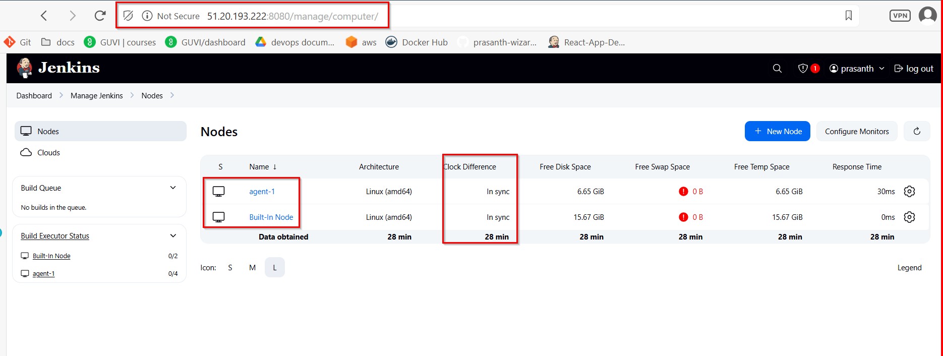

Enable GitHub Webhook Trigger in Jenkins Pipeline:
echo "testing webhook" > webhook-test.txt
git add webhook-test.txt
git commit -m "Testing GitHub webhook trigger"
[dev d8c2273] Testing GitHub webhook trigger
git push origin dev

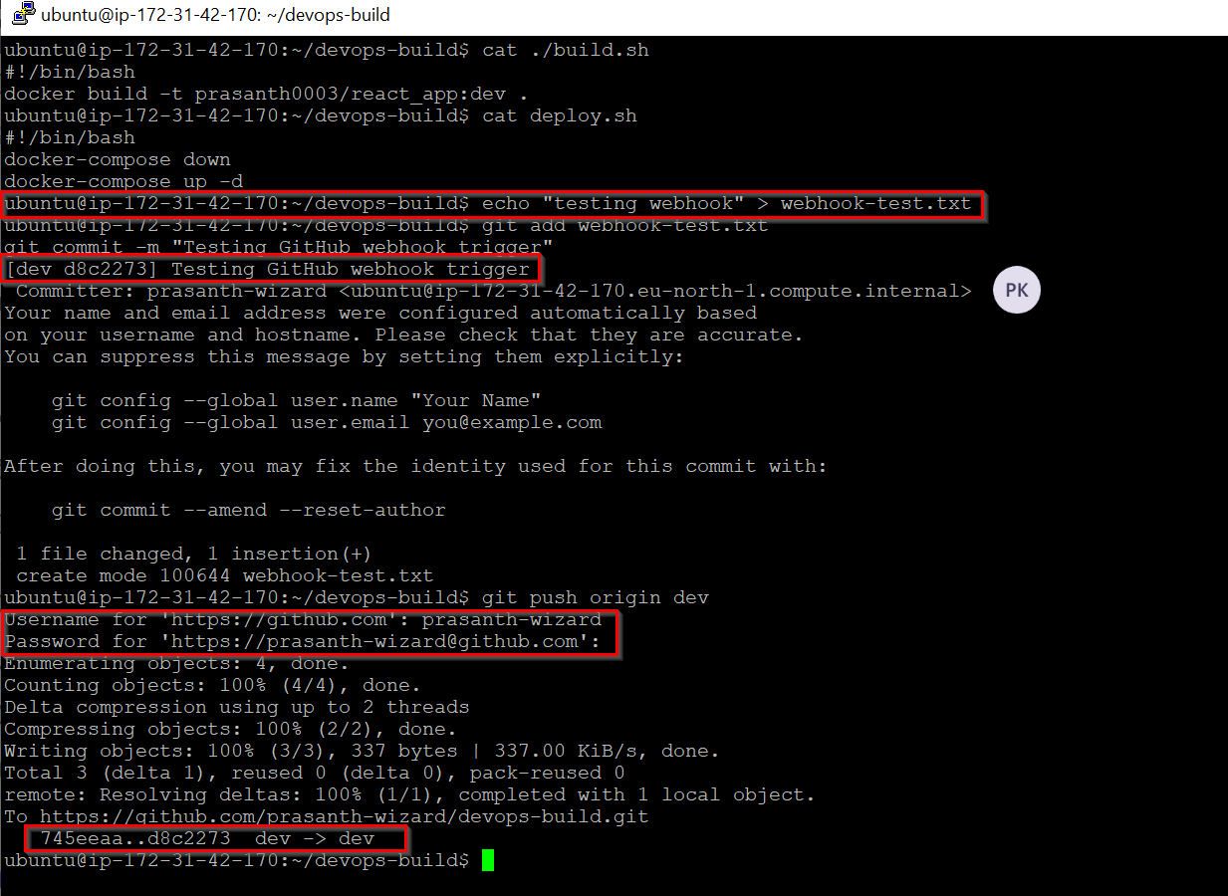

Console Output for dev branch:

Started by GitHub push by prasanth-wizard
Lightweight checkout support not available, falling back to full checkout.
Checking out git https://github.com/prasanth-wizard/devops-build.git into /var/lib/jenkins/workspace/React-App-Deployment@script/6b50294159ccdb405f909776885845b2e9d6bfa09c9732cbd4b075055044ce91 to read Jenkinsfile
Selected Git installation does not exist. Using Default
The recommended git tool is: NONE
using credential github-creds
> git rev-parse --resolve-git-dir /var/lib/jenkins/workspace/React-App-Deployment@script/6b50294159ccdb405f909776885845b2e9d6bfa09c9732cbd4b075055044ce91/.git # timeout=10
Fetching changes from the remote Git repository
> git config remote.origin.url https://github.com/prasanth-wizard/devops-build.git # timeout=10
Fetching upstream changes from https://github.com/prasanth-wizard/devops-build.git
> git --version # timeout=10
> git --version # 'git version 2.34.1'
using GIT_ASKPASS to set credentials GitHub Access Token
> git fetch --tags --force --progress -- https://github.com/prasanth-wizard/devops-build.git +refs/heads/*:refs/remotes/origin/* # timeout=10
Seen branch in repository origin/dev
Seen branch in repository origin/main
Seen 2 remote branches
> git show-ref --tags -d # timeout=10
Checking out Revision 6d2e84dec5c3ccee0e1d596cd518e222a0b97437 (origin/dev)
> git config core.sparsecheckout # timeout=10
> git checkout -f 6d2e84dec5c3ccee0e1d596cd518e222a0b97437 # timeout=10
Commit message: "jenkinsfile update"
> git rev-list --no-walk 4b8fb15bd357bd977f300d7d58ae290acbcaaa1d # timeout=10
[Pipeline] Start of Pipeline
[Pipeline] node
Running on agent-1 in /home/ubuntu/jenkins/workspace/React-App-Deployment
[Pipeline] {
[Pipeline] stage
[Pipeline] { (Declarative: Checkout SCM)
[Pipeline] checkout
Selected Git installation does not exist. Using Default
The recommended git tool is: NONE
using credential github-creds
Fetching changes from the remote Git repository
Checking out Revision 6d2e84dec5c3ccee0e1d596cd518e222a0b97437 (origin/dev)
Commit message: "jenkinsfile update"
[Pipeline] }
[Pipeline] // stage
[Pipeline] withEnv
[Pipeline] {
[Pipeline] withEnv
[Pipeline] {
[Pipeline] stage
[Pipeline] { (Checkout Code)
[Pipeline] checkout
Selected Git installation does not exist. Using Default
The recommended git tool is: NONE
using credential github-creds
Fetching changes from the remote Git repository
Checking out Revision 6d2e84dec5c3ccee0e1d596cd518e222a0b97437 (origin/dev)
Commit message: "jenkinsfile update"
> git rev-parse --resolve-git-dir /home/ubuntu/jenkins/workspace/React-App-Deployment/.git # timeout=10
> git config remote.origin.url https://github.com/prasanth-wizard/devops-build.git # timeout=10
Fetching upstream changes from https://github.com/prasanth-wizard/devops-build.git
> git --version # timeout=10
> git --version # 'git version 2.34.1'
using GIT_ASKPASS to set credentials GitHub Access Token
> git fetch --tags --force --progress -- https://github.com/prasanth-wizard/devops-build.git +refs/heads/*:refs/remotes/origin/* # timeout=10
Seen branch in repository origin/dev
Seen branch in repository origin/main
Seen 2 remote branches
> git show-ref --tags -d # timeout=10
> git config core.sparsecheckout # timeout=10
> git checkout -f 6d2e84dec5c3ccee0e1d596cd518e222a0b97437 # timeout=10
[Pipeline] script
[Pipeline] {
[Pipeline] sh
+ git rev-parse --short=7 HEAD
[Pipeline] echo
Branch: dev
[Pipeline] echo
Image Tags: docker.io/prasanth0003/dev:6d2e84d docker.io/prasanth0003/dev:latest docker.io/prasanth0003/dev:dev docker.io/prasanth0003/dev:62
[Pipeline] }
[Pipeline] // script
[Pipeline] }
[Pipeline] // stage
[Pipeline] stage
[Pipeline] { (Build Docker Image)
[Pipeline] script
[Pipeline] {
> git rev-parse --resolve-git-dir /home/ubuntu/jenkins/workspace/React-App-Deployment/.git # timeout=10
> git config remote.origin.url https://github.com/prasanth-wizard/devops-build.git # timeout=10
Fetching upstream changes from https://github.com/prasanth-wizard/devops-build.git
> git --version # timeout=10
> git --version # 'git version 2.34.1'
using GIT_ASKPASS to set credentials GitHub Access Token
> git fetch --tags --force --progress -- https://github.com/prasanth-wizard/devops-build.git +refs/heads/*:refs/remotes/origin/* # timeout=10
Seen branch in repository origin/dev
Seen branch in repository origin/main
Seen 2 remote branches
> git show-ref --tags -d # timeout=10
> git config core.sparsecheckout # timeout=10
> git checkout -f 6d2e84dec5c3ccee0e1d596cd518e222a0b97437 # timeout=10
[Pipeline] sh
+ docker build -t docker.io/prasanth0003/dev:6d2e84d -t docker.io/prasanth0003/dev:latest -t docker.io/prasanth0003/dev:dev -t docker.io/prasanth0003/dev:62 .
DEPRECATED: The legacy builder is deprecated and will be removed in a future release.
Install the buildx component to build images with BuildKit:
https://docs.docker.com/go/buildx/

Sending build context to Docker daemon 2.633MB

Step 1/6 : FROM nginx:alpine
---> 6769dc3a703c
Step 2/6 : WORKDIR /usr/share/nginx/html
---> Using cache
---> 7a981b94e632
Step 3/6 : RUN rm -rf ./*
---> Using cache
---> 24d854bee91b
Step 4/6 : COPY build/ .
---> Using cache
---> ef3addf8967e
Step 5/6 : EXPOSE 80
---> Using cache
---> 4729f3fc2f6a
Step 6/6 : CMD ["nginx", "-g", "daemon off;"]
---> Using cache
---> 9cac7341a0dd
Successfully built 9cac7341a0dd
Successfully tagged prasanth0003/dev:6d2e84d
Successfully tagged prasanth0003/dev:latest
Successfully tagged prasanth0003/dev:dev
Successfully tagged prasanth0003/dev:62
+ docker images
+ grep prasanth0003
prasanth0003/dev 62 9cac7341a0dd 57 minutes ago 50.8MB
prasanth0003/dev 6d2e84d 9cac7341a0dd 57 minutes ago 50.8MB
prasanth0003/dev dev 9cac7341a0dd 57 minutes ago 50.8MB
prasanth0003/dev latest 9cac7341a0dd 57 minutes ago 50.8MB
prasanth0003/prod 1.0.58 9cac7341a0dd 57 minutes ago 50.8MB
prasanth0003/prod 1.0.60 9cac7341a0dd 57 minutes ago 50.8MB
prasanth0003/prod latest 9cac7341a0dd 57 minutes ago 50.8MB
prasanth0003/dev <none> 0d761b2d38d1 27 hours ago 50.8MB
[Pipeline] sh
+ docker inspect --type=image docker.io/prasanth0003/dev:6d2e84d
[
{
"Id": "sha256:9cac7341a0ddf876542c4c8898fb02f887fdf4597758a075cd37982ec40dee2d",
"RepoTags": [
"prasanth0003/dev:62",
"prasanth0003/dev:6d2e84d",
"prasanth0003/dev:dev",
"prasanth0003/dev:latest",
"prasanth0003/prod:1.0.58",
"prasanth0003/prod:1.0.60",
"prasanth0003/prod:latest"
],
"RepoDigests": [
"prasanth0003/dev@sha256:6fe52943a7b972cef9c2615d6d5a22220eb912ecfbe1ba77375f385a5da720a6",
"prasanth0003/prod@sha256:6fe52943a7b972cef9c2615d6d5a22220eb912ecfbe1ba77375f385a5da720a6"
],
"Parent": "sha256:4729f3fc2f6a950cf7f7dd9430e0159dbe05346d30f414174142d7c0019cd45e",
"Comment": "",
"Created": "2025-06-11T17:08:50.798025408Z",
"DockerVersion": "27.5.1",
"Author": "",
"Config": {
"Hostname": "",
"Domainname": "",
"User": "",
"AttachStdin": false,
"AttachStdout": false,
"AttachStderr": false,
"ExposedPorts": {
"80/tcp": {}
},
"Tty": false,
"OpenStdin": false,
"StdinOnce": false,
"Env": [
"PATH=/usr/local/sbin:/usr/local/bin:/usr/sbin:/usr/bin:/sbin:/bin",
"NGINX_VERSION=1.27.5",
"PKG_RELEASE=1",
"DYNPKG_RELEASE=1",
"NJS_VERSION=0.8.10",
"NJS_RELEASE=1"
],
"Cmd": [
"nginx",
"-g",
"daemon off;"
],
"Image": "sha256:4729f3fc2f6a950cf7f7dd9430e0159dbe05346d30f414174142d7c0019cd45e",
"Volumes": null,
"WorkingDir": "/usr/share/nginx/html",
"Entrypoint": [
"/docker-entrypoint.sh"
],
"OnBuild": null,
"Labels": {
"maintainer": "NGINX Docker Maintainers <docker-maint@nginx.com>"
},
"StopSignal": "SIGQUIT"
},
"Architecture": "amd64",
"Os": "linux",
"Size": 50842926,
"GraphDriver": {
"Data": {
"LowerDir": "/var/lib/docker/overlay2/b7384d2a13d0d8dd222103044ef3e0ecb18e20e7f49360ac4e1bad206c0696b9/diff:/var/lib/docker/overlay2/2e53d516ba6efe288ee1c3e1910c0ec144704e03bc624c5334a978ab64fa787c/diff:/var/lib/docker/overlay2/063be06a73b0e59d3e23d3fc604d70c6efa113c40d645d32e074d78544dbfc70/diff:/var/lib/docker/overlay2/bfe6a78617ea0c01fd83530f7a63ca2da6588277bfe05f3ea9b27afa8708c3bc/diff:/var/lib/docker/overlay2/0526f6e2120601cee541b71f55573e0bd52e01d8a0ce3828da59cdd45dc38b87/diff:/var/lib/docker/overlay2/e99e398efb3034da28bcb2fb58147808859cafafa01919e78746f60d99e5ecd7/diff:/var/lib/docker/overlay2/1e2d5648db4b7db345be0a075d7ec3dcf9b16400a06343220bd256408f138b2f/diff:/var/lib/docker/overlay2/66a68b332a6872a0907ce4d714372c176673b96e6357aca642f5cd2225e9d080/diff:/var/lib/docker/overlay2/5ace7f0c811f4ccea9b85c7ecf0118cd6d2d209e76bf98ad607589e34ad2c2eb/diff",
"MergedDir": "/var/lib/docker/overlay2/070b7b4559afdfd2d317acf9ca7531427b88a9c9c1fc4314276999846a474146/merged",
"UpperDir": "/var/lib/docker/overlay2/070b7b4559afdfd2d317acf9ca7531427b88a9c9c1fc4314276999846a474146/diff",
"WorkDir": "/var/lib/docker/overlay2/070b7b4559afdfd2d317acf9ca7531427b88a9c9c1fc4314276999846a474146/work"
},
"Name": "overlay2"
},
"RootFS": {
"Type": "layers",
"Layers": [
"sha256:08000c18d16dadf9553d747a58cf44023423a9ab010aab96cf263d2216b8b350",
"sha256:d71eae0084c1aa823dd8fb2ecf8604d5c0f4911226c042bb1f8297e819f4b192",
"sha256:c56f134d380585340a68d0db2f2c170641a1c0ff72ccf2438cf2f693df756a85",
"sha256:e244aa659f612a80c40dd8645812301e3def6b15ec67b9e486ed2201172b51d1",
"sha256:b8d7d1d2263425d6044e059b2810017d062d659b9b755241f3747eda77726250",
"sha256:811a4dbbf4a5309e4390cf655c12db92e1a4304fb9d9731f83e7b02e95a617c6",
"sha256:947e805a4ac71f68e6703550c0b36c2aa2e554c4fa670ca2da6a25c6d7dccb66",
"sha256:0d853d50b128aa460b47e7121849463a14b18d4fd976caf5014744aae24d28aa",
"sha256:0741406cbd2ef066f67447fc167b14bb4451821de55541197fe2fa6a11d50c2c",
"sha256:320d0d9d1060d5ea2a301d007c3f7b3646a109583286a53031dee51ffecbf5a2"
]
},
"Metadata": {
"LastTagTime": "2025-06-11T18:05:55.684599876Z"
}
}
]
[Pipeline] }
[Pipeline] // script
[Pipeline] }
[Pipeline] // stage
[Pipeline] stage
[Pipeline] { (Push Docker Image)
[Pipeline] withCredentials
Masking supported pattern matches of $DOCKER_PASS
[Pipeline] {
[Pipeline] script
[Pipeline] {
[Pipeline] sh
Warning: A secret was passed to "sh" using Groovy String interpolation, which is insecure.
Affected argument(s) used the following variable(s): [DOCKER_PASS]
See https://jenkins.io/redirect/groovy-string-interpolation for details.
+ echo ****
+ docker login -u prasanth0003 --password-stdin
WARNING! Your password will be stored unencrypted in /home/ubuntu/.docker/config.json.
Configure a credential helper to remove this warning. See
https://docs.docker.com/engine/reference/commandline/login/#credential-stores

Login Succeeded
[Pipeline] retry
[Pipeline] {
[Pipeline] sh
+ docker push docker.io/prasanth0003/dev:6d2e84d
The push refers to repository [docker.io/prasanth0003/dev]
320d0d9d1060: Preparing
0741406cbd2e: Preparing
0d853d50b128: Preparing
947e805a4ac7: Preparing
811a4dbbf4a5: Preparing
b8d7d1d22634: Preparing
e244aa659f61: Preparing
c56f134d3805: Preparing
d71eae0084c1: Preparing
08000c18d16d: Preparing
b8d7d1d22634: Waiting
e244aa659f61: Waiting
c56f134d3805: Waiting
d71eae0084c1: Waiting
08000c18d16d: Waiting
947e805a4ac7: Layer already exists
0741406cbd2e: Layer already exists
0d853d50b128: Layer already exists
811a4dbbf4a5: Layer already exists
320d0d9d1060: Layer already exists
c56f134d3805: Layer already exists
b8d7d1d22634: Layer already exists
e244aa659f61: Layer already exists
08000c18d16d: Layer already exists
d71eae0084c1: Layer already exists
6d2e84d: digest: sha256:6fe52943a7b972cef9c2615d6d5a22220eb912ecfbe1ba77375f385a5da720a6 size: 2406
[Pipeline] }
[Pipeline] // retry
[Pipeline] retry
[Pipeline] {
[Pipeline] sh
+ docker push docker.io/prasanth0003/dev:latest
The push refers to repository [docker.io/prasanth0003/dev]
320d0d9d1060: Preparing
0741406cbd2e: Preparing
0d853d50b128: Preparing
947e805a4ac7: Preparing
811a4dbbf4a5: Preparing
b8d7d1d22634: Preparing
e244aa659f61: Preparing
c56f134d3805: Preparing
d71eae0084c1: Preparing
08000c18d16d: Preparing
b8d7d1d22634: Waiting
e244aa659f61: Waiting
c56f134d3805: Waiting
d71eae0084c1: Waiting
08000c18d16d: Waiting
0d853d50b128: Layer already exists
0741406cbd2e: Layer already exists
947e805a4ac7: Layer already exists
320d0d9d1060: Layer already exists
811a4dbbf4a5: Layer already exists
b8d7d1d22634: Layer already exists
d71eae0084c1: Layer already exists
c56f134d3805: Layer already exists
e244aa659f61: Layer already exists
08000c18d16d: Layer already exists
latest: digest: sha256:6fe52943a7b972cef9c2615d6d5a22220eb912ecfbe1ba77375f385a5da720a6 size: 2406
[Pipeline] }
[Pipeline] // retry
[Pipeline] retry
[Pipeline] {
[Pipeline] sh
+ docker push docker.io/prasanth0003/dev:dev
The push refers to repository [docker.io/prasanth0003/dev]
320d0d9d1060: Preparing
0741406cbd2e: Preparing
0d853d50b128: Preparing
947e805a4ac7: Preparing
811a4dbbf4a5: Preparing
b8d7d1d22634: Preparing
e244aa659f61: Preparing
c56f134d3805: Preparing
d71eae0084c1: Preparing
08000c18d16d: Preparing
b8d7d1d22634: Waiting
e244aa659f61: Waiting
c56f134d3805: Waiting
d71eae0084c1: Waiting
08000c18d16d: Waiting
947e805a4ac7: Layer already exists
320d0d9d1060: Layer already exists
811a4dbbf4a5: Layer already exists
0d853d50b128: Layer already exists
0741406cbd2e: Layer already exists
e244aa659f61: Layer already exists
b8d7d1d22634: Layer already exists
c56f134d3805: Layer already exists
08000c18d16d: Layer already exists
d71eae0084c1: Layer already exists
dev: digest: sha256:6fe52943a7b972cef9c2615d6d5a22220eb912ecfbe1ba77375f385a5da720a6 size: 2406
[Pipeline] }
[Pipeline] // retry
[Pipeline] retry
[Pipeline] {
[Pipeline] sh
+ docker push docker.io/prasanth0003/dev:62
The push refers to repository [docker.io/prasanth0003/dev]
320d0d9d1060: Preparing
0741406cbd2e: Preparing
0d853d50b128: Preparing
947e805a4ac7: Preparing
811a4dbbf4a5: Preparing
b8d7d1d22634: Preparing
e244aa659f61: Preparing
c56f134d3805: Preparing
d71eae0084c1: Preparing
08000c18d16d: Preparing
b8d7d1d22634: Waiting
e244aa659f61: Waiting
c56f134d3805: Waiting
d71eae0084c1: Waiting
08000c18d16d: Waiting
947e805a4ac7: Layer already exists
0741406cbd2e: Layer already exists
0d853d50b128: Layer already exists
320d0d9d1060: Layer already exists
811a4dbbf4a5: Layer already exists
b8d7d1d22634: Layer already exists
d71eae0084c1: Layer already exists
c56f134d3805: Layer already exists
e244aa659f61: Layer already exists
08000c18d16d: Layer already exists
62: digest: sha256:6fe52943a7b972cef9c2615d6d5a22220eb912ecfbe1ba77375f385a5da720a6 size: 2406
[Pipeline] }
[Pipeline] // retry
[Pipeline] }
[Pipeline] // script
[Pipeline] }
[Pipeline] // withCredentials
[Pipeline] }
[Pipeline] // stage
[Pipeline] stage
[Pipeline] { (Deploy to Agent-1)
[Pipeline] script
[Pipeline] {
[Pipeline] withCredentials
Masking supported pattern matches of $SSH_KEY
[Pipeline] {
[Pipeline] sh
Warning: A secret was passed to "sh" using Groovy String interpolation, which is insecure.
Affected argument(s) used the following variable(s): [SSH_KEY]
See https://jenkins.io/redirect/groovy-string-interpolation for details.
+ ssh -o StrictHostKeyChecking=no -i **** ubuntu@51.20.2.247
docker pull docker.io/prasanth0003/dev:6d2e84d
docker stop react-app || true
docker rm react-app || true
docker run -d --name react-app -p 80:80 docker.io/prasanth0003/dev:6d2e84d

6d2e84d: Pulling from prasanth0003/dev
Digest: sha256:6fe52943a7b972cef9c2615d6d5a22220eb912ecfbe1ba77375f385a5da720a6
Status: Image is up to date for prasanth0003/dev:6d2e84d
docker.io/prasanth0003/dev:6d2e84d
react-app
react-app
af17b8a73491244f73310c5acc58fe7765d70c9a4a44eee6646b60e77fd734bb
[Pipeline] echo
🚀 Successfully deployed docker.io/prasanth0003/dev:6d2e84d to 51.20.2.247
[Pipeline] }
[Pipeline] // withCredentials
[Pipeline] }
[Pipeline] // script
[Pipeline] }
[Pipeline] // stage
[Pipeline] stage
[Pipeline] { (Declarative: Post Actions)
[Pipeline] script
[Pipeline] {
[Pipeline] sh
+ docker logout
Removing login credentials for https://index.docker.io/v1/
[Pipeline] sh
+ docker rmi docker.io/prasanth0003/dev:6d2e84d
Untagged: prasanth0003/dev:6d2e84d
[Pipeline] sh
+ docker rmi docker.io/prasanth0003/dev:latest
Untagged: prasanth0003/dev:latest
[Pipeline] sh
+ docker rmi docker.io/prasanth0003/dev:dev
Untagged: prasanth0003/dev:dev
[Pipeline] sh
+ docker rmi docker.io/prasanth0003/dev:62
Untagged: prasanth0003/dev:62
Untagged: prasanth0003/dev@sha256:6fe52943a7b972cef9c2615d6d5a22220eb912ecfbe1ba77375f385a5da720a6
[Pipeline] cleanWs
[WS-CLEANUP] Deleting project workspace...
[WS-CLEANUP] Deferred wipeout is used...
[WS-CLEANUP] done
[Pipeline] }
[Pipeline] // script
[Pipeline] echo
Successfully built and pushed images with tags: docker.io/prasanth0003/dev:6d2e84d docker.io/prasanth0003/dev:latest docker.io/prasanth0003/dev:dev docker.io/prasanth0003/dev:62
[Pipeline] }
[Pipeline] // stage
[Pipeline] }
[Pipeline] // withEnv
[Pipeline] }
[Pipeline] // withEnv
[Pipeline] }
[Pipeline] // node
[Pipeline] End of Pipeline
Finished: SUCCESS

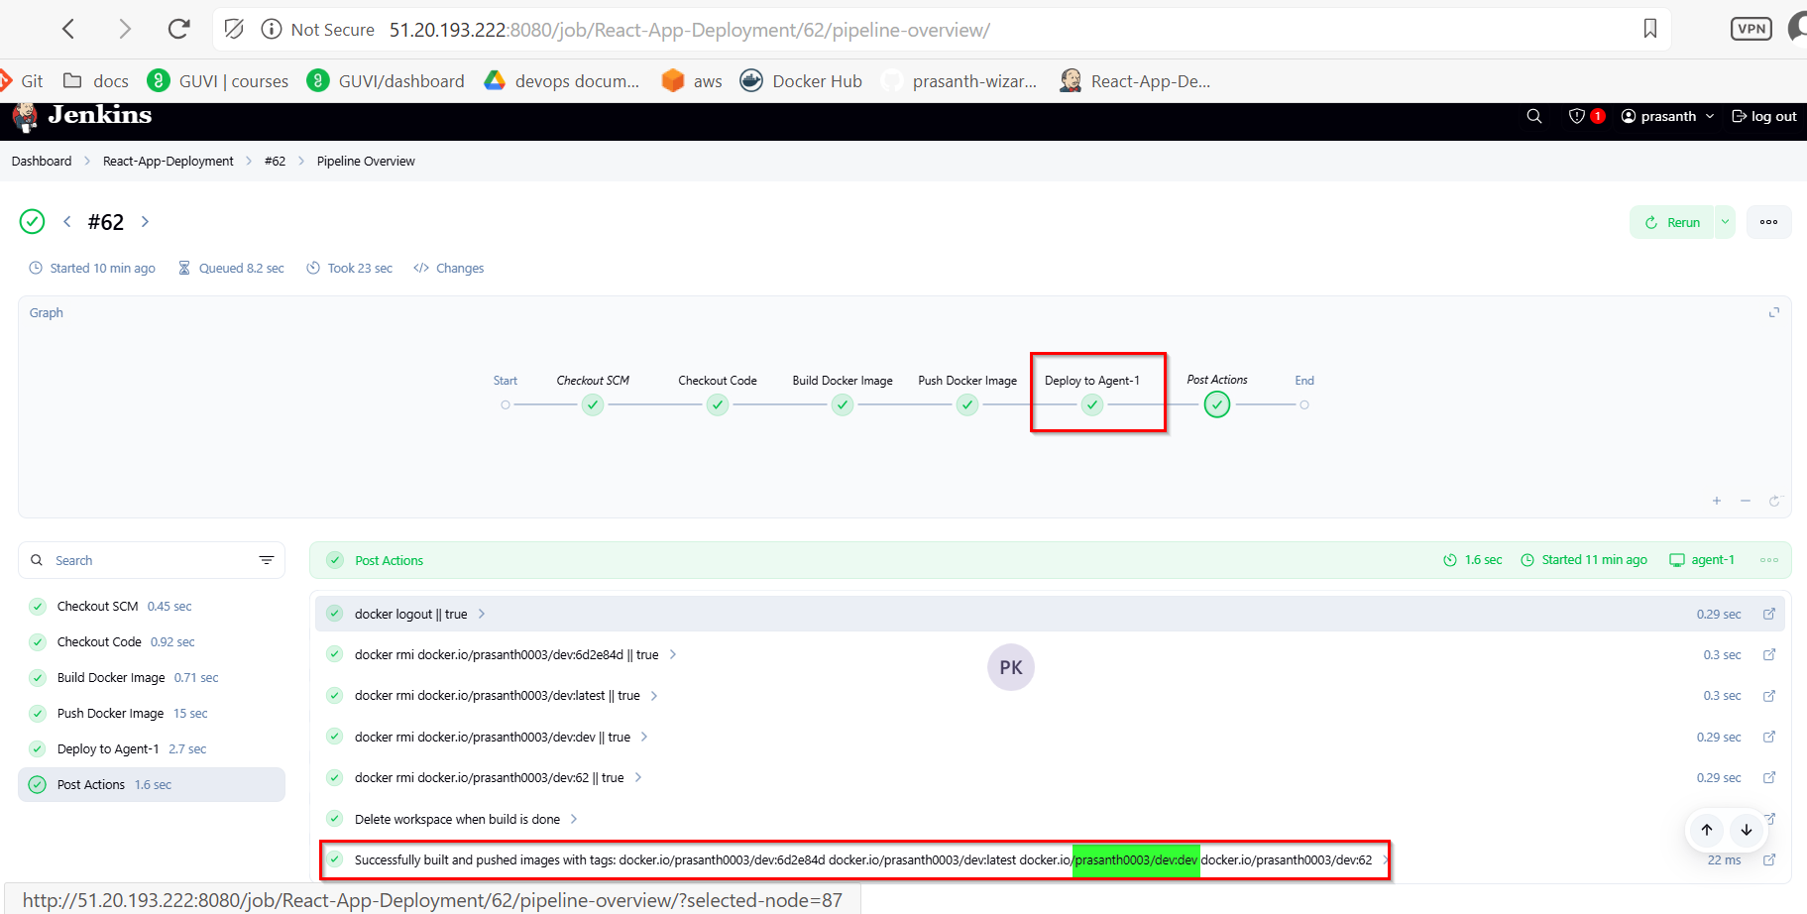

Github dev branch:

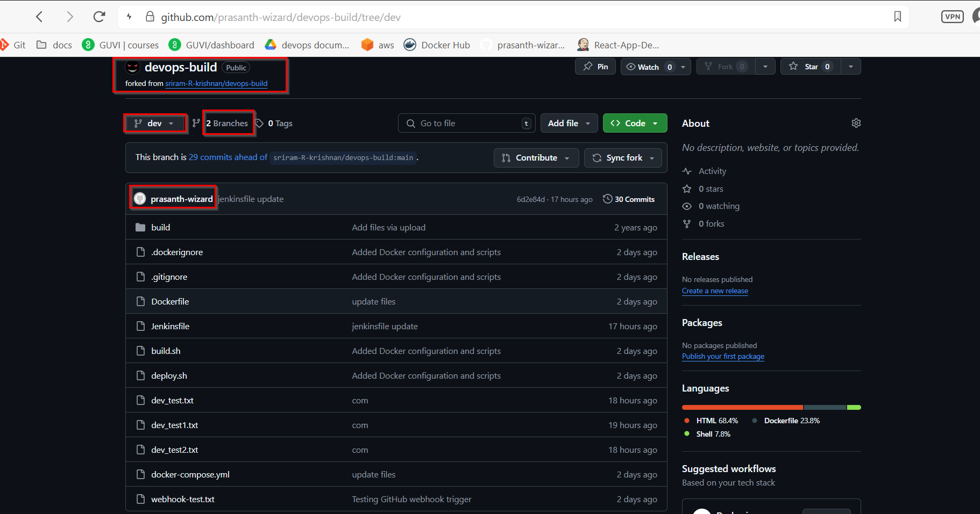

Dev branch merged to main branch:
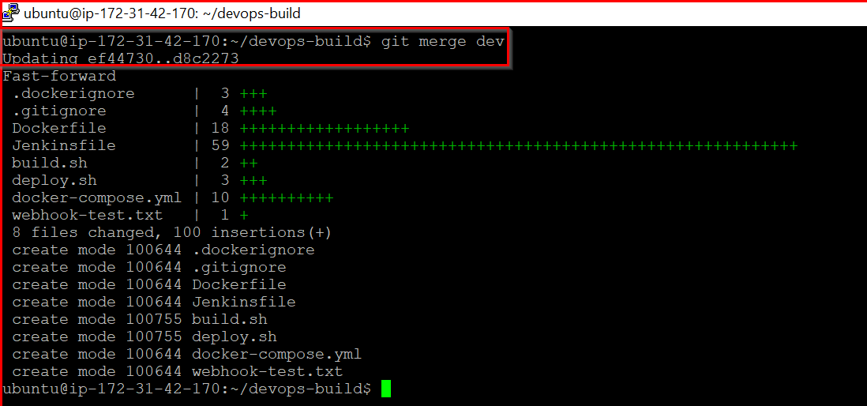
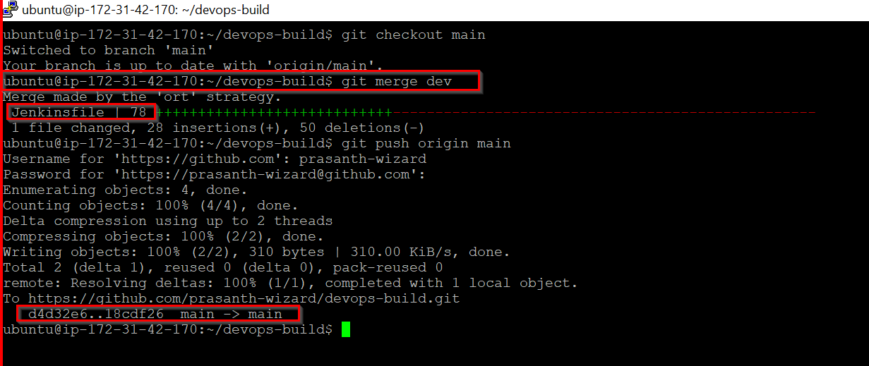

Github main and dev branches:
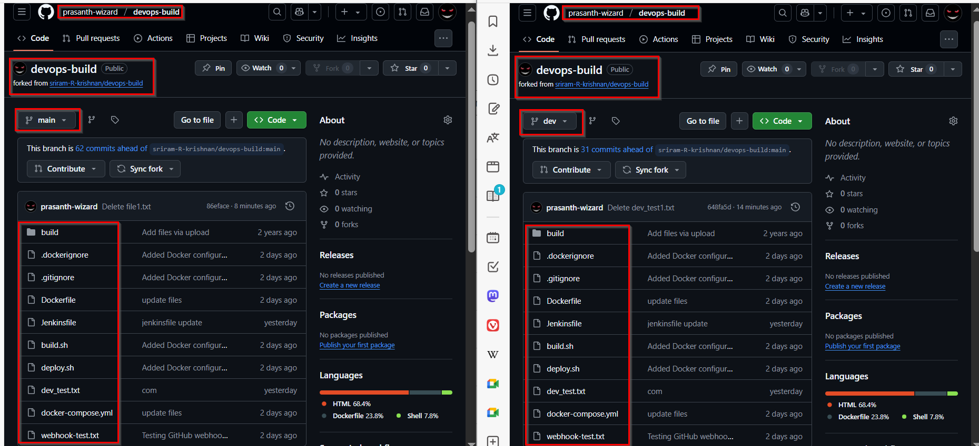
Console Output for main branch:

Started by GitHub push by prasanth-wizard
Lightweight checkout support not available, falling back to full checkout.
Checking out git https://github.com/prasanth-wizard/devops-build.git into /var/lib/jenkins/workspace/React-App-Deployment@script/6b50294159ccdb405f909776885845b2e9d6bfa09c9732cbd4b075055044ce91 to read Jenkinsfile
Selected Git installation does not exist. Using Default
The recommended git tool is: NONE
using credential github-creds
> git rev-parse --resolve-git-dir /var/lib/jenkins/workspace/React-App-Deployment@script/6b50294159ccdb405f909776885845b2e9d6bfa09c9732cbd4b075055044ce91/.git # timeout=10
Fetching changes from the remote Git repository
> git config remote.origin.url https://github.com/prasanth-wizard/devops-build.git # timeout=10
Fetching upstream changes from https://github.com/prasanth-wizard/devops-build.git
> git --version # timeout=10
> git --version # 'git version 2.34.1'
using GIT_ASKPASS to set credentials GitHub Access Token
> git fetch --tags --force --progress -- https://github.com/prasanth-wizard/devops-build.git +refs/heads/*:refs/remotes/origin/* # timeout=10
Seen branch in repository origin/dev
Seen branch in repository origin/main
Seen 2 remote branches
> git show-ref --tags -d # timeout=10
Checking out Revision 18cdf26a339a78d5f2fb474d4966bfa03af6dbd4 (origin/main)
> git config core.sparsecheckout # timeout=10
> git checkout -f 18cdf26a339a78d5f2fb474d4966bfa03af6dbd4 # timeout=10
Commit message: "Merge branch 'dev'"
> git rev-list --no-walk d4d32e693f7322d5eb419e5d99346048310d66ec # timeout=10
[Pipeline] Start of Pipeline
[Pipeline] node
Running on agent-1 in /home/ubuntu/jenkins/workspace/React-App-Deployment
[Pipeline] {
[Pipeline] stage
[Pipeline] { (Declarative: Checkout SCM)
[Pipeline] checkout
Selected Git installation does not exist. Using Default
The recommended git tool is: NONE
using credential github-creds
Cloning the remote Git repository
Avoid second fetch
Checking out Revision 18cdf26a339a78d5f2fb474d4966bfa03af6dbd4 (origin/main)
Commit message: "Merge branch 'dev'"
[Pipeline] }
[Pipeline] // stage
[Pipeline] withEnv
[Pipeline] {
[Pipeline] withEnv
[Pipeline] {
[Pipeline] stage
[Pipeline] { (Checkout Code)
[Pipeline] checkout
Selected Git installation does not exist. Using Default
The recommended git tool is: NONE
using credential github-creds
Fetching changes from the remote Git repository
> git rev-parse --resolve-git-dir /home/ubuntu/jenkins/workspace/React-App-Deployment/.git # timeout=10
> git config remote.origin.url https://github.com/prasanth-wizard/devops-build.git # timeout=10
Cloning repository https://github.com/prasanth-wizard/devops-build.git
> git init /home/ubuntu/jenkins/workspace/React-App-Deployment # timeout=10
Fetching upstream changes from https://github.com/prasanth-wizard/devops-build.git
> git --version # timeout=10
> git --version # 'git version 2.34.1'
using GIT_ASKPASS to set credentials GitHub Access Token
> git fetch --tags --force --progress -- https://github.com/prasanth-wizard/devops-build.git +refs/heads/*:refs/remotes/origin/* # timeout=10
> git config remote.origin.url https://github.com/prasanth-wizard/devops-build.git # timeout=10
> git config --add remote.origin.fetch +refs/heads/*:refs/remotes/origin/* # timeout=10
Seen branch in repository origin/dev
Seen branch in repository origin/main
Seen 2 remote branches
> git show-ref --tags -d # timeout=10
> git config core.sparsecheckout # timeout=10
> git checkout -f 18cdf26a339a78d5f2fb474d4966bfa03af6dbd4 # timeout=10
Checking out Revision 18cdf26a339a78d5f2fb474d4966bfa03af6dbd4 (origin/main)
Commit message: "Merge branch 'dev'"
[Pipeline] script
[Pipeline] {
[Pipeline] sh
+ git rev-parse --short=7 HEAD
[Pipeline] echo
Branch: main
[Pipeline] echo
Image Tags: docker.io/prasanth0003/prod:18cdf26 docker.io/prasanth0003/prod:latest docker.io/prasanth0003/prod:main docker.io/prasanth0003/prod:63
[Pipeline] }
[Pipeline] // script
[Pipeline] }
[Pipeline] // stage
[Pipeline] stage
[Pipeline] { (Build Docker Image)
[Pipeline] script
[Pipeline] {
Fetching upstream changes from https://github.com/prasanth-wizard/devops-build.git
> git --version # timeout=10
> git --version # 'git version 2.34.1'
using GIT_ASKPASS to set credentials GitHub Access Token
> git fetch --tags --force --progress -- https://github.com/prasanth-wizard/devops-build.git +refs/heads/*:refs/remotes/origin/* # timeout=10
Seen branch in repository origin/dev
Seen branch in repository origin/main
Seen 2 remote branches
> git show-ref --tags -d # timeout=10
> git config core.sparsecheckout # timeout=10
> git checkout -f 18cdf26a339a78d5f2fb474d4966bfa03af6dbd4 # timeout=10
[Pipeline] sh
+ docker build -t docker.io/prasanth0003/prod:18cdf26 -t docker.io/prasanth0003/prod:latest -t docker.io/prasanth0003/prod:main -t docker.io/prasanth0003/prod:63 .
DEPRECATED: The legacy builder is deprecated and will be removed in a future release.
Install the buildx component to build images with BuildKit:
https://docs.docker.com/go/buildx/

Sending build context to Docker daemon 2.64MB

Step 1/6 : FROM nginx:alpine
---> 6769dc3a703c
Step 2/6 : WORKDIR /usr/share/nginx/html
---> Using cache
---> 7a981b94e632
Step 3/6 : RUN rm -rf ./*
---> Using cache
---> 24d854bee91b
Step 4/6 : COPY build/ .
---> Using cache
---> ef3addf8967e
Step 5/6 : EXPOSE 80
---> Using cache
---> 4729f3fc2f6a
Step 6/6 : CMD ["nginx", "-g", "daemon off;"]
---> Using cache
---> 9cac7341a0dd
Successfully built 9cac7341a0dd
Successfully tagged prasanth0003/prod:18cdf26
Successfully tagged prasanth0003/prod:latest
Successfully tagged prasanth0003/prod:main
Successfully tagged prasanth0003/prod:63
+ docker images
+ grep prasanth0003
prasanth0003/prod 1.0.58 9cac7341a0dd About an hour ago 50.8MB
prasanth0003/prod 1.0.60 9cac7341a0dd About an hour ago 50.8MB
prasanth0003/prod 18cdf26 9cac7341a0dd About an hour ago 50.8MB
prasanth0003/prod 63 9cac7341a0dd About an hour ago 50.8MB
prasanth0003/prod latest 9cac7341a0dd About an hour ago 50.8MB
prasanth0003/prod main 9cac7341a0dd About an hour ago 50.8MB
prasanth0003/dev <none> 0d761b2d38d1 27 hours ago 50.8MB
[Pipeline] sh
+ docker inspect --type=image docker.io/prasanth0003/prod:18cdf26
[
{
"Id": "sha256:9cac7341a0ddf876542c4c8898fb02f887fdf4597758a075cd37982ec40dee2d",
"RepoTags": [
"prasanth0003/prod:1.0.58",
"prasanth0003/prod:1.0.60",
"prasanth0003/prod:18cdf26",
"prasanth0003/prod:63",
"prasanth0003/prod:latest",
"prasanth0003/prod:main"
],
"RepoDigests": [
"prasanth0003/prod@sha256:6fe52943a7b972cef9c2615d6d5a22220eb912ecfbe1ba77375f385a5da720a6"
],
"Parent": "sha256:4729f3fc2f6a950cf7f7dd9430e0159dbe05346d30f414174142d7c0019cd45e",
"Comment": "",
"Created": "2025-06-11T17:08:50.798025408Z",
"DockerVersion": "27.5.1",
"Author": "",
"Config": {
"Hostname": "",
"Domainname": "",
"User": "",
"AttachStdin": false,
"AttachStdout": false,
"AttachStderr": false,
"ExposedPorts": {
"80/tcp": {}
},
"Tty": false,
"OpenStdin": false,
"StdinOnce": false,
"Env": [
"PATH=/usr/local/sbin:/usr/local/bin:/usr/sbin:/usr/bin:/sbin:/bin",
"NGINX_VERSION=1.27.5",
"PKG_RELEASE=1",
"DYNPKG_RELEASE=1",
"NJS_VERSION=0.8.10",
"NJS_RELEASE=1"
],
"Cmd": [
"nginx",
"-g",
"daemon off;"
],
"Image": "sha256:4729f3fc2f6a950cf7f7dd9430e0159dbe05346d30f414174142d7c0019cd45e",
"Volumes": null,
"WorkingDir": "/usr/share/nginx/html",
"Entrypoint": [
"/docker-entrypoint.sh"
],
"OnBuild": null,
"Labels": {
"maintainer": "NGINX Docker Maintainers <docker-maint@nginx.com>"
},
"StopSignal": "SIGQUIT"
},
"Architecture": "amd64",
"Os": "linux",
"Size": 50842926,
"GraphDriver": {
"Data": {
"LowerDir": "/var/lib/docker/overlay2/b7384d2a13d0d8dd222103044ef3e0ecb18e20e7f49360ac4e1bad206c0696b9/diff:/var/lib/docker/overlay2/2e53d516ba6efe288ee1c3e1910c0ec144704e03bc624c5334a978ab64fa787c/diff:/var/lib/docker/overlay2/063be06a73b0e59d3e23d3fc604d70c6efa113c40d645d32e074d78544dbfc70/diff:/var/lib/docker/overlay2/bfe6a78617ea0c01fd83530f7a63ca2da6588277bfe05f3ea9b27afa8708c3bc/diff:/var/lib/docker/overlay2/0526f6e2120601cee541b71f55573e0bd52e01d8a0ce3828da59cdd45dc38b87/diff:/var/lib/docker/overlay2/e99e398efb3034da28bcb2fb58147808859cafafa01919e78746f60d99e5ecd7/diff:/var/lib/docker/overlay2/1e2d5648db4b7db345be0a075d7ec3dcf9b16400a06343220bd256408f138b2f/diff:/var/lib/docker/overlay2/66a68b332a6872a0907ce4d714372c176673b96e6357aca642f5cd2225e9d080/diff:/var/lib/docker/overlay2/5ace7f0c811f4ccea9b85c7ecf0118cd6d2d209e76bf98ad607589e34ad2c2eb/diff",
"MergedDir": "/var/lib/docker/overlay2/070b7b4559afdfd2d317acf9ca7531427b88a9c9c1fc4314276999846a474146/merged",
"UpperDir": "/var/lib/docker/overlay2/070b7b4559afdfd2d317acf9ca7531427b88a9c9c1fc4314276999846a474146/diff",
"WorkDir": "/var/lib/docker/overlay2/070b7b4559afdfd2d317acf9ca7531427b88a9c9c1fc4314276999846a474146/work"
},
"Name": "overlay2"
},
"RootFS": {
"Type": "layers",
"Layers": [
"sha256:08000c18d16dadf9553d747a58cf44023423a9ab010aab96cf263d2216b8b350",
"sha256:d71eae0084c1aa823dd8fb2ecf8604d5c0f4911226c042bb1f8297e819f4b192",
"sha256:c56f134d380585340a68d0db2f2c170641a1c0ff72ccf2438cf2f693df756a85",
"sha256:e244aa659f612a80c40dd8645812301e3def6b15ec67b9e486ed2201172b51d1",
"sha256:b8d7d1d2263425d6044e059b2810017d062d659b9b755241f3747eda77726250",
"sha256:811a4dbbf4a5309e4390cf655c12db92e1a4304fb9d9731f83e7b02e95a617c6",
"sha256:947e805a4ac71f68e6703550c0b36c2aa2e554c4fa670ca2da6a25c6d7dccb66",
"sha256:0d853d50b128aa460b47e7121849463a14b18d4fd976caf5014744aae24d28aa",
"sha256:0741406cbd2ef066f67447fc167b14bb4451821de55541197fe2fa6a11d50c2c",
"sha256:320d0d9d1060d5ea2a301d007c3f7b3646a109583286a53031dee51ffecbf5a2"
]
},
"Metadata": {
"LastTagTime": "2025-06-11T18:09:50.934996153Z"
}
}
]
[Pipeline] }
[Pipeline] // script
[Pipeline] }
[Pipeline] // stage
[Pipeline] stage
[Pipeline] { (Push Docker Image)
[Pipeline] withCredentials
Masking supported pattern matches of $DOCKER_PASS
[Pipeline] {
[Pipeline] script
[Pipeline] {
[Pipeline] sh
Warning: A secret was passed to "sh" using Groovy String interpolation, which is insecure.
Affected argument(s) used the following variable(s): [DOCKER_PASS]
See https://jenkins.io/redirect/groovy-string-interpolation for details.
+ echo ****
+ docker login -u prasanth0003 --password-stdin
WARNING! Your password will be stored unencrypted in /home/ubuntu/.docker/config.json.
Configure a credential helper to remove this warning. See
https://docs.docker.com/engine/reference/commandline/login/#credential-stores

Login Succeeded
[Pipeline] retry
[Pipeline] {
[Pipeline] sh
+ docker push docker.io/prasanth0003/prod:18cdf26
The push refers to repository [docker.io/prasanth0003/prod]
320d0d9d1060: Preparing
0741406cbd2e: Preparing
0d853d50b128: Preparing
947e805a4ac7: Preparing
811a4dbbf4a5: Preparing
b8d7d1d22634: Preparing
e244aa659f61: Preparing
c56f134d3805: Preparing
d71eae0084c1: Preparing
08000c18d16d: Preparing
e244aa659f61: Waiting
c56f134d3805: Waiting
d71eae0084c1: Waiting
08000c18d16d: Waiting
b8d7d1d22634: Waiting
0d853d50b128: Mounted from prasanth0003/dev
947e805a4ac7: Mounted from prasanth0003/dev
320d0d9d1060: Mounted from prasanth0003/dev
0741406cbd2e: Mounted from prasanth0003/dev
811a4dbbf4a5: Mounted from prasanth0003/dev
b8d7d1d22634: Mounted from prasanth0003/dev
c56f134d3805: Mounted from prasanth0003/dev
e244aa659f61: Mounted from prasanth0003/dev
d71eae0084c1: Mounted from prasanth0003/dev
08000c18d16d: Mounted from prasanth0003/dev
18cdf26: digest: sha256:6fe52943a7b972cef9c2615d6d5a22220eb912ecfbe1ba77375f385a5da720a6 size: 2406
[Pipeline] }
[Pipeline] // retry
[Pipeline] retry
[Pipeline] {
[Pipeline] sh
+ docker push docker.io/prasanth0003/prod:latest
The push refers to repository [docker.io/prasanth0003/prod]
320d0d9d1060: Preparing
0741406cbd2e: Preparing
0d853d50b128: Preparing
947e805a4ac7: Preparing
811a4dbbf4a5: Preparing
b8d7d1d22634: Preparing
e244aa659f61: Preparing
c56f134d3805: Preparing
d71eae0084c1: Preparing
08000c18d16d: Preparing
b8d7d1d22634: Waiting
e244aa659f61: Waiting
c56f134d3805: Waiting
d71eae0084c1: Waiting
08000c18d16d: Waiting
947e805a4ac7: Layer already exists
811a4dbbf4a5: Layer already exists
0741406cbd2e: Layer already exists
320d0d9d1060: Layer already exists
0d853d50b128: Layer already exists
b8d7d1d22634: Layer already exists
e244aa659f61: Layer already exists
c56f134d3805: Layer already exists
d71eae0084c1: Layer already exists
08000c18d16d: Layer already exists
latest: digest: sha256:6fe52943a7b972cef9c2615d6d5a22220eb912ecfbe1ba77375f385a5da720a6 size: 2406
[Pipeline] }
[Pipeline] // retry
[Pipeline] retry
[Pipeline] {
[Pipeline] sh
+ docker push docker.io/prasanth0003/prod:main
The push refers to repository [docker.io/prasanth0003/prod]
320d0d9d1060: Preparing
0741406cbd2e: Preparing
0d853d50b128: Preparing
947e805a4ac7: Preparing
811a4dbbf4a5: Preparing
b8d7d1d22634: Preparing
e244aa659f61: Preparing
c56f134d3805: Preparing
d71eae0084c1: Preparing
08000c18d16d: Preparing
e244aa659f61: Waiting
c56f134d3805: Waiting
d71eae0084c1: Waiting
08000c18d16d: Waiting
b8d7d1d22634: Waiting
0d853d50b128: Layer already exists
811a4dbbf4a5: Layer already exists
320d0d9d1060: Layer already exists
947e805a4ac7: Layer already exists
0741406cbd2e: Layer already exists
e244aa659f61: Layer already exists
d71eae0084c1: Layer already exists
08000c18d16d: Layer already exists
b8d7d1d22634: Layer already exists
c56f134d3805: Layer already exists
main: digest: sha256:6fe52943a7b972cef9c2615d6d5a22220eb912ecfbe1ba77375f385a5da720a6 size: 2406
[Pipeline] }
[Pipeline] // retry
[Pipeline] retry
[Pipeline] {
[Pipeline] sh
+ docker push docker.io/prasanth0003/prod:63
The push refers to repository [docker.io/prasanth0003/prod]
320d0d9d1060: Preparing
0741406cbd2e: Preparing
0d853d50b128: Preparing
947e805a4ac7: Preparing
811a4dbbf4a5: Preparing
b8d7d1d22634: Preparing
e244aa659f61: Preparing
c56f134d3805: Preparing
d71eae0084c1: Preparing
08000c18d16d: Preparing
b8d7d1d22634: Waiting
e244aa659f61: Waiting
c56f134d3805: Waiting
d71eae0084c1: Waiting
08000c18d16d: Waiting
0d853d50b128: Layer already exists
811a4dbbf4a5: Layer already exists
947e805a4ac7: Layer already exists
320d0d9d1060: Layer already exists
0741406cbd2e: Layer already exists
b8d7d1d22634: Layer already exists
c56f134d3805: Layer already exists
d71eae0084c1: Layer already exists
e244aa659f61: Layer already exists
08000c18d16d: Layer already exists
63: digest: sha256:6fe52943a7b972cef9c2615d6d5a22220eb912ecfbe1ba77375f385a5da720a6 size: 2406
[Pipeline] }
[Pipeline] // retry
[Pipeline] }
[Pipeline] // script
[Pipeline] }
[Pipeline] // withCredentials
[Pipeline] }
[Pipeline] // stage
[Pipeline] stage
[Pipeline] { (Deploy to Agent-1)
[Pipeline] script
[Pipeline] {
[Pipeline] withCredentials
Masking supported pattern matches of $SSH_KEY
[Pipeline] {
[Pipeline] sh
Warning: A secret was passed to "sh" using Groovy String interpolation, which is insecure.
Affected argument(s) used the following variable(s): [SSH_KEY]
See https://jenkins.io/redirect/groovy-string-interpolation for details.
+ ssh -o StrictHostKeyChecking=no -i **** ubuntu@51.20.2.247
docker pull docker.io/prasanth0003/prod:18cdf26
docker stop react-app || true
docker rm react-app || true
docker run -d --name react-app -p 80:80 docker.io/prasanth0003/prod:18cdf26

18cdf26: Pulling from prasanth0003/prod
Digest: sha256:6fe52943a7b972cef9c2615d6d5a22220eb912ecfbe1ba77375f385a5da720a6
Status: Image is up to date for prasanth0003/prod:18cdf26
docker.io/prasanth0003/prod:18cdf26
react-app
react-app
416cc29d68d57f5c2dfcf681898a935722d9c7dcb851828839c8cb8f1fe51755
[Pipeline] echo
🚀 Successfully deployed docker.io/prasanth0003/prod:18cdf26 to 51.20.2.247
[Pipeline] }
[Pipeline] // withCredentials
[Pipeline] }
[Pipeline] // script
[Pipeline] }
[Pipeline] // stage
[Pipeline] stage
[Pipeline] { (Declarative: Post Actions)
[Pipeline] script
[Pipeline] {
[Pipeline] sh
+ docker logout
Removing login credentials for https://index.docker.io/v1/
[Pipeline] sh
+ docker rmi docker.io/prasanth0003/prod:18cdf26
Untagged: prasanth0003/prod:18cdf26
[Pipeline] sh
+ docker rmi docker.io/prasanth0003/prod:latest
Untagged: prasanth0003/prod:latest
[Pipeline] sh
+ docker rmi docker.io/prasanth0003/prod:main
Untagged: prasanth0003/prod:main
[Pipeline] sh
+ docker rmi docker.io/prasanth0003/prod:63
Untagged: prasanth0003/prod:63
[Pipeline] cleanWs
[WS-CLEANUP] Deleting project workspace...
[WS-CLEANUP] Deferred wipeout is used...
[WS-CLEANUP] done
[Pipeline] }
[Pipeline] // script
[Pipeline] echo
Successfully built and pushed images with tags: docker.io/prasanth0003/prod:18cdf26 docker.io/prasanth0003/prod:latest docker.io/prasanth0003/prod:main docker.io/prasanth0003/prod:63
[Pipeline] }
[Pipeline] // stage
[Pipeline] }
[Pipeline] // withEnv
[Pipeline] }
[Pipeline] // withEnv
[Pipeline] }
[Pipeline] // node
[Pipeline] End of Pipeline
Finished: SUCCESS

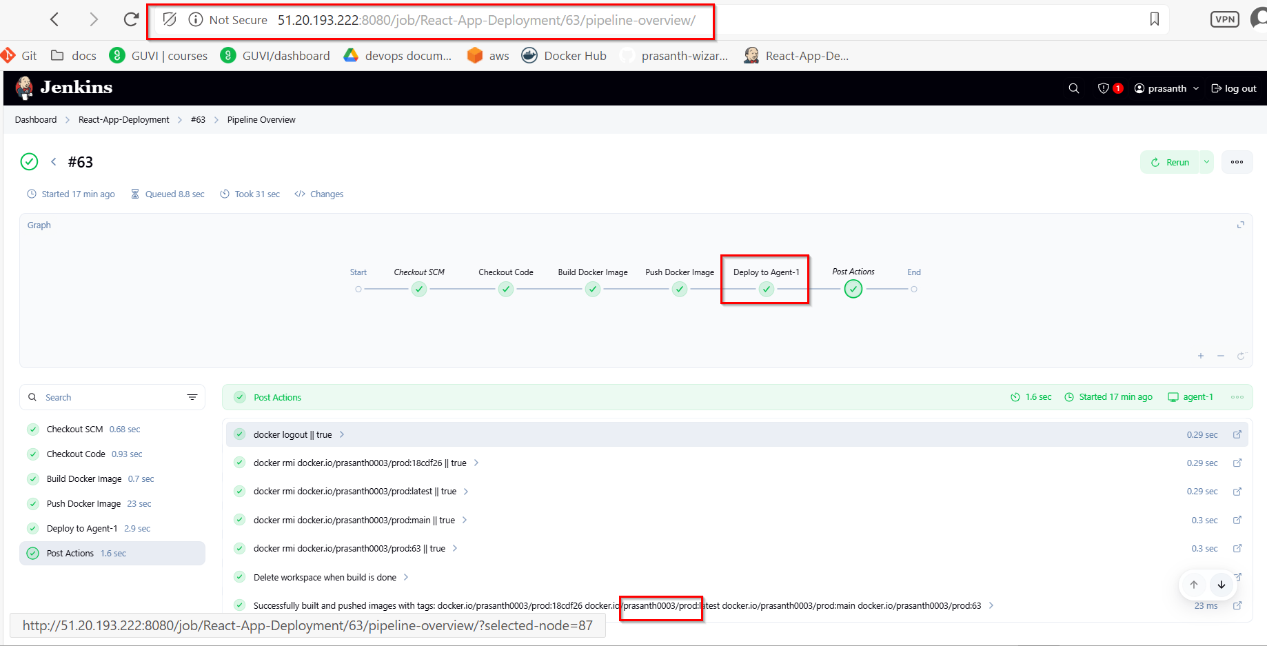

Dockerhub “dev” public: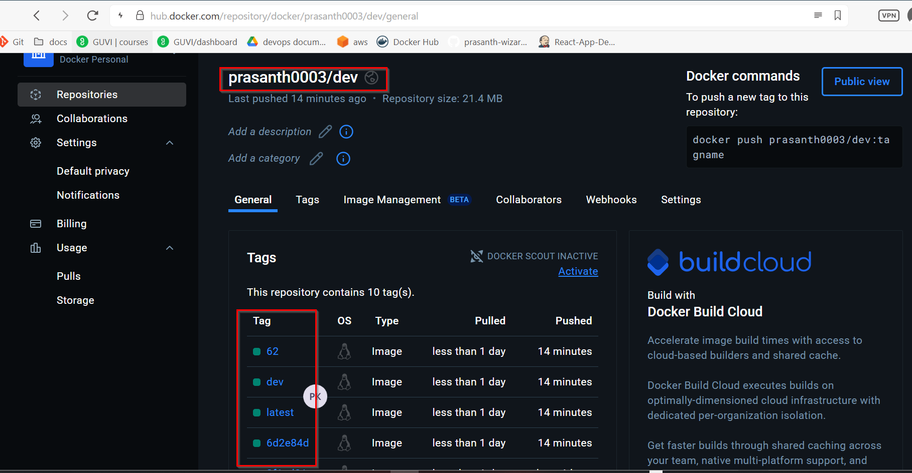
Dockerhub “prod” private:
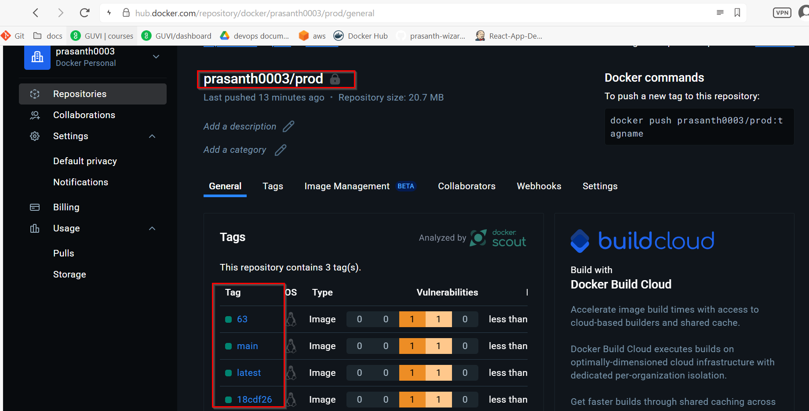
Agent_1 Container Status:
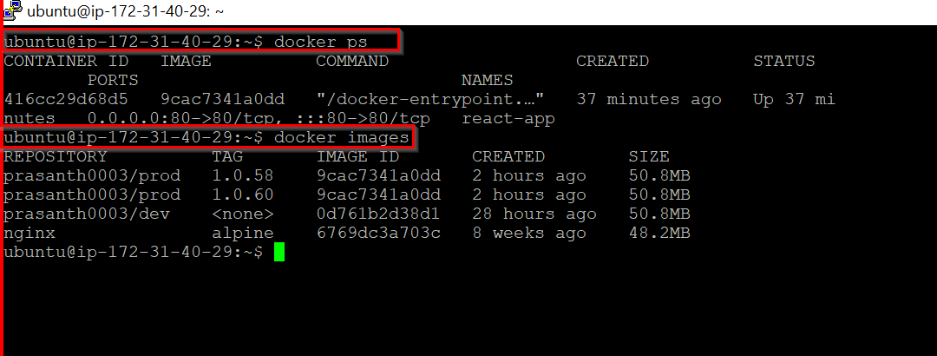

React application running in Jenkins server IP and worker node IP:
Jenkins server:
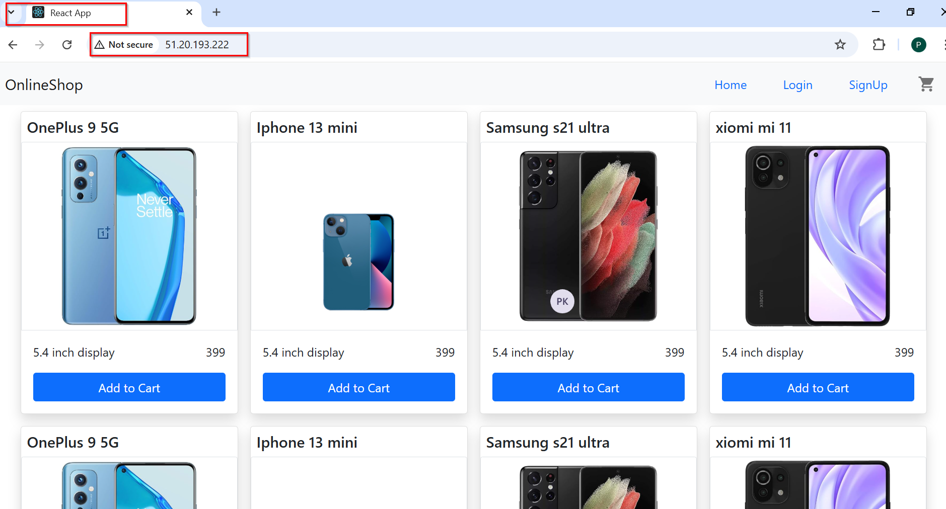

Agent-1 IP:
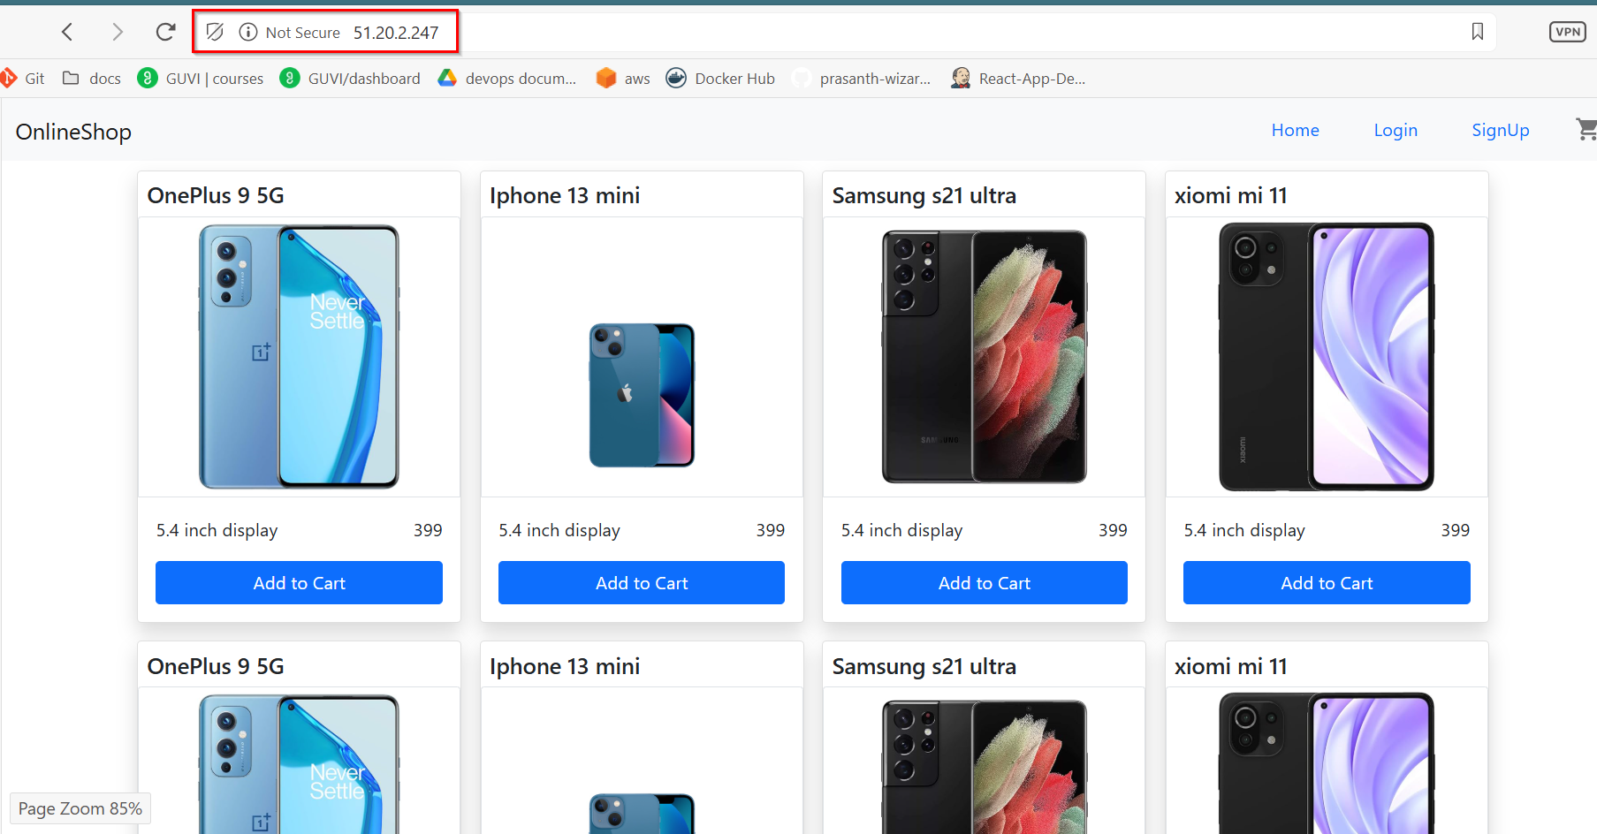

AGENT-1:

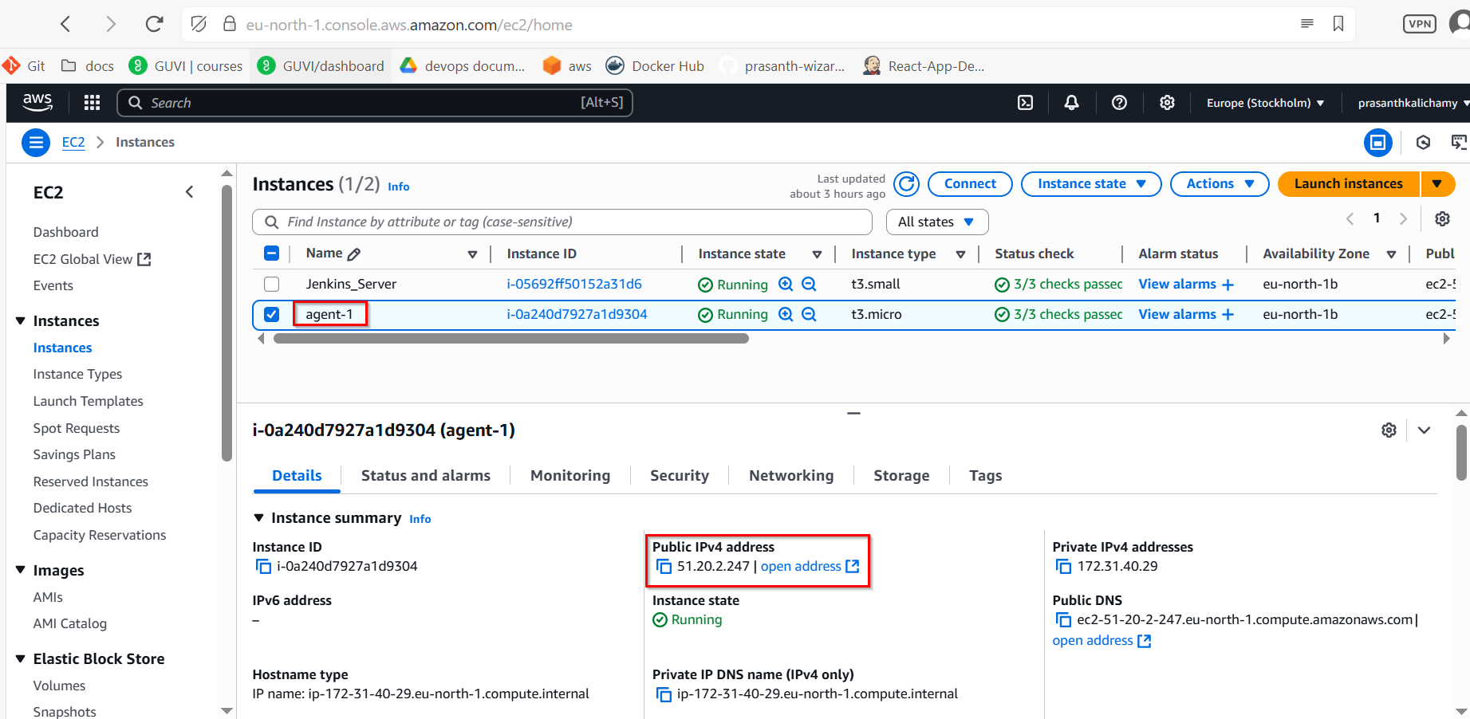

Agent-1 Security_Group Inbound rules:

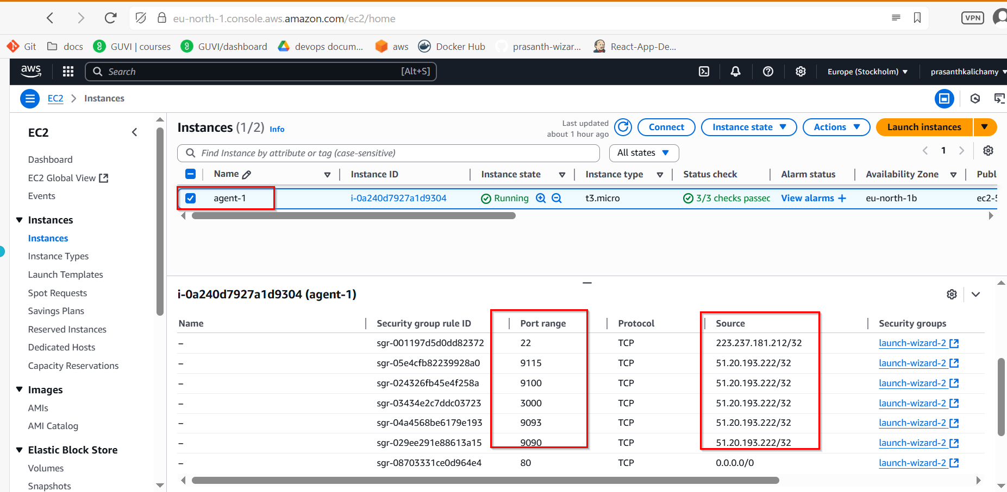

Docker Install

sudo apt update

sudo apt install apt-transport-https ca-certificates curl gnupg-agent software-properties-common -y

curl -fsSL https://download.docker.com/linux/ubuntu/gpg | sudo apt-key add –

sudo add-apt-repository "deb [arch=amd64] https://download.docker.com/linux/ubuntu $(lsb_release -cs) stable"

sudo apt update
sudo apt install docker-ce docker-ce-cli containerd.io -y
sudo usermod -aG docker $USER

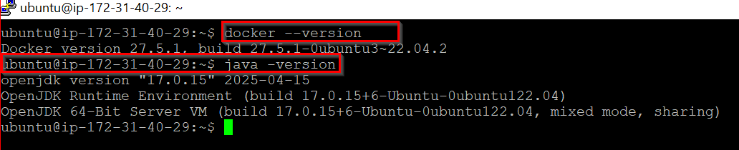

MONITORING
├── alertmanager
│ └── alertmanager.yml
├── blackbox
│ └── blackbox.yml
├── docker-compose.yml
└── prometheus
├── alert_rules.yml
└── prometheus.yml

docker-compose.yml
version: '3.8'

services:
react-app:
image: prasanth0003/dev:latest
container_name: react-app
ports:
- "80:80"

prometheus:
image: prom/prometheus
container_name: prometheus
volumes:
- ./prometheus/prometheus.yml:/etc/prometheus/prometheus.yml
- ./prometheus/alert_rules.yml:/etc/prometheus/alert_rules.yml
command:
- '--config.file=/etc/prometheus/prometheus.yml'
ports:
- "9090:9090"

alertmanager:
image: prom/alertmanager
container_name: alertmanager
volumes:
- ./alertmanager/alertmanager.yml:/etc/alertmanager/alertmanager.yml
command:
- '--config.file=/etc/alertmanager/alertmanager.yml'
ports:
- "9093:9093"

grafana:
image: grafana/grafana
container_name: grafana
ports:
- "3000:3000"
depends_on:
- prometheus

node-exporter:
image: prom/node-exporter
container_name: node-exporter
ports:
- "9100:9100"
volumes:
- /proc:/host/proc:ro
- /sys:/host/sys:ro
- /:/rootfs:ro
command:
- '--path.procfs=/host/proc'
- '--path.sysfs=/host/sys'
- '--path.rootfs=/rootfs'

blackbox:
image: prom/blackbox-exporter
container_name: blackbox
ports:
- "9115:9115"
volumes:
- ./blackbox:/config
command:
- '--config.file=/config/blackbox.yml'

prometheus.yml
global:
scrape_interval: 15s
evaluation_interval: 15s

alerting:
alertmanagers:
- static_configs:
- targets: ['alertmanager:9093']

rule_files:
- alert_rules.yml

scrape_configs:
- job_name: 'prometheus'
static_configs:
- targets: ['localhost:9090']

- job_name: 'node_exporter'
static_configs:
- targets: ['node-exporter:9100']

- job_name: 'react_http_probe'
metrics_path: /probe
params:
module: [http_2xx]
static_configs:
- targets:
- http://51.20.2.247
relabel_configs:
- source_labels: [__address__]
target_label: __param_target
- source_labels: [__param_target]
target_label: instance
- target_label: __address__
replacement: blackbox:9115

alert_rules.yml
groups:
- name: react_app_alerts
rules:
- alert: ReactAppContainerDown
expr: up{job="react_app"} == 0
for: 15s
labels:
severity: critical
annotations:
summary: "React container unreachable"
description: "Prometheus can't connect to react-app on port 80."

- alert: ReactHTTPProbeFailed
expr: probe_success{job="react_http_probe"} == 0
for: 15s
labels:
severity: critical
annotations:
summary: "React HTTP health check failed"
description: "React app did not return HTTP 200."

alertmanager.yml
global:
smtp_smarthost: 'smtp.gmail.com:587'
smtp_from: 'prasanthkalichamy30@gmail.com'
smtp_auth_username: 'prasanthkalichamy30@gmail.com'
smtp_auth_password: 'aqsa nfqv kkhz rloa'
smtp_require_tls: true

route:
receiver: 'email-alert'

receivers:
- name: 'email-alert'
email_configs:
- to: 'prasanthkalichamy30@gmail.com'
send_resolved: true

blackbox.yml
modules:
http_2xx:
prober: http
timeout: 5s
http:
valid_http_versions: ["HTTP/1.1", "HTTP/2"]
valid_status_codes: [200]
method: GET

Run Everything
cd devops-monitoring/
docker-compose up -d

Docker Containers:
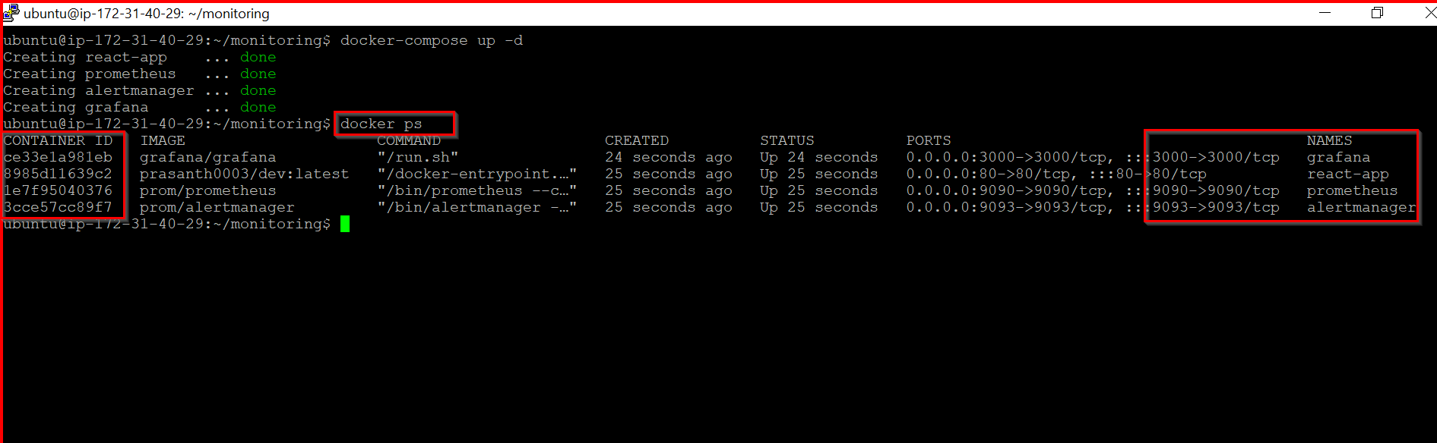

All_Metric_Agent-1:
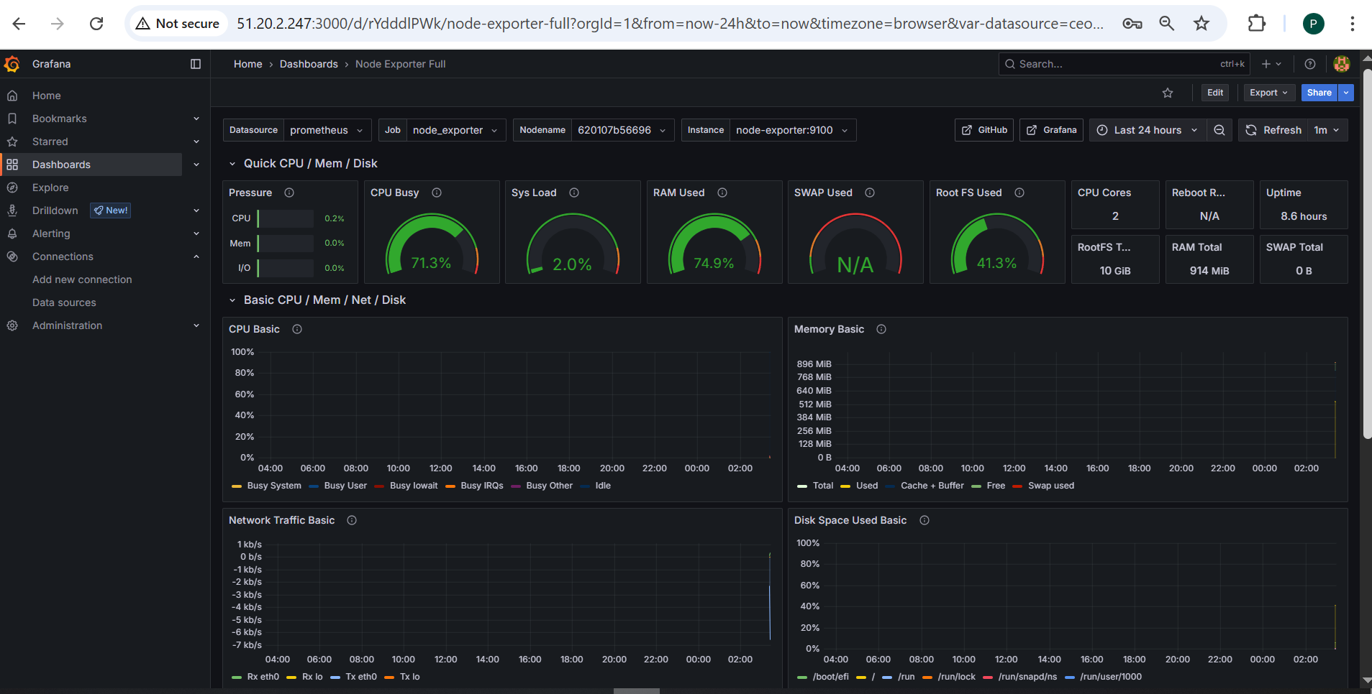

React Applicaiotn Health-check:
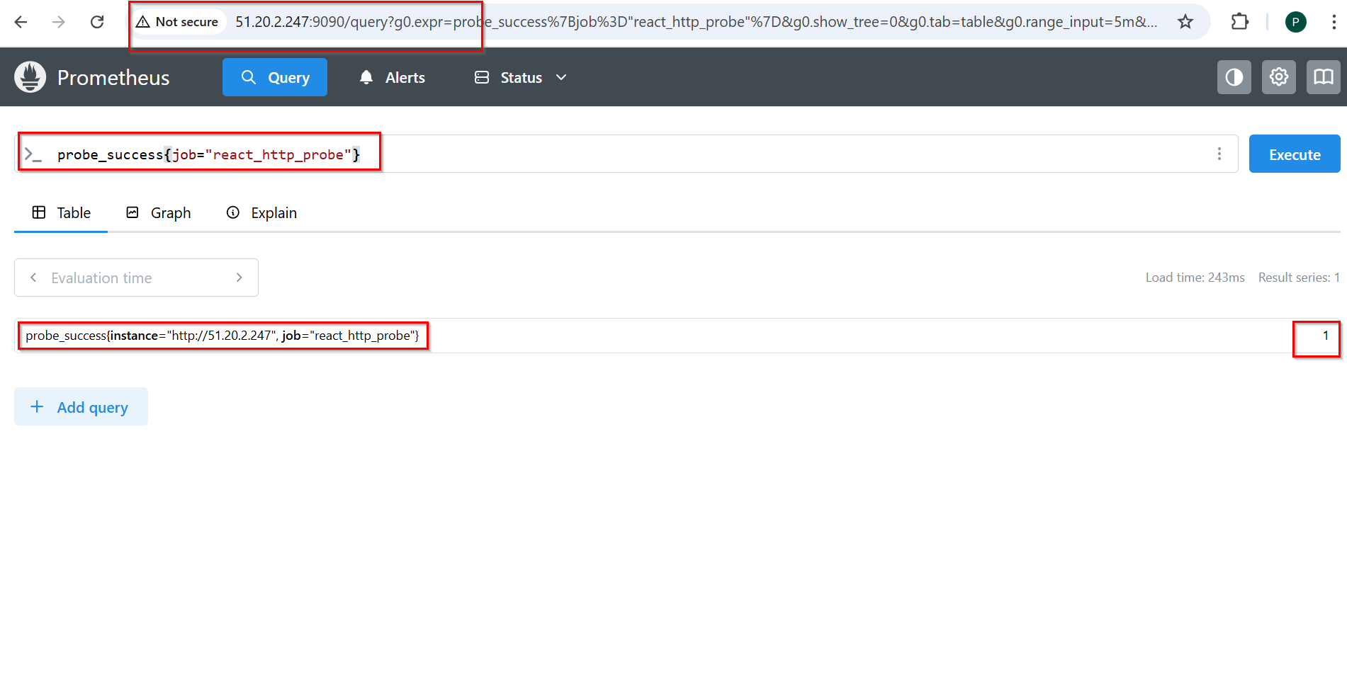

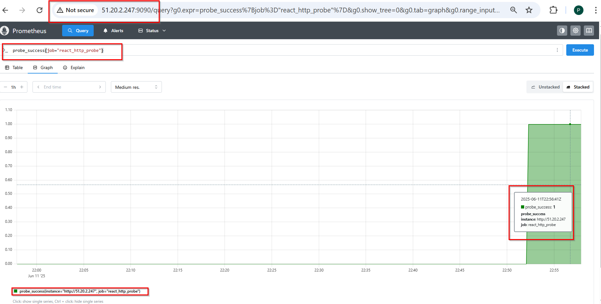

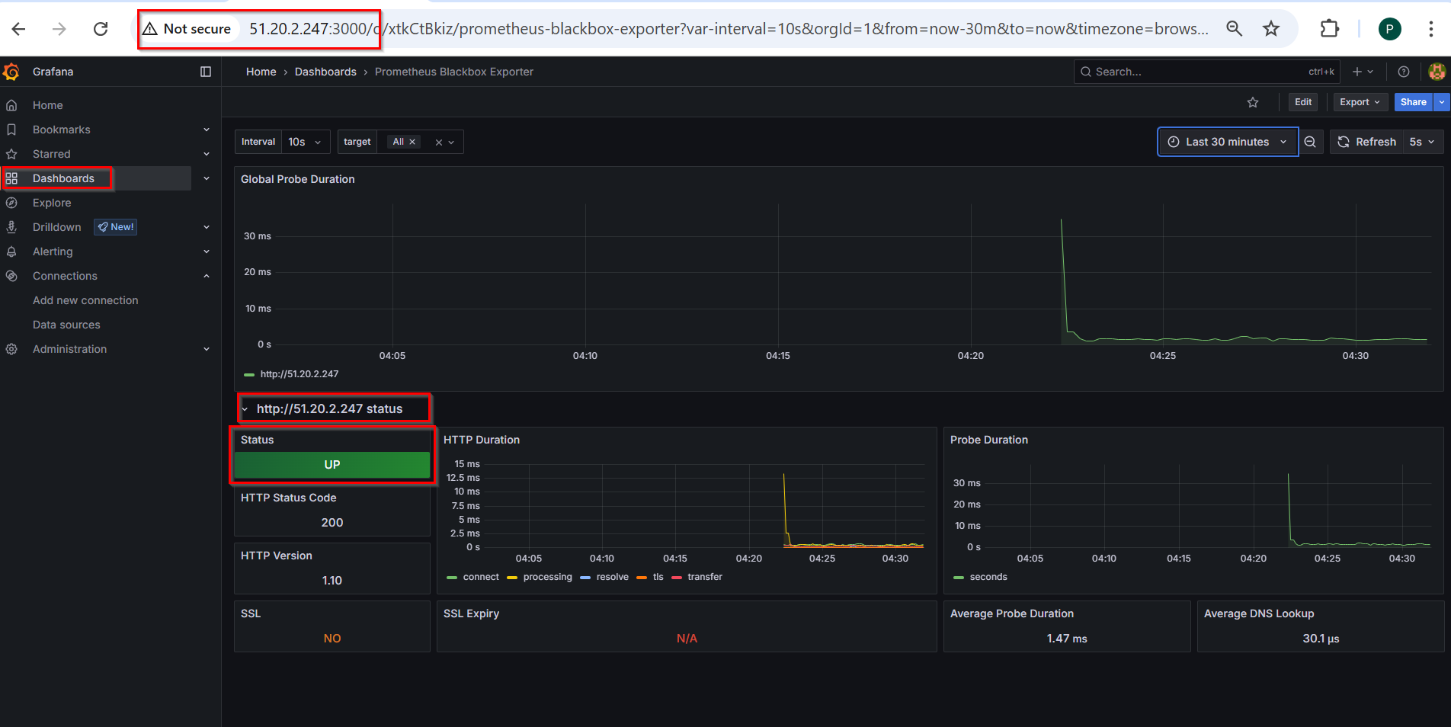
Stopping the React container:
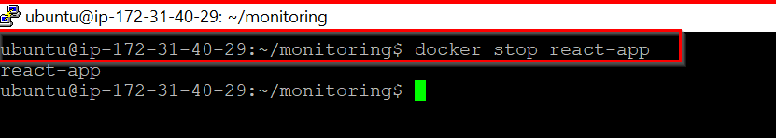

React App is Down:
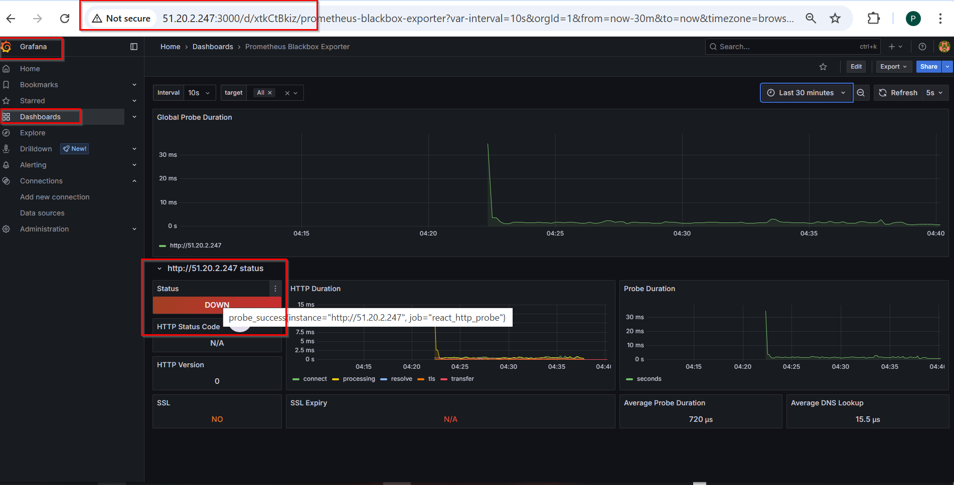

Email Notification:
