Customer Churn & Retention Analysis

1. Project Overview
This project focuses on analysing customer behaviour using real e-commerce transactional data (≈500,000 records). The primary aim is to identify churn patterns, build a predictive churn model using machine learning, segment customers using RFM methods, study retention patterns through cohort analysis, and develop a Power BI dashboard to support business decision-making.
The analysis integrates Python, MySQL, and Power BI, demonstrating end-to-end data analytics capability relevant to modern industry standards.
Business Goal:
Reduce customer churn, increase repeat purchases, and optimize revenue recovery from at-risk customers.

2. Dataset Summary
Source: Online Retail Dataset (Kaggle)
Tables Used: E-Commerce Data (~500k rows)
Key Columns: InvoiceNo, StockCode, Description, Quantity, InvoiceDate, UnitPrice, CustomerID, Country

3. Exploratory Data Analysis using Python
Used Python for initial cleaning, transformation, and feature engineering.
Steps performed:
● Data Loading
Loaded raw CSV data using pandas.
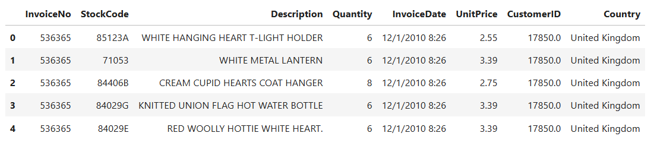
● Cleaning & Transformation
- Dropped null customer IDs
- Removed negative quantity rows
- Created TotalAmount = Quantity × UnitPrice

● Customer Summary Table
A customer-level summary table was created by aggregating total orders, total revenue, total quantity, first purchase date, and last purchase date for each CustomerID. This table serves as the foundation for RFM segmentation, churn labelling, and all SQL-based customer analytics.

● Export to SQL
The processed tables were pushed into MySQL using SQLAlchemy for further analysis.

4. Data Analysis using SQL
Used SQL to create analytics-ready tables, KPIs, and structured business answers.
Key SQL Analysis Performed:
● KPI Calculations
- What is the average order value across all transactions?
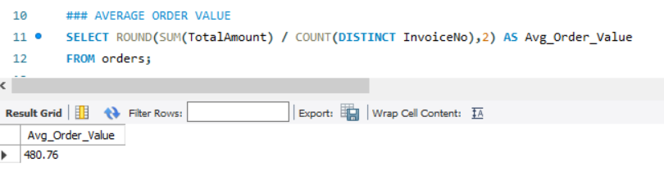
- What percentage of customers purchase more than once?
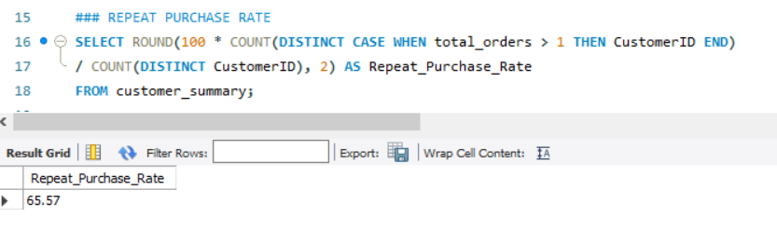

- What percentage of customers are churned (inactive for > 90 days)?
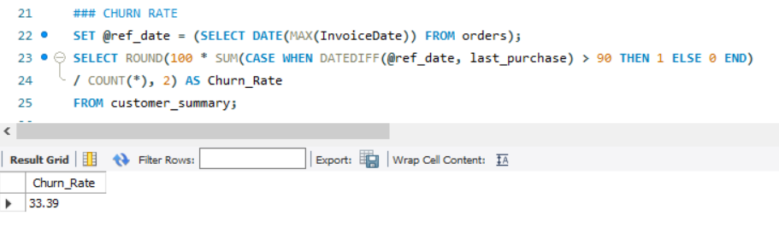

● RFM base Table Creation
Contains recency, frequency, and monetary metrics for each customer and provide features for segmentation, churn modelling, and customer lifetime analysis.
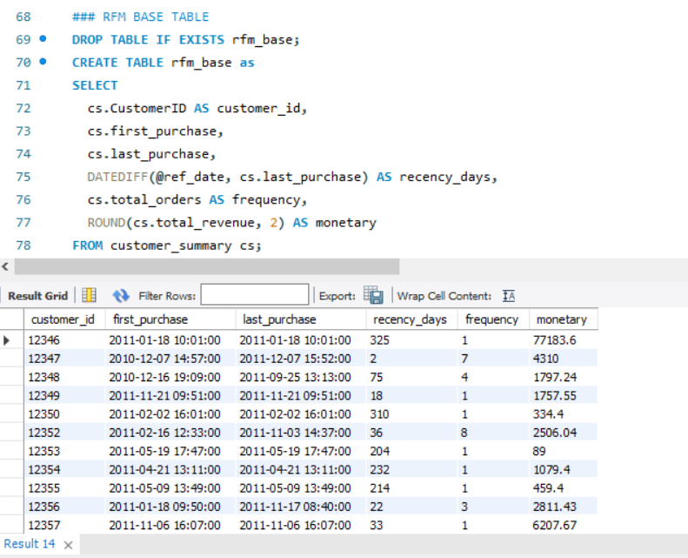

● RFM Segmentation
RFM Scores were combined into an RFM string and mapped to the following segments:
Champions, Loyal, Need Attention, At Risk, Lost
● Revenue Generated by RFM Segments
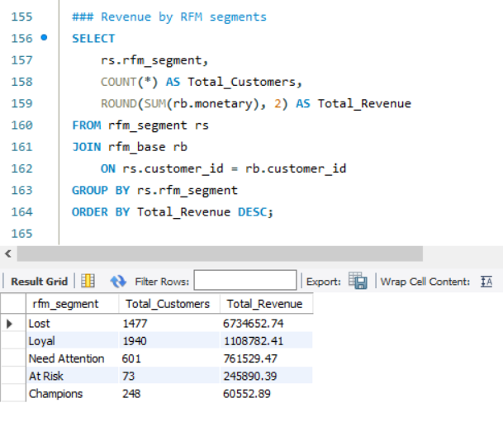
● Cohort Analysis
- How does recent cohort retention (0–2 months) compare with older cohorts?
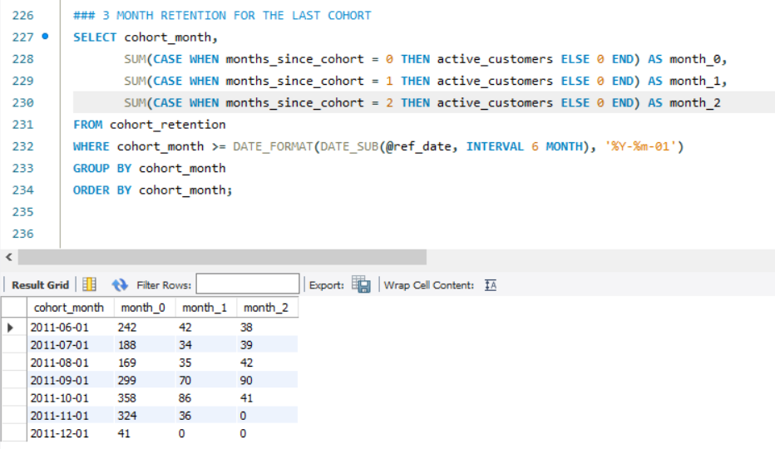
- What is the month-over-month retention rate for each customer cohort?
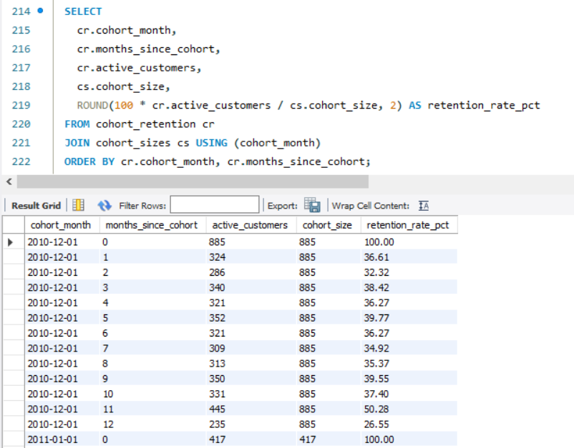

- How many customers remain active in each cohort month over time?
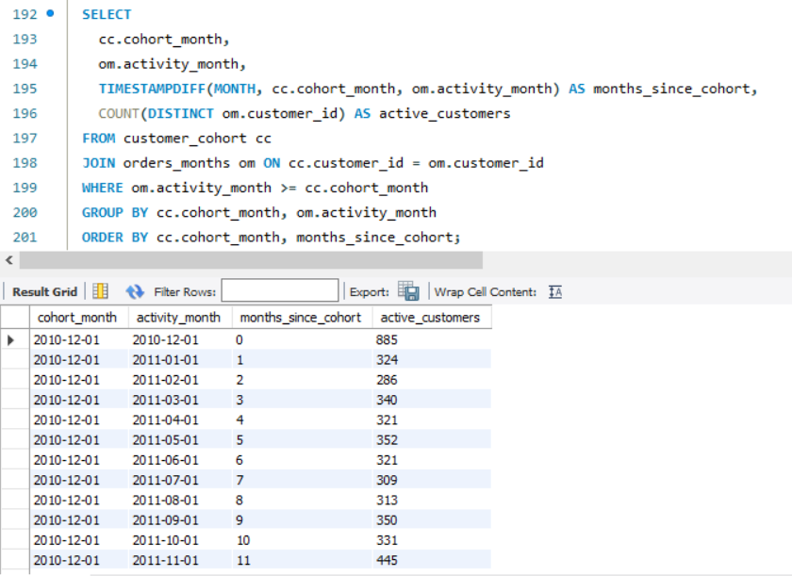
● Identification of At-Risk & Lost Customers
Using the RFM segmentation output, customers labelled ‘At Risk’ and ‘Lost’ were extracted.
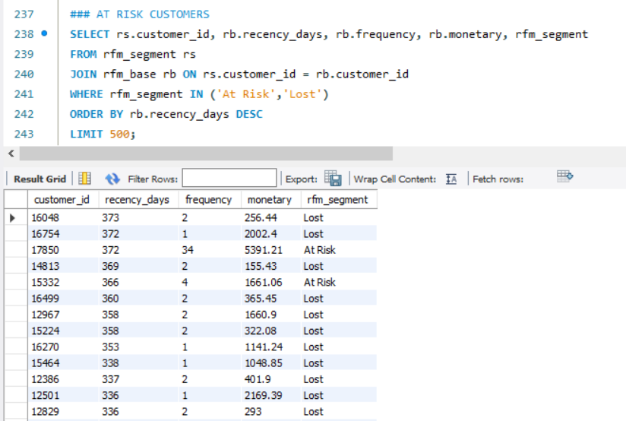

5. Machine Learning (Python)
Used RandomForestClassifier to predict customer churn.
● Pipeline Overview:
- Train/test split (80–20)
- Model training using:
  - recency_days
  - frequency
  - monetary
- Model Evaluation:
  - Accuracy = 0.97
  - AUC = 0.996
- SHAP Explainability:
  - Identified frequency as the strongest churn driver
  - recency_days also impactful
● Model Outputs Exported to SQL
- churn_histogram
- churn_predictions
- feature_importance
- model_metrics
- top_at_risk_customers

6. Dashboard in Power BI
A 2-page executive-level dashboard was built for business consumption.

📄 Page 1 — Customer & Revenue Overview
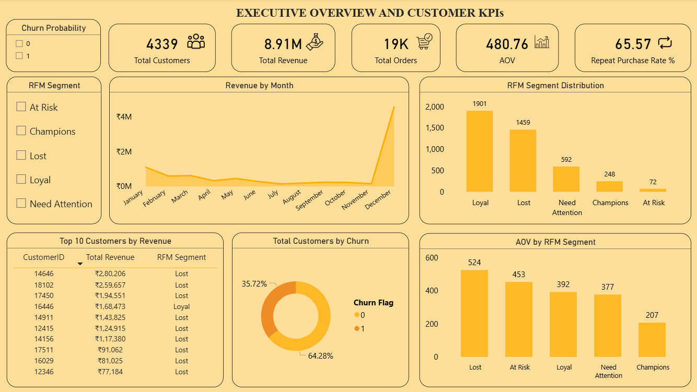

📄 Page 2 — Predictive Insights & Retention Action
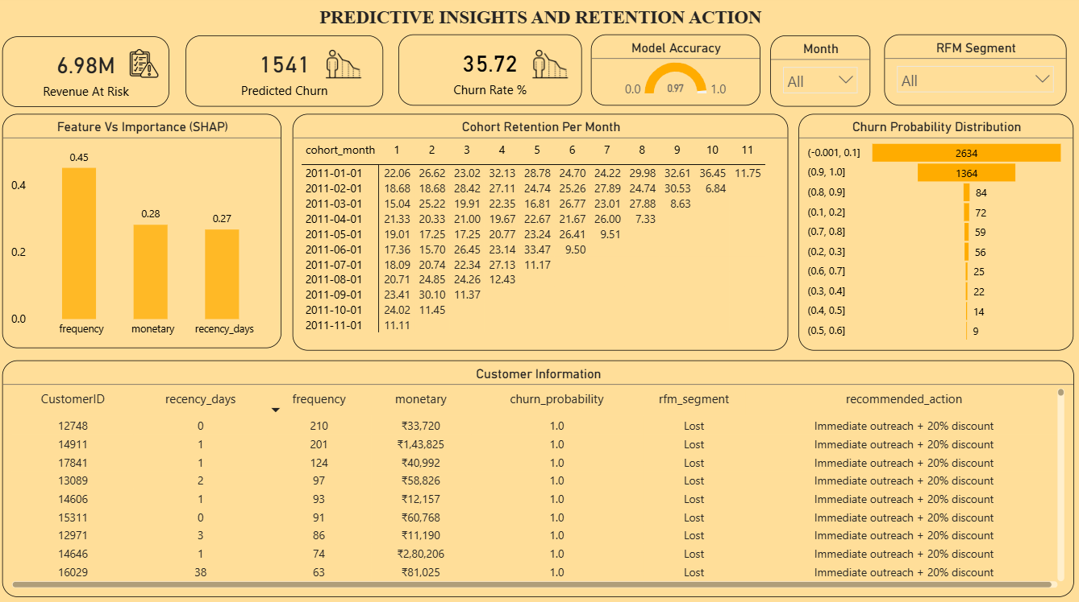

7. Business Insights & Findings
Key Insights:
1. Loyal customers drive the business
2. Revenue is heavily dependent on “Lost” customers
3. Churn risk is high (35.7%)
4. Frequency is the strongest driver of churn
5. Revenue at risk is extremely high (₹6.98M)
6. Cohort retention drops sharply after Month 1
7. Late-year revenue spikes (December)
8. “At Risk” customers show very low engagement
9. High churn probabilities are concentrated in two bins (0.9-1 & 0-0.1)
10. Significant gap between segments in AOV

8. Business Recommendations
1. Recover Lost Revenue
Target high-value Lost customers with quick win-back offers to restore immediate revenue.
2. Improve Early Retention
Strengthen first-month engagement to reduce the steep Month-1 churn drop.
3. Boost Purchase Frequency
Use targeted promotions to increase buying frequency, the strongest churn driver.
4. Strengthen Loyalty Base
Reward Loyal customers with exclusive perks to protect core recurring revenue.
5. Upsell Active Customers
Increase AOV by promoting bundles and higher-value items to active segments.

