Student Name: A.B.M.Prasanth Pullarao
Student ID: 11709207
Email Address:alapatiprasanth1234@gmail.com
GitHub Link: https://github.com/KumarSaurabh8934/Safe-State-System
Code:

#include<stdio.h>
#include <stdio.h>
#define P 5
#define R 3
int main()
{
int MaxMatrix[P][R], needMatrix[P][R], allocationMatrix[P][R], available[R], finished[P];
int i, j, process, count;
count = 0;
for(i = 0; i< P; i++)
finished[i] = 0;
printf("\n\nEnter the MaxMatrix for each process : ");
for(i = 0; i < P; i++)
{
printf("\nP%d : ", i);
for(j = 0; j < R; j++)
scanf("%d", &MaxMatrix[i][j]);
}
printf("\n\nEnter the allocation for each process : ");
for(i = 0; i < P; i++)
{
printf("\nP%d : ",i);
for(j = 0; j < R; j++)
scanf("%d", &allocationMatrix[i][j]);
}
printf("\n\nEnter the Available Resources : ");
for(i = 0; i < R; i++)
scanf("%d", &available[i]);
for(i = 0; i < P; i++)
for(j = 0; j < R; j++)
needMatrix[i][j] = MaxMatrix[i][j] - allocationMatrix[i][j];
Do
{
process = -1;
for(i = 0; i < P; i++)
{
if(finished[i] == 0)//if not finished
{
process = i ;
for(j = 0; j < R; j++)
{
if(available[j] < needMatrix[i][j])
{
process = -1;
break;
}
}
}
if(process != -1)
break;
}
if(process != -1)
{
count++;
for(j = 0; j < R; j++)
{
available[j] += allocationMatrix[process][j];
allocationMatrix[process][j] = 0;
MaxMatrix[process][j] = 0;
finished[process] = 1;
}
}
}while(count != P && process != -1);
if(count == P)
{
printf("\nThe system is in a safe state!!\n");
}
else
printf("\nThe system is in an unsafe state!!");
}

Description: The banker’s algorithm is a resource allocation and deadlock avoidance algorithm that tests for safety by simulating the allocation for predetermined maximum possible amounts of all resources, then makes an “s-state” check to test for possible activities, before deciding whether allocation should be allowed to continue.
Available :
- It is a 1-d array of size ‘m’ indicating the number of available resources of each type.
- Available[ j ] = k means there are ‘k’ instances of resource type R_{j}
Max :
- It is a 2-d array of size ‘n*m’ that defines the maximum demand of each process in a system.
- Max[ i, j ] = k means process P_{i} may request at most ‘k’ instances of resource type R_{j.}

Allocation :
- It is a 2-d array of size ‘n*m’ that defines the number of resources of each type currently allocated to each process.
- Allocation[ i, j ] = k means process P_{i} is currently allocated ‘k’ instances of resource type R_{j}
- It is a 2-d array of size ‘n*m’ that indicates the remaining resource need of each process.

Need :
Need [ i, j ] = k means process P_{i} currently need ‘k’ instances of resource type R_{j}
for its execution.
- Need [ i, j ] = Max [ i, j ] – Allocation [ i, j ]

Algorithm:
1) Let Work and Finish be vectors of length ‘m’ and ‘n’ respectively.
Initialize: Work = Available
Finish[i] = false; for i=1, 2, 3, 4….n

2) Find an i such that both
a) Finish[i] = false
b) Need_{i} <= Work
if no such i exists goto step (4)
3) Work = Work + Allocation[i]
Finish[i] = true
goto step (2)

Complexity:
O(n^2 m)

Test Cases:
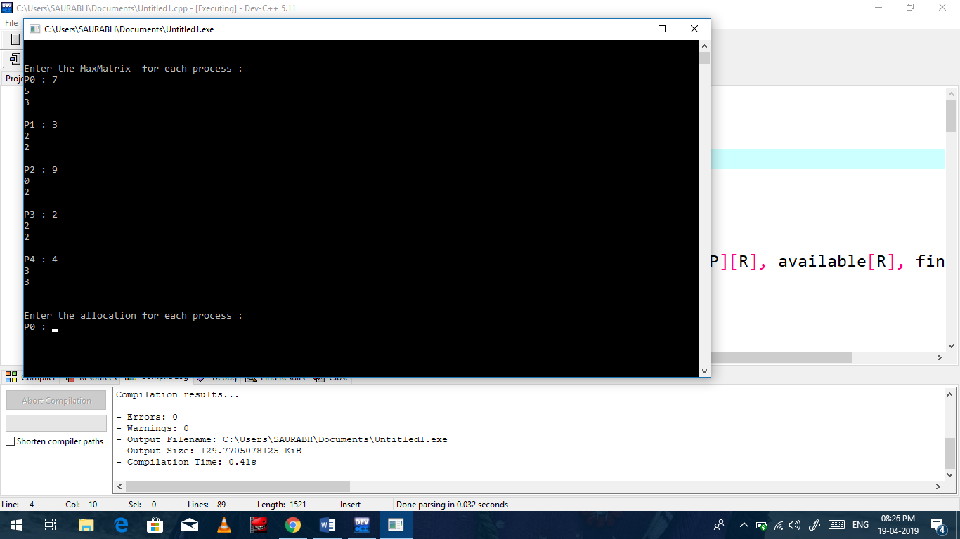

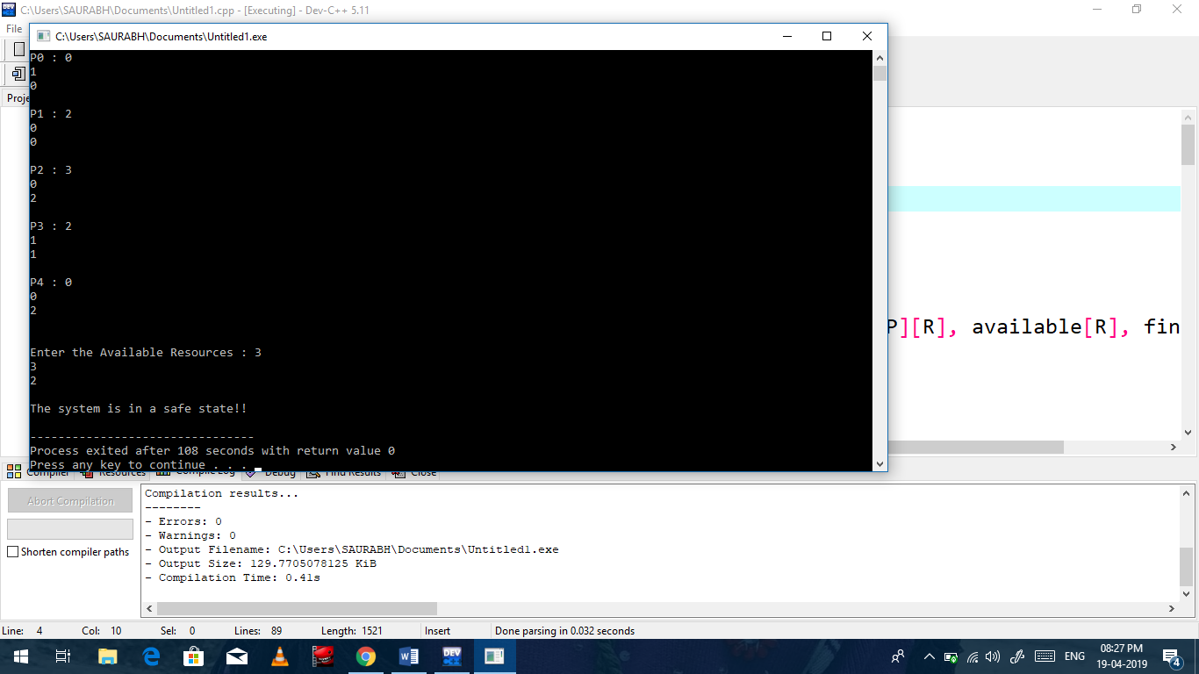

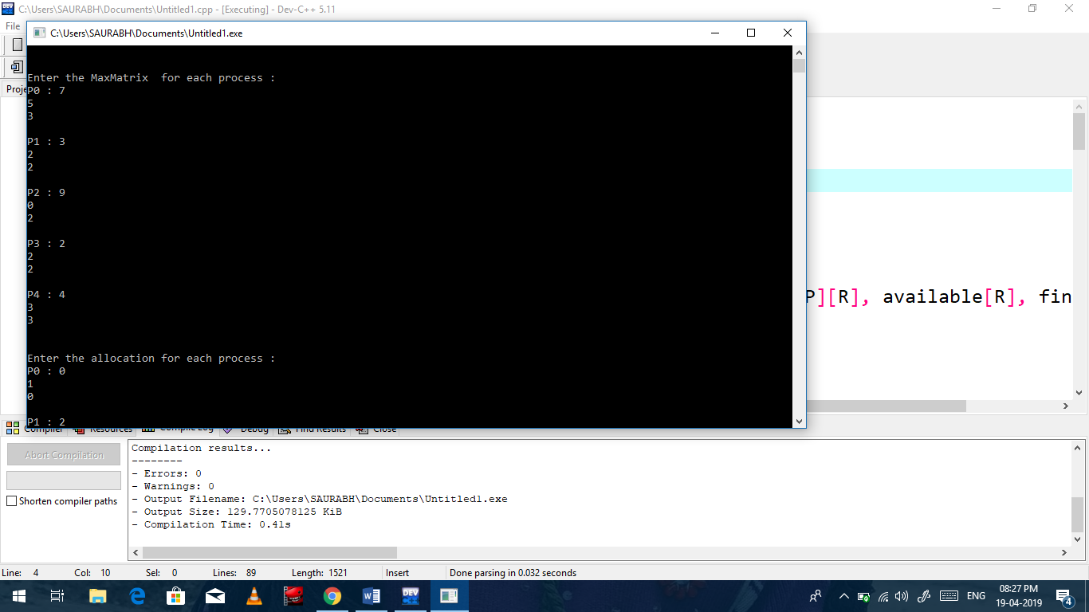

No of Commits on GitHub:5
GitHub Link: https://github.com/KumarSaurabh8934/Safe-State-System

