**HOTEL BOOKIHG BOT**

**Topics:** - Create a Chatbot using Amazon Lex Tool.

Intent of the chatbot: Book Hotel

1)All the information must be conveyed to the user after booking the room and

must be informed to the user the price of the hotel room and the day of stay.

2)Using this chatbot user must be aware of the types of Available rooms

(Classic, Duplex, etc)-Choose your own Category as well.

3)All events must be in flow for the fulfilment of the intent.

**ABSTRACT**

In recent years, conversational interfaces have gained significant importance in enhancing user interaction and providing intelligent automation across various domains. Chatbots, powered by Artificial Intelligence (AI) and Natural Language Processing (NLP), enable organizations to deliver personalized, real-time, and interactive communication. This project presents the design and implementation of a chatbot using **Amazon Lex**, a fully managed AI service by AWS for building conversational interfaces.

Amazon Lex provides automatic speech recognition (ASR) and natural language understanding (NLU), allowing the chatbot to understand user intents, process queries, and deliver appropriate responses. The proposed chatbot is designed to handle common user queries, improve accessibility, and reduce manual effort in customer support scenarios. The integration with AWS Lambda enables dynamic execution of business logic, while services like Amazon DynamoDB and Amazon S3 can be used for data storage and retrieval.

The chatbot is scalable, cost-effective, and easily deployable across platforms such as web, mobile, and Amazon Alexa. By leveraging the power of cloud-based AI, the system demonstrates how intelligent conversational agents can improve efficiency, enhance customer satisfaction, and support businesses in delivering seamless digital experiences.

TESTING BOT

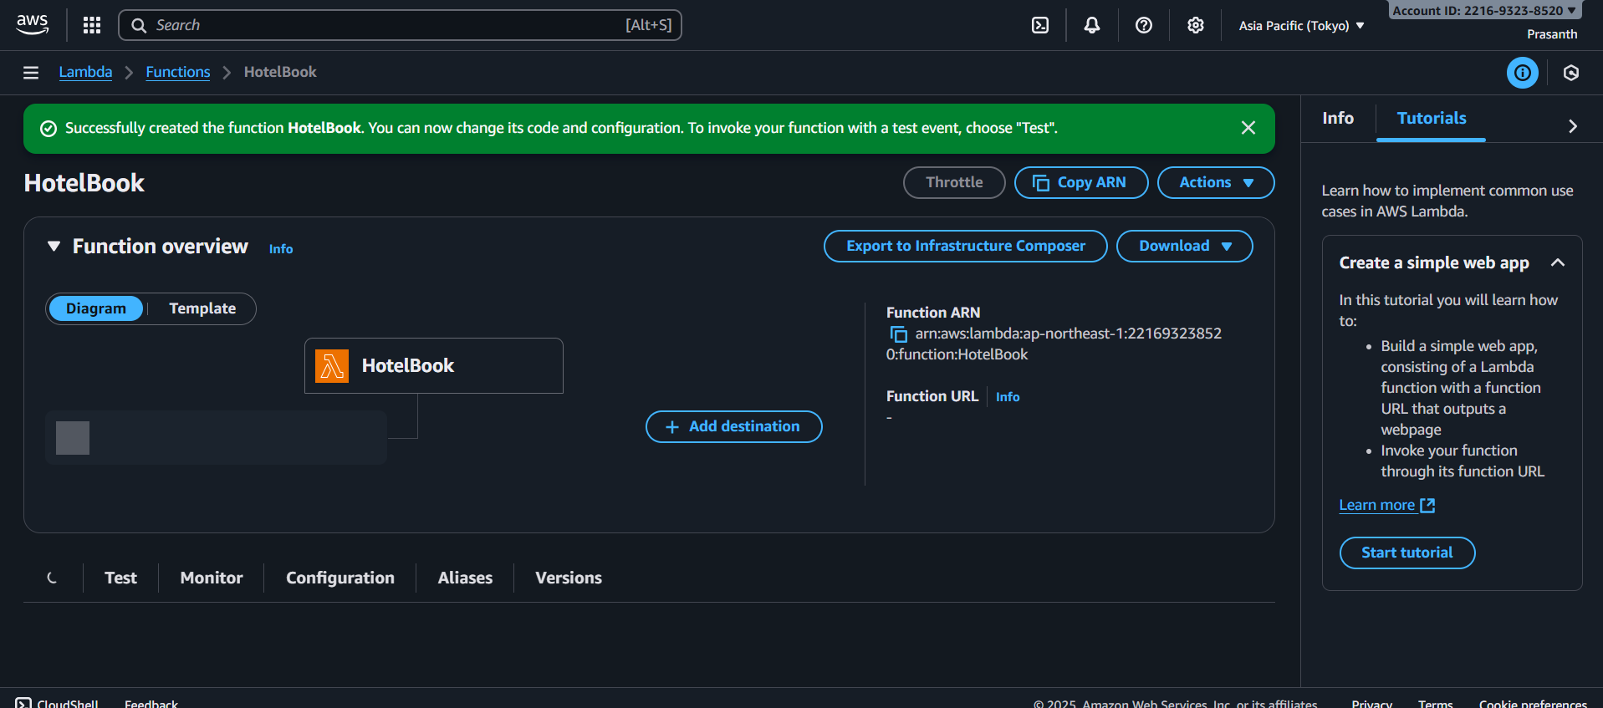

PROGRAM FOR LAMBDA

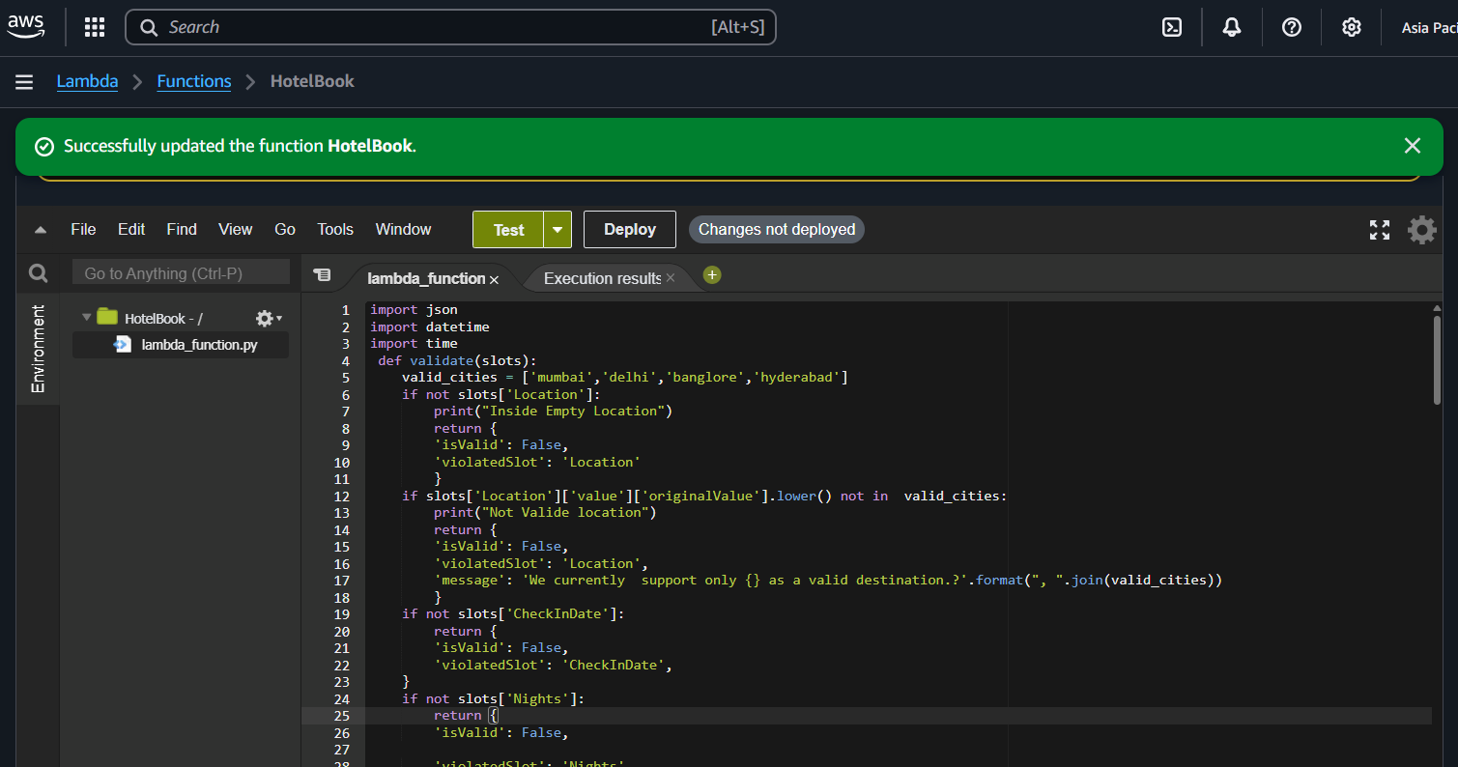

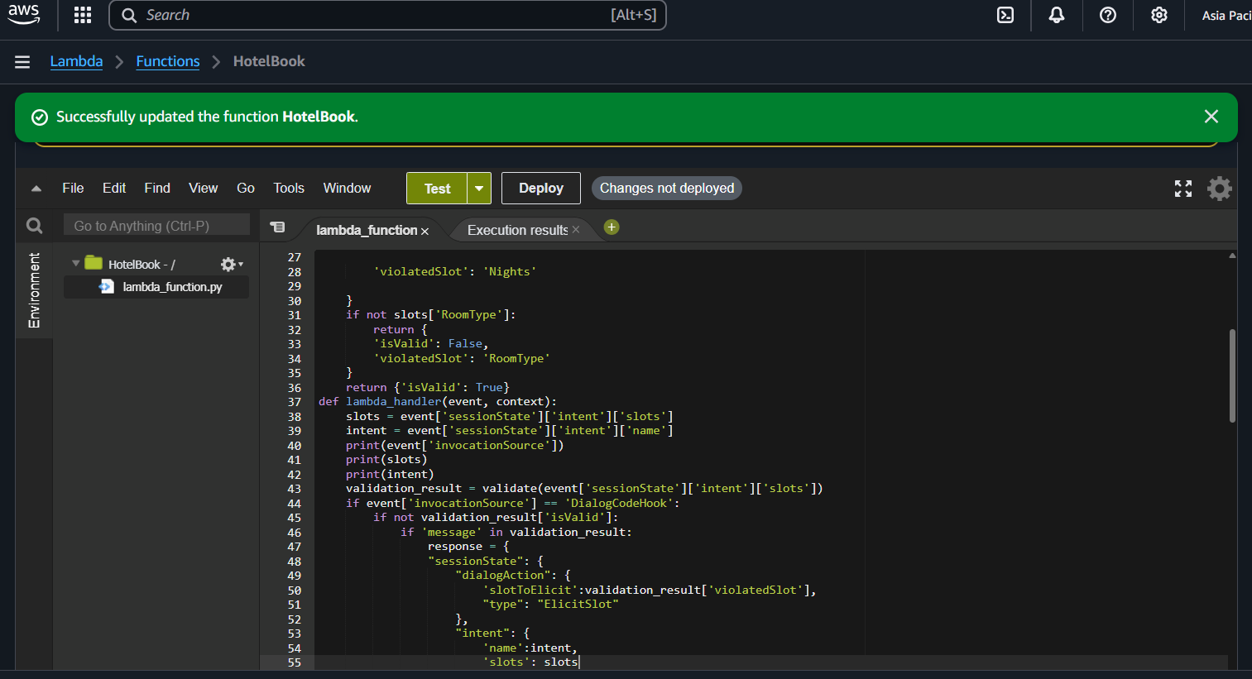

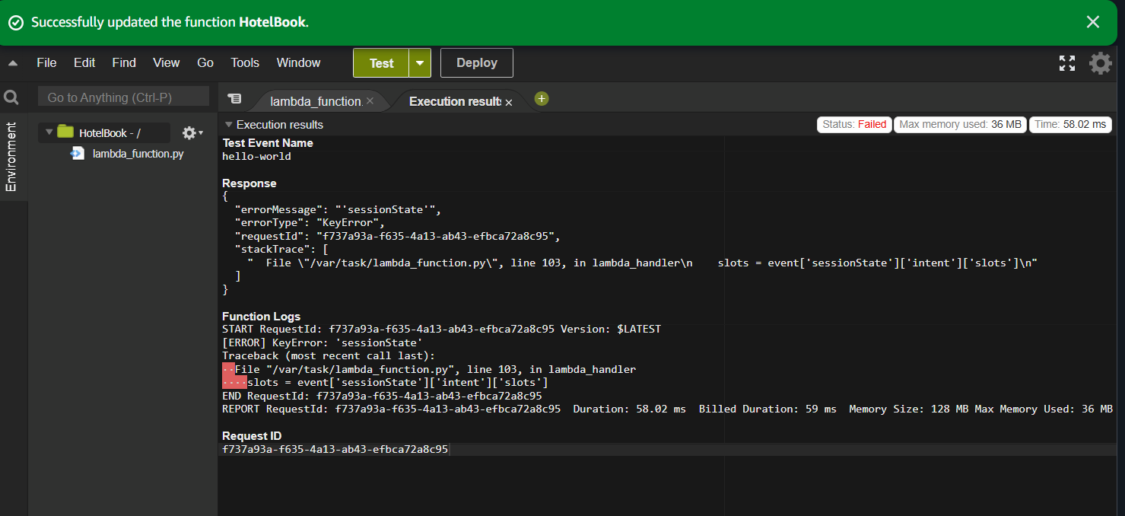

**AFTER LAMBDA FUNCTION CHARTBOT WORKING**

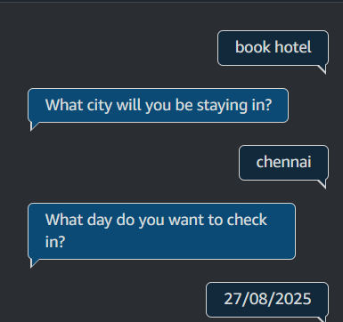

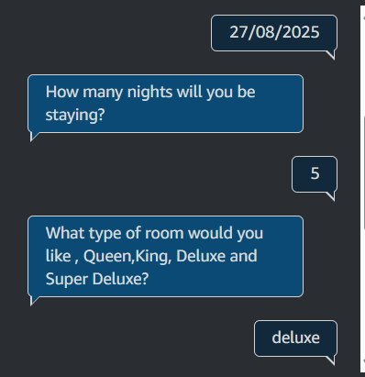

**THANK YOU.**