

**Custom Encryption**

**and**

**Decryption software**

**High Level Design Version**

**Document Control:**

|  |  |  |  |  |  |  |
| --- | --- | --- | --- | --- | --- | --- |
| **Project Revision History** | | | | | | |
|  |  |  | |  |  |  |
| **Date** | **Version** | **Author** | **Brief Description of Changes** | | | |
|  |  |  |  | | | |
|  |  |  |  | | | |
|  |  |  |  | | | |
|  |  |  |  | | | |

|  |
| --- |
| **Team Members** |

|  |  |
| --- | --- |
| **Employee ID:** | **Name** |
| 46290121 | L. S. V. Prasanthi |
| 46290114 | Tamma prasanthi |
| 46290096 | G. Kalavathi |
| 46290101 | A. Lavanya |
| 46290123 | N. Surya Prabha |

|  |
| --- |
| **Table of Contents** |

1. **High Level Design**

|  |  |  |
| --- | --- | --- |
| 1. Introduction | | 5 |
| 1.1 | Purpose | 5 |
| 1.2 | Scope | 5 |
| 1.3 | Overview | 5 |
| 2. General Description | | 5 |
| 2.1 | Product Perspective | 5 |
| 2.2 | Tools used | 6 |
| 2.3 | Special Design aspects | 6 |
| 2.4 | Assumptions |  |
| 3. Design Details | | 6 |
| 3.1 | Main Design Features | 6 |
| 3.2 | Standards | 7 |
| 3.3 | Data Flow Level-0 | 7 |
| 3.4 | Data Flow Level-1 | 8 |
| 3.5 | User Interface | 8 |
| 3.6 | Error Handling | 8 |
| 3.7 | Maintainance |  |
| 3.8 | Help | 8 |
| 3.9 | Performance | 8 |
| 3.10 | Reliability | 8 |
| 3.11 | Portability | 9 |
| 3.12 | Reusability | 10 |
| 3.13 | Application compatibility | 10 |

**High Level Design**

**1. INTRODUCTION**

**1.1Purpose**

This High-Level Design (HLD) Document adds the necessary detail to the current project description to represent a suitable model for coding. This document is also intended to help detect contradictions prior to coding and can be used as a reference manual for how the modules interact at a high level.

**1.2 Scope**

This document provides a comprehensive high level design overview of the custom encryption and decryption software. It highlights the high-level flow in Encryption and Decryption and serves as an input to the low-level design documents that would further elaborate on the proposed system design.

**1.3** **Overview**

This HLD (High Level Design) Document is arranged in the following format:

-Section1: Introduction

A brief explanation about the purpose, aim, scope, and design format of the proposed project.

- Section 2: General Description

This section is all about the general constraints, assumptions, and design aspects associated with the proposed project. The product perspective will give an overall description.

- Section 3: Design Details

This section documents the detailed design of all modules associated

With the development of the proposed simulator

**2. General Description**

The overview of our project is to save the data files in secured format.

The process of Encryption or Decryption takes place then the Data will be saved in the file and in Decryption process the file will be compared, if the original file matches with the decrypted file, then it will be considered as Decrypted.

**2.1** **Product Perspective**

The perspective of our project is to save the data files in secure format. The process of Encryption or Decryption takes place then the Data will be saved in the file and in Decryption process the file will be compared, if the original file matches with the decrypted file, then it will be considered as Decrypted. The Encrypted and Decrypted files will be saved in different paths.

**2.2** **Tools used**

1. C

2. System programming

**2.3 Special Design Aspects**

One of the Design aspects is that the system will work with a single user at a time.

**2.4 Assumptions**

We are assuming that user can choose either Encryption or decryption format from the given menu

**3. Design Details**

**3.1 Main Design Features**

The main design features include four major parts: the architecture, the user interface design, the files, process relation, and automation. To make these designs easier to understand, the design has been illustrated in attached diagram (Data flow diagrams).

**3.2 Standards**

* Security –It provides a security to the file and data that is present in it
* Quality – By keeping the interface simple and direct, quality should be kept at a maximum.

**3.3 Data Flow Diagram (Level - 0)**

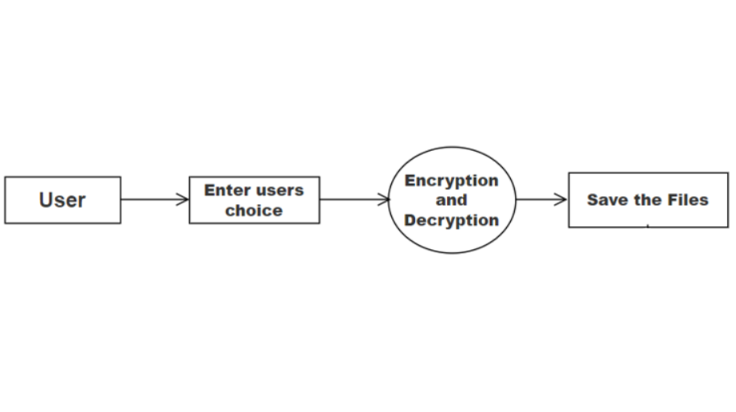

**3.4 Data Flow Diagram (Level - 1)**

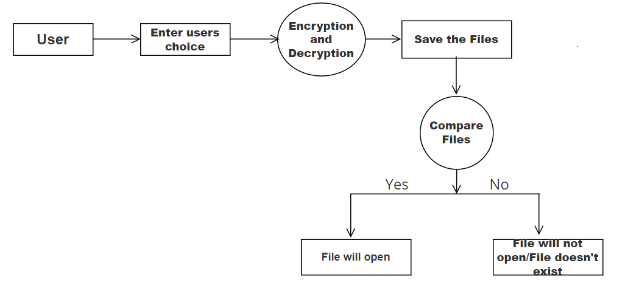

**3.5 User Interface**

Command Line Interface, Putty

**3.6 Error Handling**

Should errors be encountered, an explanation will be displayed as to what went wrong. An error will be defined as anything that falls outside the normal and intended usage.

**3.7 Maintainbaility**

NA

**3.8 Help**

Help will come in the form of all the documentation created prior to coding, which explains the intended uses. Should time allow, detailed instructions will be written on how to create and implement the system to publish it as an Open-Source solution.

**3.9** **Performance**

Performance is very important for this project. For everything to run smoothly,custom encryption and decryption will increase the performance both software and hardware level because it takes place at both levels

**3.10 Reliability**

This can schedule processes flawlessly and provide a nice overview to the user about the Algorithms implemented.

**3.11 Portability**

Code and program portability should be possible between kernel-recompiled Linux distributions. For everything to work properly, all programs should be in one folder.

**3.12 Reusability**

The code can be reused with no problems. Everything will be completely reusable to anyone.

**3.13 Application compatibility**

This was designed as an independent system. As it is not connected to any other components or interfaces, application compatibility is not a concern.