1. LP with obsolete date

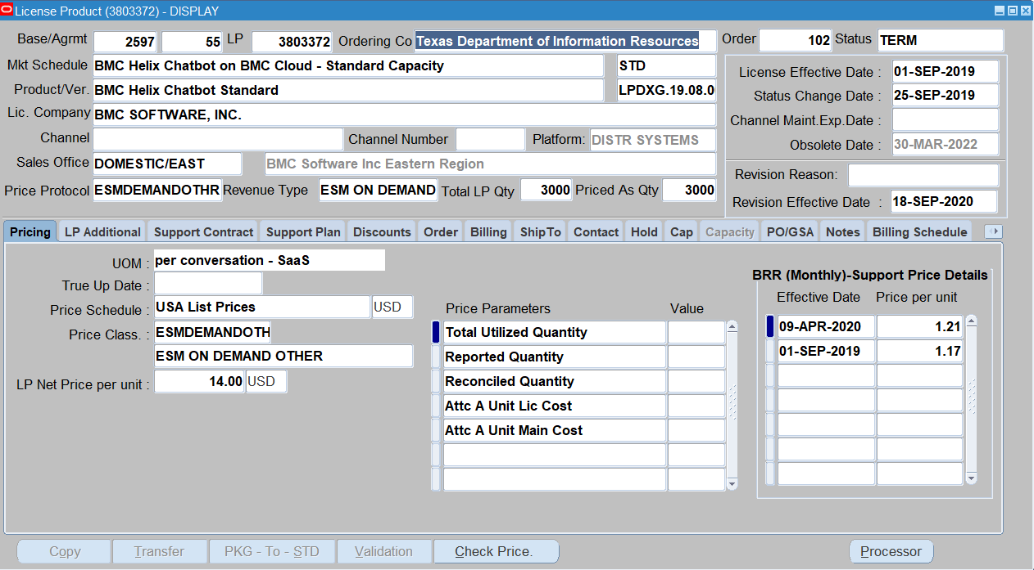

1. Support Quote screen

No validations happened after end date change

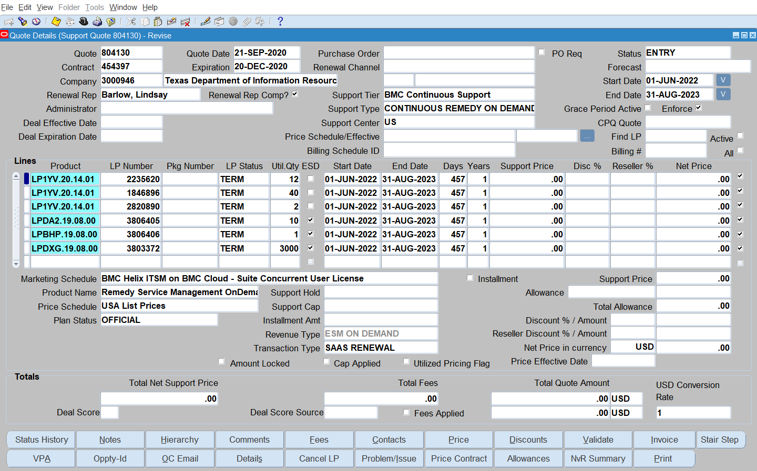

1. No validation on support quote validation error block

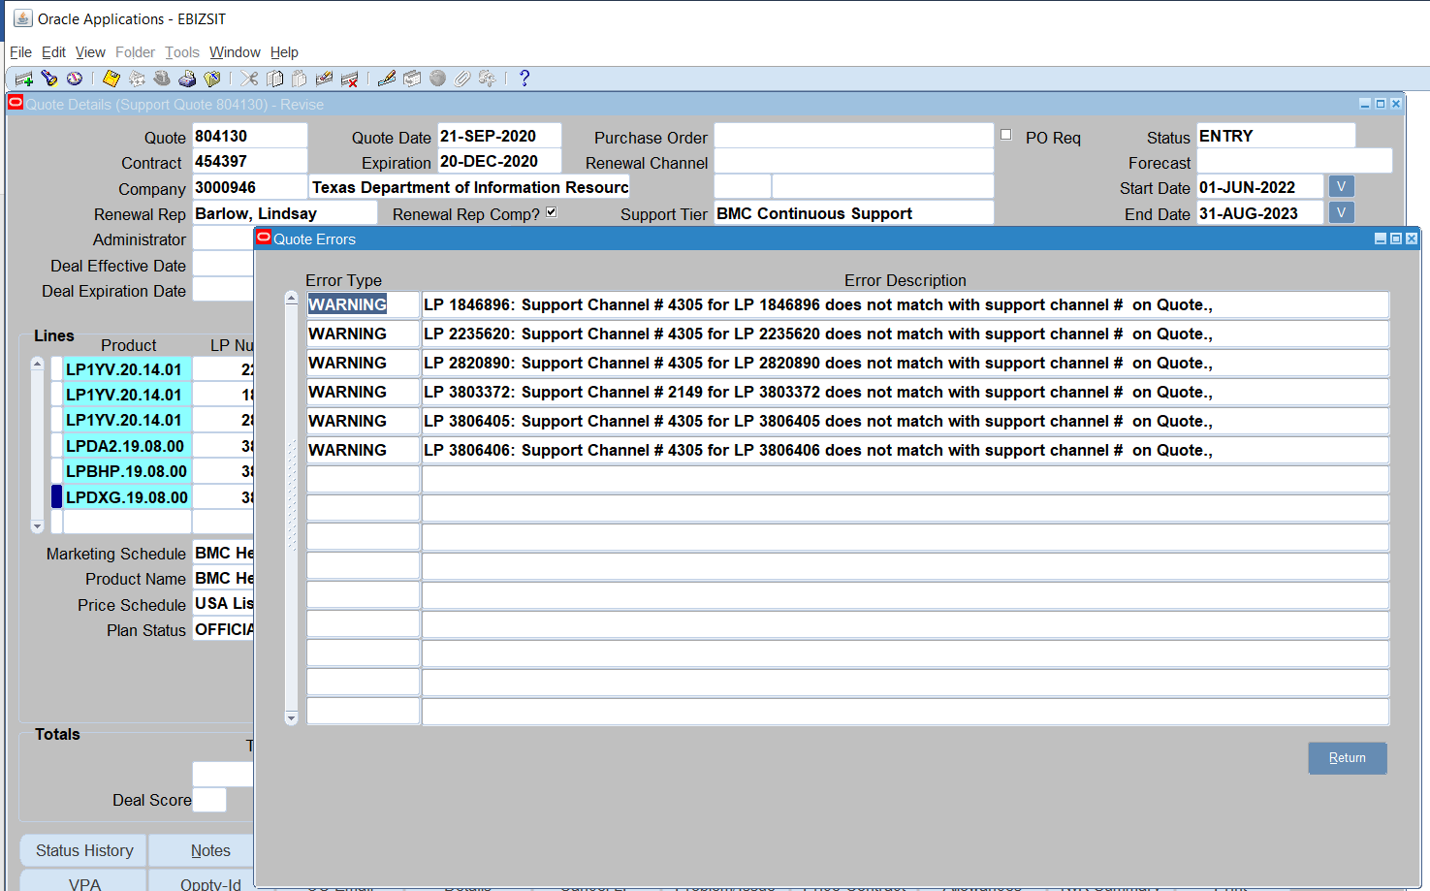

1. Support quote screen

No validations happened after end date change

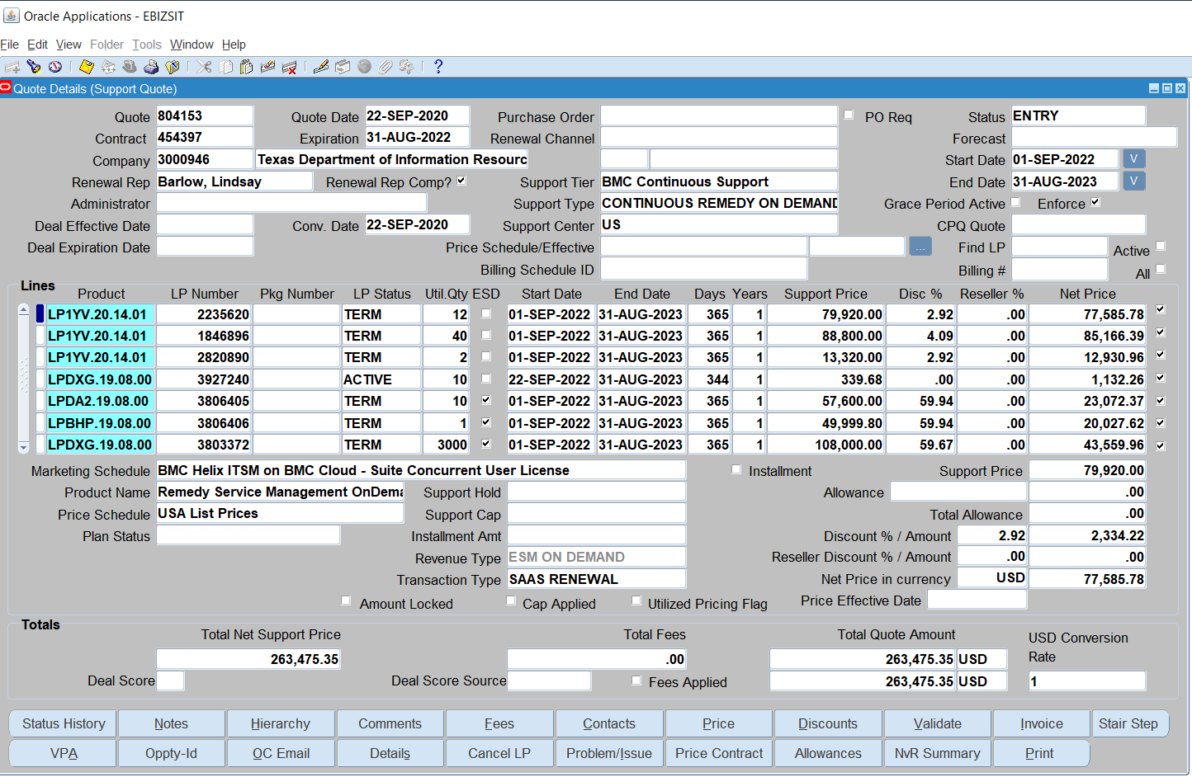

1. Validation screen
2. Billing schedule .

Warning message is shown but the bs is valid

