Project -1

API’s

1.Total revenue:
select sum(total_price) AS Total_revenue from car_sales_data;

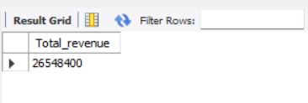

2.Average order value:
select sum(total_price) / count (distinct order_id ) AS average_ordervalue from car_sales_data;

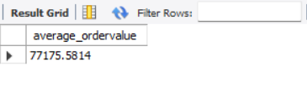

3.Total cars sold:
select sum(quantity) AS total_cars_sold from car_sales_data;

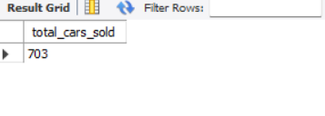
4.Total orders:
select count(distinct order_id) as total_orders from car_sales_data;

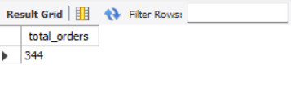

5.Average cars per order:
select sum(quantity)/ count(distinct order_id) As average_cars_perorder from car_sales_data;

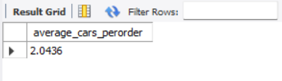

Charts requirements

1.Daily trend for total orders:
SELECT DAYNAME(STR_TO_DATE(order_date, '%Y-%m-%d')) AS weekday,
COUNT(DISTINCT order_id) AS total_orders
FROM car_sales_data
GROUP BY weekday
ORDER BY FIELD(weekday, 'Monday', 'Tuesday', 'Wednesday', 'Thursday', 'Friday', 'Saturday', 'Sunday');

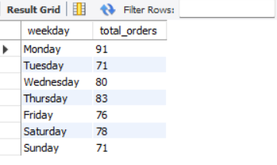

2.Monthly trends of total orders:
SELECT MONTHNAME (STR_TO_DATE (order_date, '%Y-%m-%d')) AS month name,
COUNT(DISTINCT order _id) AS total _orders
FROM car _sales_data
GROUP BY MONTH(STR_TO_DATE(order_date, '%Y-%m-%d')),
month_name
ORDER BY MONTH(STR_TO_DATE(order_date, '%Y-%m-%d'));

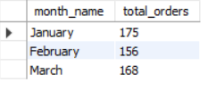

3.Percentage of sales by car category:
select car_type, sum(total_price)*100/(select sum(total_price)from car_sales_data) AS pct
from car_sales_data
group by car_type;

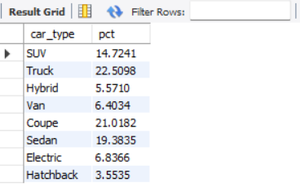

4.Percentage of sales by car_type:
select car_type,sum(total_price) as total_sales ,sum(total_price)*100/(select sum(total_price) from car_sales_data) AS PCT
from car_sales_data
group by car_type;

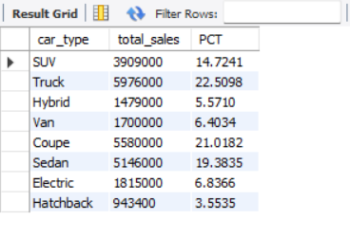

5.Total cars sold by car segment:
select car_segment,sum(total_price) as total_sales ,sum(total_price)*100/(select sum(total_price) from car_sales_data) AS PCT
from car_sales_data
group by car_segment
order by PCT Desc;

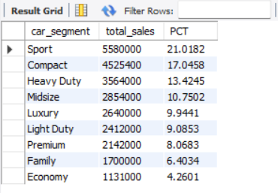

6.Top 5 Best sellers by revenue, total quantity and total orders:
# total best sellers
select car_model_id,sum(total_price)AS Total_revenue from car_sales_data
group by car_model_id
order by Total_revenue desc;

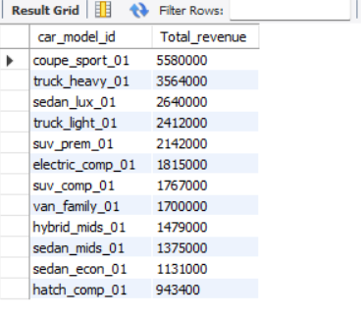

#TOP 5:
select car_model_id,sum(total_price)AS Total_revenue from car_sales_data
group by car_model_id
order by Total_revenue desc limit 5;

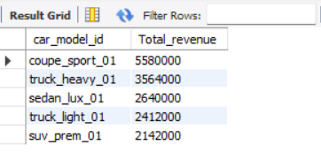

7.Bottom 5 Best sellers by revenue:
select car_model_id,sum(total_price)AS Total_revenue from car_sales_data
group by car_model_id
order by Total_revenue ASC limit 5;
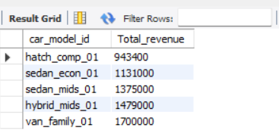

8.Top 5 Best sellers by Quantity:
select car_model_id,sum(quantity)AS Total_Quantity from car_sales_data
group by car_model_id
order by Total_Quantity desc limit 5;

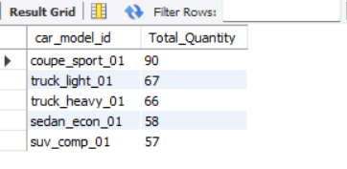

9. Bottom 5 Best sellers by Quantity:
select car_model_id,sum(quantity)AS Total_Quantity from car_sales_data
group by car_model_id
order by Total_Quantity ASC limit 5;

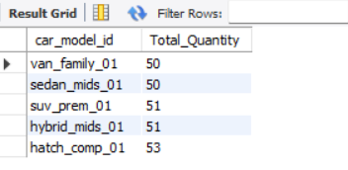

10. Top 5 Best sellers by Orders:
select car_model_id,count(distinct order_id)As Total_orders From car_sales_data
group by car_model_id
order by Total_orders DESC limit 5;

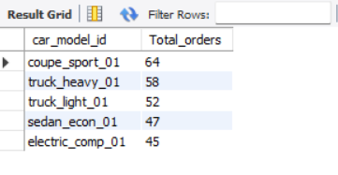

11. Bottom 5 Best sellers by Orders:
select car_model_id,count(distinct order_id)As Total_orders From car_sales_data
group by car_model_id
order by Total_orders ASC limit 5;

