**EXERCISE NO:** 10 **REGISTER NO:**1518102099

**DATE:** 23.11.2020

**AIM:**

To calculate the number of upper case letters and lower case letters .

**PROGRAM:**

def string_test(s):

d={"UPPER_CASE":0,"LOWER_CASE":0}

for x in s:

if x.isupper():

d["UPPER_CASE"]+=1

elif x.islower():

d["LOWER_CASE"]+=1

else:

pass

print("No. of Upper case characters: ",d["UPPER_CASE"])

print("No. of Lower case Characters: ",d["LOWER_CASE"])

s= input()

string_test(s)

**LINK:**

<http://103.53.53.18/mod/vpl/forms/submissionview.php?id=325&userid=1704>

**OUTPUT:**

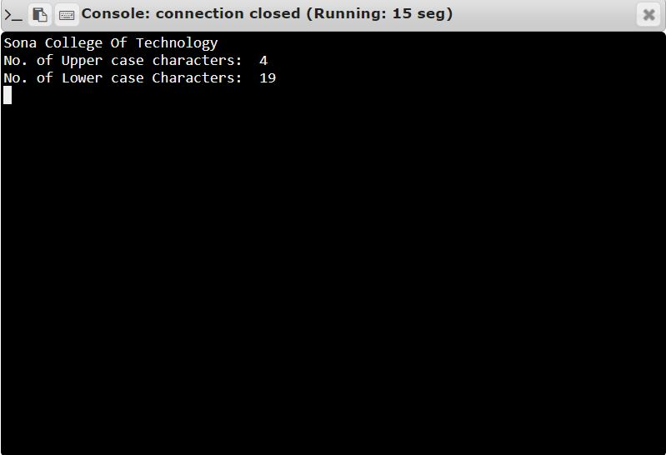

**RESULT:**

Thus, the code has been successfully executed and output is verified. ­­­­­