**EXERCISE NO:** 11 **REGISTER NO:** 1518102099

**DATE:** 23.11.2020

**AIM:**

To find the greatest common divisor (gcd) of two integers using recursion.

**PROGRAM:**

def gcd(a,b):

while(b):

a,b=b, a%b

return a

a=int(input("Enter first number:"))

b=int(input("Enter second number:"))

GCD=gcd(a,b)

print("GCD is: ")

print(GCD)

**LINK:**

<http://103.53.53.18/mod/vpl/forms/submissionview.php?id=326&userid=1704>

**OUTPUT:**

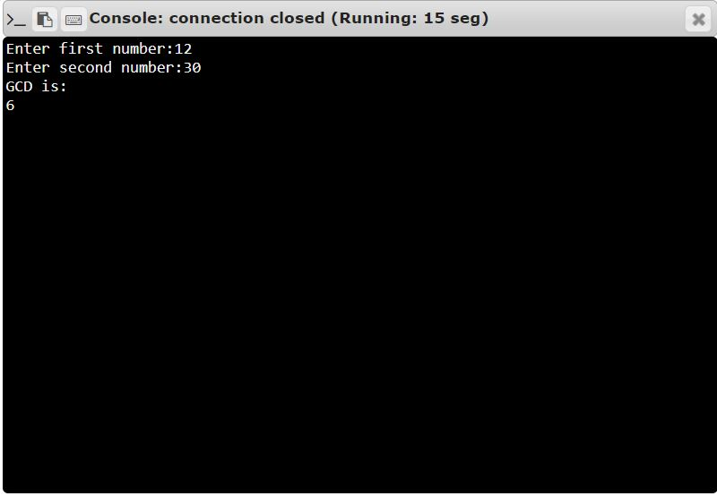

**RESULT:**

Thus, the code has been successfully executed and output is verified. ­­­­­