**EXERCISE NO:** 14 **REGISTER NO:** 1518102099

**DATE:** 23.11.2020

**AIM:**

To find validity of a string of parentheses, '(', ')', '{', '}', '[' and ']. These brackets must be close in the correct order, for example "()" and "()[]{}" are valid but "[)", "({[)]" and "{{{" are invalid.

**PROGRAM:**

class validity:

def bal(str):

stack=['()','{}','[]']

while any(i in str for i in stack):

for j in stack:

str=str.replace(j,'')

return not str

s=input()

If(validity.bal(s)):

print("valid")

else:

print("invalid")

**LINK:**

<http://103.53.53.18/mod/vpl/forms/submissionview.php?id=327&userid=1704>

**OUTPUT:**

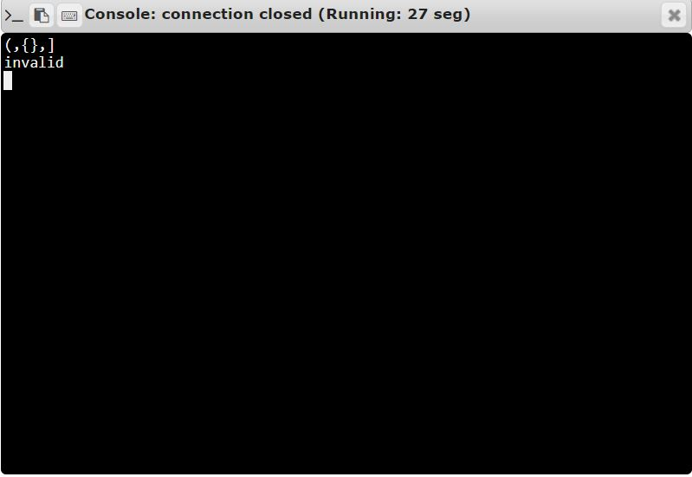

**RESULT:**

Thus, the code has been successfully executed and output is verified. ­­­­­