# Gap Analysis Document for Personal Expense Tracker

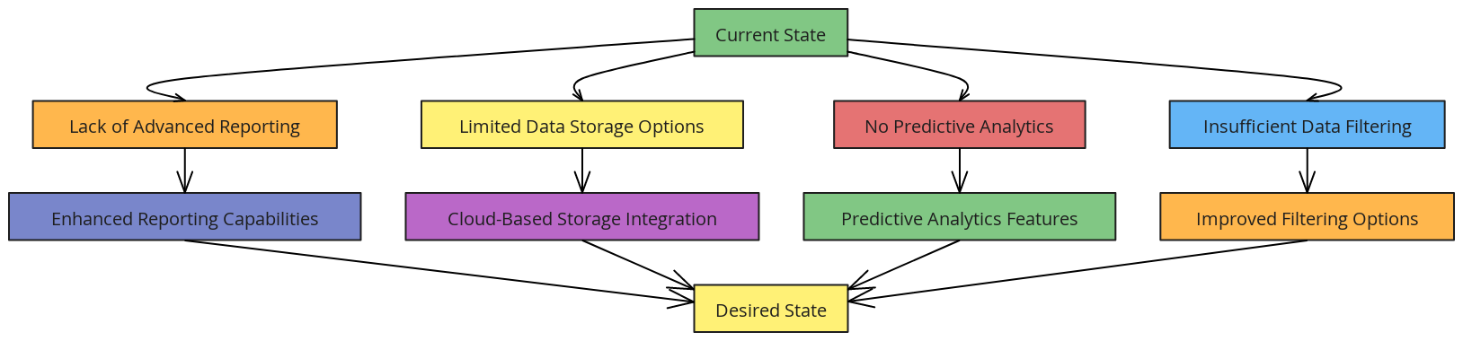

1. **Objective of Gap Analysis**
   * **Purpose**: Identify areas where the current system does not meet desired functionality or user needs.
   * **Scope**: Focus on usability, data management, reporting capabilities, and scalability.
2. **Identified Gaps**
   * **Lack of Advanced Reporting**
     + **Current State**: Basic spending summaries are provided, but there are limited options for detailed reports.
     + **Desired State**: Users require more customizable reports with filters for specific categories and time ranges.
     + **Impact**: Users may find it challenging to analyze their spending in depth, reducing the app's effectiveness as a financial tool.
   * **Limited Data Storage Options**
     + **Current State**: Data is stored locally, suitable for individual use but not scalable.
     + **Desired State**: Implement cloud-based storage to allow for multi-device access and enhanced data security.
     + **Impact**: Without cloud storage, users cannot access their data from multiple devices, limiting the app's accessibility.
   * **No Predictive Analytics**
     + **Current State**: The system does not offer forecasts or spending trend predictions.
     + **Desired State**: Integrate predictive models to help users plan for future expenses based on historical data.
     + **Impact**: Users lack insights into anticipated spending, which could assist in proactive budgeting.
   * **Insufficient Data Filtering and Sorting**
     + **Current State**: Users can view all expenses but cannot easily filter by category or sort by date.
     + **Desired State**: Enable more robust filtering and sorting features to improve data navigation.
     + **Impact**: Limits the ability of users to efficiently analyze their data, impacting usability.
3. **Recommendations**
   * **Enhanced Reporting Capabilities**: Add customizable reports for detailed financial analysis.
   * **Cloud-Based Storage Integration**: Transition to cloud storage for improved accessibility and security.
   * **Predictive Analytics Features**: Implement predictive models to provide users with spending forecasts.
   * **Improved Filtering Options**: Introduce filters and sorting options in the expense list for better data management.