# Stakeholder Management Plan for Personal Expense Tracker

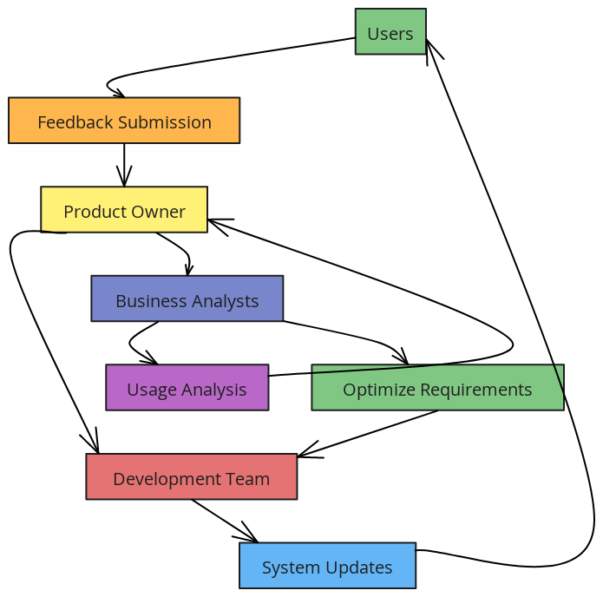

1. **Stakeholder Identification**
   * **Users**: Primary end-users who will use the application for tracking expenses.
   * **Development Team**: Developers, designers, and QA specialists involved in building and maintaining the app.
   * **Product Owner**: Individual or team responsible for defining requirements and ensuring the product meets user needs.
   * **Business Analysts**: Provide data insights and requirements alignment for accurate tracking and reporting.
2. **Stakeholder Roles and Responsibilities**
   * **Users**: Provide feedback on features, report issues, and request enhancements.
   * **Development Team**: Implement features, fix bugs, and enhance the system based on feedback.
   * **Product Owner**: Define priorities, approve changes, and communicate goals to the development team.
   * **Business Analysts**: Analyze usage data, validate requirements, and suggest optimizations based on trends.
3. **Communication Methods**
   * **Regular Updates**: Weekly progress reports to update stakeholders on development status and milestones.
   * **User Feedback Loop**: User surveys and feedback sessions to gather input on usability and performance.
   * **Team Meetings**: Bi-weekly meetings for development team and product owner to discuss project progress and address challenges.
   * **Documentation**: Maintain updated documentation accessible to all stakeholders for transparency and knowledge sharing.
4. **Engagement Strategies**
   * **User Training Sessions**: Provide users with training on app features and functionality to maximize utility.
   * **Feedback Mechanisms**: Use surveys, usability tests, and beta testing to capture user needs and preferences.
   * **Stakeholder Reviews**: Regular check-ins with the product owner and business analysts to align on priorities and expectations.
5. **Success Metrics**
   * **User Satisfaction**: Measured through feedback and surveys to ensure the app meets user needs.
   * **Feature Adoption Rate**: Tracks how effectively users engage with newly added features.
   * **Bug Resolution Time**: Measures efficiency in addressing and resolving reported issues.
   * **Project Milestone Completion**: Ensures development stays on track with defined timelines and deliverables.