# System Test Plan for Personal Expense Tracker

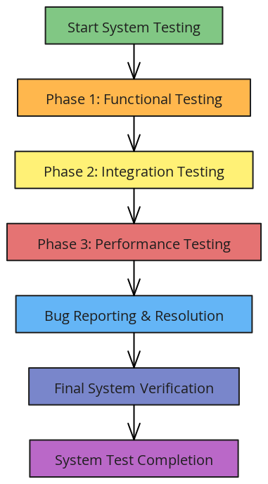

1. **Scope of Testing**
   * **Objective**: Verify that the system meets all functional and non-functional requirements, ensuring stability, usability, and performance.
   * **Components**: Includes testing of data entry forms, data visualization, data persistence, and responsiveness across devices.
2. **Testing Phases**
   * **Phase 1**: Functional Testing - Verify that core functionalities (expense entry, editing, deletion) operate as expected.
   * **Phase 2**: Integration Testing - Ensure seamless interaction between components, such as expense form updates affecting charts and summaries.
   * **Phase 3**: Performance Testing - Assess system speed, load times, and chart rendering efficiency with increasing data volume.
3. **Testing Criteria**
   * **Acceptance Criteria**: All tests must pass with no critical issues, especially in core functionalities and data accuracy.
   * **Success Metrics**: Completion of all test cases with expected results, meeting performance benchmarks for load and response times.
4. **Roles and Responsibilities**
   * **QA Lead**: Oversees test plan execution, coordinates testing activities, and reports results.
   * **Developers**: Address issues identified during testing and provide technical support.
   * **Data Analyst**: Assesses data accuracy and assists in verifying calculations within summaries and charts.
5. **Test Environment**
   * **Configuration**: Testing conducted in a controlled environment that mirrors the production setup.
   * **Browsers and Devices**: Testing will include different browsers (Chrome, Firefox, Edge) and device types (desktop, tablet, mobile) to ensure consistent performance.
6. **Test Execution and Reporting**
   * **Execution**: Test cases will be executed in order, with issues logged in a bug-tracking system.
   * **Reporting**: Daily and final reports will summarize test results, highlighting critical issues and resolution timelines.