# User Stories and Use Cases for Personal Expense Tracker

**Expense Analysis Flow sequence diagram :**

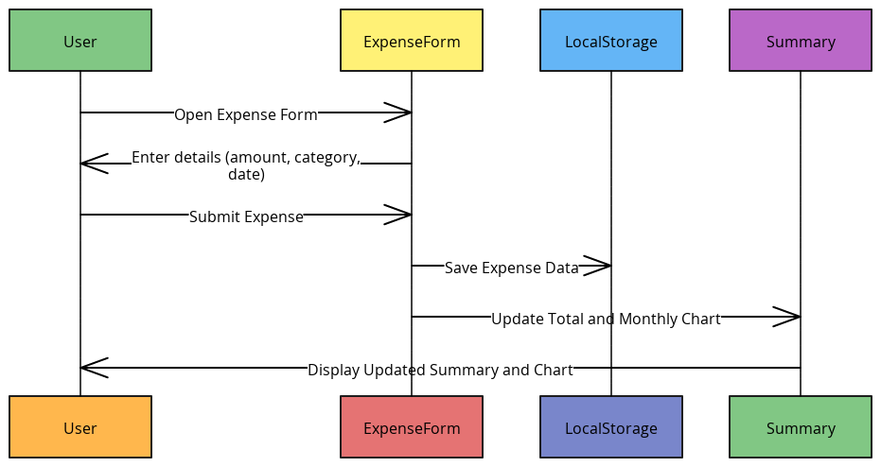

**Data Persistence Flow** sequence diagram:

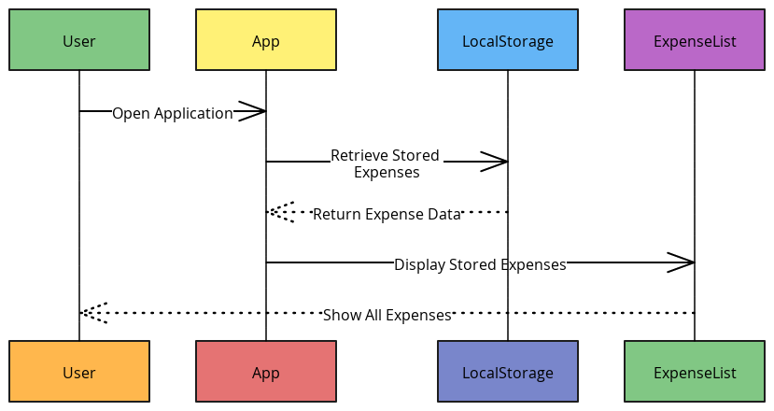

**Category Filtering Flow** sequence diagram:

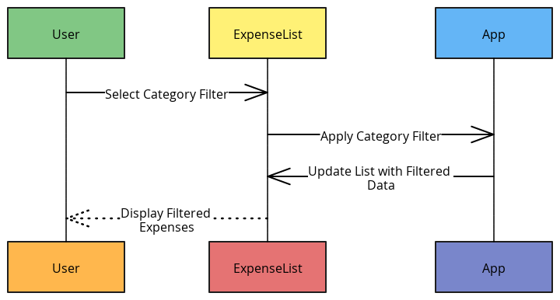

1. **User Story: Expense Tracking**
   * **As a** user, **I want** to log my daily expenses quickly, **so that** I can monitor my spending habits regularly.
   * **Use Case**:
     + **Actors**: User
     + **Preconditions**: User is logged into the application.
     + **Steps**: User navigates to the expense form, enters details (amount, category, description), and submits.
     + **Postconditions**: Expense is saved, and the total is updated in the summary and chart.
2. **User Story: Expense Analysis**
   * **As a** user, **I want** to see a visual summary of my expenses, **so that** I can identify spending trends.
   * **Use Case**:
     + **Actors**: User
     + **Preconditions**: User has logged expenses in the application.
     + **Steps**: User navigates to the summary page, where expenses are displayed as a bar chart and monthly totals.
     + **Postconditions**: The user views graphical insights, highlighting areas of high expenditure.
3. **User Story: Data Persistence**
   * **As a** user, **I want** my expense data to be saved across sessions, **so that** I can access it anytime.
   * **Use Case**:
     + **Actors**: User, LocalStorage
     + **Preconditions**: User has previously entered expenses.
     + **Steps**: User opens the application after a session; data is retrieved from localStorage.
     + **Postconditions**: All previously entered data is accessible without requiring re-entry.
4. **User Story: Category Filtering**
   * **As a** user, **I want** to filter expenses by category, **so that** I can view my spending in specific areas.
   * **Use Case**:
     + **Actors**: User
     + **Preconditions**: User has multiple categories of expenses logged.
     + **Steps**: User selects a category filter; the list updates to show only expenses for that category.
     + **Postconditions**: The list reflects filtered results, and the user can focus on selected categories.