*Scenario 1*
Metrics- Faithfulness
Input (User question):What is selenium
Actual output (Models Actual output):Selenium is a web automation framework for testing web application
Retrieval context -Selenium is a web automation framework for testing web application
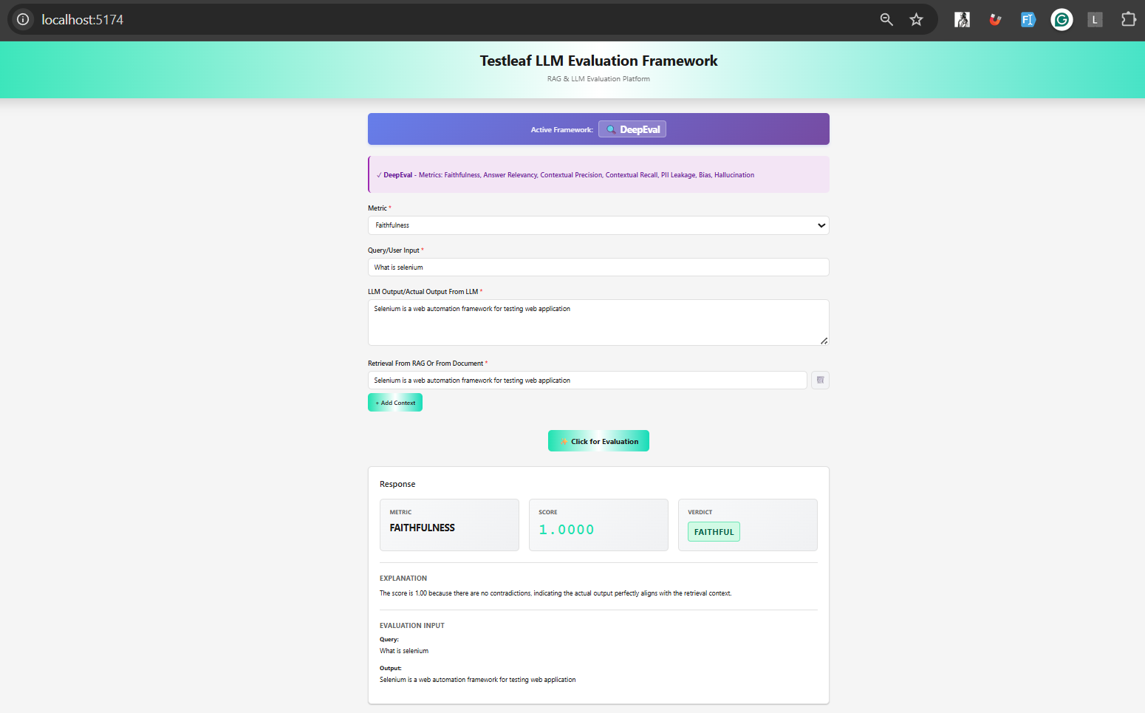

*Scenario 2*
Metrics-Faithfulness
Input:What is selenium
Actual output (Models Actual output):Selenium is a web automation framework for testing web application
Retrieval context-Selenium is a rare element
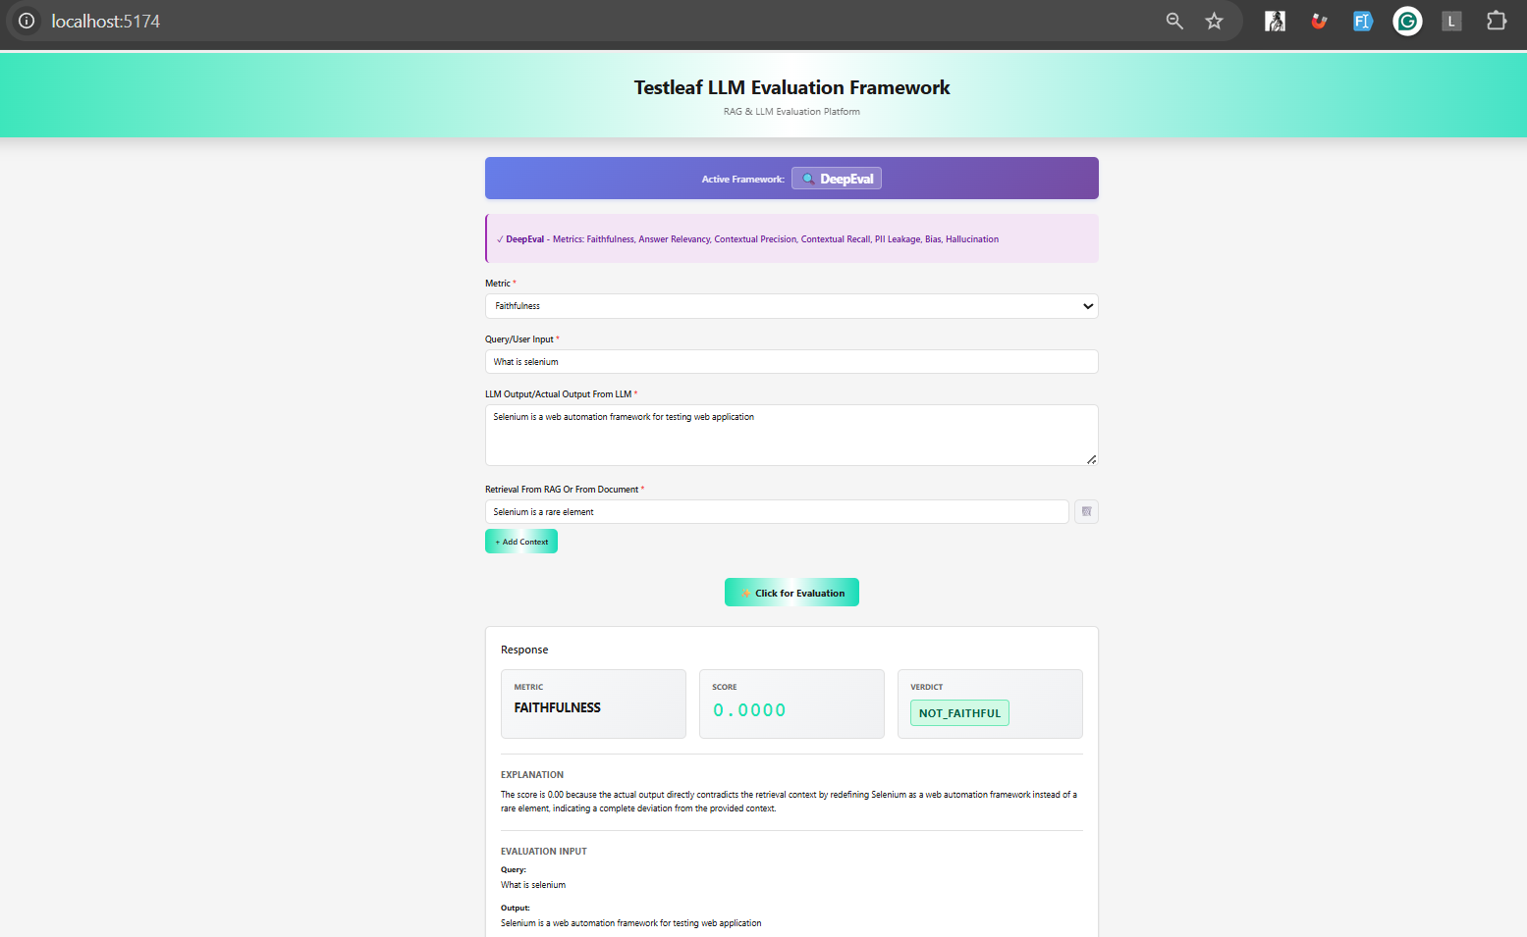

*Scenario 3*
Metrics-Faithfulness
Input (User question):What is selenium
Actual output (Models Actual output):Selenium is a automation framework for testing web and desktop application
Retrieval context -Selenium is a web automation framework for testing web application(From Mongo)

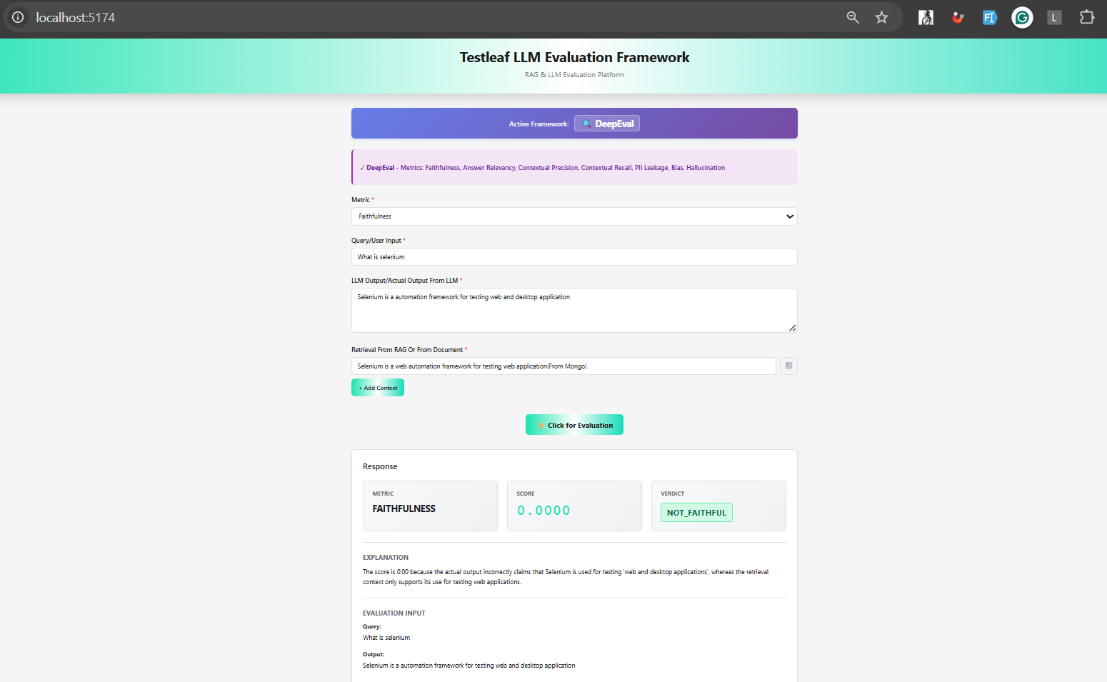

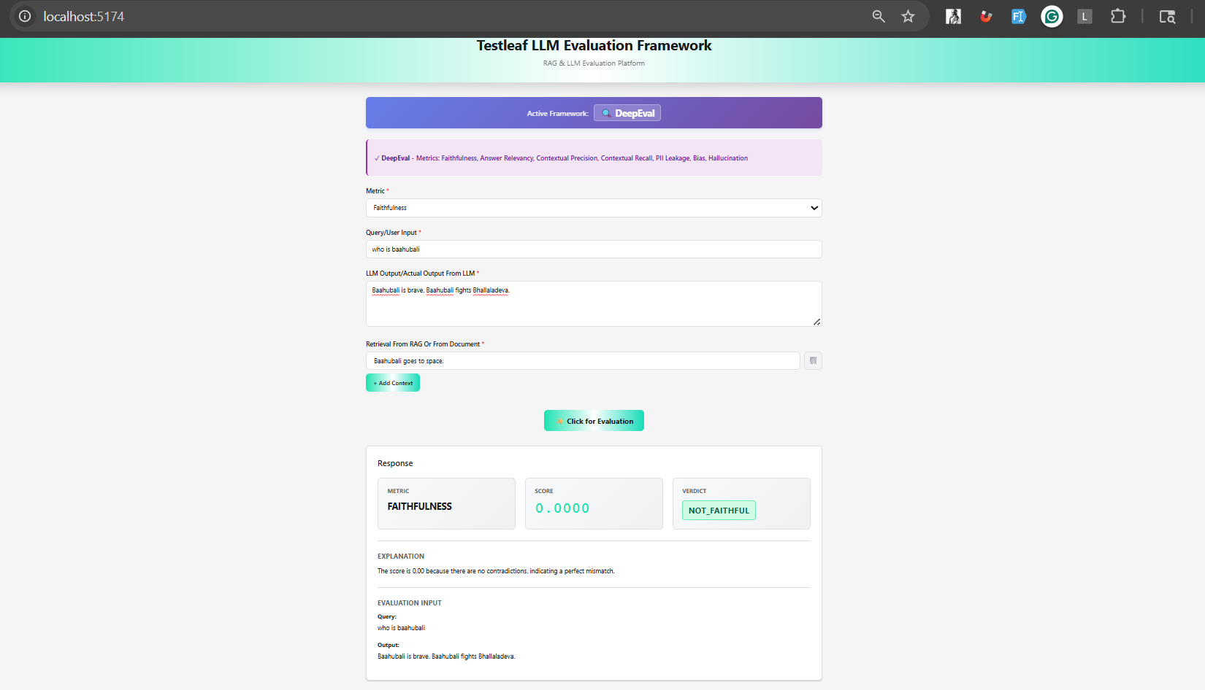
Scenario 5:
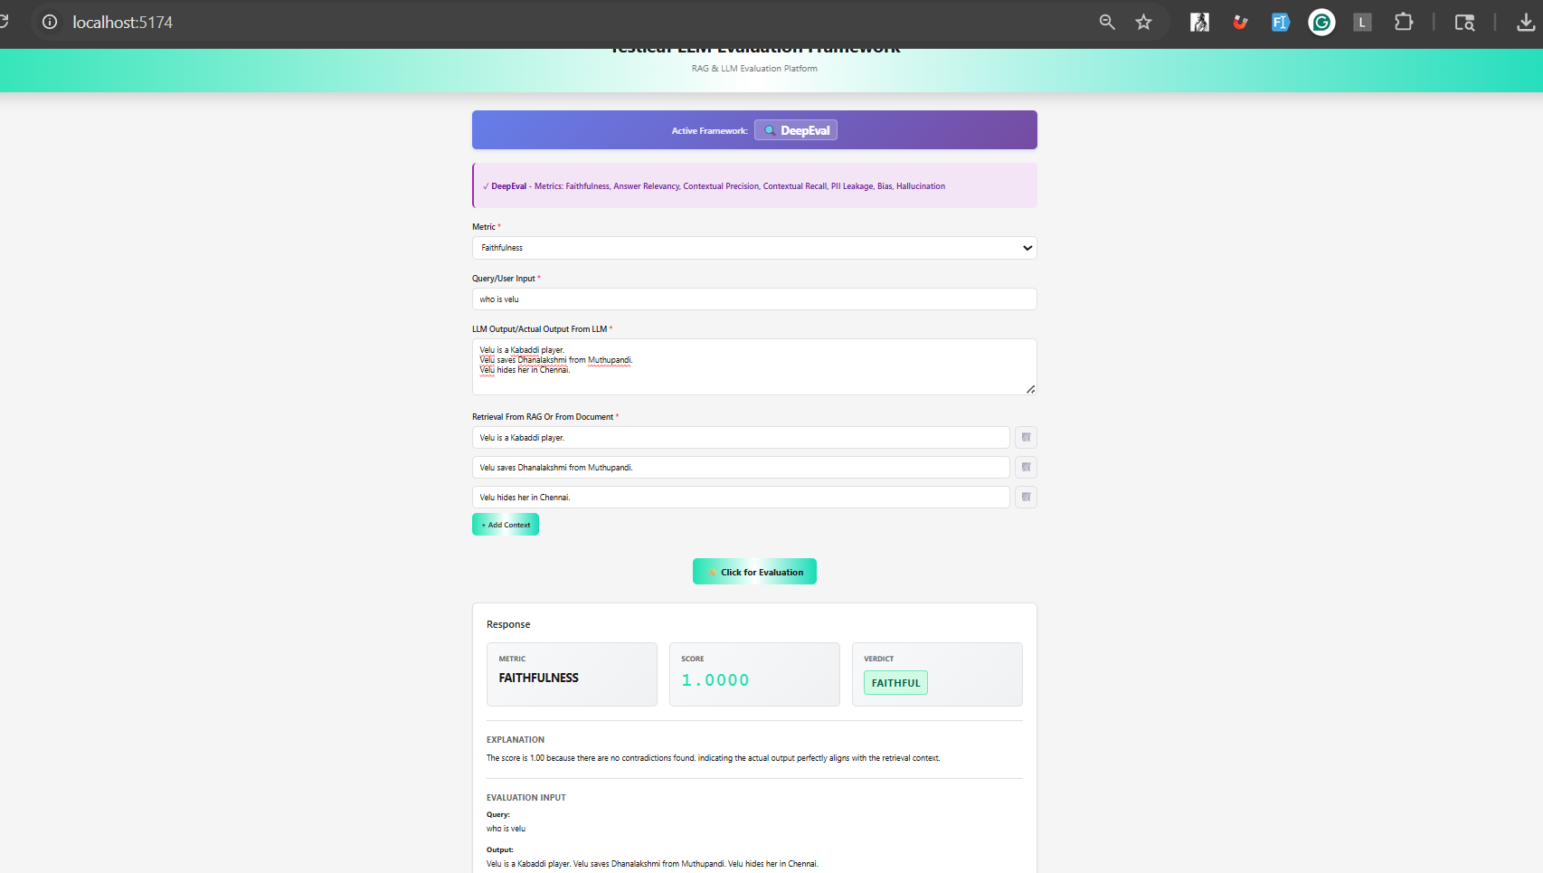

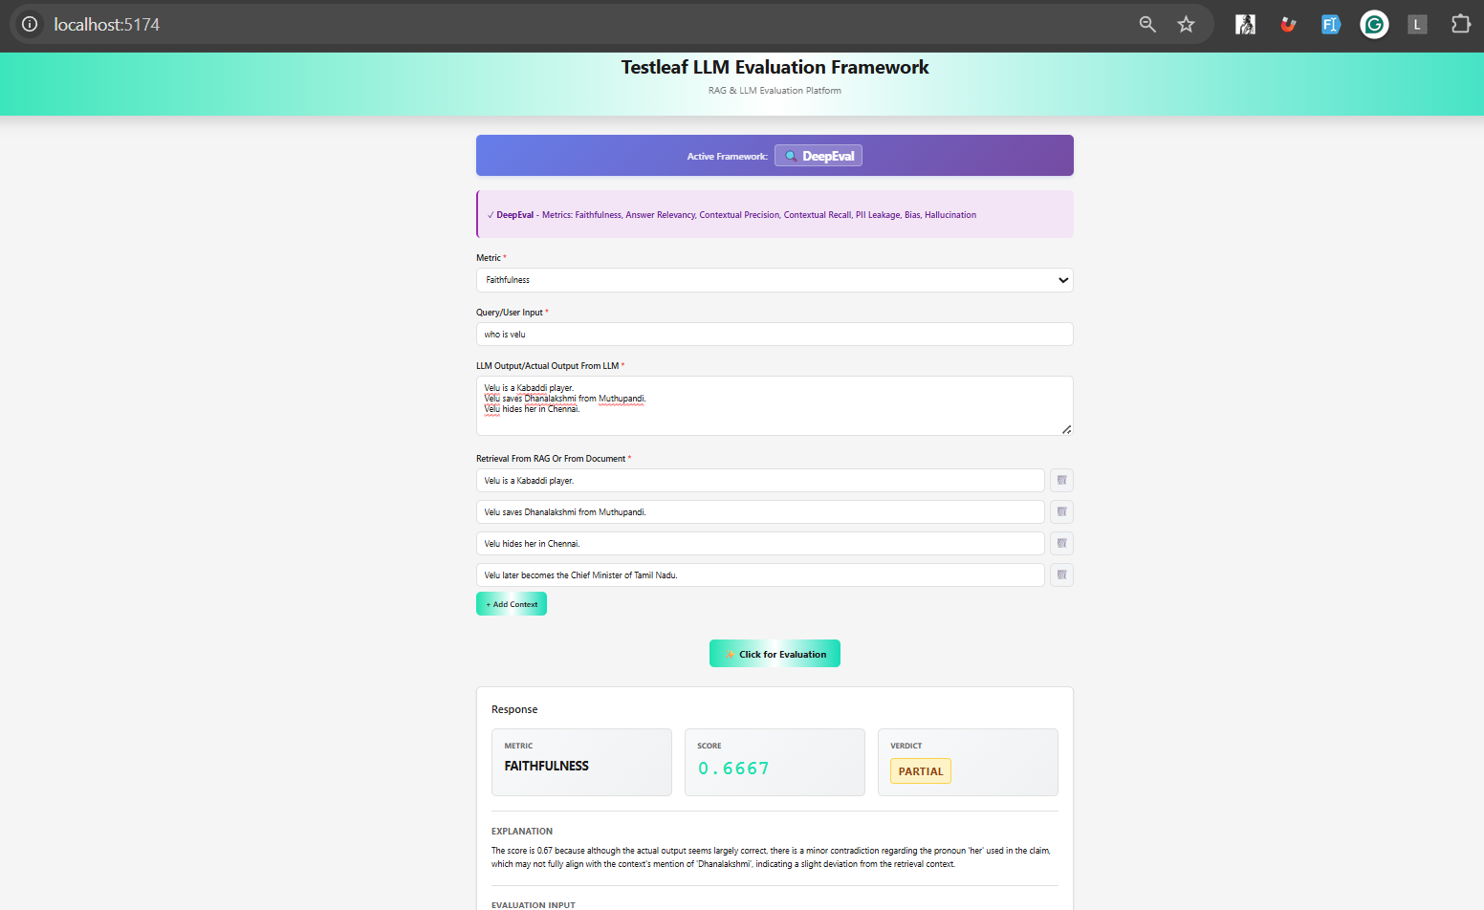
Contextual precision
