1. Create mariadb db on ec2.

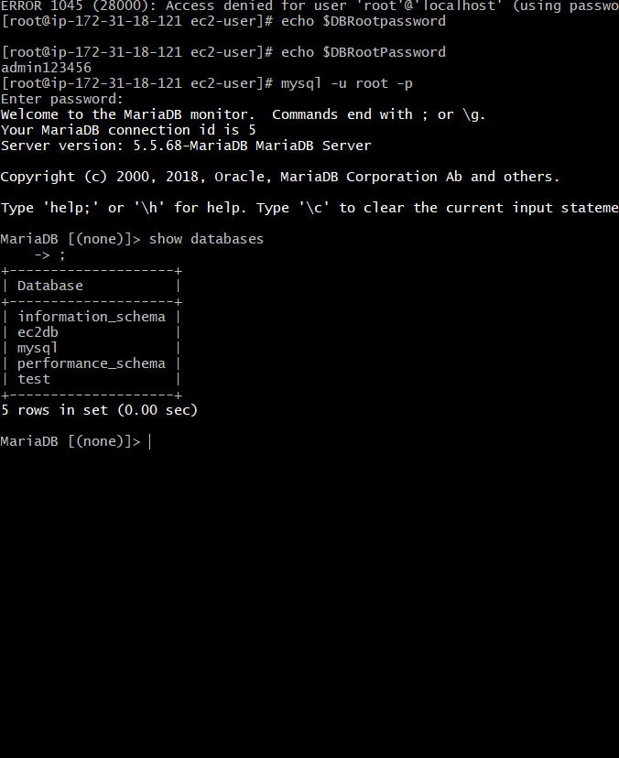

1. Insert some dummy data

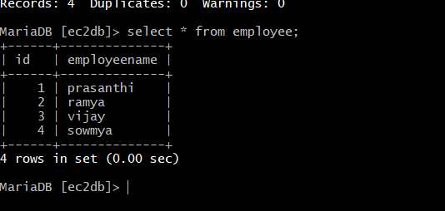

3) Take the backup of dummy data on ec2

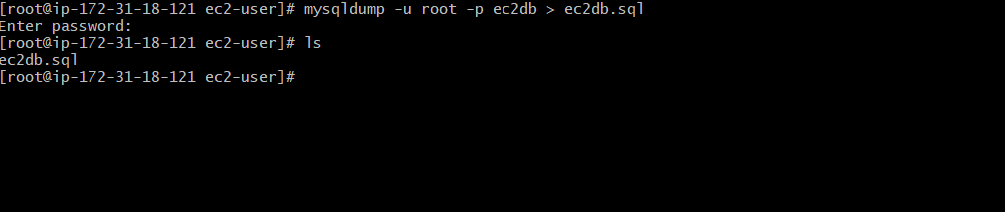

1. launch Mariadb RDS instance.

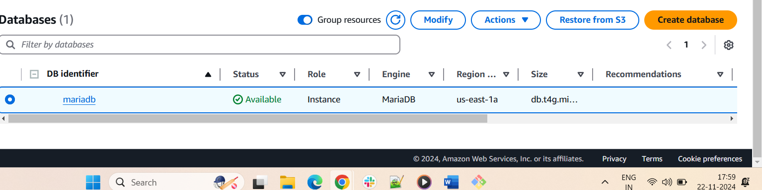

1. Migrate database from ec2 to RDS.
2. Install mysql db on ec2

