Created 4 VPCS

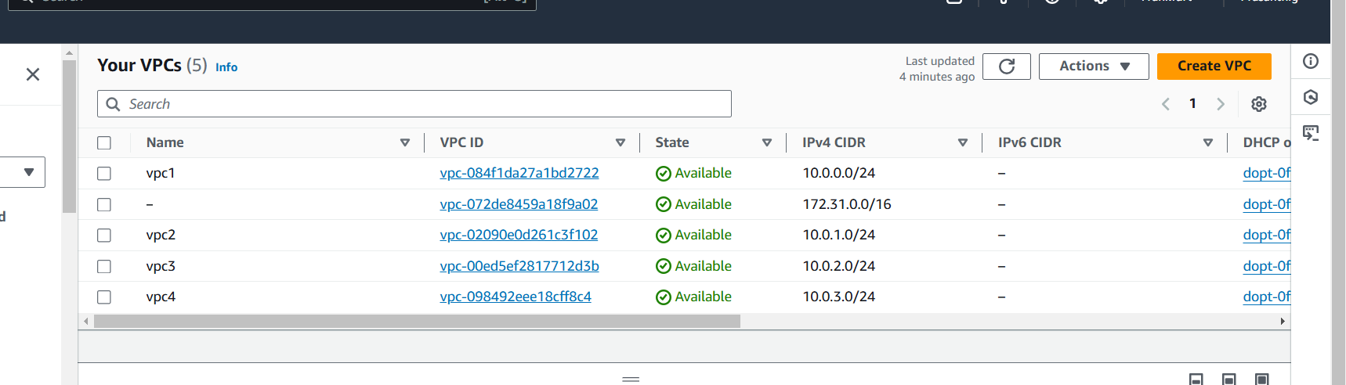

Created a subnet for each VPC

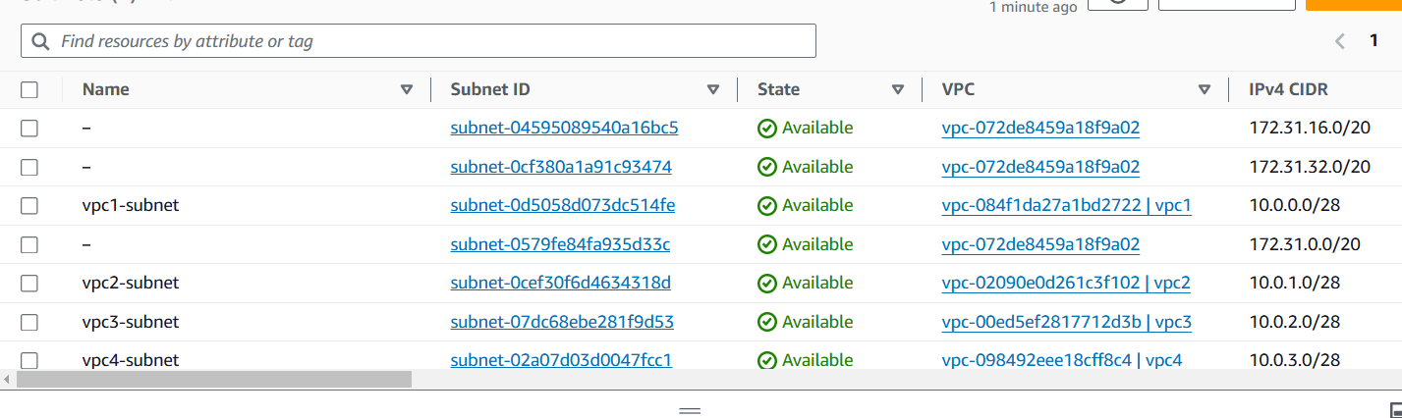

Created routes

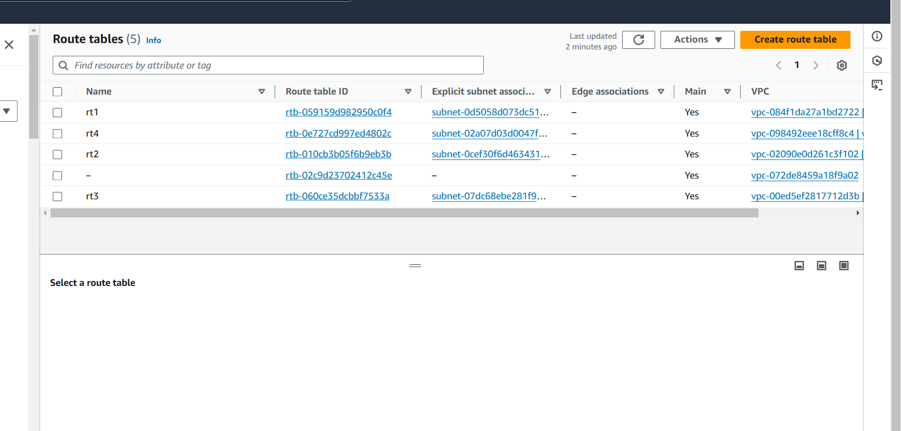

Added CIDR IPS in each route

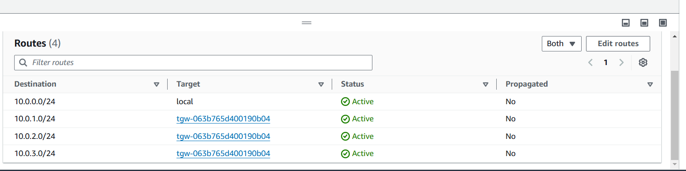

Created internet gateway and attached to 1 vpc



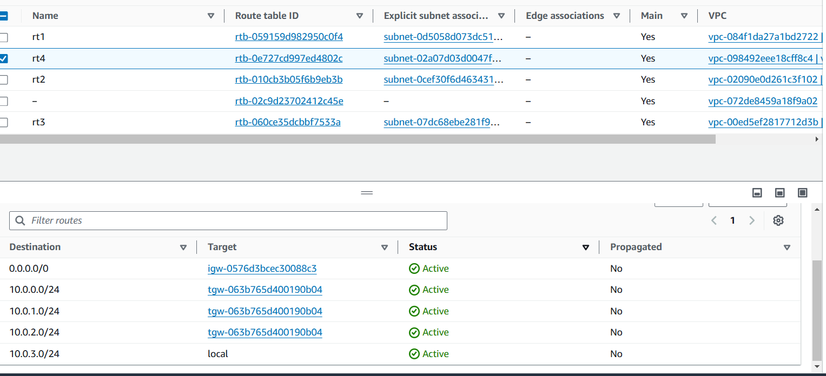

Created transit gateway

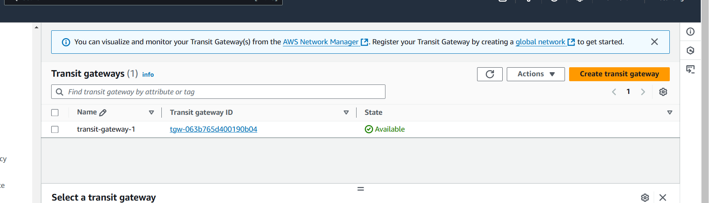

Created transit gateway attachment for each vpc

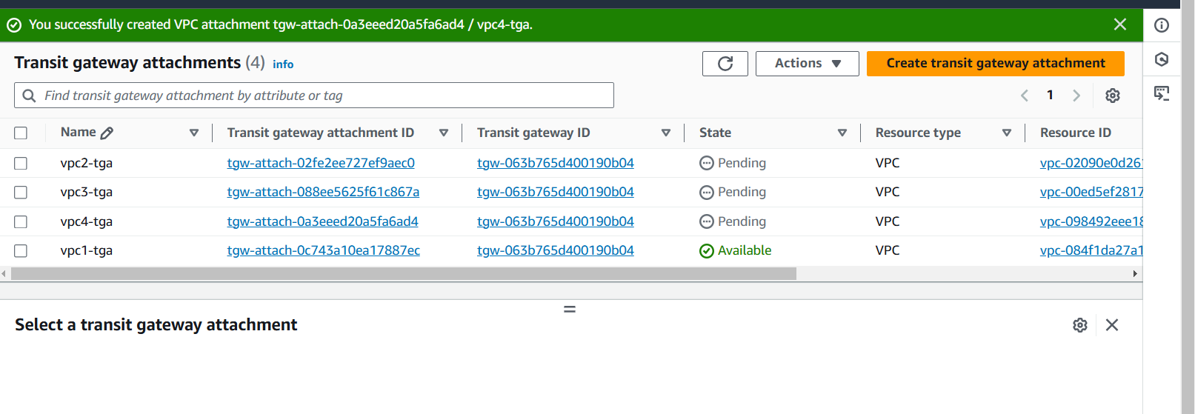

Transit gateway route table has been created by default

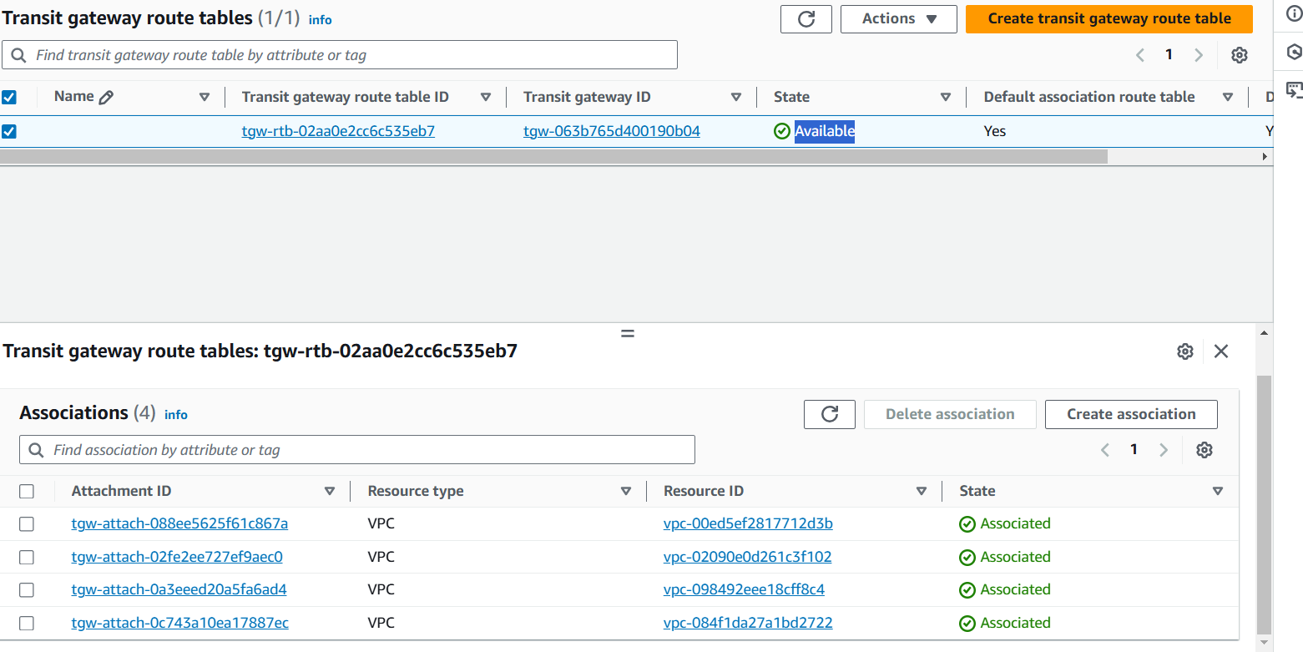

Tested the connectivity from vpc4 to all other VPCS

