1. Watch ansible-01 video and write down notes.
2. Setup one master and two worker nodes in ansible.

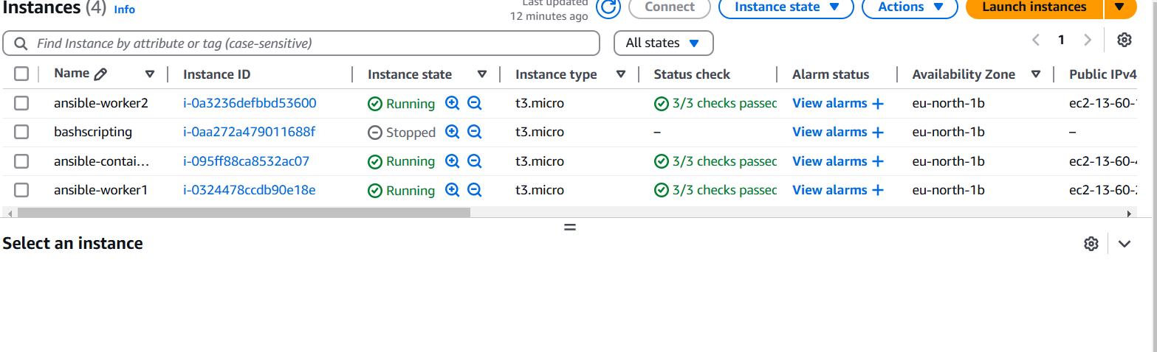

1. Execute the adhoc command shared in #dvps-cloud-documents Channel.

* Ansible all -m ping

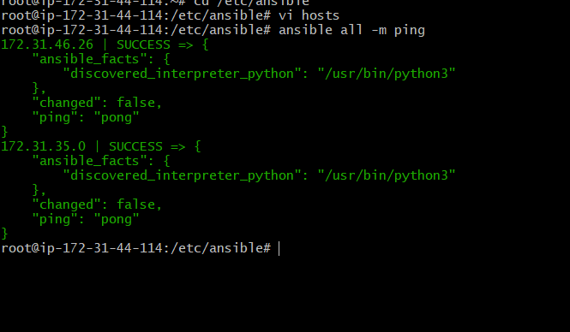

* Ansible worker_01 -m ping

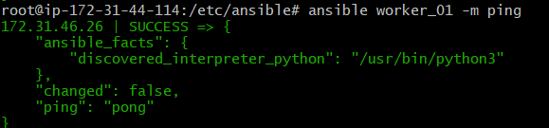

* Ansible all -m shell -a “uptime”

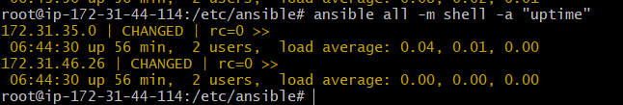

* Ansible all -m ping -i ansible_hosts

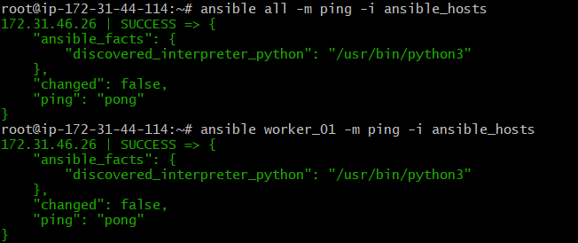

* Ansible all -m setup

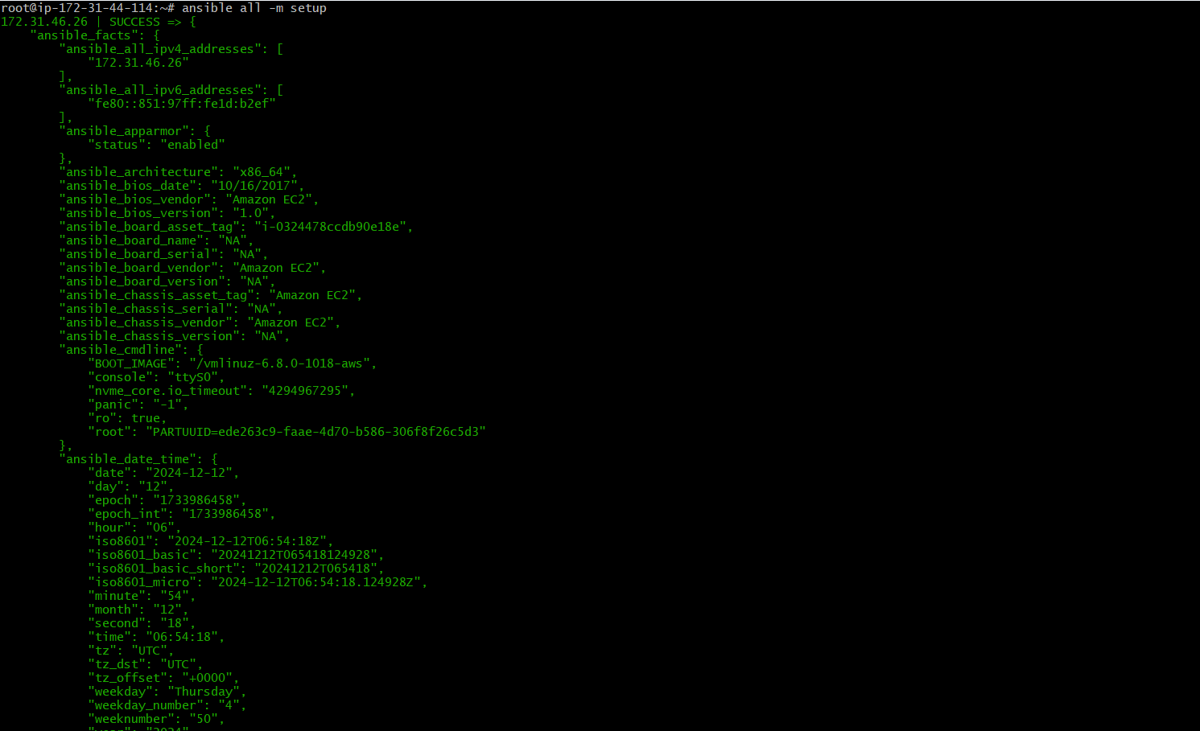

* ansible all -a "free -m"

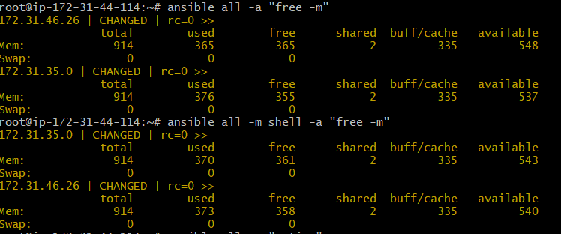

* ansible all -m shell -a "cat /etc/passwd|grep -i ubuntu" -b -K

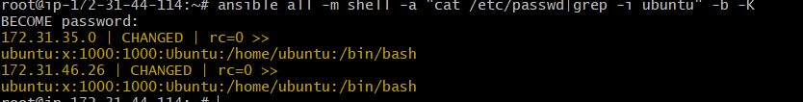

* ansible all -m file -a "path=/home/ubuntu/testfile state=touch mode=0755"

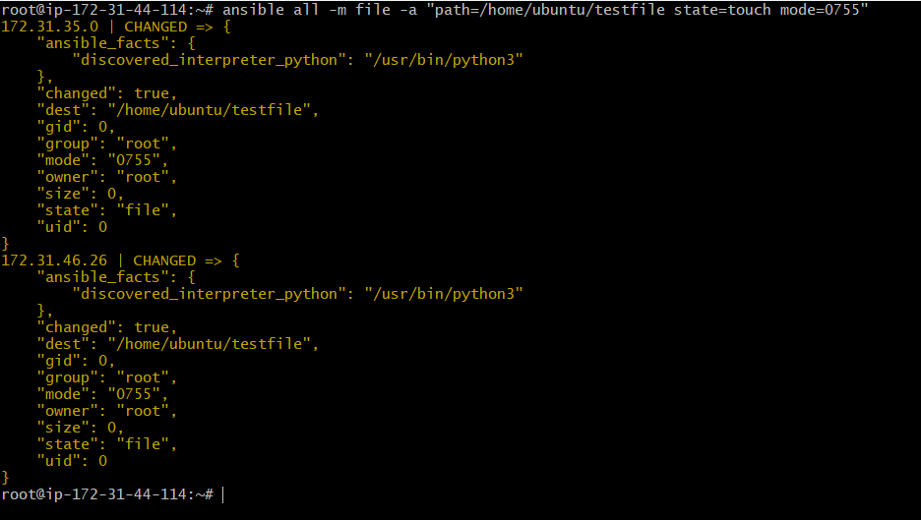

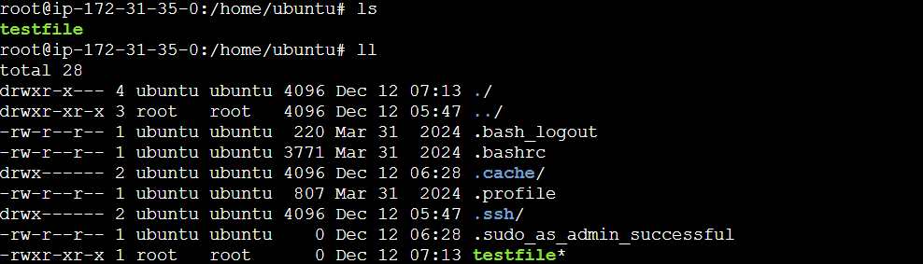

* ansible all -m file -a "path=/home/ubuntu/testfile group=ubuntu owner=ubuntu" -b

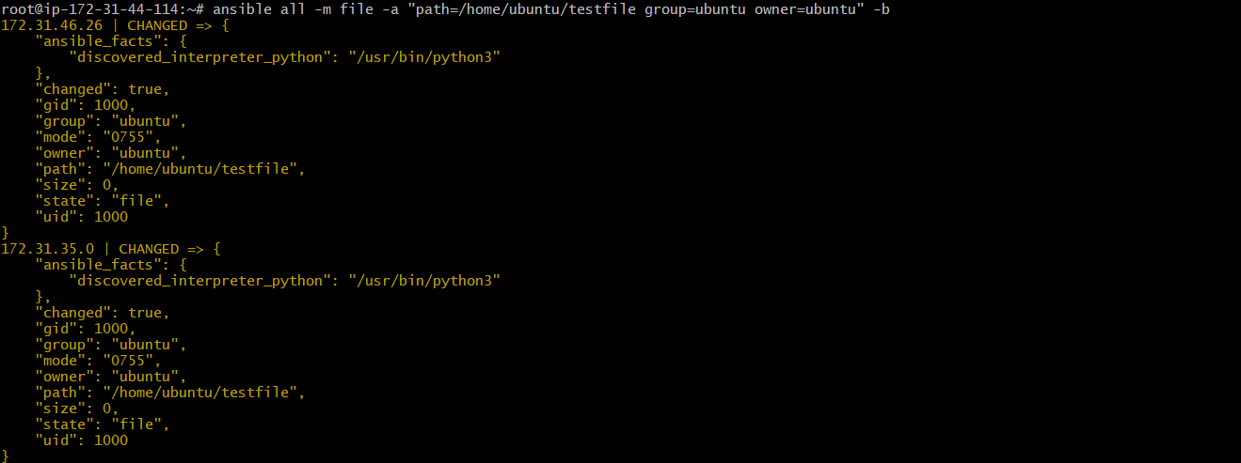

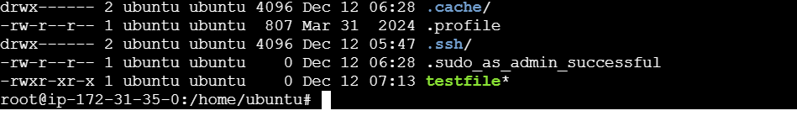

* ansible all -m apt -a “name=apache2 state=latest”

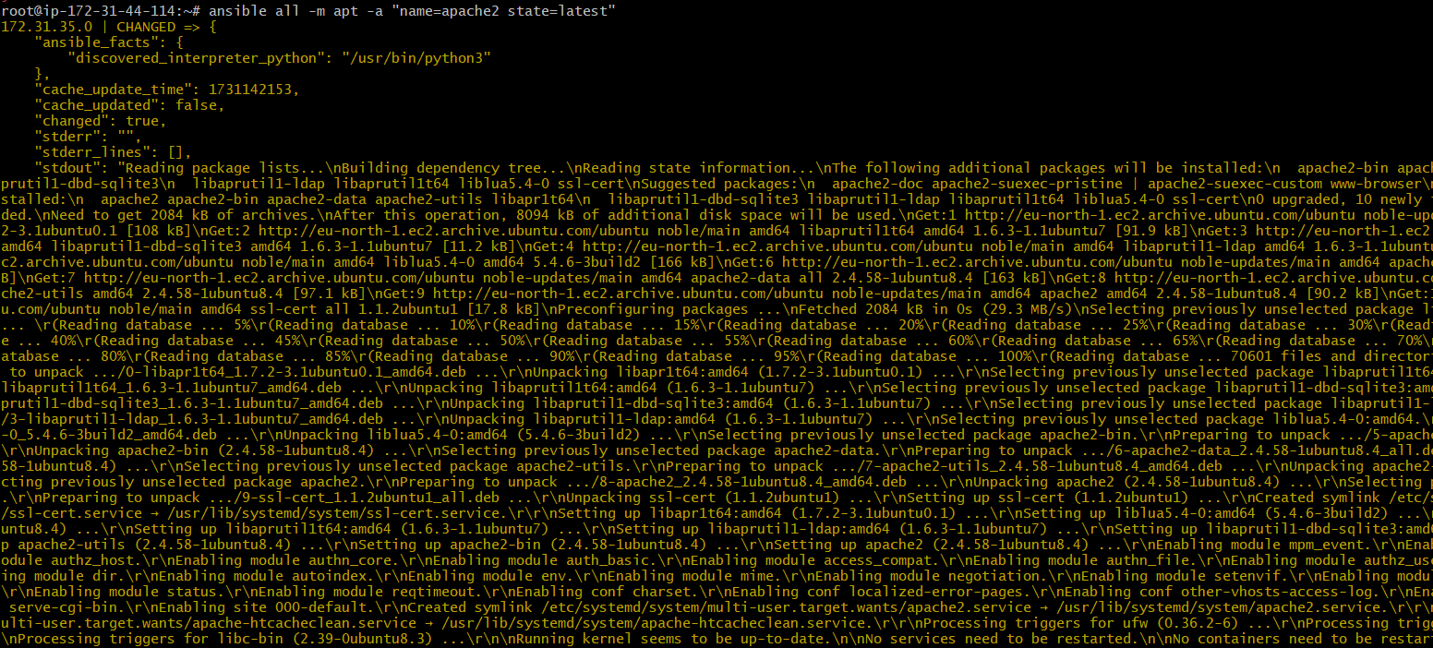

* ansible all -m service -a “name=apache2 state=started enabled=yes”

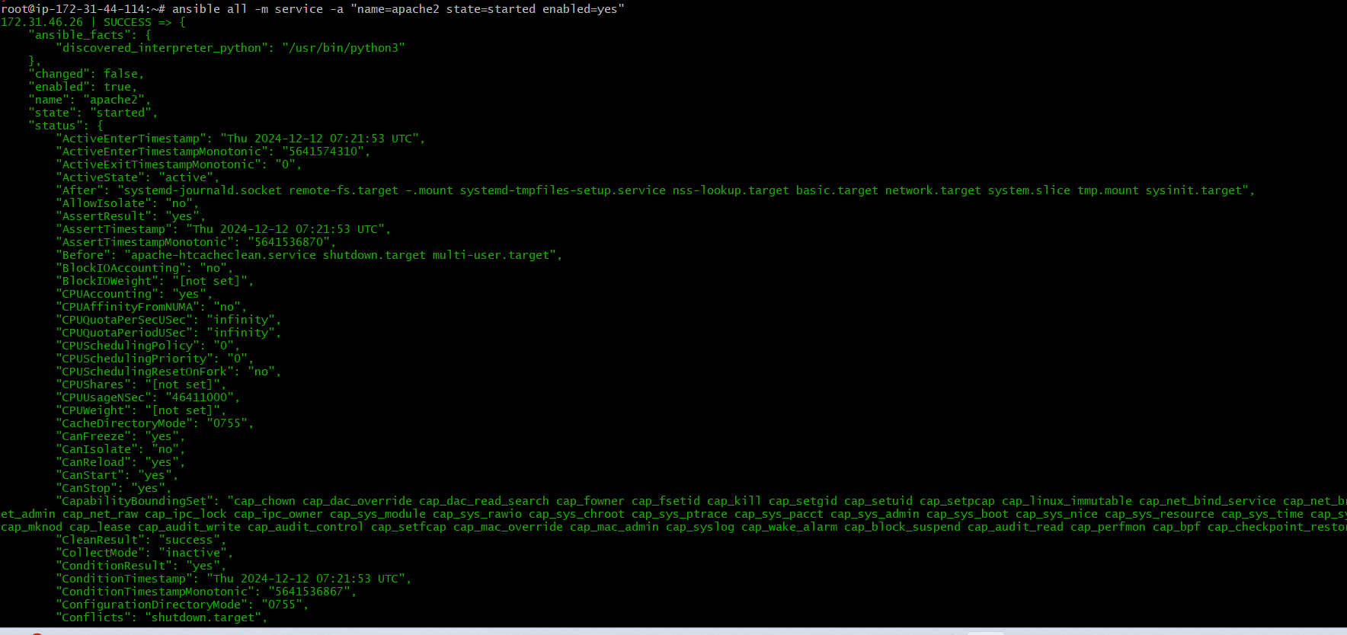

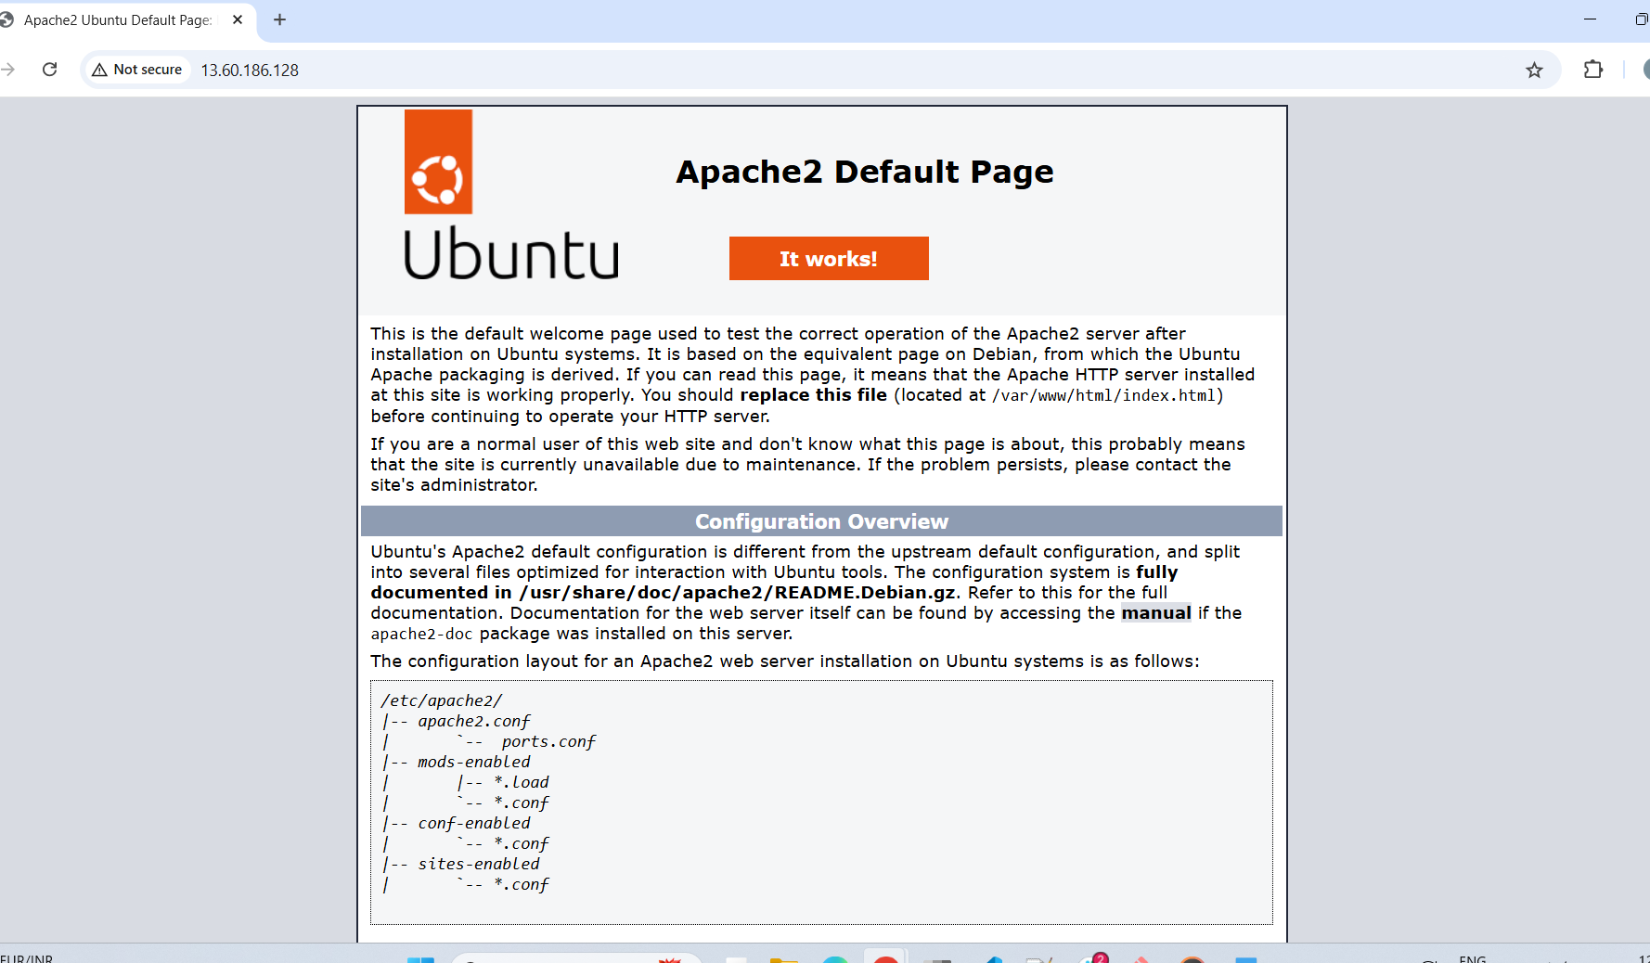

* ansible all -m service -a “name=apache2 state=stopped enabled=yes”

