1. Create ansible playbook to create ansible vault.

Variables for file name(my_secrets.yml) to be encrypted and password file(vault_pass.txt) to store the password for encrypted file

The file contents which has to be encrypted is mentioned in the key-value pair (variables_to_encrypt)

Task 1: create the vault_pass.txt file

Task 2: Create the file to be encrypted

Task 3: using ansible-vault encrypt to encrypt the content of the my_secrets.yml

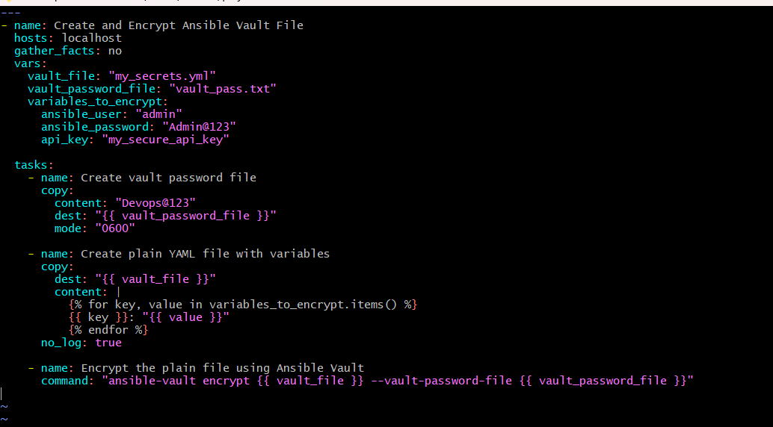

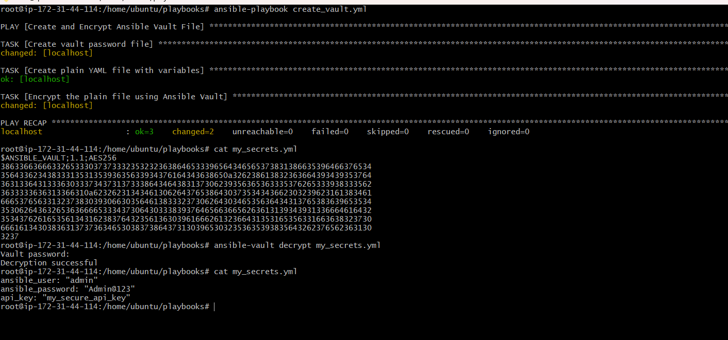

1. Write a ansible playbook to install apache in linux and ubuntu machine by using when condition.
2. 