1. Setup a virtual machine using Ubuntu image.

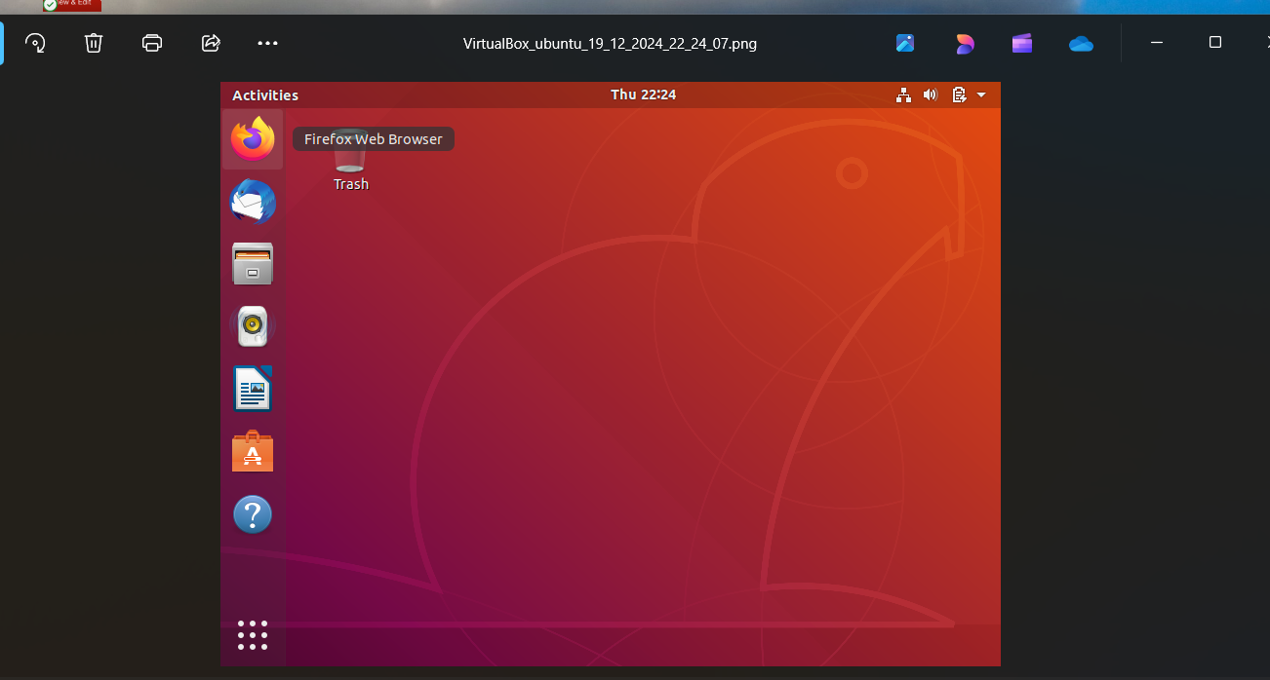

1. Install docker on ec2.



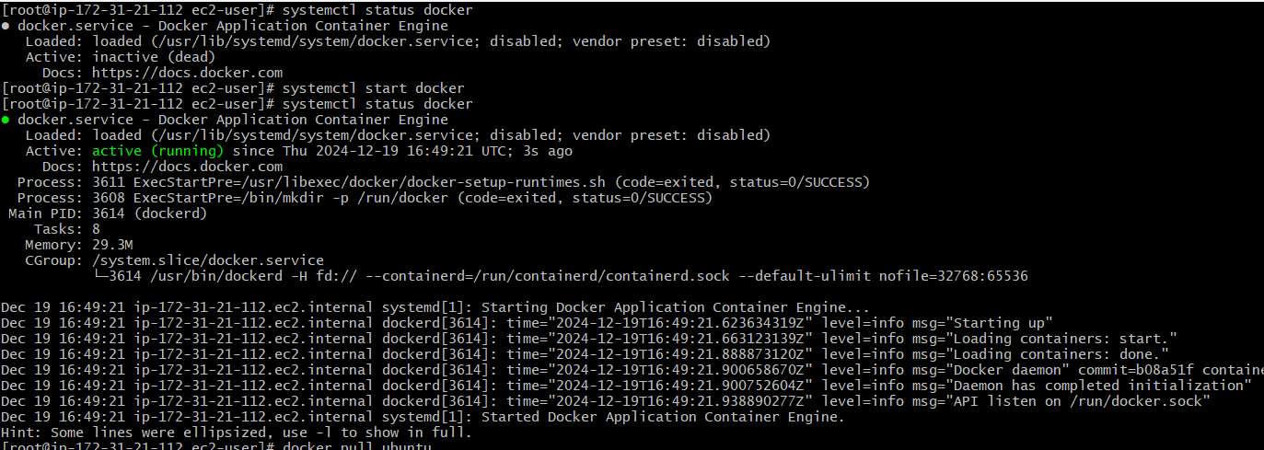

1. Pull 5 docker images.(nginx,apache tomcat,ubuntu,jenkins,sonarqube)

Pull nginx image

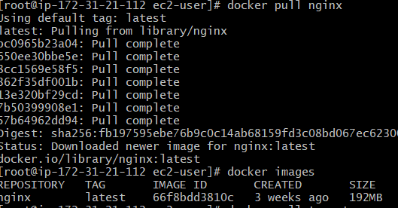

Pull apache tomcat

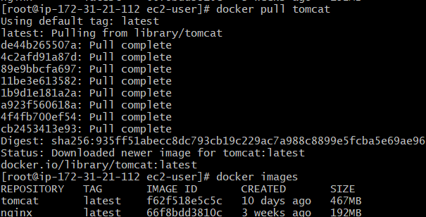

Pull ubuntu

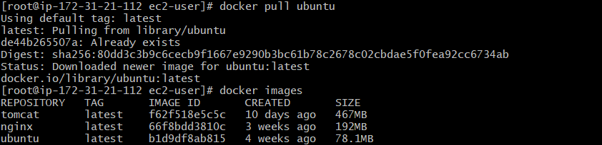

Pull jenkins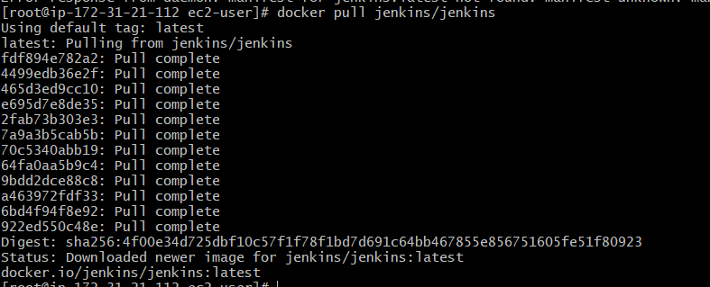

Pull Sonar Qube

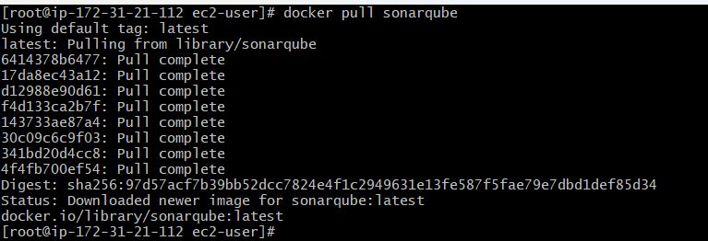

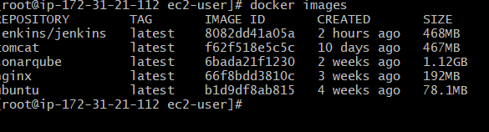

1. Run nginx container and expose on port 81.

Run nginx container

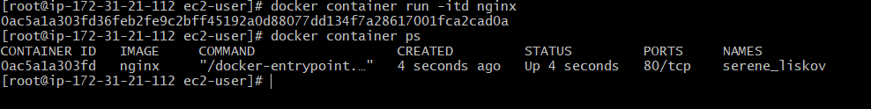

Command to expose the nginx on port 81

Docker container run -itd -p 81:80 nginx

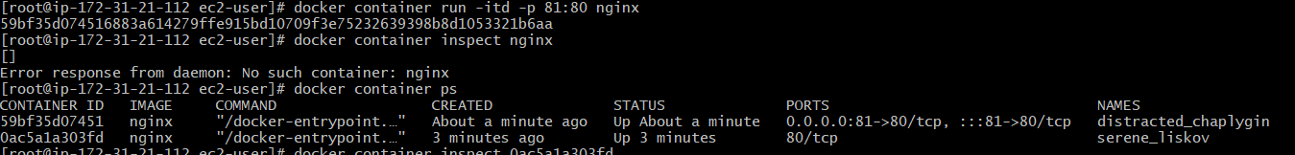

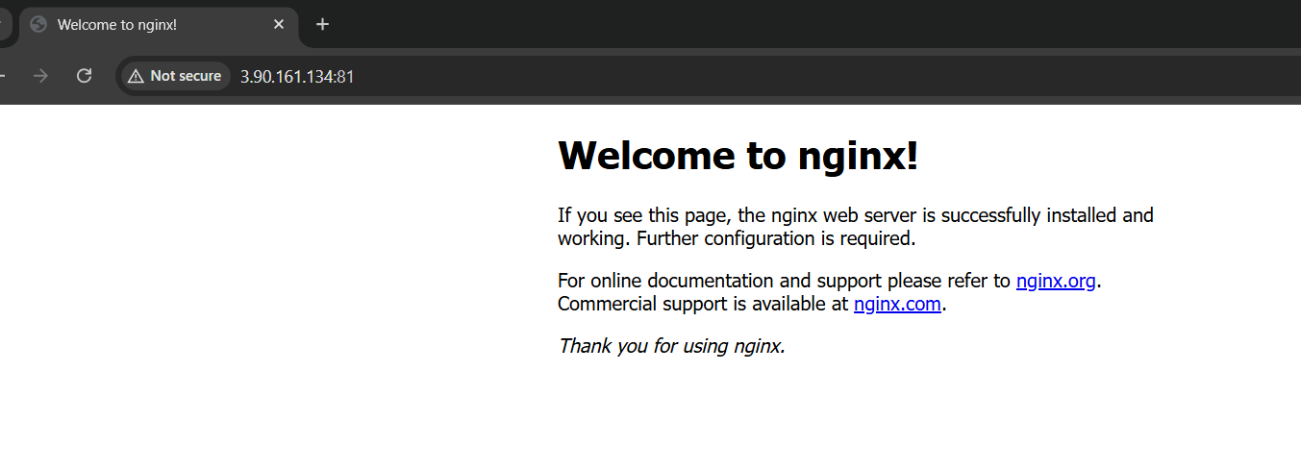

1. Delete the apache tomcat image from local.

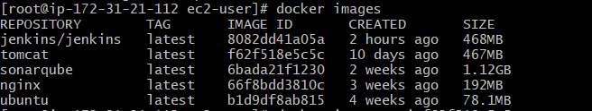

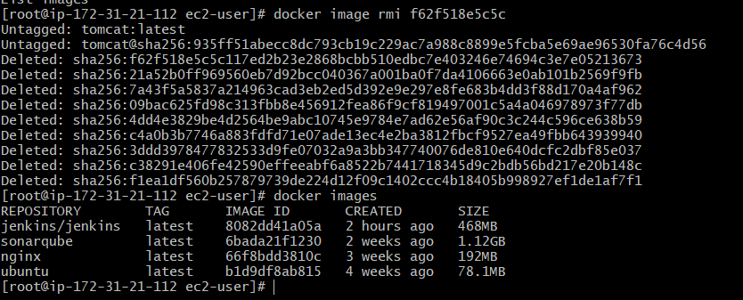

1. Inspect the jenkins image,sonarqube image.

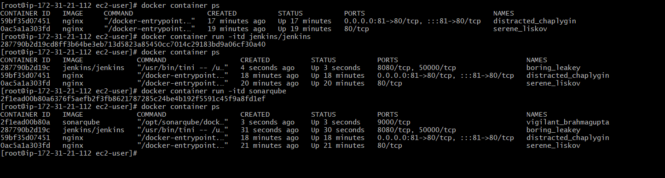

Inspect Jenkins image

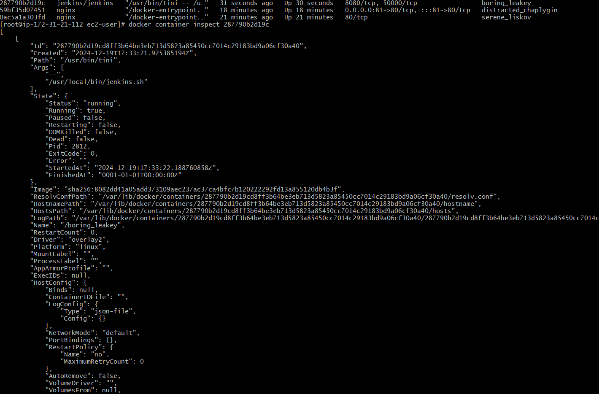

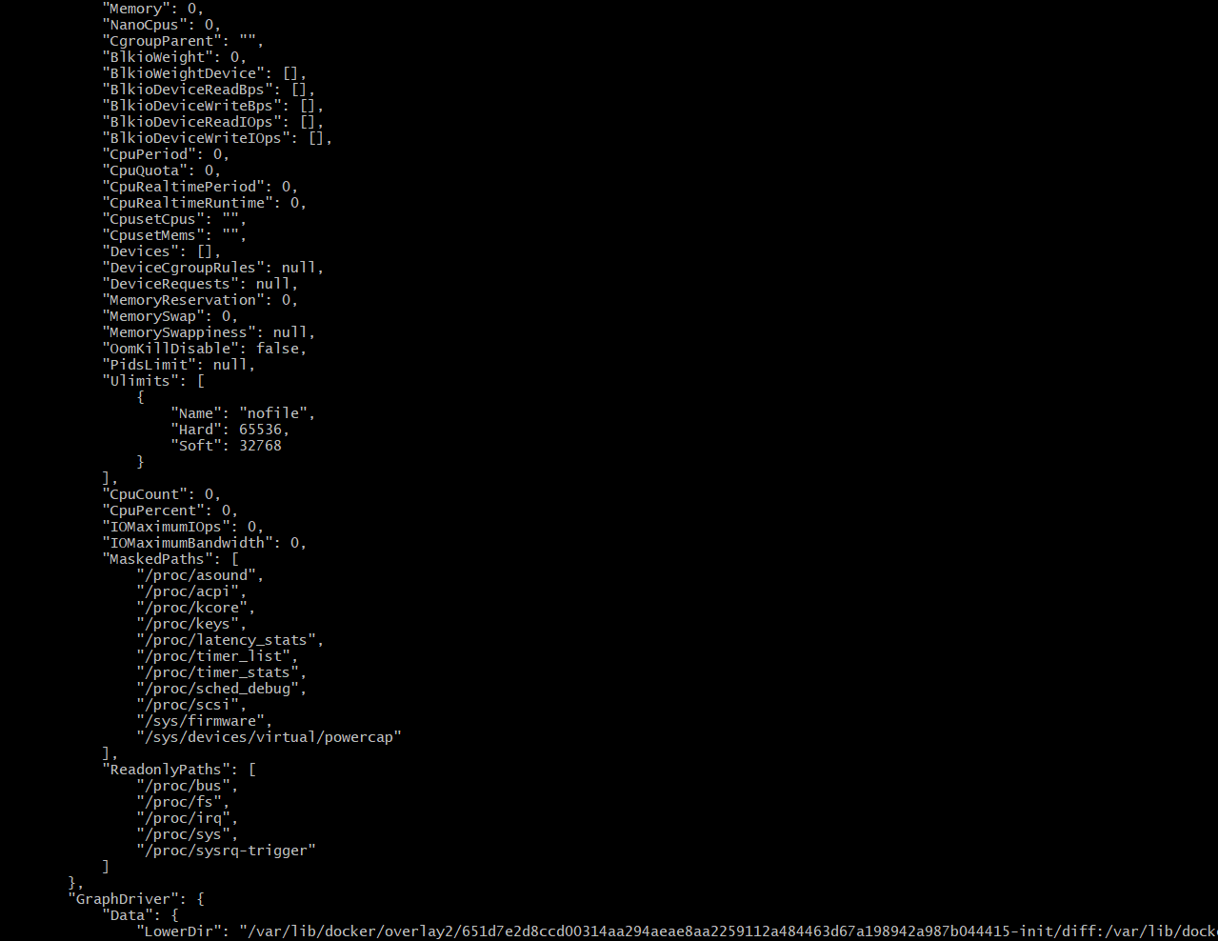

Inspect sonarqube image

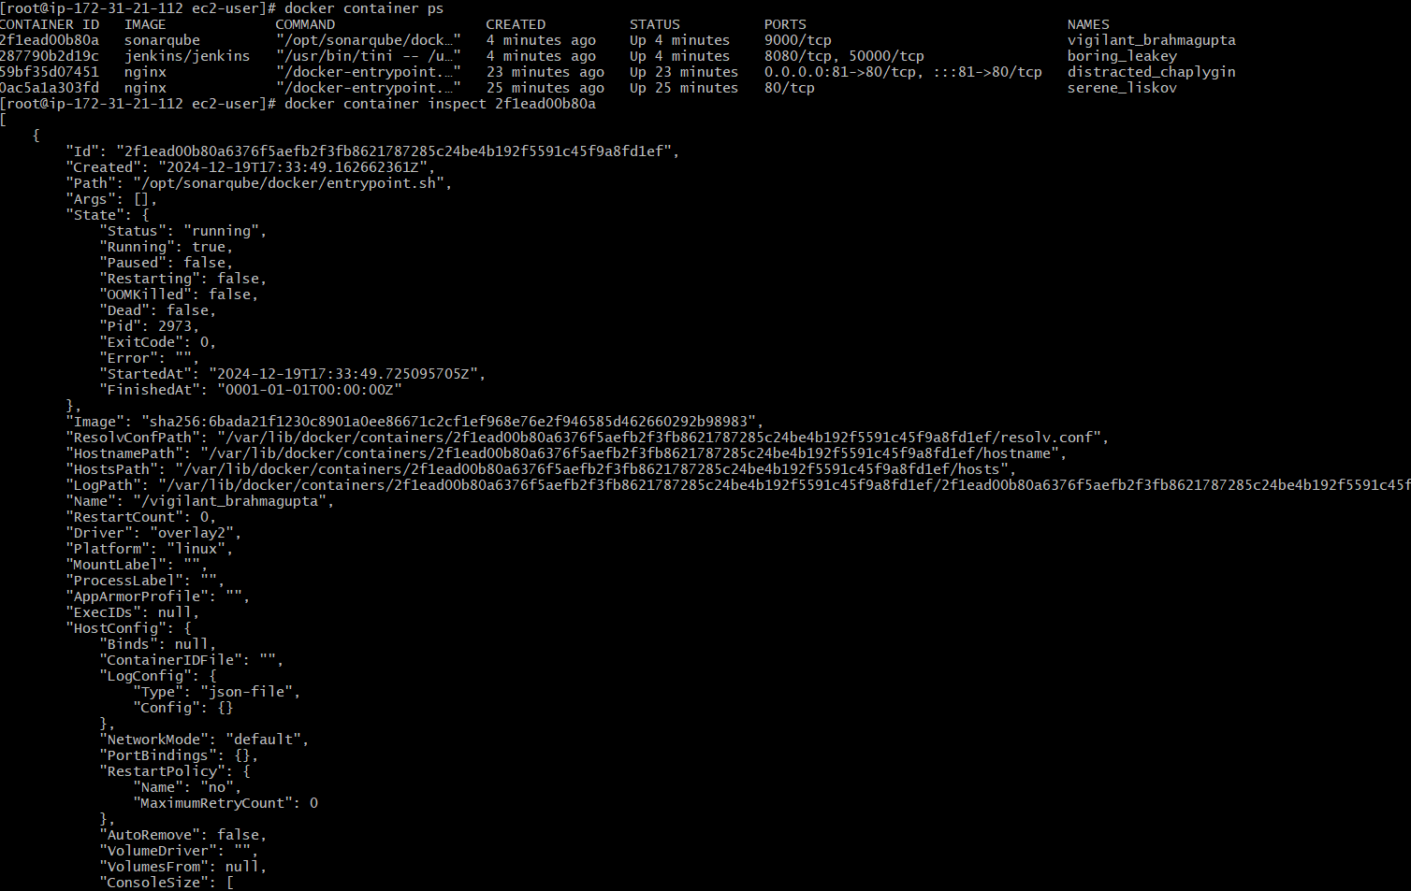

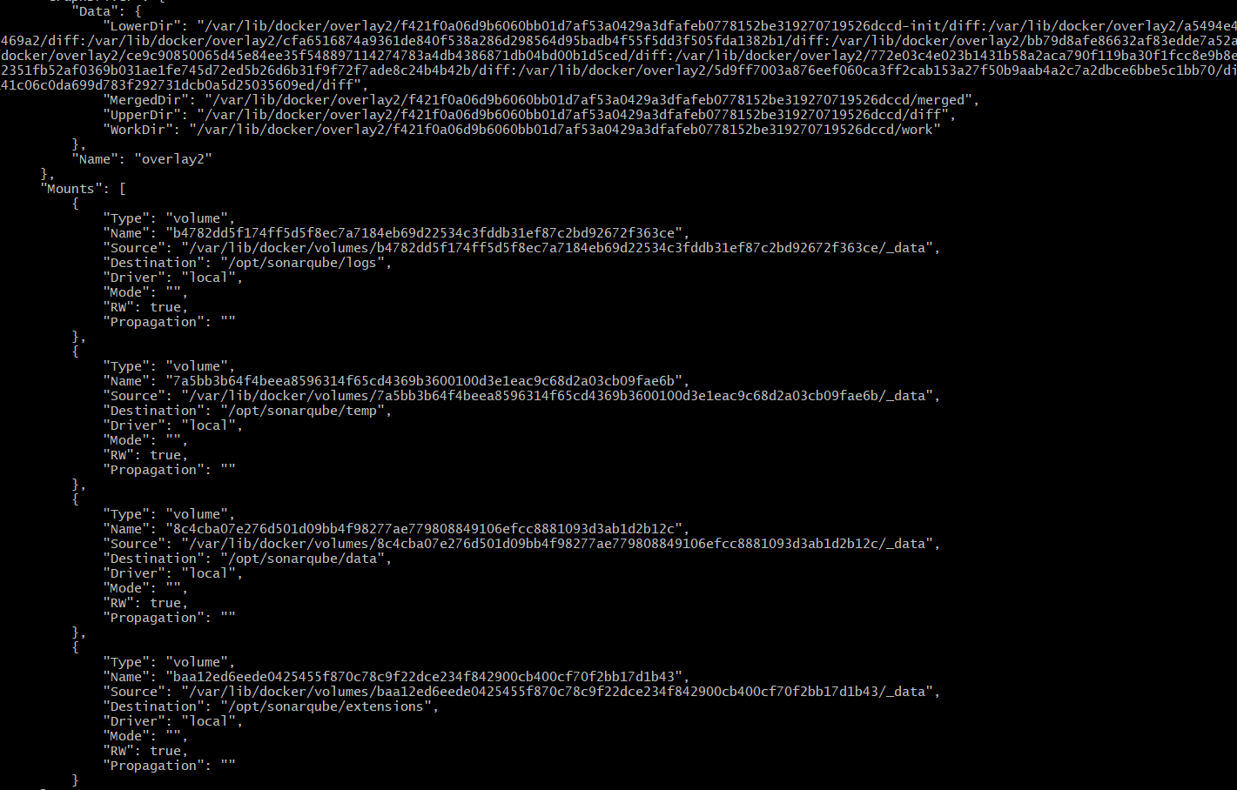

1. Run jenkins contianer and run one sample job.

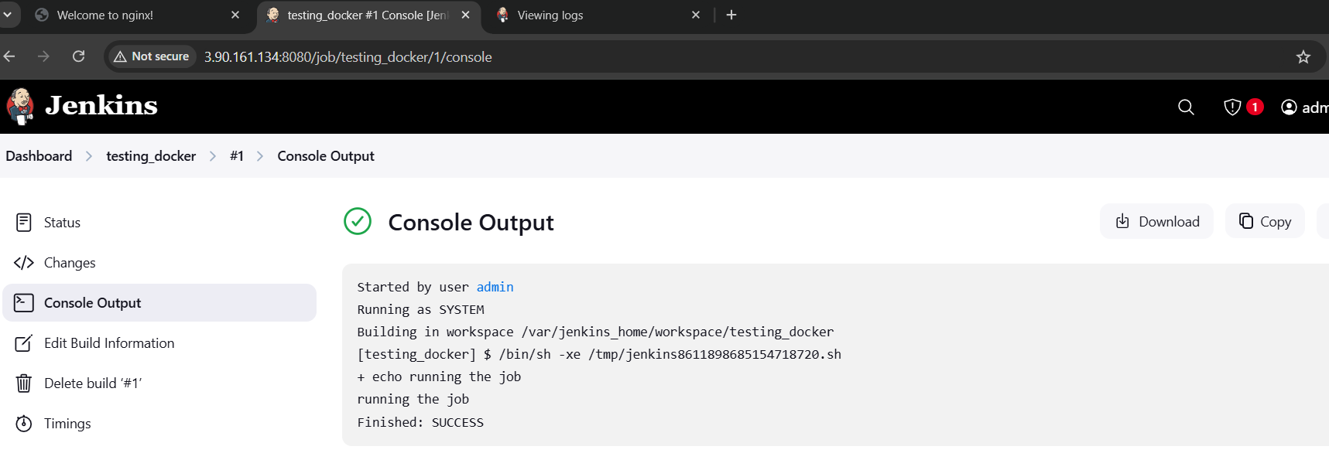ssss