1. Create a tomcat container on 8080 and deploy sample application in tomcat.

Created a tomcat container



Login to the container

Docker exec -it f9c3a22dbf07 /bin/bash

Change to webapps folder and deploy sample application

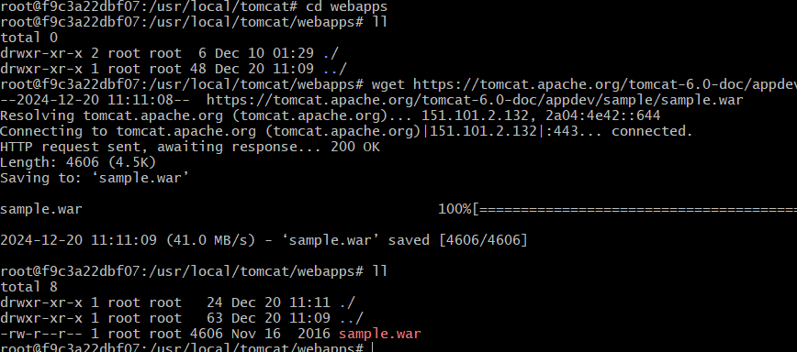

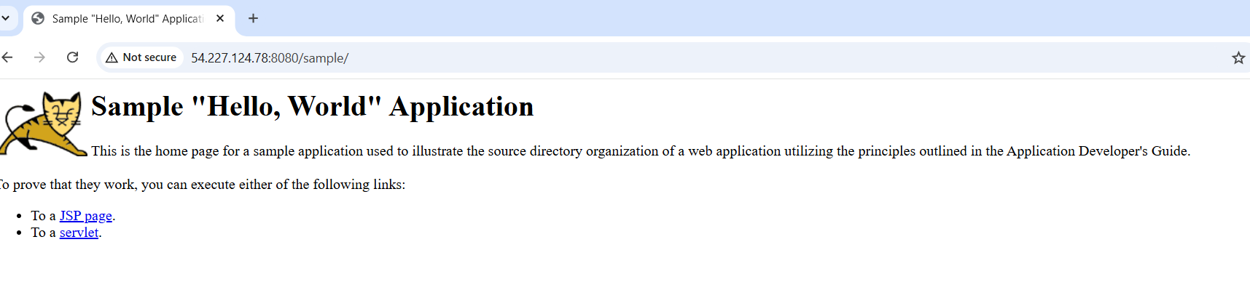

1. Create volume and deploy tomcat container on port 8081.

Created a volume



Map the container

Docker container run -itd -p 8081:8080 -v /var/lib/docker/volumes/app-deployment:/usr/local/tomcat/webapps tomcat:latest



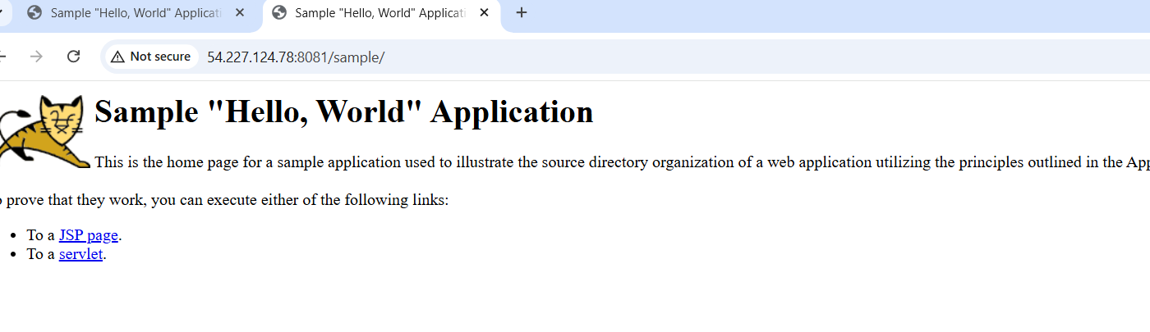

1. Limit the nginx container to 500 MB.

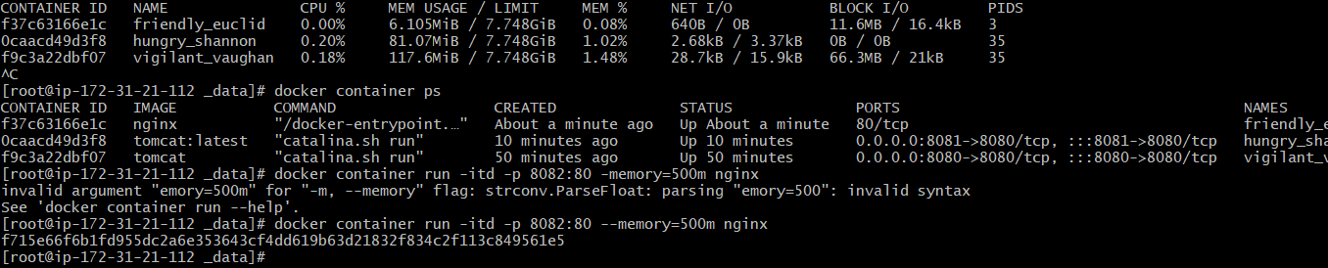



4) Create a sample docker file using below instructions.

1) Base module as amazonlinux:latest

2) Maintainer you name

3) Install nginx

4) COPY one index.html file to image

5) EXpose on port 80

6) Command to start the nginx container

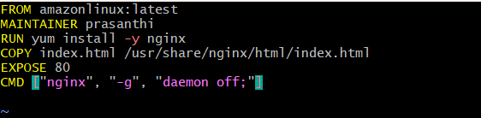

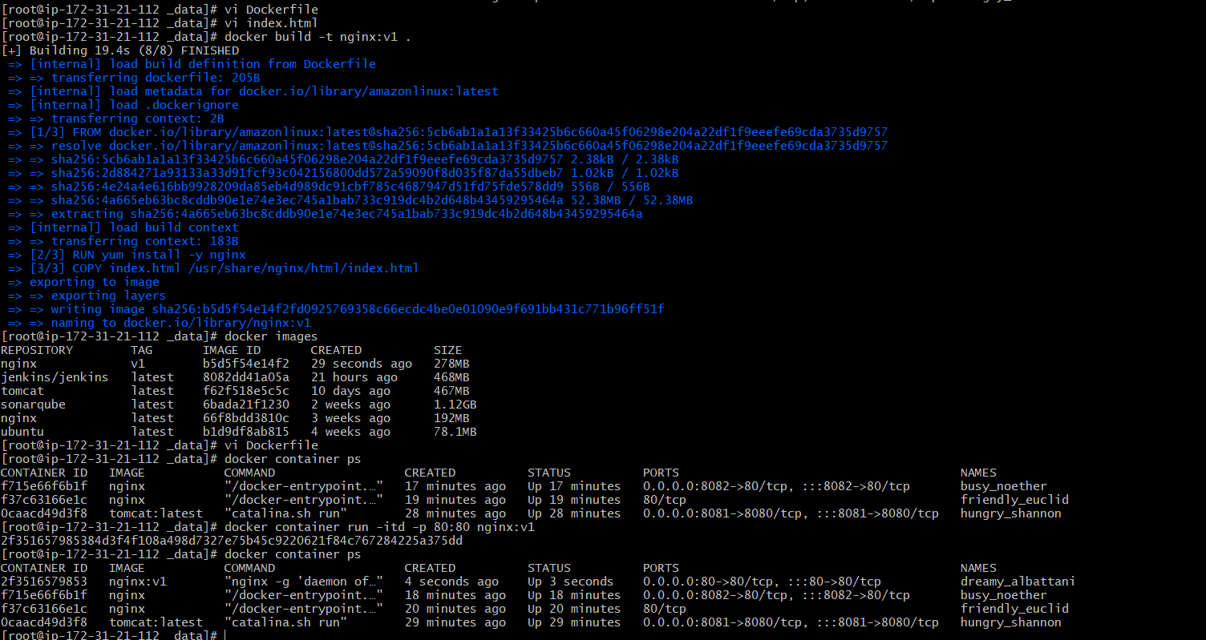

1. Push image to dockerhub

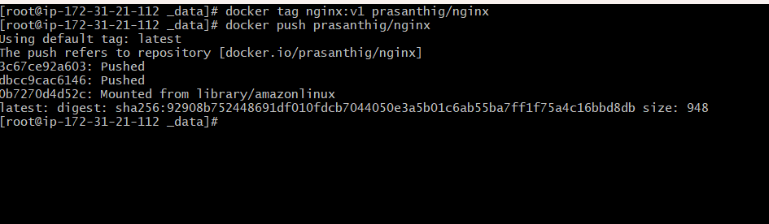

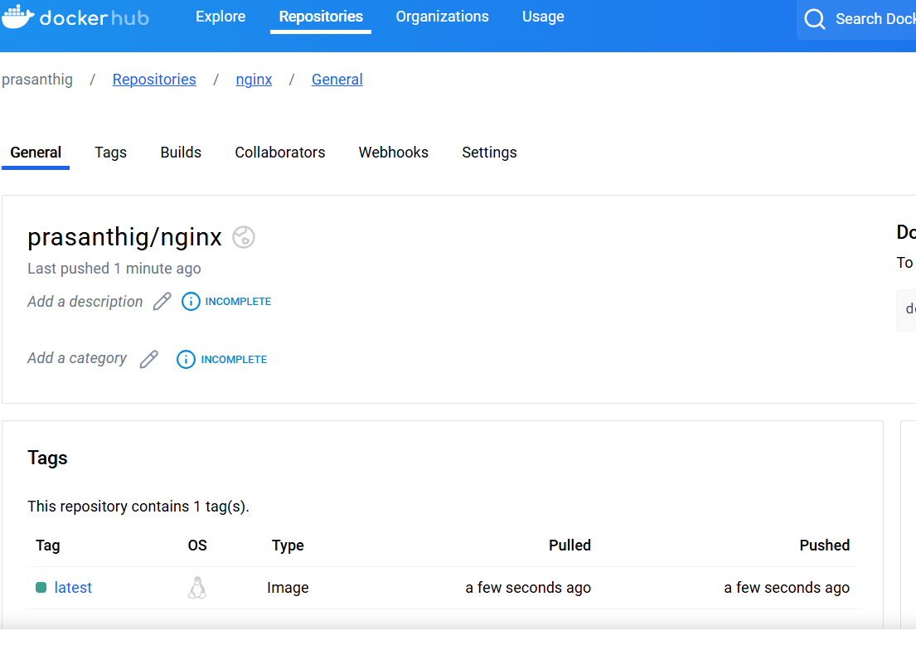

1. push image to aws ecr

Created ECR

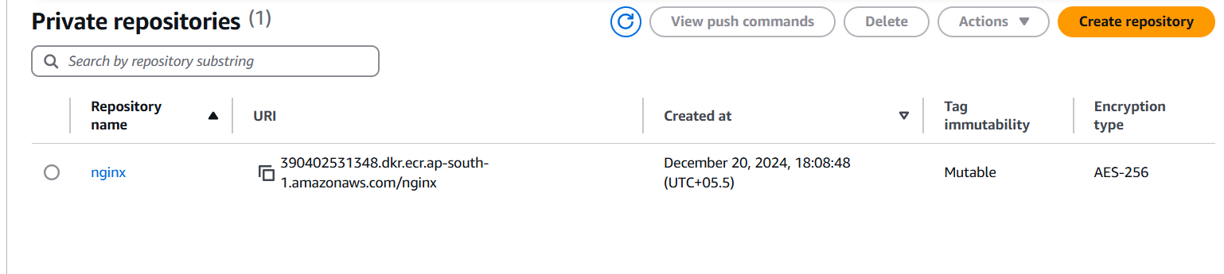

Login to the ecr repository

aws ecr get-login-password --region ap-south-1 | docker login --username AWS --password-stdin 390402531348.dkr.ecr.ap-south-1.amazonaws.com

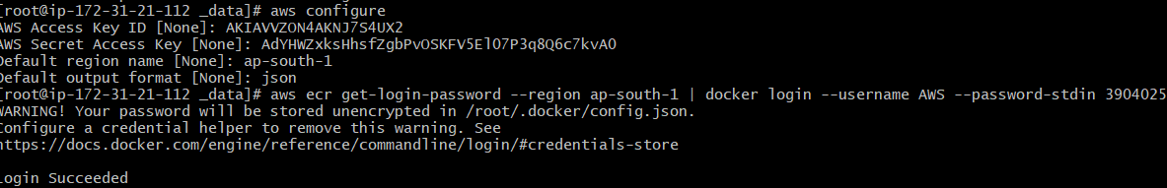

Change the tag to match the ecr repo

docker tag nginx:v1 390402531348.dkr.ecr.ap-south-1.amazonaws.com/nginx 

docker push 390402531348.dkr.ecr.ap-south-1.amazonaws.com/nginx

