1) Create one jenkins job using the below code and create three stages.

stage1: Git clone to download the source code.

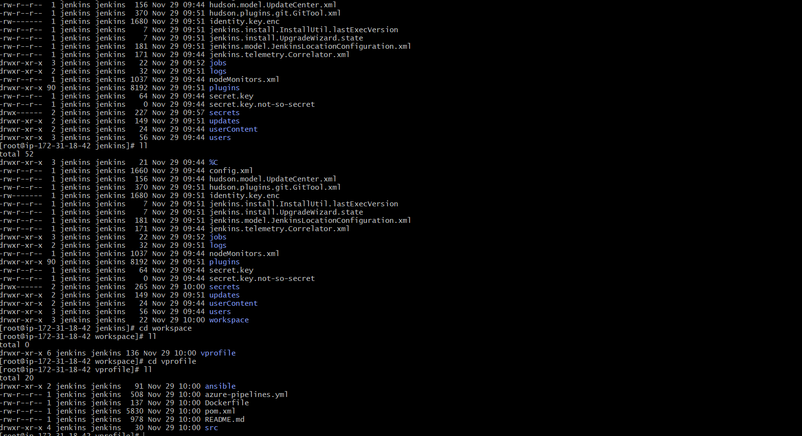

stage2: Sonarqube Integration to check the quality of code

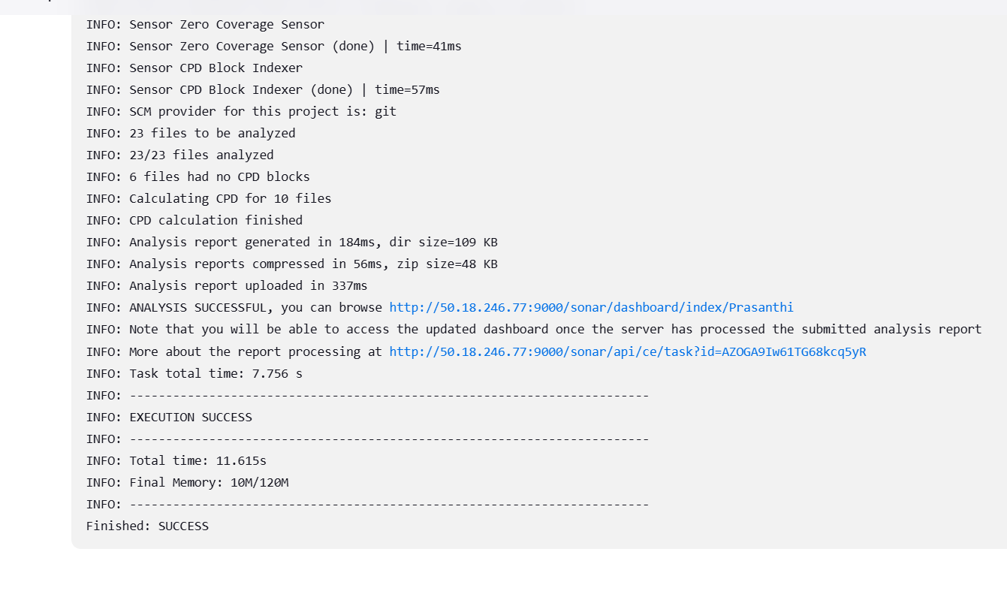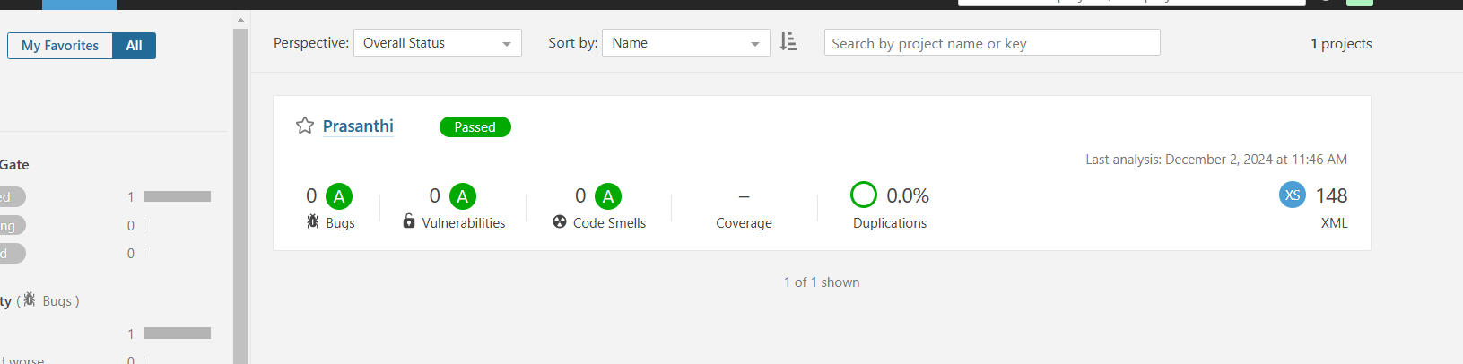

stage3: Slack Integration to send the alerts to slack.

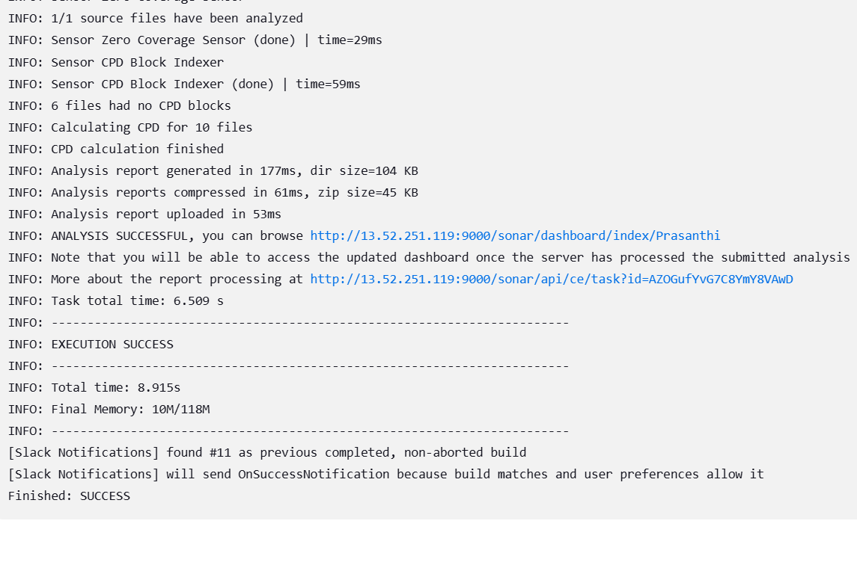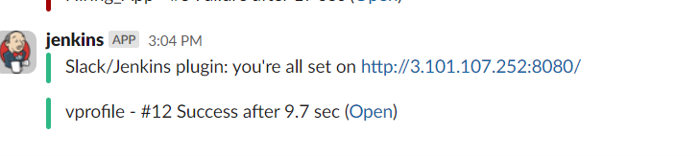

2) 1) Create one jenkins job using the below code and create three stages.

