1) Install Terraform on your PC

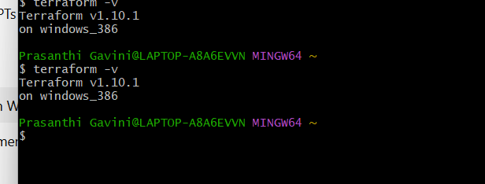

2) Execute all the templates shown in video. 3) Note down below points, Terraform Init Terraform Plan Terraform Apply

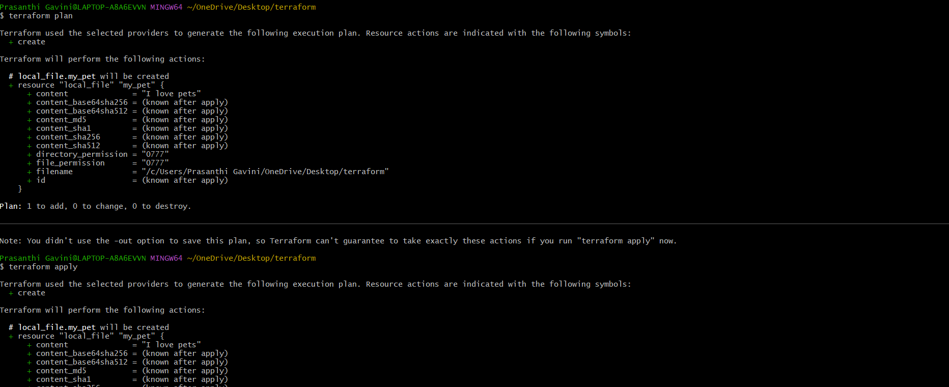

4) Integrate a sample Terraform template in jenkins.

