3) Intergrate terrafrom in jenkins using Terraform plugin.

4) Create one jenkins job using MAVEN PROJECT for the below code with two stages.

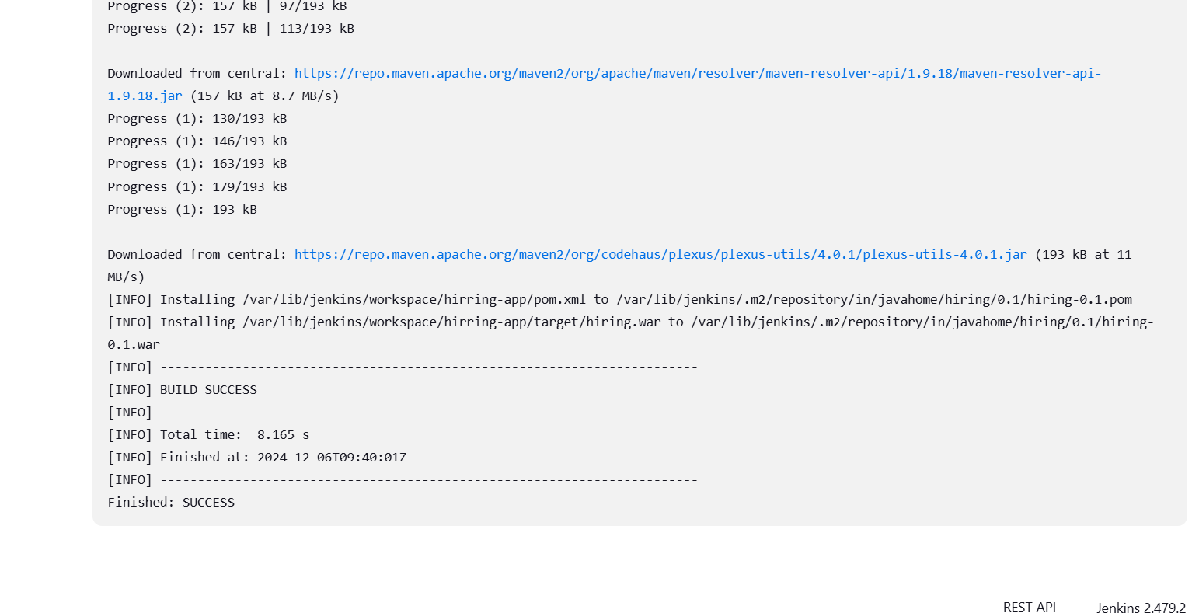

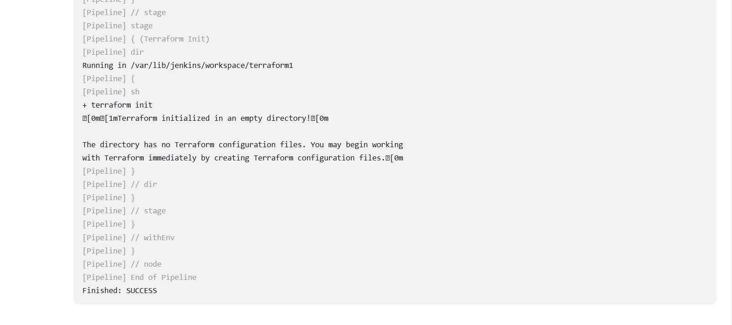

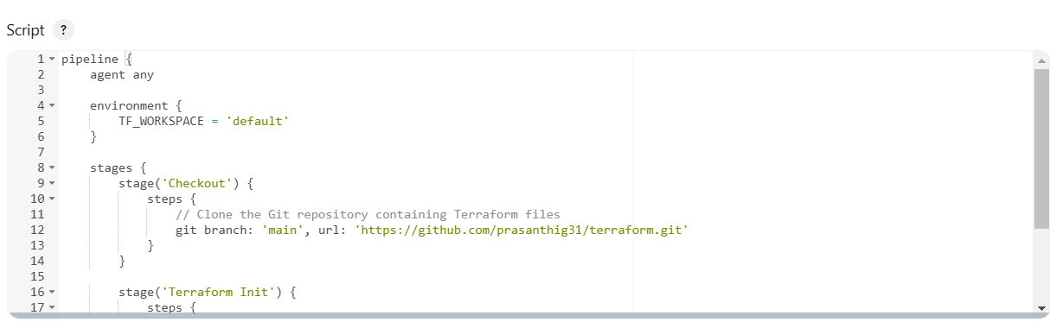

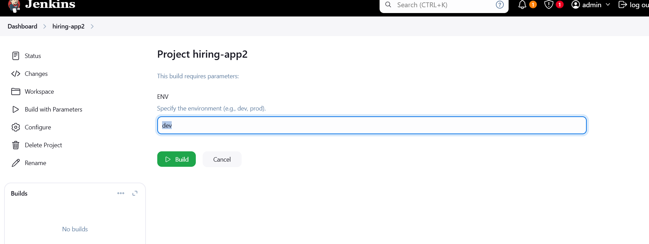

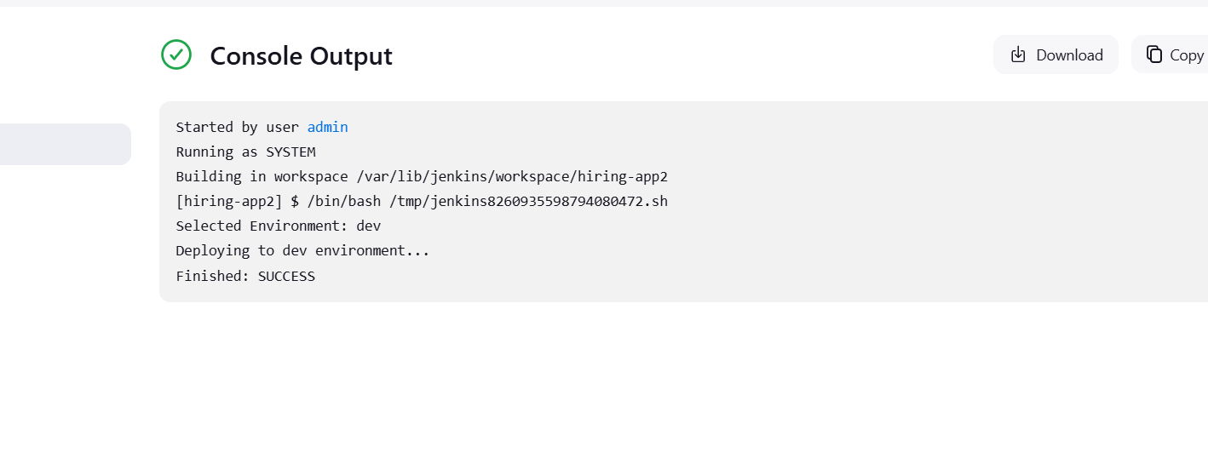

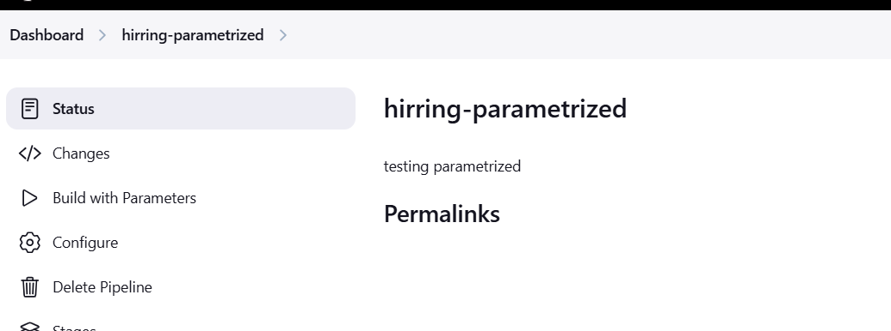

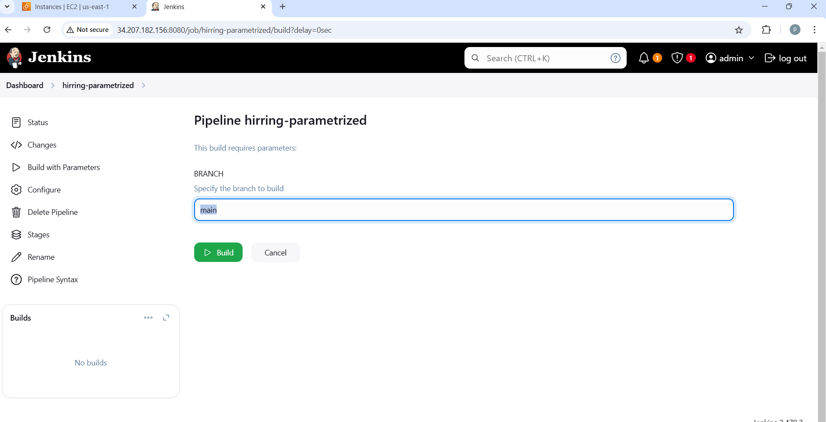

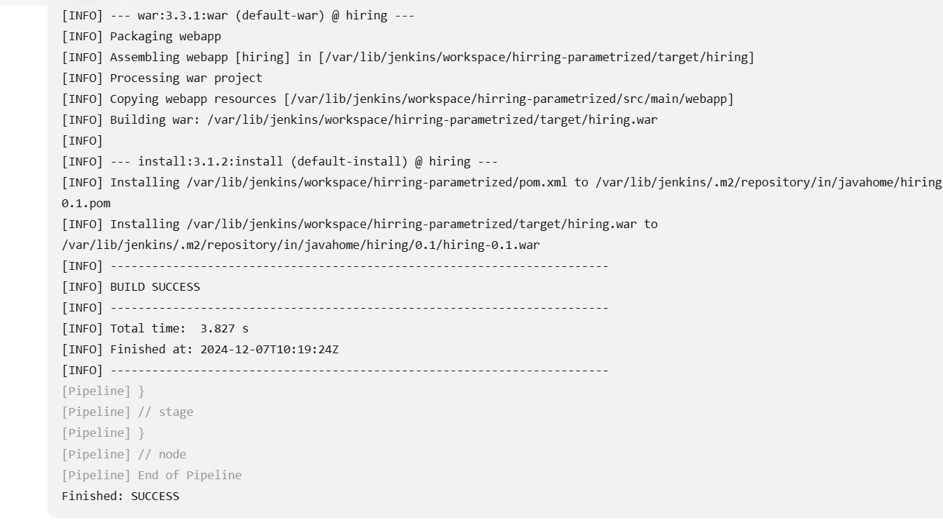

BUILD-NUMBER - THE CURRENT BUILD NUMBER

JOB_NAME – The name of the current job

WORKSPACE – The directory path of workspace for the current build

BUILD_URL--- The url to the build page in Jenkins URL

NODE_NAME -The name of the Jenkins node where the job is being executed

BUILD_ID---Unique Identifier for the build

JENKINS-URL—the url of the Jenkins server

EXECUTOR_NUMBER---The executor number used to run the build on the node

GIT_COMMIT – the git commit hash for the revision being built

GIT_BRANCH---The branch name being built

