Display All Cabs

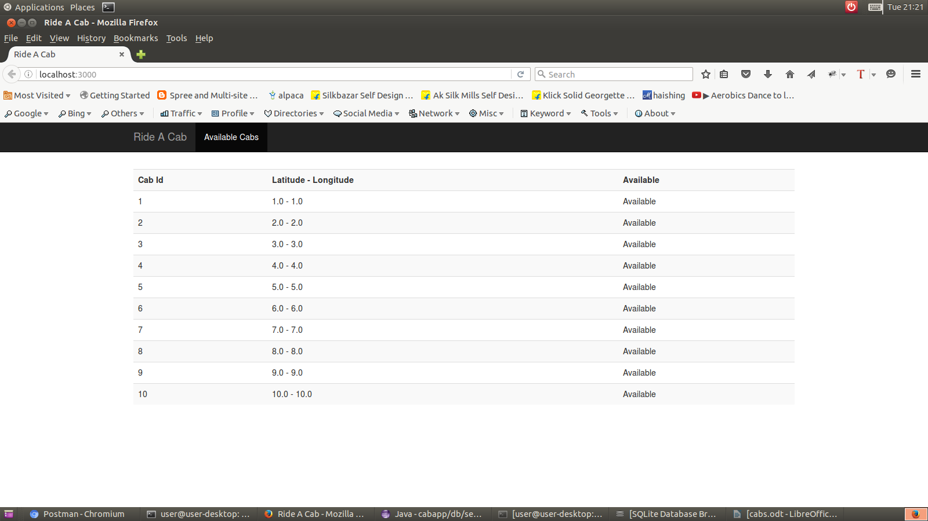

To fetch Nearest Cab

API : http://localhost:3000/nearest-cab

Method: Post

Parameters:
start_latitude : 5
start_longitude : 5

Response:
{
"cabId": "5"
}
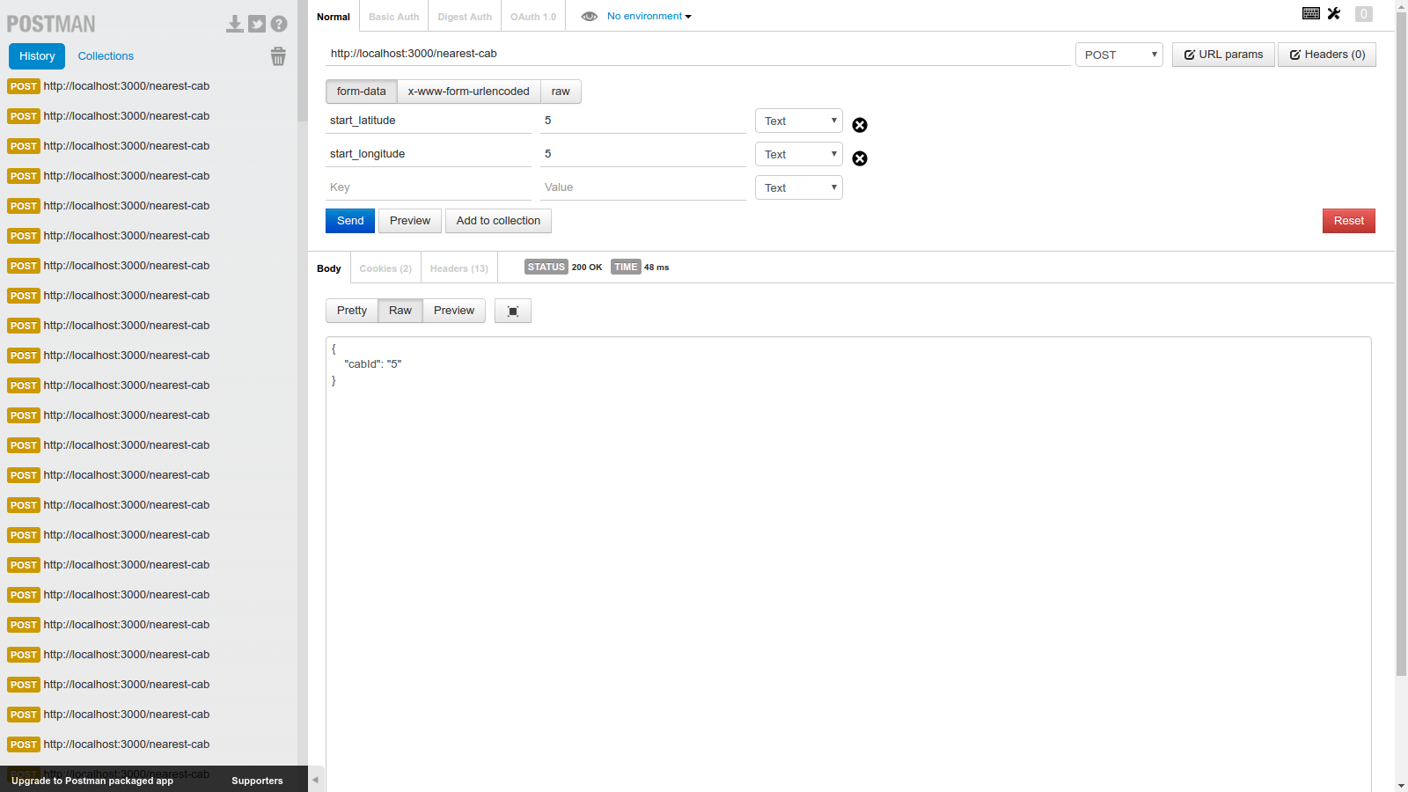

To Start Ride

API : http://localhost:3000/start-ride

Method: Put

Parameters:
start_latitude : 5
start_longitude : 5
cab_id : 5

Response:
{
"cab_id": 5,
"ride_id": 2,
"message": "Ride Started Successfully"
}

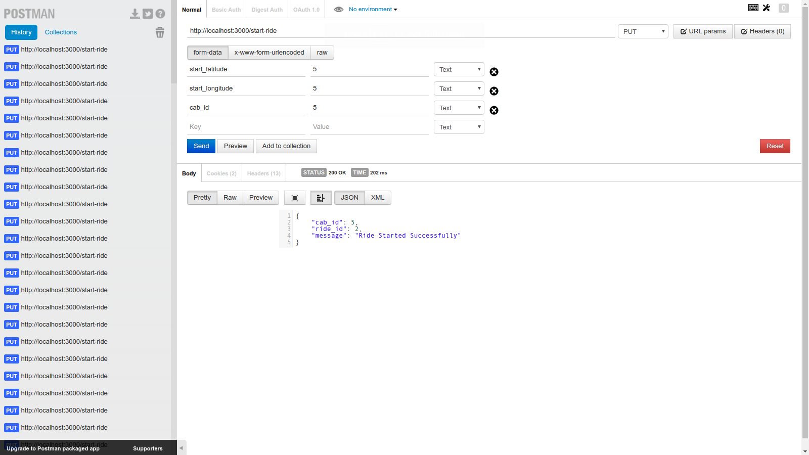

To End Ride

API : http://localhost:3000/end-ride

Method: Put

Parameters:
start_latitude : 5
start_longitude : 5
ride_id : 5

Response:
{
"ride_id": 2,
"amount": 50,
"cab_id": 5,
"message": "Ride Ended Successfully"
}

