Water Scarcity Management through Centralized Knowledge-Sharing Platform
Water is an important resources for survival of Living things but growing population and pollution rising global temperature which is leading to less rainfall in some areas and abundant rainfall in other areas. Areas which receive less rainfall must take necessary steps to save water.
Currently no tool exists which can educate peoples on how to save water using various ideas and techniques. Experts also cannot visit all areas to educate peoples on saving water. So we are developing an online tools which can allow experts to publish their ideas, techniques, tools and videos which can get saved in centralized server. Any user with internet connection on mobile or laptop can visit to this tool and can access all experts’ advices to save water.
To implement this project we have designed following modules
- New user sign up: using this module any user like experts or normal user can sign up with the application
- User Login: user can login to system
- Share Your Knowledge: any user with sufficient knowledge can share ideas, techniques and videos with the application which will get saved in centralized server.
- Access Expert Advice: user can access this module to view all experts’ advices to save water and can educate himself by using expert’s techniques and ideas.
- Most Drought Area Map: using this module user can view all major area on map which is suffering most from the drought. So by using this module user or experts can know which area is mostly hit and can visit those places for voluntary advices.
SCREEN SHOTS
To run project install python 3.7.2 and then install all packages given in requirements.txt file. Install MYSQL database and then copy content from ‘DB.txt’ file and paste in MYSQL console to create database.
Now double click on ‘runServer.bat’ file to start python server and then will get below page
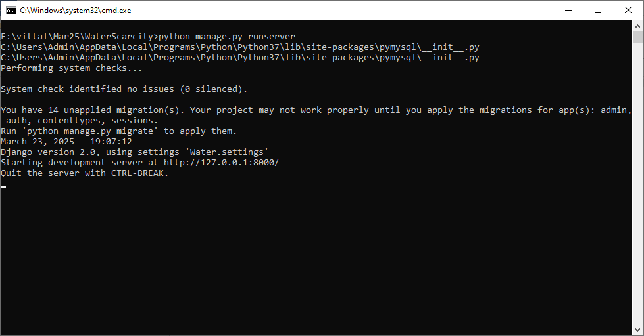
In above screen python server started and now open browser and enter URL as http://127.0.0.1:8000/index.html and then press enter key to get below page
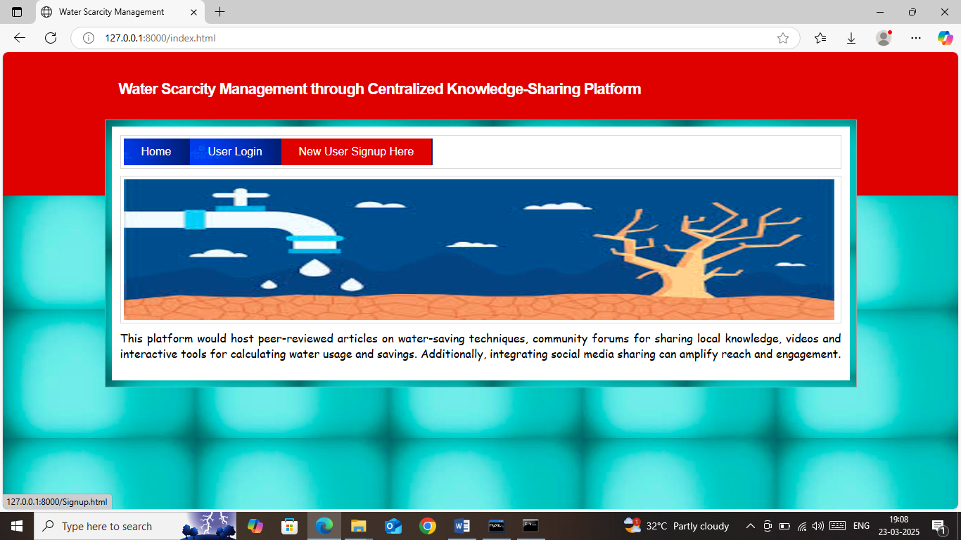
In above screen click on ‘New User Sign up’ link to get below page
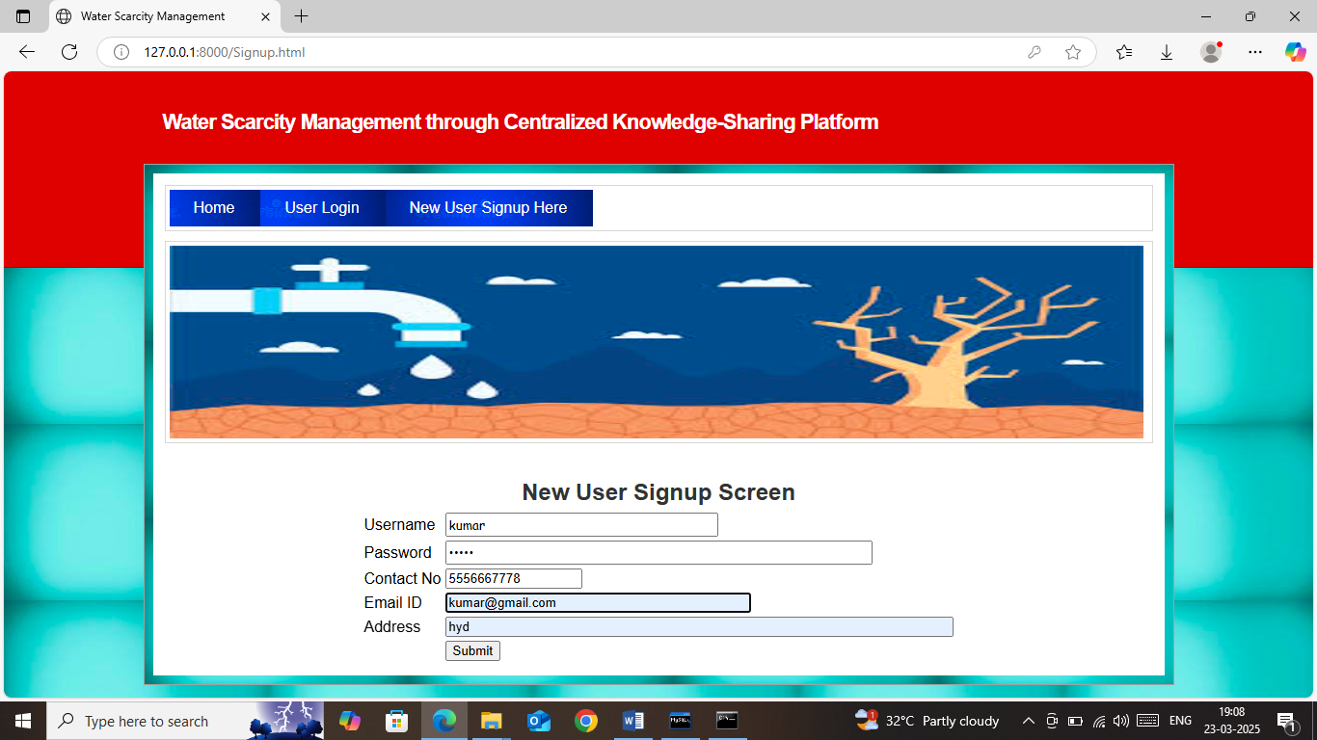
In above screen user is entering sign up details and then press button to save user details and get below page
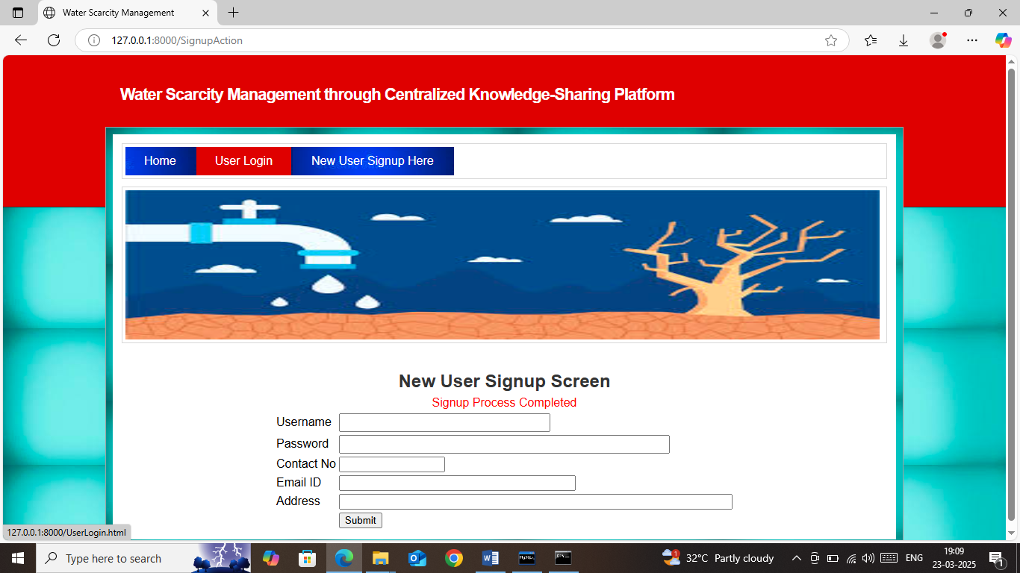
In above screen user sign up completed and now click on ‘User Login’ link to get below page
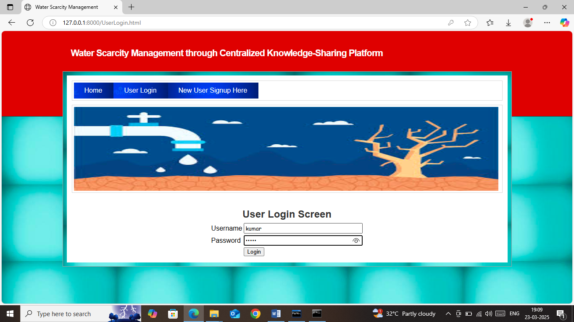
In above screen user is login and after login will get below page
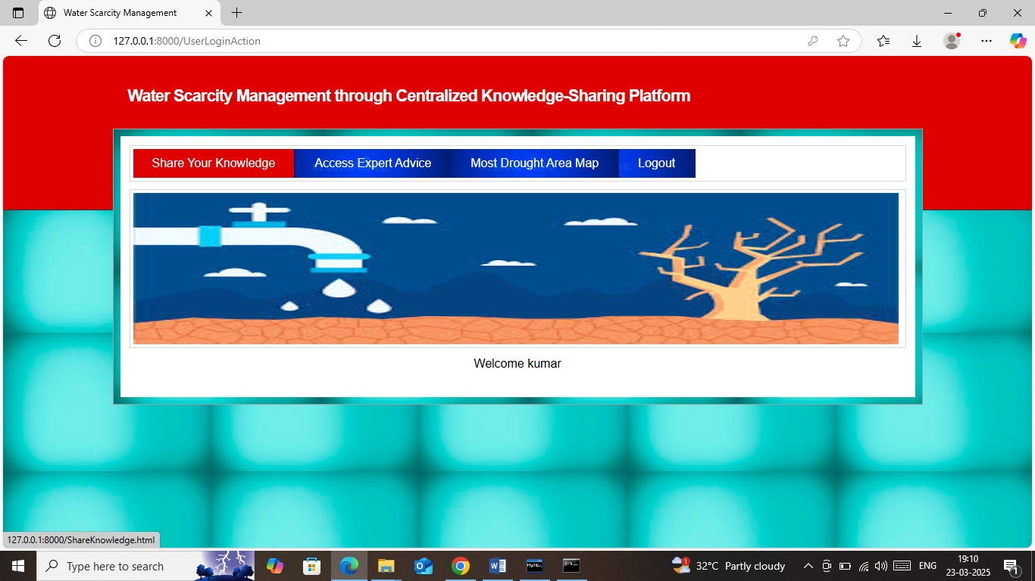
In above screen user can click on ‘Share Your Knowledge’ screen to share tips, ideas on water saving
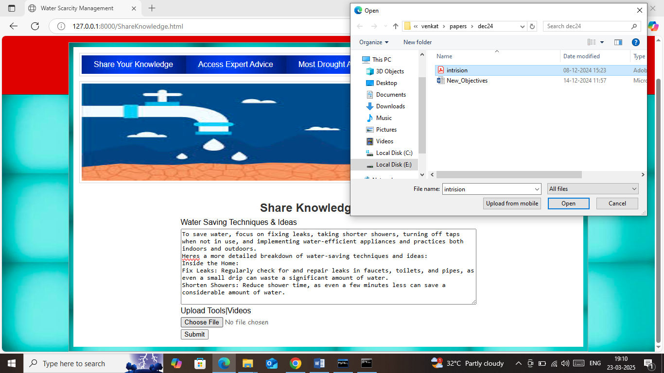
In above screen user can write ideas on water saving in text area and can upload supporting tools or videos and then press button to get below page
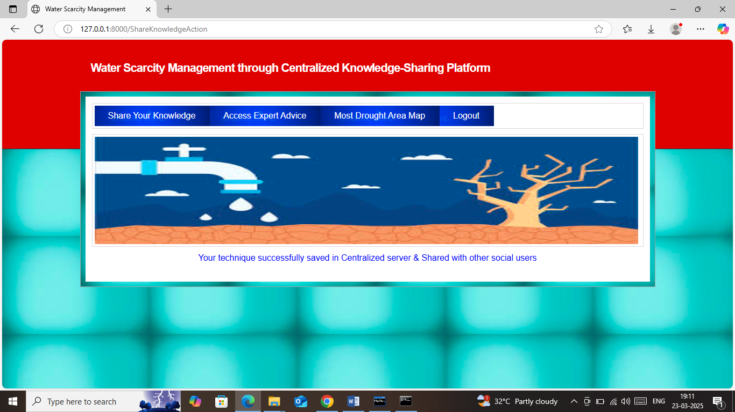
In above screen user ideas successfully saved in centralized server and can click on ‘Access Expert Advice’ link to view ideas from expertise
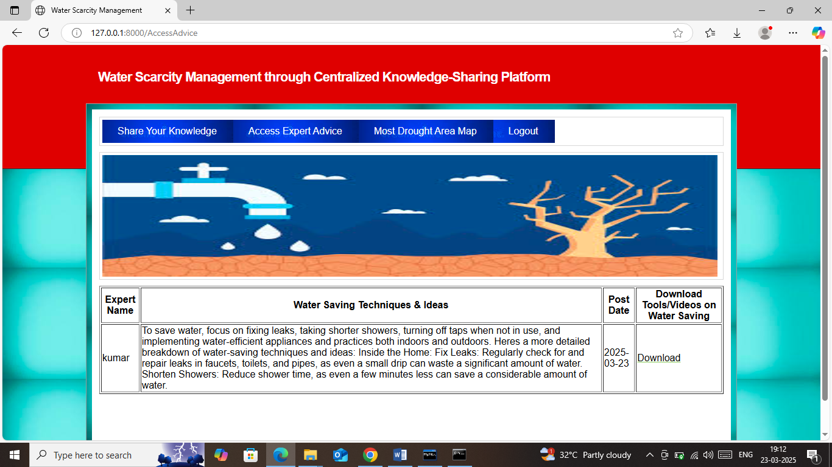
In above screen user can educate himself on water saving by reading above ideas and can click on ‘Download’ link to download videos or tools like below page
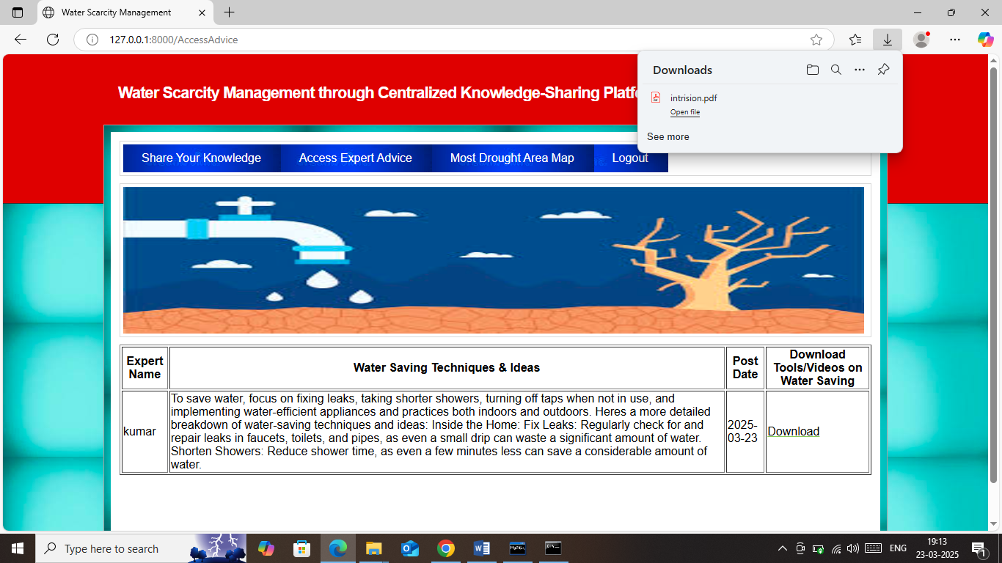
In above screen in browser task bar can see tools successfully downloaded and can click on ‘Most Drought Area Map’ link to view all those areas which are most suffering from water scarcity and get below page
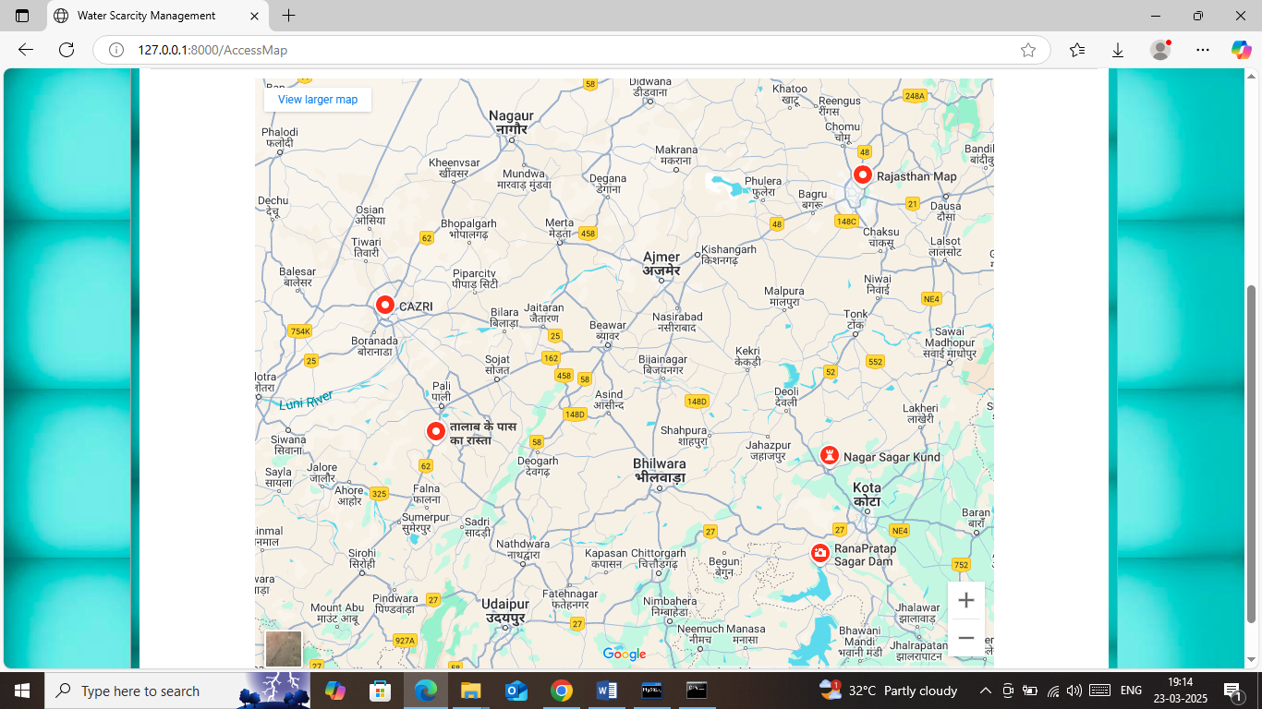
In above screen all red dots areas are most suffering from water scarcity and experts can view above places as voluntary support.
So by utilizing above tool experts can publish ideas and user can educate themselves by accessing those ideas via single centralized application.

