BioSync: Fingerprint Attendance System
IoT-Based Attendance Log Portal with Remote Handshake and Web Console

1. System Architecture & Workflow
The BioSync system features a real-time, bi-directional communication bridge between an ESP32 IoT node and an administrative React web application, synchronized via the Firebase Cloud.
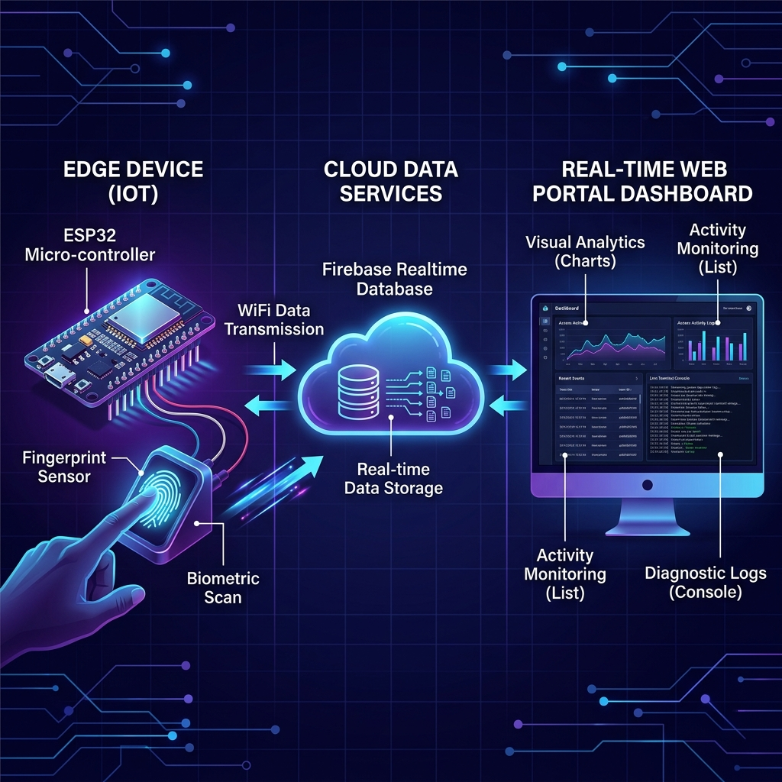
Figure 1: BioSync System Architecture & Data Flow

2. Key System Features
- Glassmorphic Admin UI: High-fidelity, modern dark design with real-time responsive feeds.
- Remote Enrollment Wizard: Trigger fingerprint registration directly from the browser with a guided steps modal.
- Remote Deletion Handshake: Remove database profiles and instruct the ESP32 to delete the template model from sensor memory.
- Live Debug Terminal Console: Pipes system boot logs, scanning outputs, and network statuses into the web dashboard.
- Background Settings Sync: Change confidence thresholds, buzzer beeps duration, and volume settings from the dashboard. The ESP32 pulls these settings live without reboots.
- Diagnostic Logs & Exports: Track working days, attendance percentages, and download compiled attendance logs as CSV spreadsheets.

3. Hardware Wiring Reference
The system interfaces the ESP32 micro-controller board with the R307 optical fingerprint scanner, an active buzzer, a status indicator LED, and a tactile push button for local triggers.
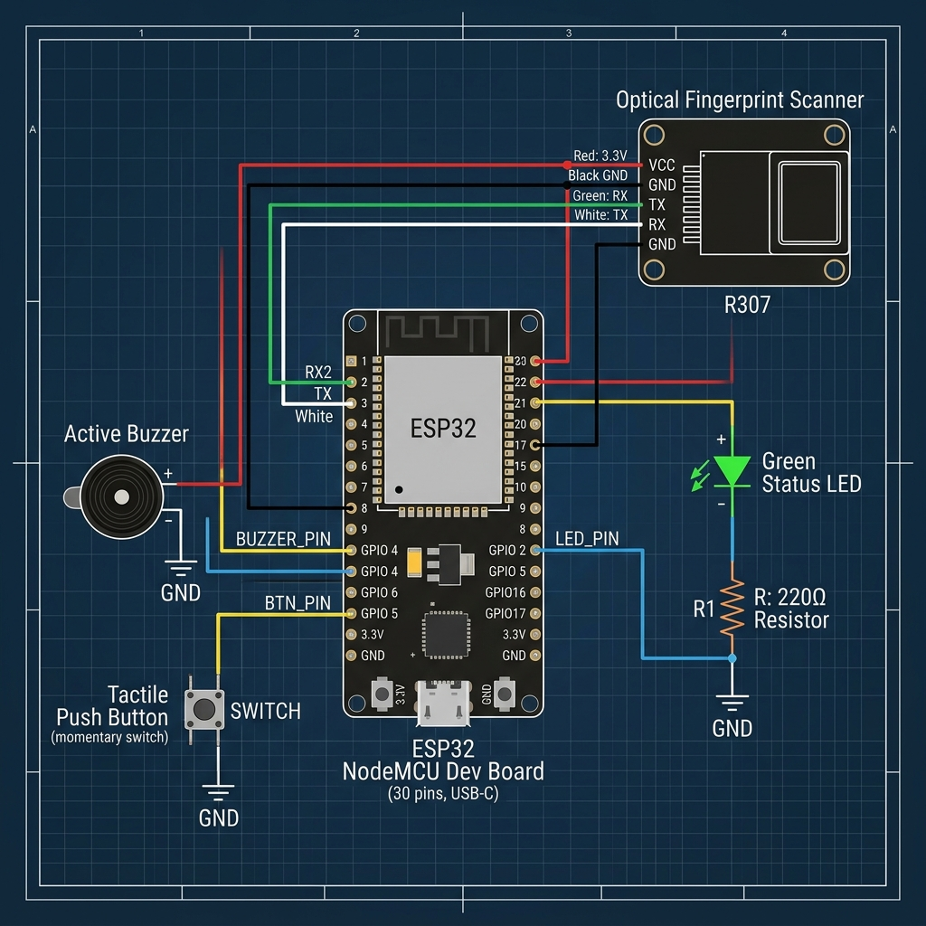
Figure 2: ESP32 Hardware Wiring Schematic

Pin-Out Connections Table
Component | Component Pin | ESP32 GPIO | Connection Notes
R307 Sensor | VCC | 3.3V / 5V | Power supply pin
R307 Sensor | GND | GND | Ground pin
R307 Sensor | TX | RX2 (GPIO 16) | UART Serial Transmit
R307 Sensor | RX | TX2 (GPIO 17) | UART Serial Receive
Status LED | Anode (+) | GPIO 2 | Connected via 220-ohm resistor
Status LED | Cathode (-) | GND | Ground leg
Buzzer | Positive (+) | GPIO 4 | Active buzzer feed
Buzzer | Negative (-) | GND | Ground leg
Push Button | Terminal A | GPIO 5 | Triggers manual enrollment
Push Button | Terminal B | GND | Ground return

