INTELLIGENT HOME SECURITY SYSTEM
Ultrasonic Intrusion Detection • Automatic Door Control • Alarm • Cloud Notification
ESP32-based IoT Project Documentation
Prepared by: Prasanth
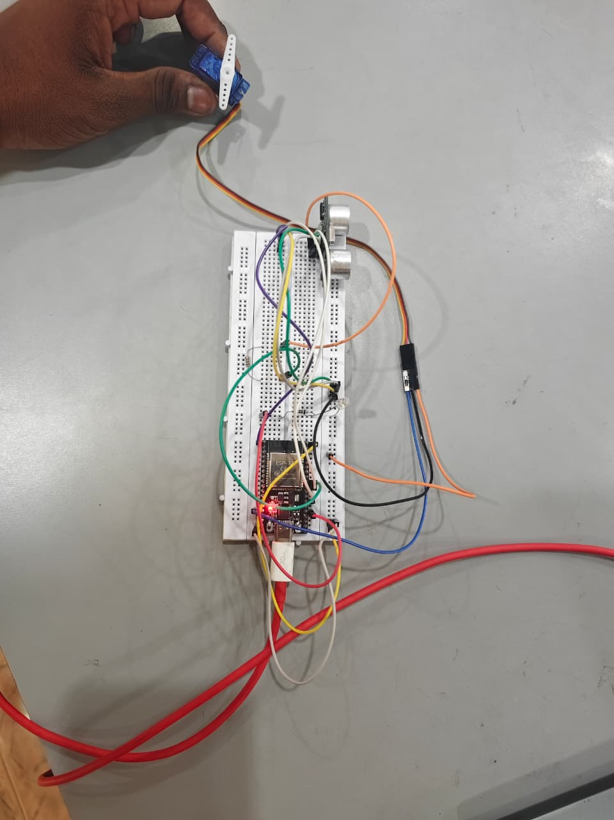
Department of Electronics and Communication Engineering
1. Project Overview
The Intelligent Home Security System is an ESP32-based IoT project that detects intrusion using an ultrasonic distance sensor, automatically actuates a servo-controlled door, raises a local audio-visual alarm, and pushes a real-time cloud notification to the owner's phone via Telegram.

1.1 Key Features
- Continuous, debounced distance sensing using an HC-SR04 ultrasonic sensor
- Automatic door actuation using an SG90/MG90 servo motor when an intrusion is detected
- Local alarm: LED + buzzer activated on detection
- Cloud notification: instant Telegram alert with the measured distance
- Non-blocking control loop — sensor polling, door timing, and Wi-Fi reconnection all run independently using millis()
- Automatic Wi-Fi reconnection with timeout and retry logic
- Alert re-arming logic to avoid repeated notifications for the same intrusion event

1.2 System Architecture
HC-SR04 Sensor → ESP32 (distance processing & debounce) → Decision Logic → [Servo Motor + LED + Buzzer] (local response) and [Wi-Fi → Telegram Bot API] (cloud notification to the owner's phone).

2. Components Required
- ESP32 Development Board
- HC-SR04 Ultrasonic Sensor
- SG90 / MG90 Servo Motor (door actuator)
- LED
- 220Ω Resistor (LED current-limiting)
- Active Buzzer (2-pin)
- Push Button (optional — manual test / reset trigger)
- Breadboard & Jumper Wires
- External 5V supply for the servo (recommended for stability)
- Two 1kΩ/2kΩ resistors (voltage divider for the ECHO line — see note below)

3. Circuit Connections

3.1 HC-SR04 Ultrasonic Sensor
HC-SR04 Pin | ESP32 Pin
VCC | 5V (VIN)
GND | GND
TRIG | GPIO 5
ECHO | GPIO 18 (via voltage divider)

Note — ECHO line voltage divider
The HC-SR04 ECHO pin outputs 5V, but ESP32 GPIOs are only 3.3V tolerant.
Use a resistor divider: ECHO → 1kΩ → GPIO 18, and GPIO 18 → 2kΩ → GND.
This drops the 5V signal to roughly 3.3V before it reaches the ESP32 pin.

3.2 SG90 / MG90 Servo Motor (Door)
Servo Wire | ESP32 Pin
Red (VCC) | 5V (external supply recommended)
Brown/Black (GND) | GND (common ground with ESP32)
Orange/Yellow (Signal) | GPIO 13

3.3 LED
LED Pin | ESP32 Pin
Anode (long leg) | GPIO 2 (via ~220–330Ω resistor)
Cathode (short leg) | GND

3.4 Buzzer (Active, 2-pin)
Buzzer Pin | ESP32 Pin
+ | GPIO 4
− | GND

Power Tip
If the servo causes the ESP32 to brown out or reset when it moves, power it from a separate 5V supply and tie all grounds together (common ground) rather than drawing servo current from the ESP32's 5V pin.

4. Telegram Bot Setup

4.1 Create a Telegram Bot
- Open Telegram.
- Search for @BotFather.
- Send /newbot.
- Give your bot a name.
- Give it a username (must end with “bot”).
- Copy the Bot Token shown — it looks like:
123456789:AAxxxxxxxxxxxxxxxxxxxxxxxx

4.2 Get Your Chat ID
- Start a chat with your new bot.
- Send the message: Hello
- Open this URL in a browser (replace YOUR_BOT_TOKEN):
https://api.telegram.org/botYOUR_BOT_TOKEN/getUpdates
- Find the chat id field in the JSON response:
"chat":{"id":123456789}
This number is your Chat ID — use it for CHAT_ID in the sketch.
Security Note
Never publish your real Bot Token or Chat ID in shared documents, GitHub repos, or public forums — anyone with the token can control your bot and send messages as it.
The code listing in Section 6 uses placeholders (YOUR_WIFI_SSID, YOUR_WIFI_PASSWORD, YOUR_TELEGRAM_BOT_TOKEN, YOUR_TELEGRAM_CHAT_ID). Replace them locally in your own copy of the sketch — do not commit real credentials to version control.

5. Program Logic
- Connect the ESP32 to Wi-Fi (with automatic retry on timeout).
- Initialize the Telegram bot client and attach the door servo.
- Continuously measure distance using the HC-SR04, averaging multiple samples to filter noise.
- If distance < 20 cm (TRIGGER_DISTANCE_CM) and no alert is currently active:
  - Turn the LED and buzzer ON
  - Rotate the servo to open the door (90°)
  - Send a Telegram alert with the measured distance
- After DOOR_OPEN_MS (5 seconds), automatically close the door, and turn off the LED/buzzer.
- Once the distance rises above 25 cm (RESET_DISTANCE_CM), the alert state resets so a new intrusion can be detected and reported again.
- If Wi-Fi drops at any point, the ESP32 reconnects automatically in the background without blocking sensor readings.
Example Telegram alert message:
🚨 Intruder Detected!
Distance : 15.20 cm
Door Opened

6. Full Source Code (Arduino / ESP32 Sketch)
Libraries required (install via Arduino IDE Library Manager): WiFi (built-in for ESP32), WiFiClientSecure (built-in), UniversalTelegramBot (by Brian Lough), ESP32Servo.
#include <WiFi.h>
#include <WiFiClientSecure.h>
#include <UniversalTelegramBot.h>
#include <ESP32Servo.h>
// ---------- WiFi & Telegram credentials ----------
const char* ssid = "YOUR_WIFI_SSID";
const char* password = "YOUR_WIFI_PASSWORD";
#define BOT_TOKEN "YOUR_TELEGRAM_BOT_TOKEN"
#define CHAT_ID "YOUR_TELEGRAM_CHAT_ID"
WiFiClientSecure client;
UniversalTelegramBot bot(BOT_TOKEN, client);
Servo doorServo;
// ---------- Pin map ----------
#define TRIG_PIN 5
#define ECHO_PIN 18
#define SERVO_PIN 13
#define LED_PIN 2
#define BUZZER_PIN 4
// ---------- Thresholds ----------
const float TRIGGER_DISTANCE_CM = 20.0;
const float RESET_DISTANCE_CM = 25.0;
const int DOOR_OPEN_MS = 5000; // how long the door stays open
const int SENSOR_INTERVAL_MS = 500; // how often we ping the sensor
const int SAMPLES = 3; // readings averaged for debounce
// ---------- State ----------
bool alertSent = false;
bool doorOpen = false;
unsigned long doorOpenedAt = 0;
unsigned long lastSensorRead = 0;
// Reads distance once. Returns -1 on timeout/out-of-range.
float readDistanceOnce() {
digitalWrite(TRIG_PIN, LOW);
delayMicroseconds(2);
digitalWrite(TRIG_PIN, HIGH);
delayMicroseconds(10);
digitalWrite(TRIG_PIN, LOW);
long duration = pulseIn(ECHO_PIN, HIGH, 30000); // 30ms timeout (~5m range)
if (duration == 0) return -1;
return duration * 0.0343 / 2.0;
}
// Averages several valid readings to reduce noise/false triggers.
float getDistance() {
float sum = 0;
int validCount = 0;
for (int i = 0; i < SAMPLES; i++) {
float d = readDistanceOnce();
if (d > 0) {
sum += d;
validCount++;
}
delay(10); // brief gap between pings
}
if (validCount == 0) return -1;
return sum / validCount;
}
void connectWiFi() {
WiFi.begin(ssid, password);
Serial.print("Connecting to WiFi");
unsigned long startAttempt = millis();
while (WiFi.status() != WL_CONNECTED) {
delay(500);
Serial.print(".");
if (millis() - startAttempt > 20000) { // 20s timeout, then retry
Serial.println("\nRetrying WiFi connection...");
WiFi.disconnect();
WiFi.begin(ssid, password);
startAttempt = millis();
}
}
Serial.println("\nWiFi Connected: " + WiFi.localIP().toString());
}
void setup() {
Serial.begin(115200);
pinMode(TRIG_PIN, OUTPUT);
pinMode(ECHO_PIN, INPUT);
pinMode(LED_PIN, OUTPUT);
pinMode(BUZZER_PIN, OUTPUT);
doorServo.attach(SERVO_PIN);
doorServo.write(0);
connectWiFi();
client.setInsecure(); // OK for prototyping; use a proper cert store for production
}
void triggerAlert(float distance) {
digitalWrite(LED_PIN, HIGH);
digitalWrite(BUZZER_PIN, HIGH);
doorServo.write(90);
doorOpen = true;
doorOpenedAt = millis();
alertSent = true;
if (WiFi.status() == WL_CONNECTED) {
String msg = "Intruder Detected!\n";
msg += "Distance : " + String(distance) + " cm\nDoor Opened";
bool sent = bot.sendMessage(CHAT_ID, msg, "");
if (!sent) {
Serial.println("Telegram message failed to send.");
}
} else {
Serial.println("WiFi not connected - skipping Telegram alert.");
}
}
void closeDoor() {
doorServo.write(0);
digitalWrite(LED_PIN, LOW);
digitalWrite(BUZZER_PIN, LOW);
doorOpen = false;
}
void loop() {
unsigned long now = millis();
// Close the door after DOOR_OPEN_MS without blocking the rest of the loop
if (doorOpen && (now - doorOpenedAt >= DOOR_OPEN_MS)) {
closeDoor();
}
// Reconnect WiFi if it drops
if (WiFi.status() != WL_CONNECTED) {
connectWiFi();
}
// Poll the sensor on its own interval instead of a blocking delay
if (now - lastSensorRead >= SENSOR_INTERVAL_MS) {
lastSensorRead = now;
float distance = getDistance();
Serial.println(distance);
if (distance > 0 && distance < TRIGGER_DISTANCE_CM && !alertSent) {
triggerAlert(distance);
}
if (distance > RESET_DISTANCE_CM) {
alertSent = false;
}
}
}

7. Testing & Calibration Checklist
- Upload the sketch and open Serial Monitor at 115200 baud to confirm Wi-Fi connects and prints the local IP.
- Wave a hand in front of the HC-SR04 and confirm distance readings print correctly (no -1 or erratic values).
- Move an object closer than 20 cm and verify: LED lights, buzzer sounds, servo rotates to 90°, and a Telegram message arrives.
- Confirm the door auto-closes after ~5 seconds and the alarm turns off.
- Move away beyond 25 cm and re-trigger to confirm a second alert is sent (alert re-arm logic).
- Temporarily disconnect Wi-Fi to confirm the system logs a warning and keeps sensing without crashing, then reconnects automatically.

8. Possible Enhancements
- Add a push button for manual door override or alert reset, wired to a free GPIO with INPUT_PULLUP.
- Add a PIR sensor for dual-sensor confirmation to reduce false triggers.
- Log all intrusion events with timestamps to Firebase or Google Sheets.
- Add an OLED display to show live distance and system status.
- Replace client.setInsecure() with a proper certificate store for production-grade TLS security.

